APML Report for the period 1.1.2017. - 31.12.2017.

Belgrade, 27 March 2018
Administration for the Prevention of Money Laundering
Masarikova 2, 11000 Belgrade

CONTENTS
CONTENTS 1
UPGRADING THE AML/CFT SYSTEM AT POLICY LEVEL 4
Standing Coordination Group for Monitoring the Implementation of the National AML/CFT Strategy 4
Memoranda of understanding (MOUs) 4
AML/CFT SYSTEM DEVELOPMENT AT LEGISLATIVE LEVEL 5
Law amending the Law on Asset Freezing with the Aim of Preventing Terrorism 5
Law on the Prevention of Money Laundering and Terrorism Financing (AML/CFT Law)
SECTOR FOR ANALYTICS AND COUNTER TERRORISM FINANCING 7
SECTION FOR COOPERATION WITH OTHER STATE AUTHORITIES 7
Prosecutors’ Offices 7
Ministry of Interior 8
Security Information Agency 9
Tax Administration 10
Anti-Corruption Agency 10
National Bank of Serbia 10
COOPERATION WITH FOREIGN FIUs 10
SECTION FOR THE ANALYSIS OF SUSPICIOUS TRANSACTIONS 11
TEAM FOR COUNTER TERRORISM FINANCING 13
Cooperation with other state authorities in Serbia 14
Cooperation with foreign FIUs 14
Analysis of suspicious reports 15
IDENTIIFIED TRENDS AND CHALLENGES IN THE COMBAT AGAINST MONEY LAUNDERING 15
Investing cash of unknown source into construction business and real estate sector 15
Financial operations through non-resodent accounts 15
Tax evasions 15
Illegal draining of domestic companies’ funds in international payment system 16
Foreign trade business - specific sectors as perceived - distribution of assets 16
Crypto currencies (virtual currencies) 16
SUPERVISION OF ACCOUNTANTS AND AUDITORS FOR COMPLIANCE WITH AML/CFT LAW 17
OFF-SITE INSPECTION 19
ON-SITE INSPECTION 21
COURT DECISIONS 22
APML EU - SERBIA NEGOTIATION PROCESS ACTIVITIES 25
Negotiating chapter 4 - Free movement of capital 27
Negotiating chapter 24 - Justice, freedom, security 28
Negotiating chapter 31 - Foreign, security and defence policy 29
INTERNATIONAL COOPERATION 30
Activities within CoE MONEYVAL Committee 30
Activities within the FATF 31
Activities within Egmont Group 32
Cooperation with international organizations and foreign counterparts 32
PROJECTS 32.
Other projects 33
HUMAN RESOURCES AND TRAINING 33
IT DEVELOPMENT 37
APML’S FINANCES 35
CHALLENGES AND OBSTACLES IN ACHIEVING GOALS 36

UPGRADING THE AML/CFT SYSTEM AT POLICY LEVEL

Standing Coordination Group for Monitoring the Implementation of the National AML/CFT Strategy

Following the adoption of the National AML/CFT Strategy and the Action Plan to go with it on 31 Dec 2014, on 23 April 2015 Government of Serbia passed a Decision establishing the Standing Coordination Group for monitoring the implementation of the National AML/CFT Strategy (hereinafter referred to as: SCG). The Strategy covers the period 2015-2019 SCG members are the representatives of state authorities working on the implementation of the Law on the Prevention of Money Laundering and Terrorism Financing (hereinafter referred to as: The Law). The activities in the National Strategy Action Plan mostly concur with activities undertaken within other relevant policies and documents referring to the negotiations within Chapters 24, 4, 31, 23 and 29.

In the reporting period the composition of the SCG was changed in line with Moneyval recommendations, so as of 2017 the SCG consists of fewer high-ranking officials and officers.

In 2017 the Administration provided administrative and technical support to SCG. The Administration analysed and prepared materials for SCG meetings; kept a record of the implementation of the Action Plan activities based on notifications from the members; issued invitations for meetings and drafted reports, memos and analyses.

In 2017 the SCG held 3 meetings (19.10.2017, 26.10.2017. and 9.11.2017).

Major topics addressed by the SCG were about the implementation of Moneyval recommendations and transposition of relevant acquis, primarily the Fourth AML Directive, as well as coordination and provision of additional information to the ICRG EEJG (FATF).

Memoranda of understanding (MOUs)

For the purpose of enhancing AML/CFT cooperation and information exchange, in 2017 the APML signed following MOUs:

With Republic Geodetic Authority - an Agreement on Access to the real estate register through web application eKatastar, which enables the APML a direct search of real estate register database. This in one part addresses a Moneyval recommendation, which reads as follows: Enhance the access that the APML has to law enforcement data, real estate information, tax information...
- With Tax Administration - an Agreement on the exchange of data and notifications relevant for work. So far there was an agreement in place with Tax Police and now there is a possibility to have a more efficient cooperation with other organizational units in the Tax Administration.

-with Republic Prosecutor’s Office a new cooperation agreement was signed. The new Agreement addresses deficiencies identified in the MER, where it was noted that a provision could affect operational independence of the APML, as well as its discretion to disseminate information to the prosecutor’s office.

-With Serbian Chamber of Commerce - an agreement was signed on cooperation with regard to training for AML officers in the obliged entities which are members of the Chamber of Commerce. The purpose of this Agreement is to establish continuing cooperation between the two institutions in creating conditions for effective implementation of AML/CFT legislation.

AML/CFT SYSTEM DEVELOPMENT AT LEGISLATIVE LEVEL

Law amending the Law on Asset Freezing with the Aim of Preventing Terrorism

Law on the Freezing of Assets with the Aim of Preventing Terrorism (Official Gazette of RS, no. 29/15) was passed on 20 March 2015. The objective of this Law is to step up the combat against terrorism by establishing a system of preventive and repressive measures against terrorism financing as preliminary necessary stages in committing acts of terrorism. United Nations Security Council (hereinafter referred to as: UN SC) passed several resolutions prescribing repressive measures against terrorists, terrorist organizations and their financiers. One of the measures is to prevent the use of property and assets of terrorists and their financiers and countries are required to pass regulations on freezing assets and funds that are located in their territories.

By passing this legislation, Serbia is in compliance with the provisions of Chapter VII of the UN Charter, which provides that the UN member states are obliged to take measures to implement resolutions adopted by the UN SC within its powers (hereinafter: UN SC). UN SC resolutions prescribing the measures for preventing the financing of terrorism and terrorism in general include: Resolution 1267 of 1999 containing a list of persons designated by UN SC against whom such measures are applied (as well as successor resolutions 1988, 1989 and 2253), Resolution 1373 of 2001, which provides for designation of individuals/entities at the proposal of countries and jurisdictions. The Law is in line with FATF Recommendations as revised in February 2012; its provisions are in line with Recommendation no. 6.

Moneyval Committee issued in its report from April 2016 recommendations for addressing deficiencies from this Law, primarily for the purpose of implementing targeted financial sanctions without delay. Firstly, the process of designation by the Government, at the proposal of the Ministry of Foreign Affairs has turned out to be very slow and in contravention to the principle of urgency, which needs to be implemented, according to relevant international standards.

Hence on 14 December 2017 the National Assembly of Serbia passed the Law on the Freezing of Assets with the Aim of Preventing Terrorism (Official Gazette of RS, no. 113/2017 of 17 December 2017) with major changes as follows:

- List of designated persons issued by the United Nations and other international organizations where Serbia is a member, is downloaded in its original form - it is applied directly, without translation;
- A relevant prosecutor’s office and a court can propose inclusion of persons into a list of designated persons;
- Government can propose to the UN SC inclusion of persons into a list, as well as delisting;
- Government can request another country to freeze the assets of a person included in the Government list, if there is knowledge that the designated person has assets in that country.
- A natural and legal person cannot make their own assets or those of another person available to a designated person or designated person’s associate.

Law on the Prevention of Money Laundering and Terrorism Financing (AML/CFT Law)

In 2017, APML worked intensively on aligning Draft Law on the Prevention of Money Laundering and Terrorism Financing with recommendations and comments of relevant authorities, as well as with proposals of the European Commission. Previous AML/CFT Law has systematically regulated the prevention of money laundering and terrorism financing as a whole. The legislator considered the possibility to pass amendments to the current AML/CFT Law, however, circumstances that changed considerably while the Law was being worked on resulted in consequent changes in current provisions. Working on the Law saw interventions in more than half the articles, that is, amendments were introduced in more than 50% of the articles. Based on single rules of methodology for drafting regulations, the aforementioned is a condition for passing a new law.

Apart from the FATF Recommendations, other international legal standards guiding the working group in charge of drafting amendments to the Law include Directive 2015/849/of the European Parliament and of the Council of 20 May 2015 on the prevention of the use of financial system for the purposes of money laundering and terrorist financing, amending Regulation (EU) No 648/2012 of the European Parliament and of the Council, and repealing Directive 2005/60/EC of the European Parliament and of the Council and Commission Directive 2006/70/EC, also known as the “Fourth money laundering directive”. In addition, amendments introduced by the Law are in line with recommendations from MER.

The National Assembly of the Republic of Serbia adopted AML/CFT Law in its session of 14 November 2017 The Law was published in the Official Journal of RS, no. 113/2017 of 17 December 2017, it comes into force on the eighth day following its publication in the Official Gazette of the Republic of Serbia and begins to apply on 1 April 2018. On the day this Law begins to apply, AML/CFT Law (Official Gazette of RS, nos. 20/09, 72/09, 91/10 and 139/14) is repealed.

Key changes of this Law in comparison to the previous AML/CFT Law are as follows:

- Customer due diligence that used to apply on foreign officials (politically exposed persons) is now applied on domestic officials as well.
- Inclusion of notaries and the public postal operator ( Post of Serbia Public Enterprise) among the obliged entities;
- Requirement for more detailed ML/TF risk analysis by obliged entities;
- Requirement to establish beneficial ownership has been broadened to include trusts and other persons under foreign law;
- Requirement to establish the source of wealth for high risk customers;
- Requirement for procedure to establish that a customer or a legal person in the ownership structure of a client is an offshore legal person;
- Requirement to conduct national Ml/TF risk assessment;
- More detailed requirement for the provider of payment services in money transfers;
- Application of sectoral laws (Law on Banks, Law on Insurance, etc) when conducting supervision of the implementation of the Law by banks and when imposing sanctions and other measures, to ensure the effectiveness of supervision and sanctions;
- Protection of obliged entities’ staff working on AML/CFT matters from hostile action.

SECTOR FOR ANALYTICS AND COUNTER TERRORISM FINANCING

Sector for analytics and counter terrorism financing consists of the Department of Analytics and Team for Countering Terrorism Financing.

Department of analytics consists of two sections, as follows: Section for the analysis of suspicious transactions and Section for Cooperation with Other State Authorities.

SECTION FOR COOPERATION WITH OTHER STATE AUTHORITIES

Prosecutors’ Offices

In 2017, prosecutors’ offices sent a total of 55 requests to the APML.

Prosecutor’s Office | No of requests:
Prosecutor’s Office for Organized Crime | 18
Higher Prosecutors’ Offices | 35
Basic Prosecutors’ Offices | 2

Description of money laundering suspicion is most commonly related to the criminal offences of abuse of office, fraudulent practice, spending money for unintended purposes, embezzlement, human trafficking, drug trafficking, forgery, all types of organized crime, etc.

Administration disseminates cases to relevant prosecutor’s offices in line with the Agreement signed with the Republic Public Prosecutor's Office on 26 January 2017. In 2017, the Administration disseminated the total of 44 information to relevant prosecutors’ offices.

Prosecutor’s Office | Number of information disseminated
Prosecutor’s Office for Organized Crime | 10
Higher Prosecutors’ Offices | 34

Most analyses and information of suspicious activities that indicate money laundering or terrorism financing were disseminated to the Higher Prosecutor’s Office in Belgrade - 23 information in total.

Regional overview of the cases per prosecutor’s office is shown in the table and chart to follow.

Higher Prosecutor’s Office | Number of information disseminated
Belgrade | 23
Subotica | 3
Novi Sad | 2
Pančevo | 2
Smederevo | 1
Vranje | 1
Sombor | 1
Pirot | 1

In most cases information was disseminated to prosecutor’s offices because of suspicion of fictitious legal transactions, which are not based on actual trade in goods and services, corruption, drug trafficking, human trafficking, forging business documentation, various types of fraud and connections with already known criminal groups in Serbia.

Ministry of Interior

In 2017 Ministry of Interior sent 320 requests to the Administration. Of the total number of requests by the Ministry of Interior, Criminal Police Directorate sent 70 requests. Apart from checking the Administration’s database of CTRs and STRs, at the request of state authorities information was collected on account turnovers (for the period of eight years on average), money transfer through agents and from foreign financial intelligence units via Egmont Group secure website.

The police directorates sent a total of 22 requests for information to the Administration. In cases where information was exchanged with police directorates, checks were usually undertaken due to suspicion of the abuse of authority in economy, tax evasion, fraud and fictitious legal transactions.

Financial Investigations Unit of the Ministry of Interior sent 228 requests to the Administration in 2017, each of them requesting to check 12 natural persons on average. Most of these requests were sent due to suspicion of money laundering related to previous criminal offences, such as fraud, tax evasion, illicit manufacture and trade in narcotics, misfeasance in commercial operation and human trafficking.

Analysing suspicious transactions reported by obligors, the Administration sent 116 requests to the Ministry of Interior, providing data but at the same time requesting information on criminal offences, ties with criminal groups in Serbia and all other operational data that the Ministry holds Activities of persons that were analysed indicated suspicion of the source of funds, drug trafficking, fraud, misfeasance in commercial operation, human trafficking, terrorism financing, securities manipulation, etc.

Security Information Agency

In 2017 Security Information Agency provided the Administration with 71 requests, which required checking account turnovers usually for previous two years, in addition to checking available databases. Exchanged information mostly referred to suspicion of drug trafficking, human trafficking, terrorist financing, links with criminal organizations, transfers of funds of suspicious origin into accounts in Serbia and forgery of identification documents committed by natural persons.

Following its analysis of suspicious transactions the Administration disseminated 46 information to the Security Information Agency for further reference, requesting feedback. These cases usually involved foreign nationals holding accounts or conducting transactions in commercial banks in Serbia, whose activities raise suspicion of human trafficking, drug trafficking, fraud and terrorist financing.

Due to the extensive migrant crisis, money transfer agents frequently report suspicious transactions. All such transactions were disseminated to the Security Information Agency because of suspicion of terrorist financing or human trafficking.

Tax Administration

In 2017 Tax Administration provided the Administration with 8 requests for information, whereas the Administration provided Tax Administration with 134 requests to undertake checks within their term of reference. The requests of the Administration mostly referred to the suspicion of fictitious legal transactions with the aim to drain cash from the accounts of legal persons, in order to avoid paying taxes. In addition, reports of suspicious transactions were related to significant participation of loans in the entire turnover, which raises suspicion that the legal person does its business in grey economy to a significant extent. Some requests of the Administration involved the repayments of founder’s loans for liquidity, suspected of never having been paid at first place.

As a result of good cooperation between the APML and Tax Administration in 2017, on the basis of information submitted by the APML, Tax Administration identified irregularities in the total amount of RSD 270 million.

Anti-Corruption Agency

According to the National risk assessment, corruption criminal offences are classified as high risk for money laundering. In 2017 Anti-Corruption Agency provided the Administration with 20 requests, which involved a suspected disproportion between the income and property held by PEPs and their associates which were declared to the Agency, as well as suspicious origin of funds used in financing political parties.

National Bank of Serbia

Pursuant to Article 6 of the Money Laundering and Terrorist Financing Cooperation Agreement, concluded between APML and NBS, in 2017 the National Bank of Serbia Provided the Administration with 24 requests to check the data on reported transactions (number and quality of reported suspicious and cash transactions) and on the persons buying shares in banks.

One of indicators of successful cooperation between the APML and other relevant state authorities is the fact that in 2017 there were 10 final sentences for money laundering. These sentences include 12 natural and 1 legal persons. One sentence is related to the predicate offence committed abroad. In addition, one of these sentences is related to third-party money laundering.

COOPERATION WITH FOREIGN FIUS
In 2017, the APML responded to 104 requests for information received from 29 foreign FIUs. The requests were mostly about Serbian nationals holding bank accounts abroad, who are suspected of having links with criminal groups or criminal activities, and about foreign nationals holding accounts in commercial banks in Serbia, or are involved in criminal activities in Serbia.
In the same period the Administration received 16 spontaneous disclosures from foreign FIUs, which were mostly about suspicious activities of natural or legal persons from Serbia, holding accounts in banks abroad. The spontaneous disclosures also included information on legal persons from abroad which hold bank accounts in Serbia, which are suspected of being used as disguise of assets illegally acquired abroad.

Working on analytical cases, the Administration sent 90 requests to 34 foreign financial intelligence units. The requests were mostly about non-residents holding accounts or conducting business activities in Serbia, due to the suspicion of origin of assets or their business activities. In addition, some requests were sent to foreign FIUs for the purpose of identifying assets held by Serbian nationals abroad.

The table shows FIUs with which the largest number of information was exchanged in 2017

 | Requests received from foreign FIUs | Requests sent by the APML
Montenegro | 21 | 2
Bosnia and Herzegovina | 11 | 7
Hungary | 8 | 6
Slovenia | 7 | 5
Croatia | 5 | 9

SECTION FOR THE ANALYSIS OF SUSPICIOUS TRANSACTIONS

In 2017 the Administration received the total of 2.471 of STRs. The table to follow shows the breakdown of STRs per types of obligors:

Obliged entities | Number of STRs
Banks | 752
Money transfer service providers | 1.643
Real estate agents | 1
Accountants | 0
Auditors | 6
Payment institutions. | 5
Entities engaged in postal communication | 31
Insurance companies | 5
Notaries | 9
Lawyers | 1
Other sources* | 18

As the chart above shows, the largest number of suspicious transactions in 2017 was reported by money transfer service providers and banks.

Banks provide comprehensive explanations regarding suspicion of money laundering or terrorism financing. In addition to this, they also provide extensive information on activities of reported persons, which took place immediately before reporting. Of the total amount of STRs submitted by banks (752), 404 reports remained on monitoring regime in the Administration, whereas the rest were disseminated to the relevant authorities for further action.

All the STRs submitted by money transfer service providers (1.643 reports) were disseminated to the relevant authorities for further action.

Participants to transactions which remained on monitoring regime in the Administration, but for which there is no sufficient information to corroborate suspicion of money laundering or terrorism financing, are still being monitored and in case of a new CTR or STR, they are analysed and assessed again.

Activities most commonly reported as suspicious by obligors are: tax evasion, inflows of money of unknown origin into the financial system of Serbia, forgery of ID documents, abuse of official position within legal persons, suspicious acquisitions of legal persons, suspicious use of granted loans by individuals, terrorism financing through charity organizations, etc.

As in previous years, tax evasion is still the most common predicate criminal offence recognized in STRs. Most often it is about fictitious legal operations which aim to drain cash from legal persons’ accounts, or transactions where funds are of suspicious origin, such as loans for which a conclusion may be drawn, on the basis of additional analyses that do not originate from legal business of a natural person that is making them.

Black market trade in goods is still present in Serbia. Individuals import and sell goods for cash, without keeping business records, and use alternative ways to pay for the goods avoiding banks (for example, through money transfer service providers). Goods sold in the black market are paid for to the suppliers under the pretext of support for one’s family, among other ways.

Analysing suspicious transactions non-resident individuals that do not have business activities in Serbia were observed to open accounts in banks in Serbia in an increasing number of cases. These accounts receive transfers of significant funds from abroad on different grounds and with no clear evidence of origin and intended purpose of funds.

As for the STRs received from money transfer service providers, they mostly refer to foreign nationals originating from areas that pose risk for terrorism financing (Syria, Saudi Arabia, Pakistan, Afghanistan, etc). Transactions conducted through money transfer service providers are done in small amounts and one can notice certain individuals depositing or withdrawing cash as service done for several persons.

TEAM FOR COUNTER TERRORISM FINANCING

Team for Counter Terrorism Financing was formed in September 2017, within the Sector of Analytics and Counter Terrorism Financing. The Team’s term of reference includes: analytical and operational tasks related to: receiving, recording and entering of reports into the database on a daily basis and of other information provided by the obliged entities from the AML/CFT Law, which are related to terrorism financing; making requests to the obliged entities, state authorities and foreign financial intelligence units; collecting and gathering data at the initiative of state authorities; responding to requests submitted by state authorities which relate to terrorism financing; recommending actions to obliged entities with regard to suspicious transaction reports; participating in national FT risk assessment; other tasks from its term of reference.

The Team also pursues tasks which are within the APML’s term of reference in relation to the Law on the Freezing of Assets for the Purpose of Prevention of Terrorism. The Law came into force on 25 December 2017. With the adoption of this Law, one of the most important pre-conditions at the level of technical compliance of AML/CFT system was met. APML took on the obligation to monitor changes to the UN SC lists of designated persons and to post the lists on the APML website at the shortest notice following the change. With the notice on the change posted on the APML website, UN SC lists become enforceable, that is, there is no longer a requirement to wait for the Government’s decision on the change to the list.

The key amendments to the Law are as follows:
- list of designated persons issued by the United Nations and other international organizations where Serbia is a member, is downloaded in its original form - it is applied directly, without translation;
- a relevant prosecutor’s office and a court can propose inclusion of persons into a list of designated persons;
- Government can propose to the UN SC inclusion of persons into a list, as well as delisting;
- Government can request another country to freeze the assets of a person included in the Government list, if there is knowledge that the designated person has assets in that country;
- a natural and legal person cannot make their own assets or those of another person available to a designated person or designated person’s associate.

In cooperation with Security Information Agency, Republic Prosecutor’s Office, Prosecutor’s Office for Organized Crime, Ministry of Justice, Ministry of Interior, Ministry of Defense and Ministry of Foreign Affairs, members of the Team also work on drafting the Law on National Database for Combat against Terrorism. This Law is envisaged to come into force in the first half of 2018 and the National database for combat against Terrorism should be established within six months following the adoption of the Law.

The Team staff also participated in developing the Action Plan and National Strategy for the Prevention and Combat against Terrorism for the period 2017-2021.

Cooperation with other state authorities in Serbia

In addition to the activities related to drafting he Law on the National Database for Combat against Terrorism and Action Plan and the National Strategy for the Prevention and Combat against Terrorism for the period 2017-21, the Team for Counter Terrorism Financing fosters intensive cooperation with Security Information Agency and Service for Combat against Terrorism and Extremism within the Ministry of Interior in terms of gathering and analysing financial information on the persons suspected to be involved in terrorist activities.

In 2017 Team for Counter Terrorism Financing acted upon 33 requests of the Security Information Agency and 24 requests of the Service for Combat against Terrorism and Extremism. In 20 analytical cases the information from the requests above was gathered and analysed.

Team for Counter Terrorism Financing sent 36 requests to the Security Information Agency based on 11 cases and 15 requests to the Service for Combat against Terrorism and Extremism based on 9 cases.

Working on their cases, the Team for Counter Terrorism Financing often detect suspicion of other criminal offences. Most often these criminal offences include illegal border crossing and human smuggling, but there have been cases of drug trade as well. The analyses are disseminated to relevant prosecutor’s offices for further reference. In 2017 the Team provided 13 information to the Higher Prosecutor’s Offices due to suspicion of other criminal offences.

For the purpose of awareness-raising on risks of abuse of the NPOs for terrorism financing, the APML initiated educational meetings with non-governmental organizations, together with the Government’s Office for Cooperation with Civil Society and the National Convent on EU. The first in a range of planned meetings was held on 21 November 2017, where the representatives of the OSCE and foreign embassies were in attendance in addition to non-profit organizations included in Chapter 24 (Justice, Freedom and Security) and Chapter 31 (Common Foreign and Security Policy). There is a plan to make a publication on the risks of abuse of NPOs by terrorists and to deliver several seminars to non-governmental organizations on the topic, all of it in cooperation with OSCE.

Cooperation with foreign FIUs

In 2017 the Team for Counter Terrorism Financing sent 7 requests to foreign FIUs due to suspicion that the persons from the requests are linked to terrorist financing. Foreign FIUs sent 4 requests to the APML, where persons are implicated in terrorism.
Analysis of STRs

Team for Counter Terrorism Financing analyses all suspicious reports.
Obliged entities filed 8 suspicious reports where suspicion of terrorism financing was directly identified. Out of the reports above, six of them are related to the cases already opened, whereas for two reports no links with terrorist groups and activities were found, following checks with relevant authorities.

IDENTIIFIED TRENDS AND CHALLENGES IN THE COMBAT AGAINST MONEY LAUNDERING

- Investing cash of unknown source into construction business and real estate sector
As in 2016, in 2017 the common trend of investing cash or money of unknown origin or originating from organized crime or individual criminals was observed. In support of these statements is cooperation with state authorities in investigations to check money flows which ended in construction business or trade in real estate. This state-of-affairs is probably aggravated by the fact that illegal construction business is still possible, although there is visible progress in the regulations on obtaining construction licences.

- Financial operations through non-resident accounts
There is an ever increasing trend of transferring funds through non-resident accounts of foreign legal and natural persons in banks in Serbia. Economic and legal justification of financial operations for some non-residents in terms of re-export business in goods and services is questioned and brought under suspicion. Additional analyses, international enquiries included, and especially on-site supervision, would prove suspicions to be justified and would result in segmenting specific trade operations (certain types of goods or services), which are used fictitiously, either for carousel fraud or money laundering alone, or both.

- Tax evasions
The trend of detecting suspicion of economic crime activities - tax crime persists. The notion that the number of cases referred to the Tax Administration increased in comparison to 2016 is in support of the statement above. There are still the phenomena of fictitious business operations, fictitious transfer of funds and draining cash using the accounts of natural persons and entrepreneurs. In the same way there are the cases of arranging fictitious business operations in order to fail to declare tax as the legal trade is avoided, or on the other hand there are false declarations for tax refund. In both cases we primarily mean VAT. Experience and cooperation with relevant state authorities indicate that there are organized crime groups, or such groups are emerging all the time, the only aim of which is to commit premeditated fiscal frauds - tax evasions for their own benefit or the one of their clients, which unequivocally does enormous damage to the budget of Serbia.

- Illegal draining of domestic companies’ funds in international payment system
Based on their previous experiences and successful practices of illegal draining of funds from accounts, professional organized crime groups devise new and more complex ways to drain money. The following international practice has been detected, as follows: the money of domestic companies which want to drain cash pay directly or indirectly into non-resident accounts of foreign companies in country (the organizer), or is transferred by intermediary companies into a non-resident account of the provider of (fictitious) services in the surrounding countries; subsequently the money is re-imported into the country as cash through a number of couriers, most of the money remains undeclared to the relevant authorities. The cash was withdrawn from the account held by the organizer in that country.

- Foreign trade business - specific sectors as perceived - distribution of assets
It is worth mentioning a following trend: significant circulation of cash in car import and trade business. The import of cars, especially used ones, is known to have been significant in 2017. Financial activities indicating irregularities in the import of, trade in and payments for cars have been observed. Such activities also indicate problems that companies trading in used cars have with liquidity. In addition, there is a trend of significant cash loans for the purpose of maintaining liquidity of accounts, as declared daily receipts or incoming payments can in no way cover the debts incurred. Direct and frequent controls have increased these suspicions as it was discovered in many cases that the sales were done illegally or at unrealistic price by items, therefore there is no adequate accounting and tax payments. Such cases involve the use of cash when paying for purchased goods, selling goods in the national market, buying foreign currency - hence there is false and rigged statement of entire business. Therefore the import of used cars can be classified in high risk operations for money laundering. The trend will probably continue, as further import of used cars has been announced in the foreseeable future, as the market in Serbia is interested and EU wishes to get rid of used cars.

- Crypto currencies (virtual currencies)
The emergence of crypto currencies (virtual currencies) is seen as a hypothetical threat of money laundering in near future. The above means the production and circulation of currency, as well as trading in currencies; it is widely known that there is a global stock market trading in crypto currencies. Technological development enables the creation of countless crypto currencies and is difficult to predict what may result in the end, in terms of their purpose, usefulness and justification. Practice teaches us that the fluctuation of these currencies is common and that it rises or falls steeply. This fact is probably affected by speculative actions caused by enhanced demand and the increase in price. What monetary authorities see as concern is the enormous amount of money converted to crypto currencies. Allegedly, there are hundreds of billions of USD moving from one account into another in a pretty anonymous (virtual) business environment.

Serbia is not immune to the growing trend of trading into crypto currencies. Given the great deal of anonymity in a trading chain and in virtual wallets, this is an alluring opportunity for criminal organizations and criminals to use this undefined and unregulated newly emerged industry for their criminal acts and money laundering. In recent future there will certainly be quite a few challenges and necessary steps to take with regard to sound prevention and control of crypto currencies; this primarily means defining and identifying relevant stakeholders, actors in trading, monitoring and controlling flows of funds subject to the conversion into crypto currencies and vice versa.

SUPERVISION OF ACCOUNTANTS AND AUDITORS FOR COMPLIANCE WITH AML/CFT LAW

Pursuant to the provisions of Articles 82 and 83 of the Law on the Prevention of Money Laundering and Terrorism Financing (“Official Gazette of RS”, nos. 20/2009, 72/2009, 91/2010 and 139/2014, hereinafter referred to as the Law), Administration for the Prevention of Money Laundering supervises accountants and auditors for the compliance with the Law, exercising,
- Off-site supervision
- On-site supervision.

Off-site supervision is conducted by sending out, based on pre-defined criteria, questionnaires on the activities that the obliged entities, i.e. accountants and auditors undertake in applying the AML/CFT legislation and by analysing the answers received. The criteria used to decide to whom the questionnaire will be sent, with respect to accountants, include the following: number of employees, annual operating income, net profit of the legal entity/entrepreneur, information received from the Administration’s Department of Analytics, etc. With regard to auditors, the questionnaire was sent to all officially registered auditing companies.

Onsite supervision is conducted by inspecting company’s policies and procedures, records and documentation, as well as business books, statements of accounts, correspondence and other documents on the supervised subject’s premises or those of the entity directly or indirectly related to the supervised subject, by taking statements from the responsible person or other supervised subject’s employees, as well as by requesting information from state authorities and holders of public authority and by inspecting documentation.

In developing the 2017 Onsite Inspection Plan, risk-based approach was applied; this approach means that the obliged entities that are assessed as exposed to a higher ML/TF risk in performing their registered business will be prioritised accordingly when determining the Inspection Plan timetable.

The following elements were used as criteria for assessing the exposure to ML/TF risk:
- ML/TF NRA findings, based on which accountants and auditors were assessed as vulnerable at a medium and low level compared to other sectors (auditors - low level, accountants – medium-to-low);
- Offsite inspection findings - in case that they reveal certain irregularities, the onsite inspection will be used to establish the factual situation;
- Number of employees in the obliged entity;
- Obliged entity’s annual income;
- Business relationships with foreign PEPs;
- Information received from other state authorities and anonymous persons;
- Information obtained from the Administration’s databases.

In conducting supervision of the compliance with the Law, inspectors look at what kind of AML/CFT actions and measures are undertaken by the obligors.

Onsite inspection covers at least the check whether the obliged entity:

- the obliged entity has fulfilled the obligation to develop a risk analysis in line with the ML/TF Risk Assessment Guidelines for auditing companies and providers of accounting services;
- the obliged entity conducts actions and measures for the prevention and detection of money laundering and terrorism financing before, during the course of, and following the establishment of a business relationship and whether the obliged entities:
- apply CDD, i.e. whether they have identified and verified the identity of the customer and established the identity of the beneficial owner;
- send information, documentation and data to the APML;
- appoint a compliance officer and his/her deputy and whether they provide the act on the appointment of the above individuals to the Administration within the deadline prescribed by the Law;
- develop an annual training plan and whether they implement the training programme, i.e. whether they have delivered regular professional training to their employees;
- conduct regular internal control and whether they have made the report on the controls conducted and measures taken after the control within the deadline prescribed by the Law;
- develop a list of indicators for recognising suspicious transactions;
- apply other actions and measures set out in the Law.

OFF-SITE INSPECTION IN 2017

In 2017 the Administration conducted off-site inspections of accounting service providers and auditing companies by sending them a questionnaire on their AML/CFT activities as well as by analysing the answers received.
The Questionnaire has following objectives:

- Looking into the current level of obliged entities’ awareness of their obligations under the AML/CFT Law;
- Indirect monitoring of the development of the AML/CFT system;
- Looking into the level of obliged entities’ understanding of the AML/CFT legislation.

The Questionnaire is divided into 5 sections:

Part I – General information about the company
Part II – Company’s activity
Part III – Information on company’s clients
Part IV – Reporting to the APML
Part V – Training of the company’s employees.

The total number of auditing companies in Serbia is 69.. In the previous year, the Administration sent memos to all then registered auditing companies, informing them that they had obligations under the AML/CFT Law. Along with this notification, the Questionnaire were sent to 66 auditing companies. Offsite inspection was conducted in all of the 66 auditing companies. Three reminders were sent to auditing companies in 2017, to which responses were provided. In addition to the Questionnaire sent to 66 auditing companies, the Administration sent instructions to newly established auditing companies so that they should know they were obligors in line with Article 4 of the Law, and to help them establish a system based on the instructions. It should be emphasised that the auditing companies showed exceptional willingness to cooperate.

In 2017 the APML sent memos to all then registered auditing companies, requesting information on the opinions issued by the APML in 2017, which refer to the cases from 2016. APML initiated inspection of 65 auditing companies. All the companies responded to the Questionnaire, therefore the off-site inspection was conducted in 65 auditing companies.

In 2017 APML provided auditing companies with the information on UN SC Resolution 1540 on prevention of proliferation of WMD and means of their delivery. The information above was provided to all 69 auditing companies.

In 2017 APML informed auditing companies on the Law on the Freezing of Assets with the Aim of Preventing Terrorism and the Rulebook on the Ways of Providing Notice, Information and Data on the Designated Person and his/her Assets, as well as the consolidated UN SC sanctions list. The information above was provided to all 69 auditing companies.

In 2017, APML informed auditing companies on the new AML/CFT Law. The Law was published in the Official Journal of RS, no. 113/2017 of 17 December 2017, it comes into force on the eighth day following its publication in the Official Gazette of the Republic of Serbia and begins to apply on 1 April 2018. On the day this Law begins to apply, AML/CFT Law (Official Gazette of RS, nos. 20/09, 72/09, 91/10 and 139/14) is repealed. Auditing companies were informed that on 14 December 2017 the National Assembly of Serbia passed the Law on the Freezing of Assets with the Aim of Preventing Terrorism. The Law was published in the Official Journal of RS, no. 113/2017 of 17 December 2017. The information above was provided to all 69 auditing companies.

The total number of accounting service providers in Serbia surpasses 7000. In 2017, offsite inspections were carried out throughout the entire year using various criteria, by sending out AML/CFT activity Questionnaires to accounting service providers. A memo was sent to previously sampled out 132 companies, informing them of being obliged entities in line with Article 4 of the AML/CFT Law And were given the deadline of 20 days to complete the Questionnaire.

Out of 132 supervised entities, 78 entrepreneurs/companies responded to the Questionnaire, whereas 18 entrepreneurs/legal persons failed to do so. Offsite control is pending in 42 accounting service providers and will continue in 2018. As for the accounting services providers that did not reply to the Questionnaire, 2 did not pick up the memo containing the Questionnaire in a Post Office, whereas 16 failed to respond in 2017 even after Reminders had been sent. 22 Reminders were sent to accounting service providers.

ON-SITE SUPERVISION

In 2017, the APML conducted 6 onsite inspections. Two on-site inspections were conducted in an auditing company and four on-site inspections were conducted in accounting service providers. No irregularities were found in the auditing companies.

Irregularities were found in all four supervised accounting companies.

25 economic offences were found in 4 supervised accounting service providers, as follows:
- Four accounting companies failed to conduct a risk analysis, thereby breaching Article 7 of the AML/CFT Law.
- Four accounting companies failed to write down the date, time and name of the employee inspecting the documents on the decisions issued by the Business Registers Agency, thereby breaching Article 15 para 2 of the AML/CFT Law.
- Two accounting companies failed to write down the date, time and name of the employee inspecting the documents on the document kept by the relevant authority, thereby breaching Article 13 paras. 1,2 and 6 of the AML/CFT Law.
- Three accounting companies failed to appoint compliance officer and his/her deputy, thereby breaching Article 39 of the AML/CFT Law.
- Three accounting companies failed to provide regular AML/CFT training for their staff, thereby breaching Article 43 para. 1 of the AML/CFT Law.
- Three accounting companies failed to develop the annual AML/CFT training plan for staff tasked with detecting and preventing money laundering and terrorism financing, thereby breaching Article 43 para. 3 of the AML/CFT Law.
- Three accounting firms failed to conduct regular internal control and make the report on the internal control conducted and measures taken after the internal control, thereby breaching Article 44 of the AML/CFT Law.
- Three accounting companies failed to develop a list of indicators for identifying suspicious transactions, thereby breaching Article 50 para. 1 of the AML/CFT Law.

Upon conducting the onsite inspections on supervised entities’ premises, the Administration inspectors continued the onsite inspection at their own premises by making the inspection report. The supervised entities were given a deadline in the report, within which they could provide objections to the factual situation as established.

Following the expiry of legal deadline, the APML inspectors filed reports against 3 supervised entities to the Basic Prosecutor’s Office for economic offences, and one report against one accounting company was filed to the Basic Prosecutor’s Office at Pančevo.

COURT DECISIONS

In 2017, the Belgrade Commercial Court notified and sent to the APML 6 final and binding judgments.

Below is a short overview of all court decisions passed by the Commercial Court in 2017:

In one case, an aggregate fine in the amount of RSD 450,000 was imposed on the legal entity and RSD 56,000 on the responsible person in the legal entity, which was equivalent, according to the NBS median rate on the date when the judgment became final, to EUR 3,634.01 for the legal entity and EUR 452.23 for the responsible individual in the legal entity.

In the second case, an aggregate fine in the amount of RSD 235,000 was imposed on the legal entity and RSD 88,000 on the responsible person in the legal entity (EUR 1,899.45 for the legal entity and EUR 711.28 for the responsible individual in the legal entity).

In the third case, an aggregate fine in the amount of RSD 540,000 was imposed on the legal entity and RSD 104,000 on the responsible person in the legal entity (EUR 4,494.00 for the legal entity and EUR 865.51 for the responsible individual in the legal entity).

In the fourth case, an aggregate fine in the amount of RSD 240,000 was imposed on the legal entity and RSD 24,000 on the responsible person in the legal entity (EUR 1,949.79 for the legal entity and EUR 194.97 for the responsible individual in the legal entity).

In the fifth case, an aggregate fine in the amount of RSD 240,000 was imposed on the legal entity and RSD 60,000 on the responsible person in the legal entity (EUR 1,936.79 for the legal entity and EUR 484.18 for the responsible individual in the legal entity).

In the sixth case, an aggregate fine in the amount of RSD 190,000 was imposed on the legal entity and RSD 35,000 on the responsible person in the legal entity (EUR 1,594.27 for the legal entity and EUR 293.68 for the responsible individual in the legal entity).

Individual fines for the committed economic offences are as follows:

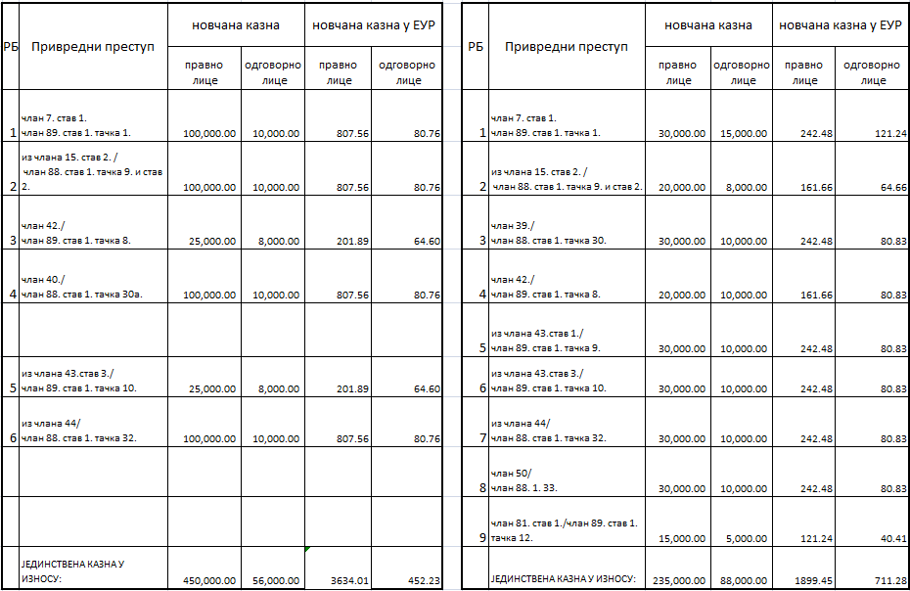
Table 1: Breakdown of amounts as per economic offences in relation to supervised entities 1 and 2 as described in the narrative part

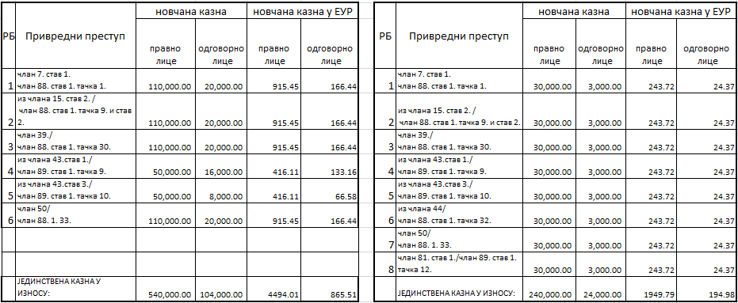
Table 2: Breakdown of amounts as per economic offences in relation to supervised entities 3 and 4 as described in the narrative part
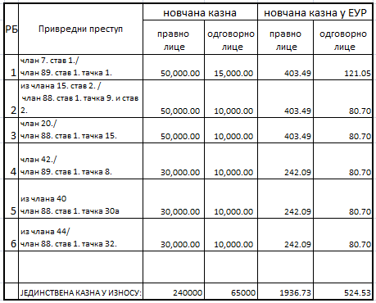

Table 3: Breakdown of amounts as per economic offences in relation to supervised entity 5 as described in the narrative part
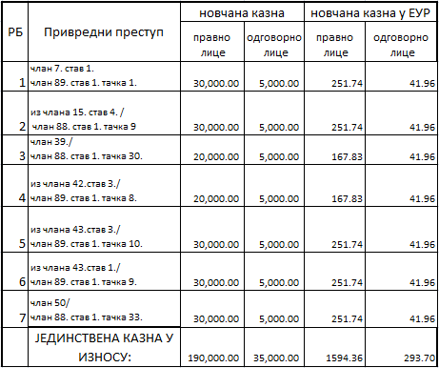
Table 4: Breakdown of amounts as per economic offences in relation to supervised entity 6 as described in the narrative part
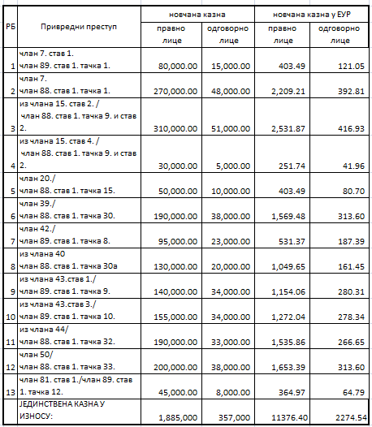
Table 5: Breakdown of amounts as per economic offences in relation to all supervised entities as described in aggregate in the narrative part

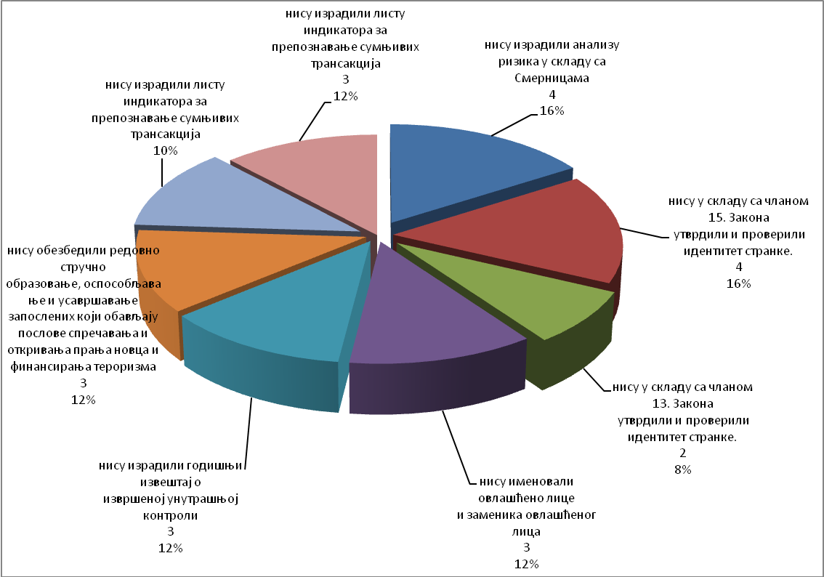
Chart showing the economic offences found in 2017 in accounting services providers (entrepreneurs and companies)

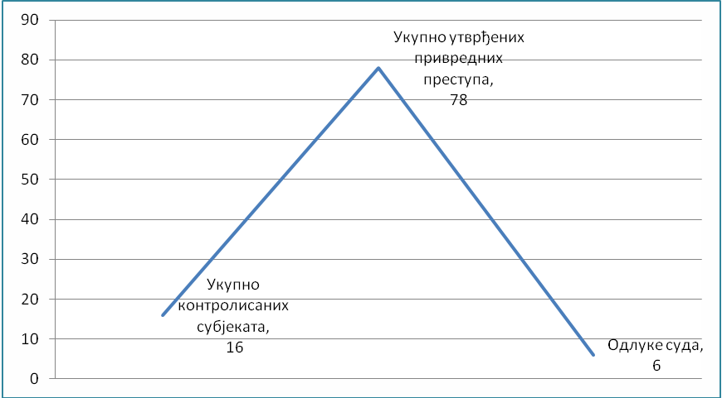

Chart showing the ratio between the total number of supervised entities for which no court decisions were passed in 2016, economic offences found in these supervised entities in 2012, 2013, 2014, 2015, 2016 and 2017, and court decisions passed in 2017.

APML EU - SERBIA NEGOTIATION ACTIVITIES

Negotiating chapter 4 - Free movement of capital

Free movement of capital is one of the four freedoms on which the functioning of the EU internal market is based. Prevention of money laundering and terrorism financing is one of the topics under this negotiating chapter, in addition to harmonisation of legislation in the area of capital movements and current payments. The Ministry of Finance is the coordinator of the negotiating group for this chapter.

In the free movement of capital area, member states are required, with certain exceptions, to remove all restrictions to capital movements both within the EU and between member states and other countries. Current payments are related to current transactions, i.e. transactions involving residents and non-residents, whose underlying aim is not transfer of capital. Rules have been defined concerning the national and cross-border payment services in EU. The aim is for the member state to have simple, efficient and safe cross-border payments while improving the beneficiaries’ rights to use of payment services. Also, the intent is to improve competition by opening the payment services market to new participants, thus fostering increased efficiency and reduction of costs and establishing the necessary platform for a single area for payment in Euros.

Full liberalisation of capital movements is a prerequisite of EU membership and opens up possibilities, for instance, of opening bank accounts abroad, granting loans to non-residents, taking cash in and out of country without restrictions, equal treatment of nationals of other member states with respect to the acquisition of legal title over real estate, etc. In achieving liberalisation of capital movements, there is a considerable risk of attempts to misuse the free movement of capital and freedom of provision of financial services which are characteristic of the integrated financial area. It is the possibility of misuse that constitutes the reason why measures, which are the subject-matter of relevant EU acquis, are needed at the EU level. Misuse of the financial system to move illegal proceeds but also of the money that has been legally obtained but can be used to finance terrorism, poses a clear threat to integrity, proper functioning, reputation and stability of financial systems.

The most important preventive EU legislation in this area is the so-called Fourth Directive, i.e. Directive (EU) 2015/849 of the European Parliament and of the Council of 20 May 2015 on the prevention of the use of the financial system for the purposes of money laundering or terrorist financing, amending Regulation (EU) No 648/2012 of the European Parliament and of the Council, and repealing Directive 2005/60/EC of the European Parliament and of the Council and Commission Directive 2006/70/EC.

In addition to the Fourth Directive, also relevant EU acquis is the Regulation (EU) 2015/847 of the European Parliament and of the Council of 20 May 2015 on information accompanying transfers of funds and repealing Regulation (EC) No 1781/2006.

In 2017, the APML was finalised the drafting of the new Law on the Prevention of Money Laundering and Terrorist Financing (AML/CFT Law) in order to harmonise this segment of the AML/CFT system with the FATF Recommendations and the above EU acquis, taking into account MoneyVal’s recommendations. This AML/CFT Law was adopted on 14 December 2017 (Official Gazette of the Republic of Serbia, 113/2017 of 17.12.2017), and it will become effective on 1 April 2018.

Negotiating Chapter 24 - Justice, freedom, security

Creating an area of justice, freedom and security is also one of the EU objectives. Even though it is addressed under Negotiating Chapter 4 on free movement of capital prevention of money laundering and terrorism financing, i.e. the criminal aspect of these issues, is covered also within Negotiating Chapter 24 - Justice, freedom, security, particularly under the section on fight against organised crime (money laundering) or fight against terrorism (financing of terrorism). The Ministry of Interior is the coordinator for the negotiating group in this chapter.

In addition to the above areas, this chapter addresses also the areas of asylum, migration, visa policy, border control and Schengen, as well as certain aspects of fight against human trafficking, fight against drugs, police cooperation, judicial cooperation in civil and civil matters, customs cooperation and Euro counterfeiting.

Relevant acquis in the ML/TF area, which are covered in this chapter, are contained in one EU act, i.e. Council Decision of 17 October 2000 concerning arrangements for cooperation between financial intelligence units of the Member States in respect of exchanging information. However, through the work in this chapter, all other aspects of the fight against ML and TF are considered, especially by presenting information concerning the fulfillment of Interim Benchmark 7 related to the implementation of Moneyval recommendations, increase the number of suspicious transactions reported to the APML and APML cases, as well as proactive use of APML information in investigations.

In 2017, the APML took an active part in implementing the Action Plan for Negotiating Chapter 24, i.e. the part of it covering the fight against money laundering (subchapter on the fight against organised crime). It also contributed to subchapter 7 on fight against terrorism.

Negotiating chapter 31 - Foreign, security and defence policy

Commmon foreign and security policy of the European Union was established in the Mastricht Treaty, and especially strengthened in the Lisbon Treaty, as the EU wants to speak with one voice when it comes to foreign policy. It is mostly founded on consensus of the member states and it constitutes a mechanism for adopting common declarations and guidelines for political and scurity issues that lead to common diplomatic action and to undertaking common actions. Decisions are adopted to define the EU position towards certain issues and measures to implement Common foreign and security policy, including sanctions. In addition to diplomatic action, main lines of action within this chapter is the Common security and defence policy, restrictive measures and arms control. Ministry of Foreign Affairs is the coordinator for this negotiating chapter.

Relevant EU acquis, within the APML’s remit, are mostly those related to restrictive measures taken where the EU decides that certain country violates international law or human rights and that it does not respect fundamental democratic values and rule of law as well as the acquis related to the fight against terrorism, i.e. its financing (e.g. The fight against terrorist financing [Council 16089/04], 14 December 2004; Revised Strategy on Terrorist Financing [Council 11778/08], 11 July 2008). Sanctions may vary from diplomatic to economic, and the candidate country is expected to align, in the negotiation process, with the regime of restrictive measures provided by EU.

The segment where the APML offered its contribution is related to the application of international restrictive measures. Namely, the Law on Freezing of Assets with the Aim of Preventing Terrorism specifies the measures for freezing of assets thereby implementing the UN Security Council Resolutions 1267 and 1373 and hence the relevant EU acquis, i.e.

- Council Regulation (EC) No 467/2001 of 6 March 2001 prohibiting the export of certain goods and services to Afghanistan, strengthening the flight ban and extending the freeze of funds and other financial resources in respect of the Taliban of Afghanistan (implementing UNSCR 1267(1999) and 1333(2000);
- Council Regulation (EC) No 881/2002 of 27 May 2002 imposing certain specific restrictive measures directed against certain persons and entities associated with Usama bin Laden, the Al-Qaida network and the Taliban, and repealing Council Regulation (EC) No 467/2001 prohibiting the export of certain goods and services to Afghanistan, strengthening the flight ban and extending the freeze of funds and other financial resources in respect of the Taliban of Afghanistan;
- Common Position 2001/931/CFSP on the application of specific measures to combat terrorism [implementing UNSCR 1373 (2001);
- Council Regulation (EC) No 2580/2001 of 27 December 2001 on specific restrictive measures directed against certain persons and entities with a view to combating terrorism;
- Council Framework Decision 2002/475/JHA on Combating Terrorism of 13 June 2002, amended by Council Framework Decision 2008/919/JHA of 28 November 2008 (OJ L 330, 09/12/2008, p. 21–23).

As the FATF in its revised recommendations set the standard also with respect to the prevention of the financing of proliferation of weapons of mass destruction, the issue of prevention of proliferation of WMD, which is covered in this chapter, will be more and more important for APML work.

In 2017, there were no major activities in this chapter.

INTERNATIONAL COOPERATION

Activities at the MoneyVal Committee

Serbia joined Moneyval in 2003. MoneyVal conducts mutual evaluations according to the FATF (Financial Action Task Force – international AML/CFT standard setter) Methodology and Standards. Serbian delegation consists of the representatives of the APML, Ministry of Interior, Ministry of Justice and the National Bank of Serbia; Ministry of Justice state secretary serves as the head of Serbian delegation to Moneyval.

In 2017 three regular MoneyVal plenaries were held, i.e. 53th Plenary on 30.5 – 1.6.2017, 54th Plenary on 26 - 28.9.2017 and 55th Plenary on 5–7.12.2017. APML Director and/or APML’s staff members took part at the 54th and 55th Plenary meetings.

At the 54th Plenary (26 – 28.9.2017) Serbian delegation was represented by the Ministry of Justice, Ministry of the Interior, Administration for the Prevention of Money Laundering и National Bank of Serbia. The delegation was headed by state secretary of the Ministry of Justice.

On the second day of the meeting, Moneyval noted the 1st Enhanced Follow-up Report for Serbia. The enhanced monitoring was the consequence of insufficient level of effectiveness of measures and actions taken by the Republic of Serbia in the AML/CFT area, as found in the Moneyval mutual evaluation report (MER) for Serbia which was adopted on 13 April 2016. Having analysed Serbia's progress in implementing the MER recommendations, MoneyVal Secretariat noted that Serbia had taken some steps but still needed to make significant progress, in particular by the time of September 2018 Plenary. Further, Moneyval noted that Serbia needed to demonstrate it fulfilled all recommendations concerning technical compliance (passage and harmonisation of legislation, etc.). In addition, Serbia should provide information corroborating progress as far as effectiveness is concerned (final deadline according to fifth evaluation round to demonstrate progress in effectiveness is 2021).

In parallel with the monitoring done by Moneyval, Serbia became subject, on the basis of the MER ratings, of monitoring (observation) by FATF ICRG (International Cooperation Review Group). On 8 December 2017, Serbian delegation met ICRG Joint Group for Europe and Eurasia which analysed the situation on the basis of the Moneyval 1st follow-up report and additional information provided to the JG by Serbia. Ever since the adoption of the Moneyval’s First Follow-Up report, Serbia had provided to the JG additional information in November, December (twice) and in January 2018.

APML work was rated relatively good in the 2016 Moneyval MER, and in the period after the evaluation, the APML demonstrated that it was achieving positive and tangible progress in remedying the concerns and implementing the recommendations of the Moneyval MER, which was also noted by the ICRG JG.

On 15 November 2017, the Government adopted an Action Plan to implement Moneyval recommendations.

Activities within the FATF

FATF is an intergovernmental body whose aim is to develop and improve AML/CFT measures at national and international levels. FATF is a policy-maker working to create political will to reform AML/CFT legislation and regulatory framework at the national level. In all its activities the FATF works with other international AML/CFT bodies. One of the most important FATF documents are the FATF Recommendations - International standards on combating money laundering and the financing of terrorism & proliferation - that are the main international standard in this area. Serbia’s compliance with these standards were evaluated by Moneyval experts during the fifth evaluation round.

In 2017, the FATF published three public statements concerning jurisdictions with strategic deficiencies posing risk to the international financial system. The statements are published so as to inform countries about the situations found in the countries involved and to take specific action where necessary.

Activities within the Egmont Group

Egmont Group is an association of financial intelligence units (FIUs) worldwide, whose objective is to promote and improve cooperation in terms of FIU to FIU financial intelligence exchange according to the Egmont Group’s principles for information exchange. The APML joined the Egmont Group in 2003. The Egmont Group holds its meetings twice a year, i.e. a Plenary Meeting (between May and July) including the meetings of the Working Groups and Heads of FIUs (HoFIU) and EG Working Groups (WG) Meetings (held usually in January or February).

In 2017, EG WG and HoFIUs meeting was held in Doha, Qatar (29 January - 2 February 2017), and the EG plenary was held in Macao on 2-7 July 2017.

As at the end of 2017, the Egmont Group had 156 member FIUs with a tendency of further expansion of this group’s membership.

Cooperation with international organisations and authorities of other countries

APML continued actively working with the OSCE with US authorities (Department of Justice, Department of State - US Embassy in Belgrade). It merits mentioning that APML was represented in an intensive training programme for proactive investigations of corruption, financial fraud and economic crime, and in specialised training programmes for certified fraud examiners and certified AML specialist.

PROJECTS

Proposal for a project to improve the quality and efficiency of suspicious transaction reporting and capacities of the Administration for the Prevention of Money Laundering .

The APML prepared under IPA 2015 a project to enhance APML’s core functions (receipt, analysis and dissemination). The tender procedure is handled by the EU Delegation in Belgrade. In 2017, the selection panel made a short list of candidates. The APML in cooperation with the EU Delegation to Serbia made the Terms of Reference for the project. It is expected that project implementation will start by mid-2018.

Other projects

Moreover, APML regularly participates in the activities of the IPA 2013 Project Against Corruption and various other projects (TAIEX, Twinning) lead by other authorities, that are intended to implement mainly to implement the Action Plan for Chapter 24.

The APML also took part in programming IPA 2018 which should, in the APML context, draw on the results of the IPA 2015 project thereby ensuring sustainability and support to APML’s long-term and strategic objectives, mainly in the area of IT.

HUMAN RESOURCES AND TRAINING

In addition to the positions of the acting director and two acting assistant directors, who were appointed by the Government, the Rulebook on the internal organisation and classification of jobs in the APML provides for 29 posts to be filled with 37 civil servants. Of the overall number of positions envisaged (37), APML has 29 staff members, meaning that 78.37% of the APML’s HR capacities were filled in 2017.

Year | Number of employees | Qualification
2017 | 29 (28 + 1 on leave of absence) | higher education | 2-year post-secondary | secondary
2017 | 29 (28 + 1 on leave of absence) | 27 | 1 | 1

Structure of APML staff

The table shows that on 31 December 2017, the APML had 23 employees with an indefinite-term contract + 3 Government-appointed persons + 1 leave of absence = 27 in total) with a university degree, 1 employee with a 2-year post-secondary education and 1 employee with secondary education which shows the APML has highly qualified staff in structure, i.e that 93.10% of staff have university-level qualifications. The data above shows a structure that meets the requirements of a financial intelligence unit, but also the APML does not have sufficient HR capacities which is why in 2017 the APML recruited two staff members under a temporary contract and one staff member to replace an absent civil servant.

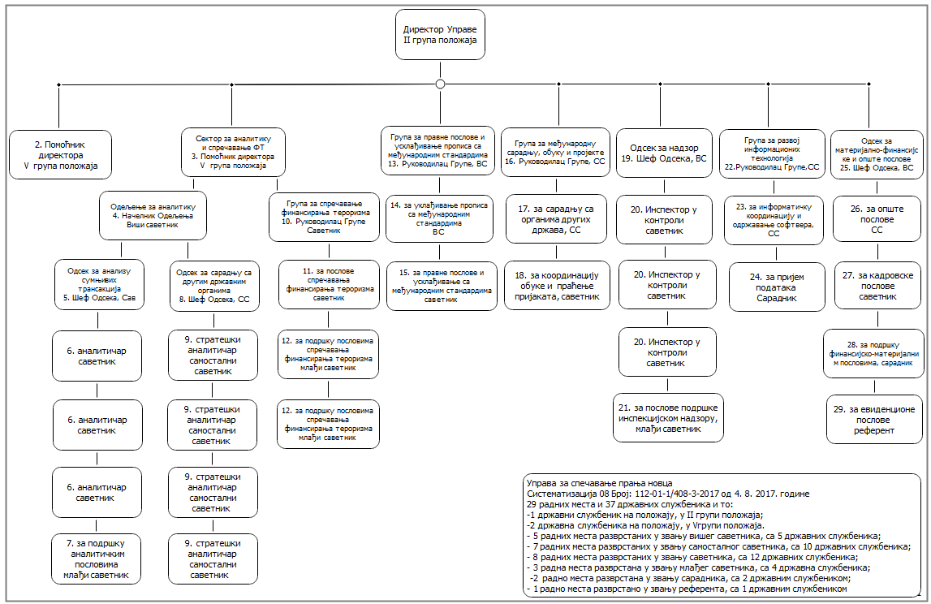

APML Organigram

On 2017, APML staff took part in the following activities:

Training, seminar, conference  (topic, title) | Time and venue | Organiser(s) | Attendees
Return of foreign fighters and ISIL external operations | 24-27.01.2017  Tirana, Albania | US Justice Department | 1
Egmont Group meeting | 29.01-03.02.2017  Qatar | Egmont Group | 1
Investigation and prosecution of preparatory terrorist actions, attacks and terrorist financing | 14-16.02.2017  La Valetta, Malta | US Embassy in Belgrade, US Justice Department | 1
ML cases, sectoral analysis, interagency cooperation | March  Belgrade | Security Information Agency | 3
Analytical methods and special FI techniques in the fight against ML and TF | 02-07.04.2017  Moscow, Russian Federation | UNODC | 2
EAG | 22-26.05.2017  Bishkek, Kyrgyz Republic | EAG | 1
Mandatory application of the new regulation concerning the records of public real estate | 22.5.2017  Belgrade | Directorate for property of the Republic of Serbia | 2
6th Serbian internal auditors conference | 18 and 19.05.2017  Belgrade | Serbian internal auditors association | 1
Cyber-crime conference | 24 and 25.05.2017  Warsaw, Poland | Polish institute for cyber security (NASK) | 2
MoneyVal Plenary | 29.05-01.06.2017  Strasbourg, France | Council of Europe | 1
Analysis of ML cases, typologies, cooperation with banks and feedback event | June  Palić | Association of Serbian Banks | 3
Workshop on search, seizure and confiscation of cyber-crime proceeds - iPROCEEDS | 12 and 13.06.2017  Luxembourg | EU and Council of Europe | 2
Forensic accounting | 20-23.06.2017  Sarajevo | US Justice Department | 1
Strengthening of all relevant authorities in fighting economic and organised crime | 19-23.06.2017  Belgrade | TAIEX | 2
Novelties that EU directives can make to public procurement, Republic commission for protection of rights in public procurement procedures | 03.07.2017  Belgrade | Procurement management centre | 1
Conference on illicit internet trade operations | 05-08.09.2017  Barcelona, Spain | Team Cymru | 2
Zlatibor public procurement fair | 25-28.09.2017  Zlatibor | Public Aktiv doo | 1
MoneyVal Plenary | 26-28.09.2017  Strasbourg, France | Council of Europe | 4
Implementation of international restrictive measures | 03-05.10.2017  Sarajevo, BiH | GIZ | 1
Regional workshop on ML guidelines and indicators for identifying fraud through internet – iPROCEEDS Project | 4 and 5.10.2017  Ljubljana, Slovenia | EU and Council of Europe | 2
Amendments to the AML/CFT Law, focus on supervision of auditing companies | 20.10.2017  Belgrade | Serbian internal auditors association | 1
Regional conference on investigating and prosecuting the crimes of corruption and financial crime | 16-21.10.2017  Dubrovnik, Croatia | US Embassy in Zagreb, Croatia | 1
FATF Plenary | 29.10-03.11.2017  Buenos Aires, Argentina | FATF | 1
Proactive investigations of corruption cases and financial fraud and economic crime cases | 7-09.11.2017  Niš | US Embassy to Belgrade, OSCE, Judicial Academy | 1
Regional conference of Heads of FIUs | 6-8.11.2017  Brdo pri Kranju, Slovenia | FIU Slovenia | 1
Awareness raising of TF risks involving the NPO sector | 21.11.2017  Belgrade | APML, National EU Convent, Government Office for Cooperation with Civil Society | 2
Suppression of illegal migrations and its financing | 23 and 24.11.2017  Athens, Greece | UK National Crime Agency | 1
Normative and administrative challenges related to foreign terrorist fighters threats | 30.11-01.12.2017  Belgrade | UNODC | 1
EAG | 21-24.11.2017  Moscow, Russian Federation | EAG | 1
Strengthening SEE regional cooperation in fighting financial crime, with a focus on ML and TF | 29 and 30.11.2017  Skopje | OSCE | 1
State Parties to the CETS No. 198, Permanent Representatives of the Council of Europe Members States and Observers to the Committee of Ministers, Observers to the C198-COP | 20-23.11.2017  Strasbourg, France | Council of Europe | 1
MoneyVal Plenary | 5-7.12.2017  Strasbourg, France | Council of Europe | 4
Training of real estate trade intermediaries | December  Belgrade, Nis, Novi Sad, Kragujevac | Serbian Chamber of Commerce and Industry | 3

IT DEVELOPMENT

Participation in the working group for establishing a single IT system for information exchange between various authorities.

Preparation of technical documentation and participation in the implementation of IT-related public procurements.

Designing and planning of projects related to the improvement and modernisation of the APML and budget development for these projects that are envisaged to be implemented in 2018.

A project was completed for retrieving data electronically from the Business Registers Agency. The project finalised the development, setting of a testing environment, testing, setting of the production environment, development of procedures for storing data in the database, initial database population and setting of incremental population. The project resulted in automatic daily takeover of data, ensures that they are up-to-date and analysed automatically.

APML staff were allowed access to a specific domestic and global database.

Creation of new and improvement of current analyses and reports used by APML staff in order to improve effectiveness and efficiency of APML staff.

Screening and manual import of all incoming documents into the APML IT system and manual import of transaction reports received from certain obliged entities.

Replacement of old and installation and configuration of the new server for managing backup copies of the entire APML IT system.

Installation, configuration, extension of the current virtual infrastructure thereby increasing reliability of operation of the entire APML IT system.

New email server installed and configured.

APML data safety and security improved through installation of new devices and implementation of data protection procedures.

Proactive action with respect to global threats with the aim of protecting the APML IT system.

Due to the change of APML internet service provider, installation connection and configuration of the required equipment was completed, as well as reconfiguration of the server, network equipment and application.

Organisation and maintenance of APML website.

Supporting obliged entities in using APML’s application for transaction reporting and exchange of documents, and management of user accounts and certificates for accessing them.

Continuous monitoring, supervision and maintenance was carried out of the APML entire IT system in the operative state (databases, network infrastructure, application servers, applications, email servers, devices for protection of IT system from unauthorised access, backup copies of the system, data storage devices, virtual infrastructure), and ongoing work to improve its performance.

MATERIAL AND FINANCIAL AFFAIRS

The Team for material, financial and general affairs in 2017 successfully performed all activities aimed at preparing and developing the financial plan and thus ensured an efficient use of funds following the adoption of the 2017 Budget Law. Timely and adequate planning of finances has created the conditions for prompt financial accounting and bookkeeping through regular settlement of liabilities at the monthly and daily levels within the appropriate budget items, as well as use of the budget according to regulations as well as record keeping and reporting.

The 2017 Budget Law allowed a total of RSD 60,672,000 for APML operations to be financed by the Republic of Serbia budget. The execution of the current expenditure totals RSD 43,487,538.04. The difference between the allocated funds and the execution figures on the appropriation Employee salaries, benefits and compensations the reason being that the envisaged recruitment did not occur in 2017 as planned. For this reason, the use of 2017 budget funds, in percentages, has been somewhat lower compared to the previous year amounting 71.68% (chart 1) even though the other appropriations do not show any major discrepancies between the funds allocated and those executed.

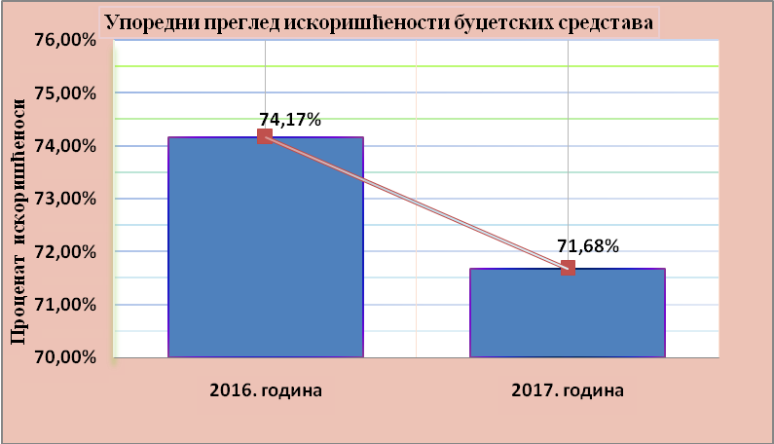

Chart 1 Comparative overview of budget funds
In 2017, the Team provided support for smooth operation of the APML as provided under the AML/CFT Law by prioritising financial activities, planning expenditures, implementing the planned procurement of goods and services in line with the Public Procurement Law and by ongoing control of the regularity and legality of documentation supporting the budget execution. The Team also issued, through the Treasury Administration, electronic payment orders for all payment orders and monitored the settlement of liabilities undertaken.

For the execution of payment orders, exchange of financial data and following of statutory provisions related to public procurement, the APML’s financial staff use fifteen specific software applications ensuring direct connection to other state authorities thereby networking the APML directly into the Finance Ministry’s IT system. Towards the end of 2017, new accounting application software Bit impex Next was procured thereby establishing the system of double accounting. The new software ensures keeping data about all transactions entered in the books, for the functioning of the system of internal accounting checks, which prevents the entered business changes from being deleted, thereby aligning with the Budget Accounting Decree, International Public Sector Accounting Standards.

In its business processes, the Team applies more than 40 laws, rulebooks, decisions, guidelines and other documents on which it reported to the Ministry of Finance and other authorities.

The Team also updated the procedures and business processes in the APML in order to simplify them. A workload analysis document was also produced in order to identify HR development needs. A catalogue of main and support processes and the risk management strategy updated on that basis.

The MoF Internal Audit Team in 2017 performed a check of APML operations.

The Team analysed the needs and conducted 18 tenders. Each of the public procurements included an assessment of whether it was justified and purposeful respecting the principle of rational spending of public funds and control of expenditure. In compliance with applicable legislation, the APML concluded a Services Contract in the area of fire protection and occupational safety and health.

The Team made an annual inventory of its property and financial commitments according to sources of funds on 31 December 2017.

All required personnel records and other tasks to ensure efficient and consistent performance of staff were well maintained and implemented.

CHALLENGES AND OBSTACLES IN ACHIEVING OBJECTIVES
Lack of capacities in terms of human resources and an extremely wide remit of APML responsibilities is a problem for APML operation. Namely, 29 civil servants are currently permanently employed. The European Commission and other international organisations following the money laundering area in Serbia, have drawn attention to the problem of the scarce APML resources particularly having in mind the various APML’s responsibilities whose number is significantly higher than what international AML/CFT standards require of an FIU. In order to increase the number of employees it is necessary to secure adequate work premises even for work of the current employees.

Further strengthening of interagency cooperation for a more efficient functioning of the entire AML/CFT system will be APML’s priority for the future.

Information taken from the Chamber of Certified Auditors’ website - www.kor.rs

