Annual Report of the Administration for the Prevention of Money Laundering, 1.1.2016-31.12.2016

Belgrade, 27 March 2017
Administration for the Prevention of Money Laundering
Masarikova 2, 11000 Belgrade
CONTENTS
CONTENTS 2
UPGRADING THE AML/CFT SYSTEM AT POLICY LEVEL 5
Standing Coordination Group for monitoring the implementation of the National AML/CFT Strategy 5
AML/CFT SYSTEM DEVELOPMENT AT LEGISLATIVE LEVEL 5
Draft Law Amending the Law on the Freezing of Assets with the Aim of Preventing Terrorism 5
Draft Law on the Prevention of Money Laundering and Terrorism Financing 6
FINANCIAL INTELLIGENCE ACTIVITY IN 2016 7
COOPERATION WITH OTHER STATE AUTHORITIES IN SERBIA 8
Ministry of the Interior 9
Security Information Agency 10
Military Security Agency 10
Tax Administration 10
Anti-Corruption Agency 10
National Bank of Serbia 11
COOPERATION WITH FOREIGN FIUs 11
ANALYSIS OF SARs 11
STRATEGIC ANALYSES AND OTHER RESEARCH 13
MONEY LAUNDERING TYPOLOGIES, TRENDS AND TECHNIQUES; FOCUSING ON FUTURE ACTIVTIES 13
TERRORIST FINANCING 14
TERRORIST FINANCING – A CASE STUDY 15
TRENDS, CHALLENGES AND OBSERVATIONS 16
SUPERVISION OF ACCOUNTANTS AND AUDITORS FOR COMPLIANCE WITH AML/CFT LAW 17
OFF-SITE INSPECTION IN 2016 19
ON-SITE SUPERVISION 20
COURT DECISIONS 21
APML EU - SERBIA NEGOTIATION ACTIVITIES 26
Negotiating chapter 4 - Free movement of capital 26
Negotiating Chapter 24 - Justice, freedom, security 27
Negotiating chapter 31 - Foreign, security and defence policy 27
INTERNATIONAL COOPERATION 28
Activities at the MoneyVal Committee 28
APML core functions - receipt, analysis and dissemination of intelligence 29
Prevention. 30
Supervision 30
Terrorist Financing 30
Activities within the FATF 30
Activities within the Egmont Group 30
Memoranda of understanding (MOUs) 32
Organisation for Security and Cooperation in Europe (OSCE) 32
Cooperation with authorities of other countries 32
PROJECTS 33
Improvement of the quality and efficiency of suspicious transaction reporting and capacities of the Administration for the Prevention of Money Laundering 33
Other projects 34
HUMAN RESOURCES AND TRAINING 34
IT DEVELOPMENT 37
MATERIAL AND FINANCIAL AFFAIRS 38
CHALLENGES AND OBSTACLES IN ACHIEVING OBJECTIVES 40

UPGRADING THE AML/CFT SYSTEM AT POLICY LEVEL

Standing Coordination Group for monitoring the implementation of the National AML/CFT Strategy

Following the adoption of the National Strategy Against Money Laundering and Terrorism Financing (National AML/CFT Strategy) and its Action Plan on 31 December 2014, on 23 April 2015 Government of Serbia passed a Decision establishing the Standing Coordination Group for Monitoring the Implementation of the National AML/CFT Strategy (SCG). The National AML/CFT Strategy covers the period 2015–2019. SCG members are state authorities having a role in implementing the Law on the Prevention of Money Laundering and Terrorism Financing (AML/CFT Law). SCG has 30 members representing 19 state authorities. The activities set out in the Action Plan mostly concur with activities undertaken within other relevant policies or set out in documents related to the EU – Serbia negotiations within Chapters 24, 4, 31, 23 and 29.

In 2016, SCG was provided administrative and technical support by the APML. The APML analysed and prepared materials for SCG meetings; kept a record of implementation of the Action Plan activities based on information from SCG members; sent out convocations and drafted reports, memos and analyses.

SCG held four meetings in 2016: on 25 January, 25 February, 6 April and 16 June. Some of the most important topics included the evaluation of Serbia by conducted by the Council of Europe MONEYVAL Committee (MoneyVal) and transposition of the relevant AML/CFT EU acquis, primarily the Fourth AML Directive. At its 5th meeting on 25 January 2016 the SCG adopted its Annual Report, which was submitted to the Government for information purposes. In addition, the SCG analysed the concerns raised in the Moneyval Mutual Evaluation Report for Serbia (MER), adopted on 13 April 2016, and provided the authorities concerned with relevant excerpts and key findings of the MER.

Given the fact that the MER stated that the SCG was not effective enough, action was taken, following the adoption of the MER, to establish a new coordinating body that would not only be in charge of monitoring the implementation of the National AML/CFT Strategy, but also of coordinating of the entire AML/CFT system, in line with the Moneyval recommendations.

AML/CFT SYSTEM DEVELOPMENT AT LEGISLATIVE LEVEL

Draft Law Amending the Law on the Freezing of Assets with the Aim of Preventing Terrorism

The Law on the Freezing of Assets with the Aim of Preventing Terrorism (Official Gazette of RS, no. 29/15) (TAF Law) was passed on 20 March 2015. The objective of the TAF Law is to step up the fight against terrorism by establishing a system of preventive and repressive measures against terrorism financing as it constitutes a necessary prior stage in the commission of an act of terrorism. The United Nations Security Council (UNSC) passed several resolutions (UNSCRs) laying down repressive measures against terrorists, terrorist organisations and their financiers. One of the measures is to prevent the use of property and assets of terrorists and their financiers by requiring countries to regulate the freezing of terrorist assets should such be identified in their territories.

By passing this legislation, Serbia complied with Chapter VII of the UN Charter, which provides that UN member states are obliged to take measures to implement resolutions adopted by the UNSCR within its powers (UNSCRs). The UNSCRs laying down the measures to prevent terrorist financing and terrorism in general are the following: UNSCR 1267 of 1999 containing a list of persons designated by the UNSC against whom such measures are to be applied (as well as subsequent UNSCR 1988, 1989 and 2253), UNSCR 1373 of 2001, which concerning the designation of individuals/entities at the proposal of countries and jurisdictions. The TAF Law is in line with the revised 2012 FATF Recommendations, i.e. Recommendation No. 6.

From December 2014 to April 2016, MoneyVal evaluated Serbia under a fifth round of evaluations scrutinising the actions and measures the country takes to combat money laundering and terrorism financing. Fifth round evaluations test technical compliance with international AML/CFT standards (i.e. FATF Recommendations), and the overall effectiveness of the AML/CFT system. Serbian MER was adopted in April 2016 at MoneyVal’s 50th Plenary. The relevant comments, assessments and recommendations have analysed and incorporated into a Draft Law Amending the TAF Law.

The amendments to the TAF Law are in line with the MER as it found deficiencies mainly concerning the implementation of the TAF Law. In particular, the process of designation by the Government, at the proposal of the Ministry of Foreign Affairs transpires as slow and in contravention to the principle of urgency, which needs to be implemented, according to relevant international standards. For a decision to be issued by the Government, names from UN lists should be transcribed into Cyrillic script, and with frequent changes to the Lists their implementation into national legal system is in constant delay.

The Draft Law was translated into English and together with the table of concordance sent to the relevant bodies of the European Commission through the Office of European Integration, for possible suggestion.

Draft Law on the Prevention of Money Laundering and Terrorism Financing

The current AML/CFT Law regulated the ML/TF system in a systemic manner. However, given the recent developments in the AML/CFT area, the APML worked intensively in 2016 to draft a law to amend the current AML/CFT Law. The legislator considered the possibility to pass amendments to the current AML/CFT Law, however, circumstances that changed considerably while the Law was being worked on resulted in consequent changes in current provisions. As more than half of the articles of the current law would be affected by amendments the legal drafting rules mandate that a new AML/CFT law be passed rather than a law amending the current AML/CFT law.

Before its finalisation, the Draft AML/CFT Law was posted on the APML’s website so that financial institutions and non-financial businesses and professionals could comment and make suggestions on the text. Acceptable suggestions have been reflected in the current version of the text. The relevant bodies of the European Commission too analysed the Draft AML/CFT Law and expressed their opinion by sending in their comments and suggestions.

The envisaged changes would align current legislative provisions with the new AML/CFT standards, i.e. FATF’s 40 Recommendations. Apart from the FATF Recommendations, other international legal standards have also been taken into account such as the Directive 2015/849/of the European Parliament and of the Council of 20 May 2015 on the prevention of the use of financial system for the purposes of money laundering and terrorist financing, amending Regulation (EU) No 648/2012 of the European Parliament and of the Council, and repealing Directive 2005/60/EC of the European Parliament and of the Council and Commission Directive 2006/70/EC, also known as the Fourth Directive.

The adoption of this Law was originally planned in 2015. As Serbia was entering the fifth round of evaluation of its AML/CFT system at the time, a decision was made to wait for the end of the evaluation and the adoption of the Moneyval Evaluation Report so that comments, remarks and recommendations from the Report could also be taken into account in the Draft AML/CFT Law, which was done in the period from July to September 2016.

Following internal consultations within the Ministry of Finance, in November 2016 the Draft AML/CFT Law was sent to the relevant state authorities for official opinion. The comments were analysed and accounted for in the Draft AML/CFT Law. Previously, the working version of the draft, together with the table of concordance with the relevant EU acquis was sent, through the Serbian Office for European Integration, to relevant services of the European Commission for analysis and possible suggestions. After the feedback from the European Commission was received, the Draft AML/CFT Law was then amended to account for the suggestions provided and as such sent to the relevant authorities for official opinion. Given the relevance of the AML/CFT Law for harmonisation with the EU, as well as the extent of changes compared to the working version that had previously been sent to the European Commission for opinion, the Office for European Integration noted that it was necessary to consider providing the European Commission with the Draft AML/CFT Law for additional consultation.

FINANCIAL INTELLIGENCE ACTIVITY IN 2016

APML’s financial intelligence is generated by the Department of Analytics, Financial Intelligence and Cooperation with State Authorities.

APML worked on 1,154 cases in the reporting period. In specific, 951 new analytical cases were opened at the initiative of other state authorities, supervisory authorities, foreign FIUs and as a result of an analysis of suspicious activity reports (SARs) submitted by obligors. APML also worked on 203 cases that had been opened in previous years (where new information emerged concerning the persons who had already been subject to APML’s analyses).

In most of the information requests received from other state authorities, the suspected underlying crimes were: tax evasion, abuse of authority in economy, misfeasance in commercial operation, illicit crossing of the state border and human trafficking, illicit production of and trade in narcotics, various types of fraud, terrorism and terrorism financing.

In most cases the suspicion was related to economic justifiability of transactions, source of funds deposited into accounts, fictitious trade in goods and services, fictitious legal transactions.

A large number of cases was analysed on account of suspicion on fictitious business relations, that is, transfers of funds based on fictitious grounds. Deposits of cash of unknown source were often made into accounts held by legal persons, followed by transfers between two or more legal persons, which often transpire to be linked. The ultimate goal of such business relations is to introduce cash of suspicious origin into legal money flows. For example, it was noticed in the previous year that obliged entities would often report suspicious activities involving individuals making significant deposits to construction companies describing them as founder’s loan for company liquidity.

A large number of requests received from state authorities were related to misfeasance in commercial operations committed by the company’s director and to draining out of funds from the company. The funds generated in this way are most commonly used for private purposes by the individuals involved.

Due to the global migrant crisis and a significant number of migrants transiting Serbia, transactions conducted by migrants in transit have been under close scrutiny. Because of possible terrorist activities and their financing, as well as smuggling and trafficking in human beings, transactions of persons linked with so-called "critical areas” have been analysed with particular attention and urgency.

COOPERATION WITH OTHER STATE AUTHORITIES IN SERBIA

Prosecutors’ Offices

In 2016, the APML received 40 requests from Serbian prosecutors’ offices.

Prosecutor’s Office | No of requests:
Prosecutor’s Office for Organised Crime | 9
Higher Prosecutors’ Offices | 28
Basic Prosecutors’ Offices | 3

The money laundering suspicion was most commonly related to the crimes of abuse of office, fraudulent practices, abuse in privatisation, embezzlement, human trafficking, illicit drugs trafficking, forgery, all types of organised crime, etc.

The APML has disseminated its cases in line with the Agreement signed with the Republic Public Prosecutor's Office on 22 January 2014. In 2016, the APML disseminated a total of 44 information reports to relevant prosecutors’ offices.

Prosecutor’s Office | Number of disseminations
Prosecutor’s Office for Organised Crime | 15
Higher Prosecutors’ Offices | 28
Republic Public Prosecutor’s Office | 1

The largest number of analyses and information concerning suspicious ML or TF activities was disseminated to the Higher Prosecutor’s Office in Belgrade, i.e. 16 information in total.

Regional overview of the cases per prosecutor’s office is shown in the table below:

Higher Prosecutor’s Office | Number of disseminations
Belgrade | 16
Novi Sad | 2
Novi Pazar | 3
Sremska Mitrovica | 4
Pančevo | 1
Kraljevo | 1
Subotica | 1

In most cases information was disseminated to prosecutor’s offices over a suspicion on fictitious legal transactions, corruption, drug trafficking, human trafficking, forgery of business documentation, various types of fraud and connections with already known criminal groups in Serbia.

Ministry of the Interior

In the reporting period, the APML received 474 requests from the Ministry of the Interior. Of this number, APML received 96 requests from the Criminal Police Directorate. Apart from checking the APML’s CTRs and STRs databases in these cases, the APML also collected data on account turnovers (covering the period of eight years on average), money transfers through agents and from foreign financial intelligence units via the Egmont Group secure website.

The APML received 30 requests directly from police directorates. The related checks were usually undertaken on suspected abuse of authority in economy, tax evasion, fraud and fictitious legal transactions.

Some requests received from the Ministry of the Interior were related to cases operated by task forces where it was necessary to check with utmost urgency a large number of natural and legal persons (associated persons) and analyse their account turnovers in all commercial banks in Serbia (currently 29 banks). Due to the urgency and seriousness of the cases, the data was to be analysed on a very short notice (usually 48 hours). In 2016, the APML received from the Ministry of the Interior 15 requests requiring urgent analysis. The requests mainly involved suspicion on the crimes of corruption and money laundering.

In the reporting period, the APML received 348 requests from the Financial Investigations Unit of the Ministry of Interior each of them involving 15 subjects to be checked on average. In most of these requests, the suspected prior crimes included fraud, tax evasion, illicit production and trade in narcotics, misfeasance in commercial operation and human trafficking.

Following its analysis of SARs reported by obliged entities, the APML sent 115 information requests to the Ministry of Interior sharing its information and requesting police information on criminal records, ties with criminal groups in Serbia and any other operational data held by the Ministry of the Interior. The activities of the subjects raised suspicion on the source of funds, illicit drugs trafficking, fraud, misfeasance in commercial operation, human trafficking, terrorism financing, securities manipulation, etc.

Security Information Agency

The APML received 55 requests for information from the Security Information Agency in the reporting period. The APML was requested to check account turnovers over the previous two years, in addition to checking its own databases. The information exchanged mostly related to suspected drugs trafficking, human trafficking, terrorist financing, ties with criminal organisations, transfers of funds of suspicious origin into accounts in Serbia and forgery of identification documents committed by natural persons.

As the result of SARs analyses, the APML sent 86 disseminations to the Security Information Agency for further utilisation, requesting feedback. These cases usually involved foreign nationals holding accounts or conducting transactions in commercial banks in Serbia whose activities are suspected to be related to human trafficking, drug trafficking, fraud and terrorist financing.

Due to the extensive migrant crisis, money transfer agents file SAR’s frequently. These SARs were shared with the Security Information Agency over suspected terrorist financing or human trafficking.

Military Security Agency

In 2016, the APML received 4 requests for information from the Military Security Agency on account of suspected trafficking in arms, corruption and terrorist financing.

The APML filed 14 disseminations to the Security Information Agency at its own initiative, requesting additional information. These specific cases were related to activities suspected to involve arms trafficking.

Tax Administration

In the reporting period, the APML received 18 requests for information from the Tax Administration, whereas the APML provided Tax Administration with 92 requests for checks within their term of reference. APML’s requests mainly involved suspicion on fictitious legal transactions the aim of which was to drain cash from the accounts of business entities, in order to avoid paying taxes. Some APML’s requests for information involved repayments of founder’s company liquidity loans which were believed to have never been given.

Anti-Corruption Agency

The 2012 National Risk Assessment (NRA) found that the crimes of corruption were high-risk offences for money laundering. In 2016, the APML received 14 requests for information from the Serbian Anti-Corruption Agency (ACAS) involving suspected disproportion between the income and the property held by a politically exposed person (PEPs) and their associates as declared to ACAS, as well as suspicion on the legitimacy of the origin of funds used to finance political parties.

National Bank of Serbia

In the reporting period, and pursuant to Article 6 of the Money Laundering and Terrorist Financing Cooperation Agreement, the APML received from the National Bank of Serbia 14 requests to check information concerning SARs filed to the APML (number and quality of reported suspicious and cash transactions).

COOPERATION WITH FOREIGN FIUs

In 2016, the APML responded to 110 requests for information received from foreign FIUs. The requests were mostly about Serbian nationals holding bank accounts abroad who are suspected of having ties with criminal groups or criminal activities, and about foreign nationals holding accounts in commercial banks in Serbia, or are involved in criminal activities in Serbia.

In the same period the APML received 20 spontaneous disclosures from foreign FIUs, which were mostly about suspicious activities of natural or legal persons from Serbia, holding accounts in banks abroad. The spontaneous disclosures also included information on foreign legal persons which hold bank accounts in Serbia, which are suspected of being used as disguise for assets illegally acquired abroad.

Working on analytical cases, the APML sent 133 requests to foreign FIUs. The requests were mostly about non-residents holding accounts or conducting business in Serbia where the APML had suspicions related to the origin of their assets or their business activities. In addition, APML sent some requests to foreign FIUs looking to identify assets held by Serbian nationals abroad.

The table below shows FIUs with which the APML had the largest number of information exchanges in 2016

 | Requests from foreign FIUs | APML’s requests
USA | 13 | 2
Bosnia and Herzegovina | 10 | 7
Montenegro | 10 | 7
Cyprus | 3 | 16
Hungary | 13 | 9

ANALYSIS OF SARs

In 2016, the APML received 2,505 SARs in total. The table below provides a breakdown of SARs per types of obligors:

Obligors | Number of STRs
Banks | 661
Money transfer service providers | 1.793.
Broker-dealer companies | 2
Accountants | 2
Auditors | 7
Bureaux de change | 2
Entities engaged in postal communication | 20
Insurance companies | 16
Leasing | 1
Lawyers | 1

As the table above shows, the largest number of SARs in 2016 was reported by money transfer service providers and banks.

Banks provide comprehensive explanations of the ML/TF suspicion. In addition to this, they also provide extensive information on activities of the reported persons, which took place before reporting. Of the total amount of SARs submitted by banks (661), 163 SARs remained on the monitoring regime in the APML, whereas the rest were disseminated to the relevant authorities for further action.

All the SARs submitted by money transfer service providers (1.793 reports) were disseminated to the relevant authorities for further action.

The subjects involved in SARs retained on monitoring regime by the APML, but for which there is no sufficient information to corroborate the suspicion of money laundering or terrorism financing, are still being monitored and in case of a new CTR or SAR, they are analysed and assessed again.

Activities most commonly reported as suspicious by obligors were: tax evasion, inflows of money of unknown origin into the financial system of Serbia, forgery of ID documents, abuse of official position within legal persons, suspicious acquisitions of legal persons, suspicious use of loans by individuals, terrorism financing through charity organisations, etc.

As in previous years, tax evasion is still the most common predicate criminal offence recognised in SARs. Most often it is about fictitious legal operations which aim to drain cash from legal persons’ accounts, or transactions where funds are of suspicious origin, such as loans made by an individual using the funds which do not originate from legal business.

A large number of SARs involve different types of fraud (forgery of documentation, forgery of ID documents, payment card fraud).

Black market trade in goods is still very common in Serbia. Individuals import and sell goods for cash, without keeping business records, and use alternative ways to pay for the goods through money transfer service providers, thus avoiding banks. They pay suppliers for the goods in black market, or describing the payment by provision of financial support to one’s family.

There have been frequent business activities of charity organisations in the regions assessed as posing a terrorism financing risk in Serbia. There is suspicion that such organisations are abused for financing and training potential terrorists.

Through SAR analyses we observed that non-resident individuals that do not have business activities in Serbia open accounts in banks in Serbia in an increasing number. These accounts are credited with significant amounts from abroad on different grounds and with no clear evidence of origin and intended purpose of the funds.

In 2016, banks submitted one SAR on suspicion of terrorism financing.

As for the SARs received from money transfer service providers, they mostly involve foreign nationals originating from areas that pose risk for terrorism financing (Syria, Saudi Arabia, Pakistan, Afghanistan, etc.). Transactions conducted through money transfer service providers are done in small amounts and it has been noticed that certain individuals depositing or withdrawing cash for several persons.

It is important to note that the use of money transfer service providers by Serbian nationals has been on a significant rise over the recent months. Funds sent by relatives working abroad are usually received in this way. Money transfer services can be abused for payment of goods by company owners. Such transactions result in tax evasion and money laundering.

STRATEGIC ANALYSES AND OTHER RESEARCH

Apart from working on specific cases in 2016, the APML did the following research and strategic analyses:

- Analysis of the Bitcoin crypto-currency;
- Organised crime and money laundering;
- Updating the analysis of terrorist financing;
- Analysis of electronic banking;
- Abuse of religious organisations for money laundering and terrorism financing purposes;
- Analysis of money laundering risk through gold trade in Serbia;
- Analysis of the GFI (Global Financial Integrity) Institute Report on Methodology and Current State of Play of Serbia’s Foreign Trade Statistics, with the aim to objectively assess the GFI Report relative to its finding concerning illegal financial outflows from Serbia in 2004-2013.

MONEY LAUNDERING TYPOLOGIES, TRENDS AND TECHNIQUES; FOCUSING ON FUTURE ACTIVTIES

The APML has observed the following money laundering typologies, techniques and instruments in 2016:

- Loans in cash of unknown or suspicious origin are given to natural or legal persons and then used for business operations or further layered into a specific kind of assets;
- Successive or structured deposits of cash of unknown origin into the financial system - into one’s private accounts or those of other people (so called front persons), with the aim of layering or integrating the cash in order to acquire business assets (insurance policies, securities, real estate, leasing operations, etc);
- Generating (integrating) cash of suspicious and unknown origin through deposit accounts, special purpose and savings accounts;
- Placing money of suspicious origin into the financial system through fictitious operations, combining legal business and fictitious (shell) companies, whereby the beneficial owner and the true purpose of business are almost never known;
- Placing money of unknown and suspicious origin from abroad into legal flows, using shell companies - companies whose beneficial owner, business purpose or indicators are difficult to trace. Such companies are usually established in off-shore jurisdictions. Untransparent funds usually come in the form of loans, dividends, credits, equities or holdings, advance payments for business operations, services or in operations with non-resident accounts of individuals;
- Conversely, dirty money or untaxed portion of capital is exported out of the country through accounts of off shore companies, usually as payments for fictitious liabilities and services. Such money was previously introduced into the financial system through structured deposits, loans, equities and deposits). This kind of operations includes money flows of natural and legal persons, with both legal and fictitious activities;
- One of the ways to launder money is through foreign trade using over-invoicing and under-invoicing. In this kind of cases, offshore companies appear as intermediaries in the trade between the actual suppliers and buyers facilitating outflows and inflows of the capital generated;
- There are complex cases which combine money laundering and tax evasion, VAT in particular, which cause substantial damage to the budget of Serbia. In such cases organised criminal groups combine money transfers between associate legal and natural persons, fictitious business operations and draining funds through accounts of natural persons. This kind of pattern is common in raw materials industry and agriculture. In such situations money is frequently deposited into accounts of legal persons, stemming from both legal and illegal sources. Money is quickly layered into a number of legal and fictitious companies, whereby some companies are used to drain funds through accounts of natural persons or to make further transfers in domestic and foreign trade;
- A trend which is beyond the reach of payment operations but which persists as such is the integration of dirty money in globally present cash-intensive sectors, such as construction business and real estate trade, betting places and casinos, hotel industry and different types of trade (street, wholesale, cash-based, trade in oil derivatives), catering facilities. Relative to the above, deposits of a company’s daily receipts, especially in excise tax goods, may seem suspicious and be reported to the APML. There is a growing trend of integrating dirty money through trade in precious metals, especially in gold, which has significant presence in illegal channels in domestic and international trade.

TERRORIST FINANCING

Activities related to terrorism financing can be observed in the majority of SARs filed by money transfer service providers. The SARs mostly involve payments made by different persons, from various locations in small individual amounts.

In cooperation with other state authorities and as a result of data collection and analysis, the APML found that certain transactions in the financial sector could be characterised as suspicious. The APML, obliged entities and state authorities intensified their activities and identified persons using the Western Union financial network, and possibly the banking sector entities too. The overall activities of the APML and state authorities are rather complex in this field, as it has been noticed that transactions are in small amounts, which is a global feature. The information obtained so far and activities undertaken have mandated intensifying the cooperation with foreign FIUs.

TERRORIST FINANCING – A CASE STUDY

The APML has noticed the following potential TF typology:

An NPO whose registered office is in Serbia raises funds through donations from Arab countries. The NPO also houses a place of worship. The APML analysed the NPO’s account history and collected information on transactions conducted by associated persons through money transfer service providers. The analysis of the information that the APML received from money transfer agents revealed frequent incoming transfers originated by various individuals from Western Europe. Further case analysis showed that the funds raised were being used to cover travel expenses for people who travelled to Syrian warfare. APML also exchanged information with authorities in charge of fighting terrorism. In this particular case seven individual have been indicted, four of whom are in detention pending trial, and three are still in Syria. In order to prevent further recruitments of fighters to Syria by this NPO, the APML is still checking the NPO’s cash flows in Serbian banks every two months.

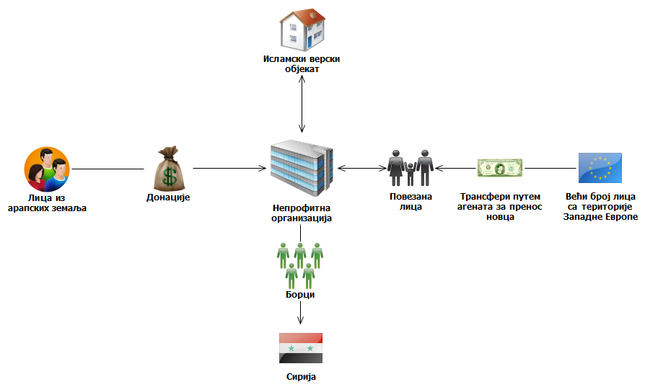

TRENDS, CHALLENGES AND OBSERVATIONS

Potential suspicious ML/TF activities expected to be identified in 2017 are as follows:

Financial transactions and business activities conducted through companies, for which there is no beneficial ownership information regardless of their location, which is one of major goals of a criminal or an organised crime groups, wishing to launder money and stay anonymous. Growing suspicion in respect of so-called shell companies, which are almost totally untransparent in terms of their operations and ownership and are registered mostly in offshore jurisdictions. Organised crime groups or criminals mostly use this kind of companies to figure as real-estate investors, or use other forms of placement of dirty money; they appear as founders or co-founders of companies, the business activities of which are conducted under untransparent ownership. Serbia is not immune to this phenomenon and so the trend will persist in future, which will constitute a problem for the preventive and repressive side of the Serbian AML/CFT system.

Fictitious legal operations, which aim at draining funds out of accounts of companies, and/or the use of payment codes (descriptions) related to trade in goods and services in order to disguise the true purpose of transfers are one of the most common types of abuse that can indicate money laundering. The stated phenomenon so far has usually been recognised in raw materials trade.

Founder’s company liquidity loans or ordinary loans, as a way to place money of unknown origin, is one the techniques to introduce suspicious and dirty money into legal flows. This kind of placement includes introducing money both in newly established and existing companies. Such money is usually used for a company’s liquidity, further transfers for company operations or for fictitious persons, only to be converted into a foreign currency by invoicing fictitious services.

Electronic banking and virtual currencies, as areas yet to be explored, are exceptionally critical for money laundering and terrorism financing. As new technologies are very often abused by persons in possession of illegally acquired proceeds, special attention should be given to this area.

Consultancy services as well as all other types of services are still abused for the purpose of integrating illegal proceeds into legal financial flows. The purposes of transactions stated above are often used when making payments from off shore jurisdictions.

International trade facilitates importing or exporting money of suspicious origin, especially if business operations are done through intermediary companies as suppliers or buyers in offshore jurisdictions; they are used for trading in goods with inflated or deflated invoices, which results in importing or exporting money based on non-realistic invoices, thus avoiding fair pricing.

There is an increasing number of non-resident individuals that do not perform business activities in Serbia but still open accounts in Serbian banks. More and more SARs are filed involving newly established business entities incorporated in Serbia by non-resident individuals, and conducting transactions without a clear economic purpose. These phenomena carry a certain risk as there is suspicion that the accounts opened in Serbian banks are used for laundering money originating from abroad and/or that Serbian banking system is misused for concealing the true origin if illegal proceeds generated abroad.

Transfers of funds described as inheritance and financial support will continue to be used when one wishes to disguise the true purpose of the transaction.

Construction business, especially construction and sale of real estate for cash still carries risk and is abused for the purpose of integrating illegally acquired money into legal flows; it is often used for the laundering of drug money. This is supported by the fact that in Serbia there is still a trend of illegal construction (it is estimated that every third building was built illegally), which can be legalised subsequently by paying certain fees. Declared value of such buildings is far below the market price, which is an additional motive for integrating dirty money. Lack of legal regulations contributes to the problem.

Trade in gold still carries an ML/TF risk. There is information that gold is being smuggled to/from neighbouring countries. As a tangible asset gold has ‘eternal value’.

Because of the current migrant crisis, frequent use of money transfer services is expected in the future. Analysing this type of transactions, we observed increasing number of Serbian residents frequently withdrawing cash for several foreign nationals.

The most vulnerable industries are those which are cash-intensive, namely, construction business, hospitality industry and hotel business, betting places, illegal trade and trading in so called “grey to black” production areas, especially textile goods and foodstuffs. The rise and development of e-money will probably be a challenge, both for its simple and efficient transfers and for the fact that it is not easy to identify a client. Virtual currencies (crypto-currencies), for example Bitcoin, have already become convenient for money laundering and they have the potential to remain as such. They are already becoming valued in stock market and anonymity is almost guaranteed through virtual wallets.

SUPERVISION OF ACCOUNTANTS AND AUDITORS FOR COMPLIANCE WITH AML/CFT LAW

Pursuant to the provisions of Articles 82 and 83 of the Law on the Prevention of Money Laundering and Terrorism Financing (Official Gazette of RS Nos. 20/2009, 72/2009, 91/2010 and 139/2014, hereinafter referred to as the Law), APML supervises accountants and auditors for the compliance with the Law, exercising,

- offsite supervision
- onsite supervision.

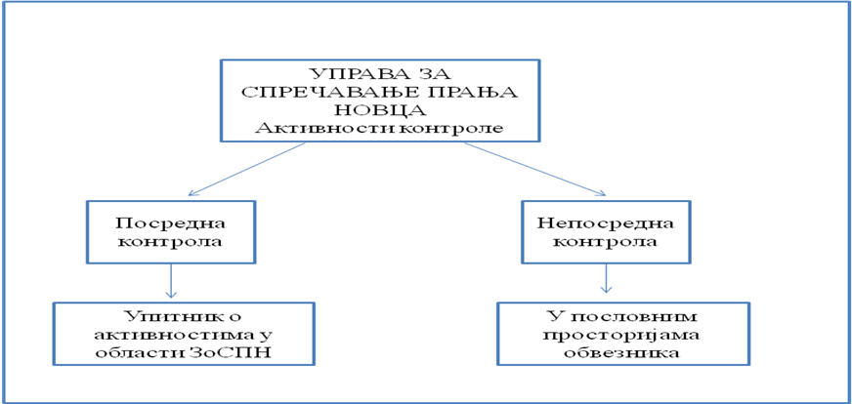

Offsite supervision is conducted by sending out, based on pre-defined criteria, questionnaires on the activities that the obliged entities, i.e. accountants and auditors undertake in applying the AML/CFT legislation and by analysing the answers received. The criteria used to decide to whom the questionnaire will be sent, with respect to accountants, include the following: number of employees, annual operating income, net profit of the legal entity/entrepreneur, information received from APML’s analysts, etc. With regard to auditors, the questionnaire was sent to all officially registered auditing companies.

Onsite supervision is conducted by inspecting general and specific company legislation, records and documentation, as well as business books, statements of accounts, correspondence and other documents on the supervised subject’s premises or those of the entity directly or indirectly related to the supervised subject, by taking statements from the responsible person or other supervised subject’s employees, as well as by requesting information from state authorities and holders of public authority and inspecting documentation.

In developing the 2016 Onsite Inspection Plan, risk-based approach was applied; this means that the obliged entities that are found to be more exposed to an ML/TF risk in performing their registered business will be prioritised accordingly when laying out the Inspection Plan timetable.

The following elements were used as criteria for assessing the exposure to ML/TF risk:

- ML/TF NRA findings, based on which accountants and auditors were assessed as vulnerable at a low-to-medium level compared to other sectors (auditors - low level, accountants – medium-to-low);
- Offsite inspection findings - in case that they reveal certain irregularities, the onsite inspection will be used to confirm the factual situation;
- Number of employees in the obliged entity;
- Obliged entity’s annual income;
- Business relationships with foreign PEPs;
- Information received from other state authorities and anonymous persons;
- Information obtained from the APML’s databases.

In conducting supervision of the compliance with the Law, inspectors look at what kind of AML/CFT actions and measures are undertaken by the obligors.

Onsite inspection covers at least whether the obliged entity:
- the obliged entity has fulfilled the obligation to develop a risk analysis in line with the ML/TF Risk Assessment Guidelines for auditing and accounting service providers;
- the obliged entity conducts actions and measures for the prevention and detection of money laundering and terrorism financing before, during the course of, and following the establishment of a business relationship and whether the obliged entities:
- applies CDD, i.e. whether they have identified and verified the identity of the customer and established the identity of the beneficial owner;
- sends information, documentation and data to the APML;
- has appointed a compliance officer and his/her deputy and whether they provided the act on the appointment of the above individuals to the APML within the deadline prescribed by the Law;
- adopted an annual training plan and whether they implemented the training programme, i.e. whether they delivered regular professional training to their employees;
- conducted regular internal control and whether they made the report on the controls conducted and measures taken after the control within the deadline prescribed by the Law;
- develop a list of indicators for recognising suspicious transactions;
- apply other actions and measures set out in the Law.

OFF-SITE INSPECTION IN 2016

The APML conducted in 2016 offsite inspections of accountants and auditors by sending them a questionnaire on their AML/CFT activities as well as by analysing the answers received.

The Questionnaire has following objectives:
- Looking into the current level of obliged entities’ awareness of their obligations under the AML/CFT Law;
- Indirect monitoring the development of the AML/CFT system;
- Looking into the level of obliged entities’ understanding of the AML/CFT legislation.

The Questionnaire is divided into 5 sections:
Part I – General information about the company
Part II – Company’s activity
Part III – Information on clients
Part IV – Reporting to the APML
Part V – Training of the company’s employees.

The total number of auditing companies in Serbia is 67.. In the previous year, the APML sent letters to all then registered auditing companies, informing them that they had obligations under the AML/CFT Law. Along with this notification, the Questionnaire were sent to 60 auditing companies. Offsite inspection was conducted in all of the 60 auditing companies. One reminder was sent to an auditing company in 2016, which was responded to. In addition to the Questionnaire sent to 60 auditing companies, the APML sent instructions to newly established auditing companies so that they should know they were obligors in line with Article 4 of the AML/CFT Law, and to help them establish a system based on the instructions. There were 4 such instructions in 2016. It should be highlighted that the auditing companies showed exceptional willingness to cooperate.

The total number of accounting service providers in Serbia is in excess of 7000. In 2016, offsite inspections were carried out throughout the entire year using various criteria, by sending out AML/CFT activity Questionnaires to accounting service providers. The total number of entrepreneurs/companies providing accounting services which were subject of supervision in 2016 was 175. 86 firms were sampled and sent a letter informing them that they had obligations under Article 4 of the AML/CFT Law and were given the deadline of 20 days to fill in the Questionnaire. In addition to the controls started in 2016, the APML conducted offsite control in 89 companies where the control was started in September and December 2015. Of the total number of accounting service providers, all those that underwent controls are legal persons. Out of 175 entities that underwent control, 134 entrepreneurs/companies responded to the Questionnaire, whereas 21 entrepreneurs/legal persons failed to do so. Offsite control is pending in 20 accounting service providers and continues in 2017. As for the accounting services providers that did not reply to the Questionnaire, nine of them failed to receive it due to the changed address, five of them did not pick up the memo containing the Questionnaire in a Post Office, whereas seven of them failed to respond even after Reminders had been sent. 79 Reminders were sent to accounting service providers; 43 entities responded, whereas 36 failed to do so. As for the Reminders, seven of them were sent as no response had been given following the additional request of the APML, whereas in 16 cases the Reminders were sent twice.

ON-SITE SUPERVISION

In 2016, the APML conducted 6 onsite inspections. One on-site inspection was conducted in an auditing company and five on-site inspections were conducted on accounting services providers. No irregularities were found in the auditing company.

Irregularities were found in all supervised accounting companies.

34 economic offences were found in 5 supervised accounting service providers, as follows:
- Four accounting firms failed to conduct a risk analysis, thereby breaching Article 7 of the AML/CFT Law.
- Four accounting companies failed to enter in the Business Registers Agency’s decisions the date, time and name of the employee inspecting the documents, thereby breaching Article 15 para 2 of the AML/CFT Law.
- Two accounting firms failed to appoint compliance officer and his/her deputy, thereby breaching Article 39 of the AML/CFT Law.
- Two accounting firms did not appoint compliance officer deputy officer, thereby breaching Article 39 of the AML/CFT Law.
- Two accounting firms did not submit the name and position title of the compliance officer within 15 days of the date of their appointment, thereby breaching Article 42 para 3 of the AML/CFT Law.
- Four accounting firms did not provide regular AML/CFT training for their staff, thereby breaching Article 43 para 1 of the AML/CFT Law.
- Four accounting firms did not develop the annual AML/CFT training plan for staff tasked with detecting and preventing money laundering and terrorism financing, thereby breaching Article 43 para 3 of the AML/CFT Law.
- Four accounting firms failed to conduct regular internal control and make the report on the internal control and measures taken afterwards within the statutory timeline, thereby breaching Article 44 of the AML/CFT Law.
- Four accounting firms failed to develop a list of indicators for identifying suspicious transactions, thereby breaching Article 50 para 1 of the AML/CFT Law.
- Four accounting firms failed to ensure that the records of clients and business relations contain all the data prescribed by Article 81 Of the AML/CFT Law.

Upon conducting the onsite inspections on supervised entities’ premises, the APML inspectors continued the onsite inspection at their own premises by making the inspection report. The supervised entities were given a deadline by the report, within which they could provide objections to the factual situation as established. Out of all supervised entities three submitted their objections to the factual situation found and noted in the inspection report. After receiving the objections to the factual situation found, the APML’s inspectors established that the supervised entities had not submitted enough evidence corroborating the objections, so the factual situation noted in the reports remained unchanged. Correction of the Report was made for two accounting companies, as the on-site controls showed certain technical fallacies.

Following the expiry of legal deadline, the APML inspectors filed reports against 4 supervised entities to the Basic Prosecutor’s Office for economic offences, whereas report against one accounting company for economic offence will be filed in 2017, following the deadline for lodging objections to the supervision report.

COURT DECISIONS

In 2016, the APML received 9 final judgments of the Commercial Court in Belgrade. Of the total number of closed cases, one supervised entity appealed against the relevant judgment which lead to a lower amount of fine ruled by the Court of Appeal.

What follows is a brief analysis of judgments passed by the Commercial Court in 2016:

For supervised entity no. 1 there was a single fine of RSD 450,000 for the legal person and RSD 50,000 for the responsible officer in the legal person, which, according to the exchange rate of the National Bank of Serbia, amounts to EUR 3,669.20 and EUR 407.68 respectively.

For supervised entity no. 2 there was a single fine of RSD 90,000 for the legal person and 30,000 RSD for the responsible officer in the legal person, which, according to the exchange rate of the National Bank of Serbia, amounts to EUR 729.57 and EUR 243.19 respectively.

For supervised entity no. 3 there was a single fine of 700.000,00 RSD for the legal person and RSD 50,000 for the responsible officer in the legal person, which, according to the exchange rate of the National Bank of Serbia, amounts to EUR 5,715.22 and EUR 408.23 respectively.

For supervised entity no. 4 there was a single fine of RSD 70,000 for the legal person and RSD 25,000 for the responsible officer in the legal person, which, according to the exchange rate of the National Bank of Serbia, amounts to EUR 567.85 and EUR 202.81 respectively.

For supervised entity no. 5 there was a single fine of RSD 260,000 for the legal person and 120.000,00 RSD for the responsible officer in the legal person, which, according to the exchange rate of the National Bank of Serbia, amounts to EUR 2,117.09 and EUR 977.12 respectively.

For supervised entity no. 6 there was a single fine of RSD 120,000 for the legal person and RSD 60,000 for the responsible officer in the legal person, which, according to the exchange rate of the National Bank of Serbia, amounts to EUR 972.76 and EUR 486.38 respectively.

For supervised entity no. 7 there was a single fine of RSD 150,000 for the legal person and RSD 30,000 for the responsible officer in the legal person, which, according to the exchange rate of the National Bank of Serbia, amounts to EUR 1,215.95 and EUR 243.19 respectively.

For supervised entity no. 8 there was a single fine of RSD 220,000 for the legal person and RSD 90,000 for the responsible officer in the legal person, which, according to the exchange rate of the National Bank of Serbia, amounts to EUR 1,783.39 and EUR 729.57 respectively.

For supervised entity no. 9 there was a single fine of RSD 10,000 for the responsible officer in the legal person, which, according to the exchange rate of the National Bank of Serbia, amounts to EUR 81.18.

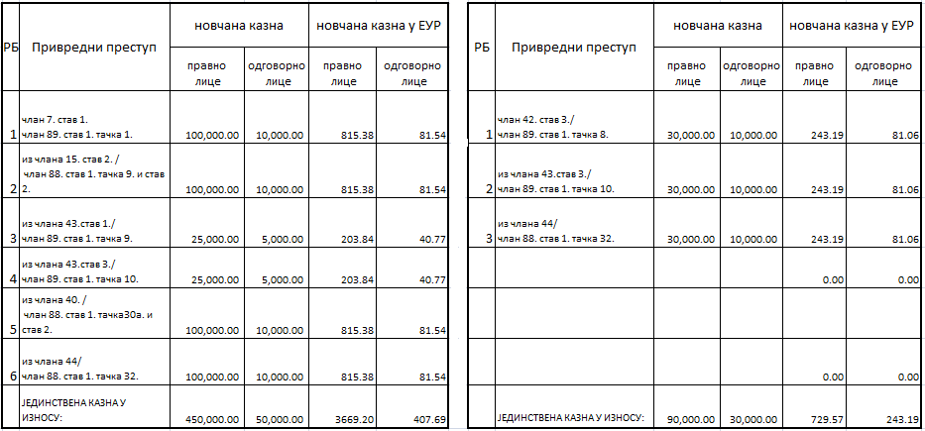

Table 1: Amounts of fine per economic offence for supervised entities no. 1 and 2 referred to in the text

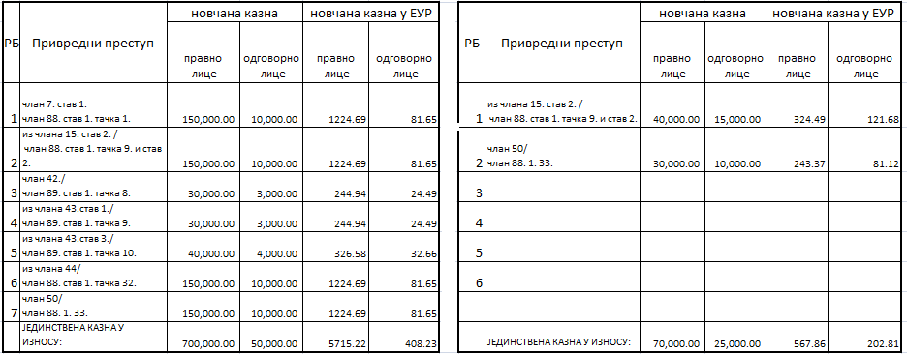

Table 2: amounts of fine per economic offence for supervised entities no. 3 and 4 referred to in the text

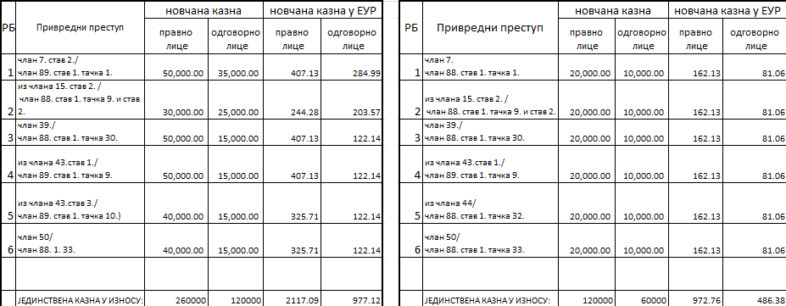

Table 3: amounts of fine per economic offence for supervised entities no. 5 and 6 referred to in the text
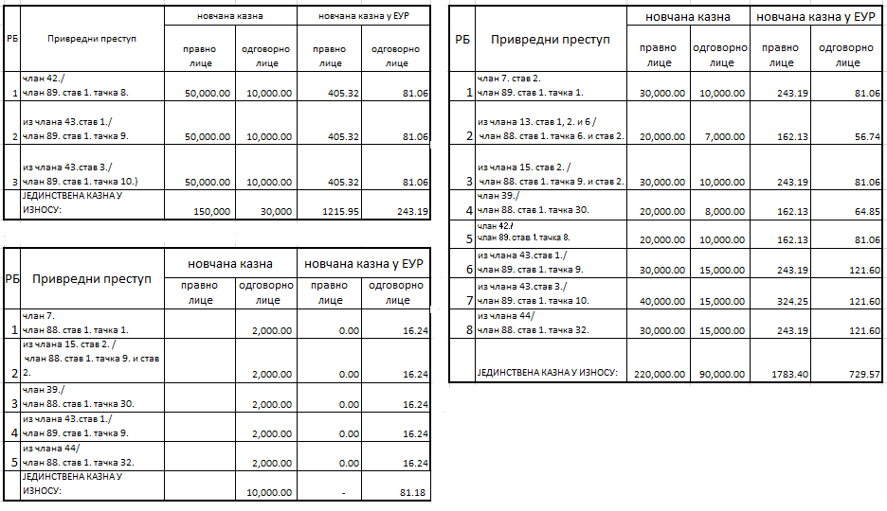
Table 4: amounts of fine per economic offence for supervised entities no. 7, 8 and 9 referred to in the text.

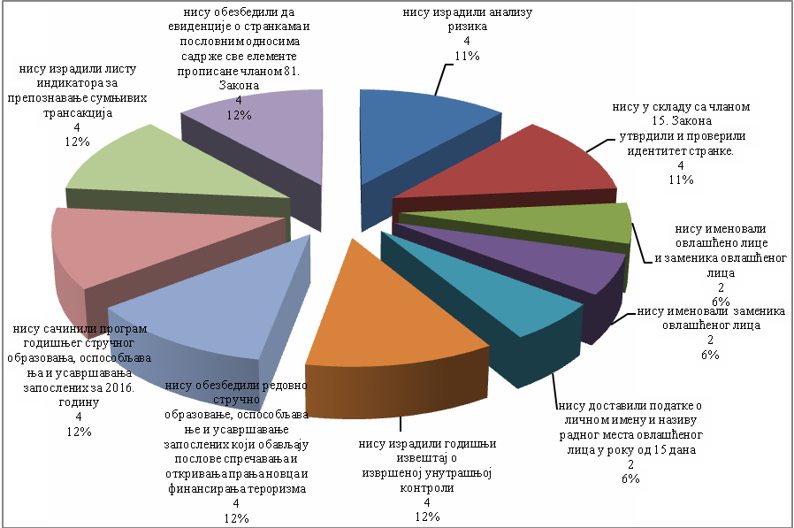
The chart showing economic offences found in 2016
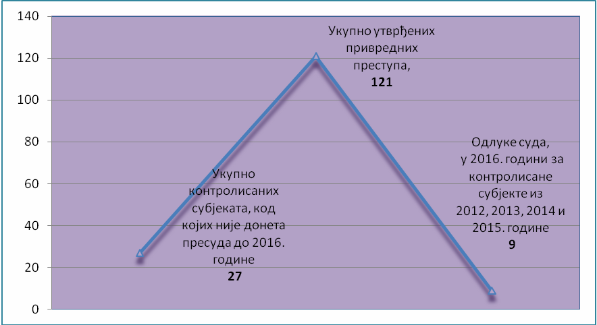
Chart showing the ratio between the total number of supervised entities which did not result in a court judgement until 2016, economic offences found in the supervised entities in 2012, 2013, 2014 and 2015 and court decisions passed in 2016.

APML EU - SERBIA NEGOTIATION ACTIVITIES

Negotiating chapter 4 - Free movement of capital

Free movement of capital is one of the four freedoms on which the functioning of the EU internal market is based. Prevention of money laundering and terrorism financing is one of the subchapters under this negotiating chapter, in addition to capital movements and current payments. The Ministry of Finance is the coordinator of the negotiating group for this chapter.

In the free movement of capital area, member states are required, with certain exceptions, to remove all restrictions to capital movements both within the EU and between member states and other countries. Current payments are related to current transactions, i.e. transactions involving residents and non-residents, whose underlying aim is not transfer of capital. Rules have been defined concerning the national and cross-border payment services in EU. The aim is for the member state to have simple, efficient and safe cross-border payments while improving the beneficiaries’ rights to use of payment services. Also, the intent is to improve competition by opening the payment services market to new participants, thus fostering increased efficiency and reduction of costs and establishing the necessary platform for a single area for payment in Euros.

Full liberalisation of capital movements is a prerequisite of EU membership and opens up possibilities, for instance, of opening bank accounts abroad, granting loans to non-residents, taking cash in and out of country without restrictions, equal treatment of nationals of other member states with respect to the acquisition of legal title over real estate, etc. In achieving liberalisation of capital movements, there is a significant risk of attempts to misuse the free movement of capital and freedom of provision of financial services, which are characteristic of the integrated financial area. It is the possibility of misuse that constitutes the reason why measures, which are the subject-matter of the relevant EU acquis, are needed at the EU level. Misuse of the financial system to move illegal proceeds but also of the money that has been legally obtained but can be used to finance terrorism, poses a clear threat to integrity, proper functioning, reputation and stability of financial systems.

The most important preventive EU legislation in this area is the so-called Fourth Directive, i.e. Directive (EU) 2015/849 of the European Parliament and of the Council of 20 May 2015 on the prevention of the use of the financial system for the purposes of money laundering or terrorist financing, amending Regulation (EU) No 648/2012 of the European Parliament and of the Council, and repealing Directive 2005/60/EC of the European Parliament and of the Council and Commission Directive 2006/70/EC.

In addition to the Fourth Directive, also relevant EU acquis is the Regulation (EU) 2015/847 of the European Parliament and of the Council of 20 May 2015 on information accompanying transfers of funds and repealing Regulation (EC) No 1781/2006.

Even though Serbian system in this area is harmonised to a large extent with the relevant EU acquis, further harmonisation will be of exceptional importance particularly bearing in mind that the Fourth Directive was adopted in 2015. The adoption of the Fourth Directive at the EU level is also a reflection of the need to harmonise the current EU system with the 2012 FATF Recommendations.

As described on page 5, the APML actively worked in 2016 on drafting a new law on the prevention of money laundering and terrorist financing which is to harmonise this segment of the AML/CFT system with the FATF Recommendations and the above EU acquis, taking into account MoneyVal’s recommendations.

Negotiating Chapter 24 - Justice, freedom, security

Creating an area of justice, freedom and security is also one of the EU objectives. Even though it is addressed under Negotiating Chapter 4 on free movement of capital prevention of money laundering and terrorist financing, i.e. the criminal aspect of these issues, is covered also within Negotiating Chapter 24 - Justice, freedom, security, particularly under the section on fight against organised crime (money laundering) or fight against terrorism (financing of terrorism). The Ministry of Interior is the coordinator of the negotiating group for this chapter.

In addition to the above areas, this chapter addresses also the areas of asylum, migration, visa policy, border control and Schengen, as well as certain aspects of fight against human trafficking, fight against drugs, police cooperation, judicial cooperation in civil and civil matters, customs cooperation and Euro counterfeiting.

Relevant acquis in the ML/TF area, which are covered in this chapter, are contained in one EU act, i.e. Council Decision of 17 October 2000 concerning arrangements for cooperation between financial intelligence units of the Member States in respect of exchanging information.

In 2016, the APML took an active part in implementing the Action Plan for Negotiating Chapter 24, i.e. the part of it covering the fight against money laundering. These activities involved the improvement of APML’s technical, spatial, IT and human resources as well as harmonisation of national legislation with the relevant EU acquis.

Negotiating chapter 31 - Foreign, security and defence policy

Common foreign and security policy of the European Union was established in the Maastricht Treaty, and especially strengthened in the Lisbon Treaty, as the EU wants to speak with one voice when it comes to foreign policy. It is mostly founded on consensus of the member states and it constitutes a mechanism for adopting common declarations and guidelines for political and security issues that lead to common diplomatic action and to undertaking common actions. Decisions are adopted to define the EU position towards certain issues and measures to implement Common foreign and security policy, including sanctions. In addition to diplomatic action, main lines of action within this chapter is the Common security and defence policy, restrictive measures and arms control. Ministry of Foreign Affairs is the coordinator for this negotiating chapter.

Relevant EU acquis, within the APML’s remit, are mostly those related to restrictive measures taken where the EU decides that certain country violates international law or human rights and that it does not respect fundamental democratic values and rule of law as well as the acquis related to the fight against terrorism, i.e. its financing (e.g. The fight against terrorist financing [Council 16089/04], 14 December 2004; Revised Strategy on Terrorist Financing [Council 11778/08], 11 July 2008). The fight against terrorist financing [Council 16089/04], 14 December 2004; Revised Strategy on Terrorist Financing [Council 11778/08], 11 July 2008). Sanctions may vary from diplomatic to economic, and the candidate country is expected to align, in the negotiation process, with the regime of restrictive measures provided by EU.

The segment where the APML offered its contribution is related to the application of international restrictive measures. Namely, the Law on Freezing of Assets with the Aim of Preventing Terrorism specifies the measures for freezing of assets thereby implementing the UN Security Council Resolutions 1267 and 1373 and hence the relevant EU acquis, i.e.

- Council Regulation (EC) No 467/2001 of 6 March 2001 prohibiting the export of certain goods and services to Afghanistan, strengthening the flight ban and extending the freeze of funds and other financial resources in respect of the Taliban of Afghanistan (implementing UNSCR 1267(1999) and 1333(2000);
- Council Regulation (EC) No 881/2002 of 27 May 2002 imposing certain specific restrictive measures directed against certain persons and entities associated with Usama bin Laden, the Al-Qaida network and the Taliban, and repealing Council Regulation (EC) No 467/2001 prohibiting the export of certain goods and services to Afghanistan, strengthening the flight ban and extending the freeze of funds and other financial resources in respect of the Taliban of Afghanistan;
- Common Position 2001/931/CFSP on the application of specific measures to combat terrorism [implementing UNSCR 1373 (2001);
- Council Regulation (EC) No 2580/2001 of 27 December 2001 on specific restrictive measures directed against certain persons and entities with a view to combating terrorism;
- Council Framework Decision 2002/475/JHA on Combating Terrorism of 13 June 2002, amended by Council Framework Decision 2008/919/JHA of 28 November 2008 (OJ L 330, 09/12/2008, p. 21–23).

As the FATF in its revised recommendations set the standard also with respect to the prevention of the financing of proliferation of weapons of mass destruction, the issue of prevention of proliferation of WMD, which is covered in this chapter, will be more and more important for the APML work.

In 2016, the APML provided contribution for the development of the NPAA.

INTERNATIONAL COOPERATION

Activities at the MoneyVal Committee

Serbia joined Moneyval in 2003. MoneyVal conducts mutual evaluations according to the FATF (Financial Action Task Force – international AML/CFT standard setter) Methodology and Standards. Serbian delegation consists of the representatives of the APML, Ministry of Interior, Ministry of Justice and the National Bank of Serbia; the APML Director is the Head of Delegation.

The APML was represented at all three regular MoneyVal plenaries held in 2016 (50th Plenary on 12–15.4.2016, 51st Plenary on 27–29.9.2015 and 52nd Plenary on 6–8.12.2016). The 50th Plenary adopted the Mutual Evaluation Report (MER) for Serbia under the fifth round of mutual evaluations.

With respect to APML’s operations, the MER sets out the following findings and recommendations in certain areas:

APML core functions - receipt, analysis and dissemination of intelligence. The report has found that the APML should be provided with additional resources in order to be able to perform its core functions and continue to fully meet the operational needs of the LEAs. It also notes that the staff complement in the analysis department is considered to be insufficient compared to the staffing of FIUs of countries in the region and taking into account the level of additional tasks performed and the number of requests sent by LEAs. In addition, the 2012-2014 budget of the APML shows a significant decrease despite the number of additional tasks of the APML, including the coordination of the AML/CFT system in the country.

The analysis products generated by the APML are of good quality and have the potential of supporting the operational needs of LEAs. However, there are a number of issues which impact on the effectiveness of the process. Information needed by the APML for its analysis is not always easily retrievable from other public authorities.

The cooperation arrangements in place between the APML and the Prosecutor’s Office, which are intended to enhance the dissemination process, are positive. However, this procedure may impact negatively on the APML’s ability to develop and disseminate cases independently from the operational priorities of law enforcement authorities.

It notes that cooperation between the APML and the authorities responsible for investigating organised crime and terrorism financing is a positive aspect of the system. The evaluators note that prioritisation of work in this area is a welcome development and reflects the risks faced by the country. Existing similar arrangements with the tax authorities should be further enhanced.

The report recommends that the APML be provided with appropriate feedback on the notifications that it disseminates and Serbian authorities should ensure that adequate statistics on the use of financial intelligence are maintained to be in a position to review the effectiveness of the system.

The report has found that despite the usefulness of intelligence provided by the APML, the role of the unit does not seem to be always understood by the other stakeholders in the system. It notes that additional efforts by the law enforcement authorities in responding to APML’s requests and disseminations would further enhance the analysis function of the APML.

The report has found that concerns still remain on the quality of reporting considering the number of actual disseminations and deficiencies noted under IO.4. Very few SARs are submitted by reporting entities other than banks and money remitters. Very little information is received by the APML from the Customs Administration concerning ML/FT suspicions related to cross-border movements of cash.

The report notes that there are no specific channels foreseen for exchange of information with non-members of the Egmont Group although the APML explained to the evaluation team some examples of where it has done so in practice.

Prevention. MoneyVal report notes that Serbian authorities should harmonise the legislative framework with the FAFT Standards, in particular by remedying the shortcomings connected to CDD measures, domestic PEPs and identification of beneficiaries of wire transfers, and by introducing notaries as reporting entities under the AML/CFT framework. It also recommends that the authorities ensure that general AML/CFT trainings are provided, in particular to provide a sufficient level of education to compliance officers.

Supervision. The report notes that all supervisory authorities, other than the National Bank of Serbia, have a significant shortfall in staff resources which has a negative impact on the thoroughness of supervision. The supervisory department of the APML remains hindered in its activities by the clear lack of resources, and they should be considerably enhanced. The report highlights that application of additional financial resources will be required in order for systematic training programmes to be put in place.

Terrorist Financing. Serbian authorities should take steps to raise awareness in all sectors on terrorist financing risks and urgently pass new legislation to regulate targeted financial sanctions related to proliferation, as well as develop an adequate outreach towards stakeholders in order to apply this legislation in an effective and efficient manner.

Activities within the FATF

FATF is an intergovernmental body whose aim is to develop and improve AML/CFT measures at national and international levels. FATF is a policy-maker working to create political will to reform AML/CFT legislation and regulatory framework at the national level. In all its activities the FATF works with other international AML/CFT bodies. One of the most important FATF documents are the FATF Recommendations - International standards on combating money laundering and the financing of terrorism & proliferation - that are the main international standard in this area.

In 2016, the FATF published three public statements (February, June, October) concerning jurisdictions with strategic deficiencies posing risk to the international financial system. The statements are published so as to inform countries about the situations found in the countries involved and to take specific action.

Activities within the Egmont Group

Egmont Group is an association of financial intelligence units (FIUs) worldwide whose objective is to promote and improve cooperation in terms of FIU to FIU financial intelligence exchange according to the Egmont Group’s principles for information exchange. The APML joined the Egmont Group in 2003. The Egmont Group holds its meetings twice a year, i.e. a Plenary Meeting (between May and July) including the meetings of the Working Groups and Heads of FIUs (HoFIU) and EG Working Groups (WG) Meetings (held usually in January or February).

The EG held one WG and HoFIUs meeting (Monaco, 31 January - 5 February 2016). One of the topics of the HoFIUs ad hoc meeting was the rising threat from terrorism following the recent series of terrorist attacks and the spread of the Middle East foreign fighter phenomenon.

The plenary that was to be held in Istanbul from 17 to 22 July 2016 was cancelled for security reasons because of the terrorist attacks in Istanbul on 28 June 2016.

One FIU was admitted in 2016 (FIU Ecuador) through an out-of-session approval given that the Istanbul plenary was cancelled.

As at the end of 2016, the Egmont Group has 152 member FIUs with a tendency of further accelerated expansion of this group’s membership.

It should be noted that the internal structure as of the Monaco meetings has been modified, among other things, so the Egmont Group now has the following four working groups:

- Technical Assistance and Training WG – TATWG (previously Training Working Group)
- Membership, Support and Compliance Working Group - MSCWG (previous outreach and legal working groups merged)
- Information Exchange Working Group – IEWG (previously IT Working Group)
- Policy and Procedures Working Group - PPWG (part of the previous Legal Working Group)

Technical Assistance and Training WG. TATWG work includes identifying the needs of FIUs, designing and provision of technical assistance and training to Egmont Group members and observer organisations as well as assistance and support to FIUs facing significant challenges in fulfilling the obligations stemming from EG membership and relevant FATF recommendations.

Membership, Support and Compliance Working Group. This working group considers and processes FIU applications for EG membership, addresses membership issues and implements the programme endorsed by the HoFIUs in the EG Support and Compliance Process. This WG also addresses all issues relative to the support to members and compliance in the EG including cooperation among the FIUS.

Information Exchange Working Group. This working group deals with synergies between the efforts of operational analysts and IT experts in addressing information sharing challenges faced by FIUs. This WG’s operational projects mostly incorporate a strong IT dimension. IEWG focuses on improving the quality and quantity of timely information exchange among FIUs based on operational and strategic analyses. A large part of the IEWG’s work is project-oriented. Project results are presented both to EG members and observer organisations.

Policy and Procedures Working Group: This working group is responsible for recognising relevant operational and strategic issues affecting the EG and for coordinating the EG response with partner organisations. This WG ensures that the EG documents are regularly reviewed so as to establish if they should be modified, and gathers experts for FIU policy, legal and operational issues. The purpose of this WG is to expand membership and to work on several major projects (review of the Charter, implementation of the Strategic Plan) over the previous years given that these projects could not fit into the terms of reference of one single working group only.

Memoranda of understanding (MOUs)

In 2016 the APML signed an MOU with the FIU of Kazakhstan which increased the number of MOUs signed to 45.

Organisation for Security and Cooperation in Europe (OSCE)

Below are the most relevant activities jointly organised by the APML and the OSCE Mission to Serbia:

Regional Conference on Terrorism Financing (7.6.2016 – 8.6.2016) gathering the analysts of regional FIUs (Serbia, Montenegro, Bosnia and Herzegovina, Macedonia and Croatia). The aim was to exchange experience and good practices in this area especially about the process of analysis of SARs related to terrorist financing.

AML/CFT seminar for public notaries (10.11.2016). The seminar gathered together about 70 public notaries. As the new AML/CFT Law will include public notaries on the list of obliged entities, the intention was to inform public notaries of the international and European standards in this area and their future obligations as stipulated in the new law.

Seminar for trade market inspectors, Aranđelovac, 16.11.2016–17.11.2016. Follow up to the 2015 seminar for the real estate trade and lease sector. The purpose of the seminar was to raise awareness about the obligations specified in the AML/CFT Law for this sector.

Presentation of money laundering typologies in Serbia - case studies (14 -16.12.2016) in Bujanovac was intended for the police, prosecutors, judges and other interested parties.

In addition, APML was represented at the expert meeting on fighting corruption in south-east Europe that was held in Vienna, Austria, 24.10.2016 – 25.10.2016, and at a seminar on 1.12.2016 at the Belgrade Law School where an APML staff member held a presentation about the role of the APML in fighting corruption.

OSCE supported the organisation of a meeting of representatives of regional FIUs in Budva 1.12.2016 – 2.12.2016; two APML employees attended the meeting.

Cooperation with authorities of other countries

APML actively cooperated with US authorities (Department of Justice, Department of State) and US Embassy in Belgrade. We should highlight the particularly important and useful participation of APML staff in the International Visitor Leadership Program in the USA, organised by US Embassy and OSCE (26.10.2016 – 6.11.2016) and in the study visit about the fight against terrorism (17.10.2016 – 28.10.2016).

Also, communication has been established with the HM Revenue and Customs.

PROJECTS

Improvement of the quality and efficiency of suspicious transaction reporting and capacities of the Administration for the Prevention of Money Laundering

The APML has prepared under IPA 2015 (Action Document for Home Affairs) a project to enhance the quality and efficiency of Suspicious Transactions Reporting and of the APML’s core functions.

Basis. Improving the fight against ML and TF is Serbia’s pre-accession obligation (stipulated in the SAA) which is set as a priority in a number of documents: National Priorities for International Assistance 2014-17 with projections to 2020 (NAD); Sectoral planning document for Home Affairs (SPD); Action document for the Home Affairs sector (AD).

Programming. In keeping with the new, i.e. sectoral, approach to planning international financial assistance, a Home Affairs sector has been established in which two administrations of the Ministry of Finance are included - Customs Administration and Administration for the Prevention of Money Laundering. The development of the sectoral planning document was organised by the Serbian EU Integration Office (as of 2014). APML participated in these activities through the Ministry of Finance Department for International Cooperation and European Integration, that is its IPA Unit. The value of the project is EUR 1.5 million.

Current stage - contracting. On 8 September 2016, Prior Information Notice was published. The Contact Notice was published on EuropeAid on 10 February 2017. The APML finalised the Terms of Reference for the Project. The contracting procedure under IPA 2015 is a centralised procedure, i.e. the tendering will be under the responsibility of the EU Delegation to Serbia. The project involves a service contract, which means that purchase of goods cannot be made.

Further steps and start of implementation. Interested candidates will be shortlisted after 13 March 2017. The shortlisted candidates will then receive the TOR. Based on the TOR the shortlisted candidates will submit their offers. On condition that all the steps in the contracting stage are completed on time, the project implementation is expected to start at the end of 2017 or beginning of 2018.

Aim, purpose, results:
Aim of the project: To support Serbia’s commitment in achieving EU standards in the areas of security and safety by implementing the action plans for Chapters 24 and 23

Project purpose: To support the fight against money laundering and prevention of the use of the financial and non-financial system for money laundering and terrorist financing purposes by strengthening the quantity and quality of the suspicious activity reporting and the quality of APML financial intelligence.

Expected results: APML internal processes are improved; APML staff competences are strengthened; Quality and Quantity of SARs are enhanced; 4. Outreach to and cooperation with the AML/CFT stakeholders and the APML’s ICT system is improved.

Timeframe: The Action Plan for Chapter 24 provides for employment of additional 15 staff members 9 of which in 2017. APML’s intention is to make the project implementation coincide with the improvement of APML’s HR capacities so as to immediately provide to the new recruits an intensive training under the project given that financial analysis skills are so-called scarce skills.

Other projects

The APML was also a beneficiary of two TAIEX events, i.e. Seminar on the transposition of the Fourth EU Directive (Belgrade, 4.11.2016) and Study visit to FIU Poland (22.11.2016).

Also, the APML participated in the PLAC II project to support the harmonisation of Serbian legislation with the acquis communautaire under Chapter 4. The two envisaged activities will be implemented in the period April - June 2017.

APML has also participated in the IPA 2017 programming for the Home Affairs sector, and in projects of other authorities mainly in the area of justice and home affairs.

HUMAN RESOURCES AND TRAINING

As on 31 December 2015, according to the internal regulations the APML had 40 posts of which 28 posts were filled (27 civil servants and a director). The streamlining of the civil service mandated that a new Rulebook on the internal organisation and systematisation of jobs be passed. It provided for 28 positions altogether (27+1). All the positions were filled.

This new regulation modified the APML’s internal organisation by forming the following internal units:

- Department for analysis, financial-intelligence and cooperation with other authorities;
- Team for legal affairs and legislative harmonisation with international standards;
- Team for international cooperation, projects and training;
- Team for supervision;
- Team for IT development;
- Team for material, financial and general affairs

As on 31 December 2016, the APML had 26 employees (25 civil servants and the director), of which four civil servants were on maternity leave. One employee has a fixed-term employment contract, two employees are recruited to replace the employees on leave and one employee is engaged on a service contract.

Training, seminar, conference | Place | Organiser | Period | Days | Partici  pants
Intercultural communication | Belgrade | Government HR Service | 22/1/2016 | 1 | 1
Egmont Group meetings, Monte Carlo, Monaco | Monaco | Egmont Group | 31/1/2016 | 6 | 1
Presentation of money laundering and terrorist financing typologies document | Novi Pazar | OSCE | 18/2/2016 | 2 | 1
Banking Supervision based on Basel Standards | Vienna | Joint Vienna Institute, Vienna, Austria | 29/2/2016 | 5 | 1
Seminar on proceeds from crime and money laundering | Belgrade | UK Embassy | 8/3/2016 | 1 | 2
Databases | Belgrade | Government HR Service | 17/3/2016 | 2 | 1
Application of grammar, stylistic and orthographic rules  in legislative drafting | Belgrade | Government HR Service | 24/3/2016 | 2 | 2
Professional training of civil servants (implementation of the professional training directive) | Belgrade | Government HR Service | 28/3/2016 | 1 | 1
First training session for intermediaries in trade and lease of real estate | Belgrade | Cluster real estate | 1/4/2016 | 1 | 1
50th MoneyVal Plenary | Strasbourg | Moneyval | 11/4/2016 | 5 | 1
System and rules for IPA management - initial training for new staff | Belgrade | Government HR Service | 5/5/2016 | 1 | 2
Essentials of public procurement and contract management (PRAG) | Belgrade | Government HR Service | 9/5/2016 | 2 | 1
Financial investigations | Šabac | US Embassy | 16/5/2016 | 4 | 2
Towards more efficient inspections | Belgrade | Government HR Service | 19/5/2016 | 2 | 3
Round table concerning recommendations for tax fraud suppression | Belgrade | OSCE | 20/5/2016 | 1 | 1
IPROCEEDS project of the EU and Council of Europe | Strasbourg | EU and Council of Europe | 23/5/2016 | 3 | 1
Training for Tax Administration staff | Belgrade | APML | 25/5/2016 | 1 | 3
Training on terrorism and financing of terrorism for APML staff | Belgrade | Anti-Terrorism and Extremism Police Service | 25/5/2016 | 1 | 15
Complex data management in organised crime and corruption cases | Belgrade | OSCE | 26/5/2016 | 2 | 2
Moneyval training for evaluators | Jerusalem | Moneyval | 30/5/2016 | 4 | 1
Annual bank compliance function consultations | Palić | Association of Serbian Banks | 1/6/2016 | 1 | 2
Fight against terrorist financing | Belgrade | OSCE | 7/6/2016 | 2 | 5
Course on corporate vehicles and financial products (CORFIN) and training of trainers | Armenia, Dilijan | Egmont Group | 13/6/2016 | 5 | 1
IPROCEEDS project of the EU and Council of Europe | Ohrid, Macedonia | EU and Council of Europe | 13/6/2016 | 2 | 1
Training for APML staff | Belgrade | Tax Administration | 14/6/2016 | 1 | 10
Intercultural communication | Belgrade | Government HR Service | 27/6/2016 | 1 | 2
Implementation of the Law on Free Access to Information of Public Importance and development of the Information Brochure | Belgrade | Commissioner for the information of public importance and personal data protection | 6/7/2016 | 1 | 2
Fight against money laundering and terrorist financing | Vienna | Joint Vienna Institute, Vienna, Austria | 18/7/2016 | 5 | 1
Written communication in English | Vienna | World Bank and Joint Vienna Institute, Vienna, Austria | 22/8/2016 | 4 | 1
Job Analysis | Belgrade | Government HR Service | 1/9/2016 | 1 | 1
HR planning | Belgrade | Government HR Service | 2/9/2016 | 1 | 1
Essentials of financial management: planning of IPA funds and national contribution | Belgrade | Government HR Service | 8/9/2016 | 1 | 1
IPA territorial cooperation programmes in the new EU financial perspective for 2014 - 2020 | Belgrade | Government HR Service | 13/9/2016 | 2 | 1
Grant agreements in territorial cooperation programmes | Belgrade | Government HR Service | 19/9/2016 | 2 | 1
Regional conference on identification of proceeds from crime | Budva | UNODC | 19/9/2016 | 2 | 1
51th MoneyVal Plenary | Strasbourg | Moneyval | 27/9/2016 | 3 | 1
Study visit on the fight against terrorism and foreign fighters | USA | US Embassy | 17/10/2016 | 12 | 1
Presentations at the annual meeting of the Chamber of Licensed Auditors | Belgrade | APML and CLA | 20/10/2016 | 1 | 3
OSCE expert meeting on fighting corruption in SEE - lessons learned | Vienna | OSCE | 24/10/2016 | 2 | 1
Study visit to OLAF | Brussels | OLAF | 24/10/2016 | 2 | 1
International Visitor Leadership program | USA | US Embassy and OSCE | 26/10/2016 | 11 | 2
General training for civil service managers | Belgrade | Government HR Service | 30/10/2016 | 1 | 1
Seminar on the transposition of the Fourth EU Directive | Belgrade | TAIEX | 4/11/2016 | 1 | 5
AML/CFT seminar for public notaries | Belgrade | OSCE | 10/11/2016 | 1 | 4
Prevention of the conflict of interests and control of property of public officials | Belgrade | Government HR Service | 15/11/2016 | 1 | 3
IMF translation service workshop for ministry of finance and central banks’ translators/interpreters | Vienna | Joint Vienna Institute, Vienna, Austria | 16/11/2016 | 3 | 2
AML/CFT training for the Trade market inspectorate | Aranđelovac | OSCE | 16/11/2016 | 2 | 2
Study visit to FIU Poland | Poland | TAIEX | 22/11/2016 | 2 | 4
IPROCEEDS project of the EU and Council of Europe | Tirana | EU and Council of Europe | 24/11/2016 | 3 | 1
Regional FIUs HoFIUs meeting | Budva | OSCE | 1/12/2016 | 2 | 2
Presentation on the role of APML in the anti-corruption system, Belgrade Law School law clinic | Belgrade | OSCE | 1/12/2016 | 1 | 1
52th MoneyVal Plenary | Strasbourg | Moneyval | 6/12/2016 | 3 | 1
AML/CFT Cyber Forum with AML.ms | Belgrade | US Embassy | 7/12/2016 | 1 | 2
Development of sectoral planning and action documents in IPA II | Belgrade | Government HR Service | 8/12/2016 | 2 | 1
Use of virtual currency | Belgrade | OSCE | 14/12/2016 | 1 | 5
Money laundering and terrorist financing typologies in Serbia - Case studies | Bujanovac | OSCE | 14/12/2016 | 2 | 1
Return of foreign fighters and ISIL external operations | Tirana, Albania | US Justice Department | 25/1/2017 | 2 | 1

IT DEVELOPMENT

IT infrastructure virtualisation was finalised.

Replacement of an outdated device for the protection of the IT system by a more modern device with the aim of increasing the security of the system and preventing unauthorised access to APML’s IT system. The new device was installed, set and made operational.

Designing and planning of projects related to the improvement and modernisation of the APML and budget development for these projects that are envisaged to be implemented in 2017.

Preparation of technical documentation and participation in the implementation of IT-related public procurements.

A project to retrieve data electronically from the Business Registers Agency has began.

IT participated in working groups mandated to link various authorities with the APML.

Activities to stabilise, remove errors and improve performance of the Transaction Management Information System and Case and Document Management System.

Supporting obliged entities in using APML’s application for transaction reporting and exchange of documents, as well as issuing and administering user certificates for access to them.

MATERIAL AND FINANCIAL AFFAIRS

The Team for material, financial and general affairs in 2016 successfully performed all major activities aimed at preparing and developing the financial plan and thus ensured an efficient use of funds following the adoption of the Budget Law. Timely and adequate planning of finances has created the conditions for prompt financial accounting and bookkeeping through regular settlement of liabilities at the monthly and daily levels within the appropriate budget items, as well as use of the budget according to regulations as well as record keeping and reporting.

In 2016 the Ministry of Finance Team for Internal Audit conducted a combined audit with elements of system control and financial audit in order to assess the adequacy and successfulness of the financial control management and control system at APML level that in fact covered all tasks and responsibilities in the remit of the Team for material, financial and general affairs. The audit review process found that the Team applies in its business processes the provisions of more than forty laws, regulations, decisions, guidelines and other enactments. The audit team’s main recommendations are with respect to the need to purchase application software for keeping data about all transactions entered in the books, for the functioning of the system of internal accounting checks, which prevents the entered business changes from being deleted, thereby aligning with the Budget Accounting Decree, International Public Sector Accounting Standards, and the establishment of an adequate risk management process. In this regard, the number of staff in the Team should be increased.

The 2016 Budget Law allowed a total of RSD 61,790,000 for APML operations to be financed by the Republic of Serbia budget. The execution of the current expenditure totals RSD 45,829,104.56. The difference between the allocated funds and the execution figures on the appropriation Employee salaries, benefits and compensations the reason being that the envisaged recruitment did not occur in 2016 as planned. For this reason, the use of 2016 budget funds, in percentages, has been somewhat lower compared to the previous year amounting 74.17% (chart 1) even though the other appropriations do not show any major discrepancies between the funds allocated and those executed.

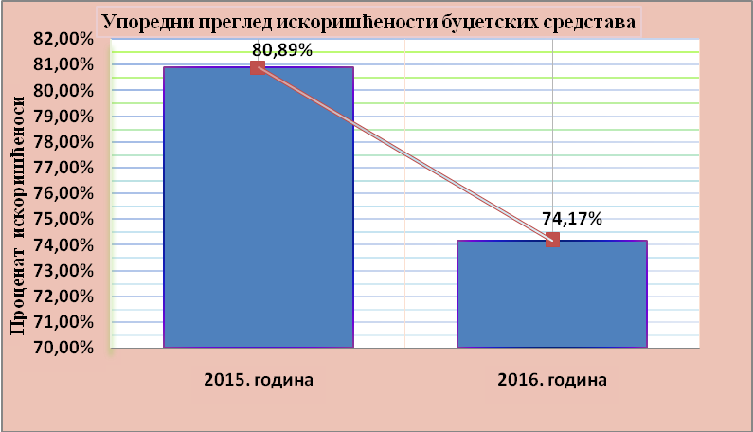
Chart 1 Comparative overview of budget funds

In 2016, the Team provided support for smooth operation of the APML as provided under the AML/CFT Law by prioritising financial activities, planning expenditures, implementing the planned procurement of goods and services in line with the Public Procurement Law and by ongoing control of the regularity and legality of documentation supporting the budget execution. The Team also issued, through the Treasury Administration, electronic payment orders for all payment orders and monitored the settlement of liabilities undertaken. For the execution of payment orders, exchange of financial data and compliance with statutory provisions related to public procurement, the APML’s financial staff use ten specific software applications ensuring direct connection with other state authorities.

Based on APML’s internal needs analysis and the 2016 Plan of Purchases, in line with the Public Procurement Law, the Team successfully completed procurement for 13 small-value public contracts, including three centralised procurements and two small-value contracts for the purchase of goods, and four centralised and four small value procurements for the procurement of services. The purchase of network protection devices, licenses, extension of guarantees and of data storage support devices has created optimal conditions for preventive and accidental maintenance of APML’s IT system’s software and hardware infrastructures, including an uninterrupted reliable and safe functioning of the internal case and document management system. Other public procurements were conducted, based on framework agreements that the Government’s Joint Services Administration has, as centralised procurements as provided under the Procurement Plan covering goods and services for current operations (stationery, toners, mobile phone and internet, physical security, etc.). Each of the procurements included an assessment of whether it was justified and purposeful respecting the principle of rational spending of public funds and control of expenditure.

In compliance with applicable legislation, the APML concluded a Services Contract in the area of fire protection and occupational safety and health.

The Team made an annual inventory of its property and financial commitments and reconciled the actual balance with the accounting records on 31 December 2016.

The Team also processes creates and keeps HR, statistical and other records related to its remit of operation, it prepares certificates and HR-related decisions and performs other operational and technical tasks ensuring efficiency and consistency of staff work.

CHALLENGES AND OBSTACLES IN ACHIEVING OBJECTIVES

The lack of capacities in terms of human resources and an extremely wide remit of APML’s responsibilities create a problem for APML operation. Specifically, 25 civil servants are currently employed on a fixed-term contract. The European Commission and other international organisations following the money laundering area in Serbia, have drawn attention to the problem of the scarce APML resources particularly having in mind the various APML’s responsibilities whose number is significantly higher than what international AML/CFT standards require of an FIU.

In order to increase the number of employees it is necessary to secure adequate work premises even for work of the current employees.

Further strengthening of interagency cooperation for a more efficient functioning of the entire AML/CFT system will be APML’s priority for the future.

Information taken from the Chamber of Certified Auditors’ website - www.kor.rs
http://www.coe.int/t/dghl/monitoring/moneyval/Countries/Serbia_en.asp
Other activities organised by OSCE alone or in partnership with foreign authorities in which APML took part can be found in the section on human resources and training.
https://webgate.ec.europa.eu/europeaid/online-services/index.cfm?do=publi.welcome&nbPubliList=15&orderby=upd&orderbyad=Desc&searchtype=RS&aofr=138350

