Administration for the Prevention of Money Laundering Work Report
1 January - 31 December 2015

2015
Administration for the Prevention of Money Laundering,
Masarikova 2, Belgrade
Belgrade, 28 March 2016
Contents

IMPROVEMENT OF THE SYSTEM FOR THE PREVENTION OF MONEY LAUNDERING AND TERRORISM FINANCING ON THE STRATEGIC LEVEL 3
Implementation of the 2015 - 2019 National Strategy against Money Laundering and the Financing of Terrorism 3
AML/CFT SYSTEM DEVELOPMENT AT LEGISLATIVE LEVEL (LAWS, BYLAWS, GUIDELINES, INDICATORS) 4
Law on the Freezing of Assets with the Aim of Preventing Terrorism 4
Draft Law Amending the Law on the Prevention of Money Laundering and Terrorism Financing 5
Guidelines for reporting suspicious transactions relevant for intermediaries in trade and lease of real estate, accountants and auditors, broker-dealer companies and authorised banks which have a permission to perform the business of broker-dealer companies 6
Indicators for recognising suspicious transactions in relation to terrorism financing 6
Indicators for recognising suspicion of money laundering or terrorism financing relevant for money remitters, accountants, auditors, broker-dealer companies, authorised banks which have a permission to perform the business of broker-dealer companies and intermediaries in trade and lease of real estate. 7
FINANCIAL INTELLIGENCE WORK IN 2015 7
COOPERATION WITH THE OTHER STATE AUTHORITIES OF THE REPUBLIC OF SERBIA 8
Ministry of Interior 9
Security Information Agency 10
Military Security Agency 11
Tax Administration 11
Anti-Corruption Agency 11
National Bank of Serbia 12
Privatisation Agency 12
COOPERATION WITH FOREIGN FINANCIAL INTELLIGENCE UNITS 12
ANALYSIS OF SUSPICIOUS TRANSACTIONS 13
STRATEGIC ANALYSIS AND OTHER RESEARCH 16
THE MOST COMMON MONEY LAUNDERING TYPOLOGIES IN 2015 16
Depositing funds of suspicious origin into non-resident accounts in Serbia 16
Agreement on a gift and the purchase of real estate with dirty money 16
Drawing funds from an account of a legal person on the basis of a loan interest 17
Privatization with funds of unknown origin 17
Abuse of money transfer agents for the purpose of human trafficking 18
Money laundering through associate legal persons 18
Money laundering through consultant activities 19
Introducing funds of unknown origin into legal flows through granted loans and as daily receipts of a business 19
Introducing funds of unknown origin to the financial system of Serbia through real estate and consulting 19
Integration of funds of unknown origin into the financial system through loans between associate legal persons 20
POSSIBLE WAYS TO FINANCE TERRORISM, AS IDENTIFIED IN 2015 20
Disguising the true identity of the beneficiary 20
Use of loans and other benefits granted without any grounds 20
Abuse of scholarships for the purpose of terrorism financing 21
Transfer of funds through Serbia for the purpose of terrorism financing 21
Abuse of companies with quick capital turnover for the purpose of financing activities that may be related to terrorism 21
THE ADMINISTRATION’S CASE STUDIES IN 2015 21
Case study no. 1: Investing capital of suspicious origin into current assets 22
Case study no. 2: Integration of dirty money through payment of loans 23
Case study no. 3: Human trafficking 24
Case study no. 4: Acquiring a company in the privatization with funds of unknown origin 25
Case study no. 5: Obtaining a loan under false pretences 26
Case study no. 6: Scholarships and terrorism financing 27
Case study no. 7: Human trafficking 28
Case study no. 8: Drug trafficking, human trafficking 28
Case study no. 9: Establishing legal persons in Serbia for money laundering purposes 29
Case study no. 10 Integration and layering of illegal money into legal flows 30
TRENDS 31
SUPERVISION OF ACCOUNTANTS AND AUDITORS IN TERMS OF AML/CFT LAW 32
OFF-SITE INSPECTION IN 2015 33
ON-SITE INSPECTION 35
COURT DECISIONS 35
COOPERATION BETWEEN RELEVANT STAKEHOLDERS AT NATIONAL LEVEL 39
Standing Coordination Group for supervision of the implementation of the National anti-money laundering and countering the financing of terrorism (AML/CFT) strategy 39
Responding to requests of the Privatisation Agency 40
APML EU - SERBIA NEGOTIATION PROCESS ACTIVITIES 40
Negotiating chapter 4 - Free movement of capital 40
Negotiating chapter 24 - Justice, freedom, security 41
Negotiating chapter 31 - Foreign, security and defence policy 42
INTERNATIONAL COOPERATION 43
Activities within the Council of Europe MoneyVal Committee 43
Fifth round of mutual evaluation 43
Activities within the FATF 43
Activities within the Egmont Group 44
Memoranda of understanding (MOUs) 44
OSCE 45
HUMAN RESOURCES AND TRAINING 45
Development of IT 47
FINANCIAL AND MATERIAL MANAGEMENT 48
CHALLENGES AND OBSTACLES IN ACHIEVING OBJECTIVES 48

IMPROVEMENT OF THE SYSTEM FOR THE PREVENTION OF MONEY LAUNDERING AND TERRORISM FINANCING ON THE STRATEGIC LEVEL

Implementation of the 2015 - 2019 National Strategy against Money Laundering and the Financing of Terrorism
Serbian Government at its session of 31 December 2014 adopted the National Strategy against Money Laundering and the Financing of Terrorism and the pertaining Action Plan (National AML/CFT Strategy).

The overall objective of the National Strategy is to contribute, through substantial strengthening of individual AML/CFT segments using targeted and well designed measures, to a full protection of the financial system and economy of the State from the threat caused by money laundering and terrorism financing and proliferation of weapons of mass destruction, whereby the integrity of the financial sector is strengthened and safety and security are contributed to.
In 2015, certain activities from the Action Plan were implemented. When implementing these activities from the Action Plan, the relevant state authorities took into consideration other initiatives, processes and plans of state authorities, as well as objective circumstances, which all required flexibility of deadlines for implementation of the activities from the Action Plan. Out of the total of109 activities, 22 were fully implemented, 39 partially and 48 were not implemented. The Action Plan envisages a 12-month deadline for implementation of 62 activities and the number of implemented activities, either in full or partially, in the reference period is 61. Having regard to the austerity measures in force, the envisaged activities in the area of improving the capacities and strengthening operational activities could not be implemented in the reporting period.

Some of the implemented activities include:

A Project Group comprising representatives of the APML, the National Bank of Serbia (hereinafter referred to as: the NBS), representatives of the banking sector and the Association of Serbian Banks implemented the activity 2.1.4.1. (analyse the current system of internal control and reporting in banks, and reporting to the APML and if necessary prompt banks to improve the system, including by defining their internal system more precisely), as well as the activity 2.1.4.2 (analyse the status of AML/CFT compliance officers and define more precisely responsibilities of the bank top management with respect to AML/CFT risk management). The analysis consists of three parts:

1. conclusions and recommendations of the Project Group formed based on the relevant international standards and good practice in the banking sector in Serbia;

2. analysis of the state of affairs in the area of the rights, obligations and authorisations of compliance officers, as well as of the system of internal reporting of suspicious transactions, done based on the answers to the questionnaire sent to representatives of the banks,
3. analysis of the system for internal control of fulfilling obligations according to the Law on the Prevention of Money Laundering and Terrorism Financing (Official Gazette of the Republic of Serbia No 20/09, 72/09, 91/10 and 139/14 - hereinafter referred to as: the Law), done based on the answers to the questionnaire.

In order to make all banks acknowledge the recommendations and undertake necessary actions to improve their ML/FT risk management system, a meeting was organised with representatives of the APML, the NBS and the Association of Serbian Banks with members of executive boards of banks.

A Working Group consisting of representatives of the NBS, the Ministry of Interior, the Security Information Agency, the Republic Public Prosecutors’ Office, the Compliance Board of the Association of Serbian Banks and the APML implemented the Activity 1.1.1.1 (establish a methodology for regular updating of the National Risk Assessment every two years) and Activity 1.2.1.1 (establish a TF NRA methodology, particularly taking into consideration the areas whose terrorism financing vulnerability has been recognized at the international level).

AML/CFT SYSTEM DEVELOPMENT AT LEGISLATIVE LEVEL (LAWS, BYLAWS, GUIDELINES, INDICATORS)

Law on the Freezing of Assets with the Aim of Preventing Terrorism
The Law on the Freezing of Assets with the Aim of Preventing Terrorism (Official Gazette of the Republic of Serbia No 29/15 - hereinafter referred to as: the Law) was adopted on 20 March 2015. The main aim of the Law is to improve fight against terrorism by establishing the system of preventive and repressive measures against terrorism financing as a stage which inevitably precedes commission of terrorist acts. Namely, the United Nations Security Council has adopted a series of resolutions laying down implementation of repressive measures against terrorists, terrorist organisations and their financiers. One of such measures refers to use of property and assets by terrorists and their financiers and countries are obliged to adopt regulations governing restriction of disposal of such funds located in the country.

By adopting this legislation, Serbia has complied with the provisions of Chapter VII of the UN Charter, which provides that the UN member states are obliged to take measures to implement resolutions adopted by the UN Security Council within its remit. The UN SC resolutions laying down the measures for preventing the financing of terrorism and terrorism in general include: Resolution 1267 of 1999 containing a list of persons designated by the UN SC against whom such measures are applied, Resolution 1373 of 2001, 1333 of 2000, 1363 of 2001 and 1455 of 2003. The Law was put in line with the FATF recommendations as revised in February 2012, in particular with Recommendation 6.

This Law lays down actions and measures for freezing of assets held by designated persons, the competences of state authorities concerning the application of these measures and provides for the rights and obligations of natural and legal persons in the application of this Law. According to the Law, the Government shall develop the list of designated persons based on:

1) the lists of designated persons made by the UN and other international organisations of which the Republic of Serbia is a member;

2) a proposal of the competent state authorities, based on a reasonable belief that a person is a terrorist, terrorist financier, involved in activities of a terrorist group or commission of a terrorist act;

3) justified request of another country.

The Law lays down the obligations to seize the assets, to conduct checks and report in case there is a contact of natural and legal entities with designated persons, which is established by an obligor on the occasion of establishing a business relationship or in the course of business, as well as an obligation for the state authorities in charge of implementation of this Law to exchange information.

For the purpose of implementing provisions of this Law, a Rulebook on the manner of delivering reports, information and data concerning a designated person and their assets (RS Official Gazette No 53/15) was adopted on 19 June 2015. This Rulebook governs the manner of delivering to the Administration for the Prevention of Money Laundering of the following: reports on the designated person and his/her assets by legal and natural persons; information by organisations competent for maintaining the register of business entities, associations, endowments, foundations and by courts and public notaries; data on the designated person and his/her property by state authorities, organisations or entities vested with public powers.

On its session of 16 July 2015 the Government passed a decision establishing the list of designated persons adopted on the grounds of the list established by the UN SC in line with the Resolutions 1267 (1999) and 1989 (2011). This decision, in line with the law, is also published on the internet pages of the Government of the Republic of Serbia and the Administration for the Prevention of Money Laundering, as well as in the RS Official Gazette.

Draft Law Amending the Law on the Prevention of Money Laundering and Terrorism Financing
In 2015, the APML worked intensively on drafting a Draft law amending the current AML/CFT Law. A number of workshops and meetings were held in 2015 with supervisors and obliged entities to hear and discuss proposals and suggestions for improving the preventive AML/CFT legal framework in Serbia. Draft Law Amending the Law on the Prevention of Money Laundering and Terrorism Financing was published on the website of the APML. A presentation was organised, at the end of which the attendees were invited to send to the APML any remarks and suggestions regarding provisions of the Law currently in force and the proposed amendments to it. Moreover, before the Draft was produced, a working document was published on the website of the APML and both financial and non-financial sectors were invited to express their remarks and suggestions about the document. The suggestions which were acceptable became part of the current version of this document. The European Commission analysed the Draft and gave its opinion on it, accompanied by comments and proposals, which will be used in further work on the document.
The envisaged amendments are designed so as to harmonise the current legislative provisions with the new AML/CFT standards, i.e. FATF’s 40 Recommendations revised in February 2012. In designing the legislative amendments, the working group was guided, in addition to the FATF’s recommendations, also by the Directive (EU) 2015/849 of the European Parliament and of the Council on the prevention of the use of financial system for the purpose of money laundering and the financing of terrorism of 20 May 2015, amending Regulation (EU) No 648/2012 of the European Parliament and of the Council, and repealing Directive 2005/60/EC of the European Parliament and of the Council and Commission Directive 2006/70/EC, also known as the “Fourth Directive”.

Guidelines for reporting suspicious transactions relevant for intermediaries in trade and lease of real estate, accountants and auditors, broker-dealer companies and authorised banks which have a permission to perform the business of broker-dealer companies
A Working Group, consisting of representatives of the APML, Securities Commission, Market Inspectorate and representatives of the private sector, namely: a broker-dealer company, an auditing company and an agency for intermediation in trade and lease of real estate produced the Guidelines for reporting suspicious transactions relevant for intermediaries in trade and lease of real estate, accountants and auditors, broker-dealer companies and authorised banks which have a permission to perform the business of broker-dealer companies. On 11 September 2015 the APML adopted these Guidelines, which were published on its official web page.

Indicators for recognising suspicious transactions in relation to terrorism financing

A Working Group, consisting of representatives of the APML, NBS, Tax Administration, commercial banks and money remitter produced Indicators for recognising suspicious transactions in relation to terrorism financing. On 24 March 2015, the amended list of the Indicators was published on the official web page of the APML. Obliged entities are requested to use this list starting from 1 June 2015.

Indicators for recognising suspicion of money laundering or terrorism financing relevant for money remitters, accountants, auditors, broker-dealer companies, authorised banks which have a permission to perform the business of broker-dealer companies and intermediaries in trade and lease of real estate.
A Working Group, consisting of representatives of the APML, Securities Commission, Market Inspectorate and representatives of the private sector, namely: a broker-dealer company, an auditing company and an agency for intermediation in trade and lease of real estate produced the Indicators for recognising suspicion of money laundering or terrorism financing relevant for money remitters, accountants, auditors, broker-dealer companies, authorised banks which have a permission to perform the business of broker-dealer companies and intermediaries in trade and lease of real estate. On 11 September 2015 the APML adopted these Indicators, which were published on its official web page.

FINANCIAL INTELLIGENCE WORK IN 2015

Financial intelligence tasks are conducted at the APML by its Section for cooperation with other state authorities and Section for analysis and financial intelligence.

In 2015 a total of 1,109 cases were worked on: 983 new analytical cases opened at the initiative of other state authorities, supervisors, at the requests of foreign FIUs and on basis of analysis of suspicious reports submitted by obligors, and 126 cases from the previous years (new information and data on persons who had already been subject to analysis in the APML).

In requests for provision of information sent by the other state authorities to the APML, the most frequent crimes involve: tax evasion, abuse of authority in economy, abuse of the position of a responsible person in a company, illicit crossing of the state border and human smuggling, trade in narcotics, frauds, terrorism and terrorism financing.

In the majority of cases what is questionable is the economic justifiability of the execution of transactions, source of funds paid to accounts, whether trade in goods and services is fictitious or legal transactions simulated.

Many cases were analysed because of a suspicion on simulated legal affairs, that is, transfers of funds on grounds of fictitious bases. These cases often involve payments of cash of unknown origin by natural persons to accounts of legal persons, followed by transfers of money between two or more connected legal persons. The ultimate goal of such transactions is integration of cash of dubious origin into legitimate money flows. For example, it was noticed in 2015 that obligors often report as suspicious the activities of payment of significant amounts of founders’ loans to the benefit of legal entities registered for construction business.

Numerous requests for provision of information received by the APML from other state authorities referred to abuse of the position of a responsible person in a company by directors, as well as draining funds from companies. Funds acquired this way are afterwards mainly used to satisfy personal needs of natural persons.

Because of the migrant crisis in the world and significant movement of migrants through Serbia, a lot of attention is also paid to monitoring of transactions executed by migrants while crossing the territory of Serbia. Namely, since there is a danger from potential terrorist acts and their financing, as well as human smuggling and trafficking, the transactions of individuals related to the so-called critical areas are analysed with special attention and urgency.

COOPERATION WITH THE OTHER STATE AUTHORITIES OF THE REPUBLIC OF SERBIA

Prosecutors’ Offices

In 2015, prosecutors’ offices sent a total of 26 requests to the APML.

Prosecutors’ Offices | Number of requests
Prosecutor’s Office for Organised Crime | 8
Higher Prosecutors’ Offices | 16
Basic Prosecutors’ Offices | 2

Description of a ML suspicion is most commonly related to the crimes: abuse of office, fraudulent practice, abuse in the process of privatisation of companies, spending of funds for unintended purposes, embezzlement, human trafficking, drug trafficking, forgery and all sorts of organised crime, etc.

Cases are forwarded to prosecutors’ offices according to the Agreement signed with the Republic Public Prosecutor's Office on 22 January 2014. The APML forwarded information to the prosecution in 58 cases.

Prosecutor’s Office | No. of referrals
Prosecutor’s Office for Organised Crime | 11
Higher Prosecutors’ Offices | 45
Republic Public Prosecutor’s Office | 2

Most analyses and referrals about suspicion of ML were sent to the Higher Public Prosecutor’s Office in Belgrade (27 cases in total), Higher Public Prosecutor’s Office in Novi Sad (3 cases), while Higher Public Prosecutor’s Offices in Jagodina, Kragujevac, Sremska Mitrovica and Subotica were forwarded two cases each and the Prosecutors’ Offices in Kraljevo, Niš, Smederavo, Šabav, Vranje, Zaječar and Zrenjanin were forwarded one case each.

Regional overview of the cases per prosecutor’s office is shown in the chart below.

Higher Public Prosecutor’s Office | No. of referrals
Belgrade | 27
Novi Sad | 3
Jagodina | 2
Kragujevac | 2
Sremska Mitrovica | 2
Subotica | 2
Kraljevo | 1
Smederevo | 1
Niš | 1
Šabac | 1
Vranje | 1
Zaječar | 1
Zrenjanin | 1

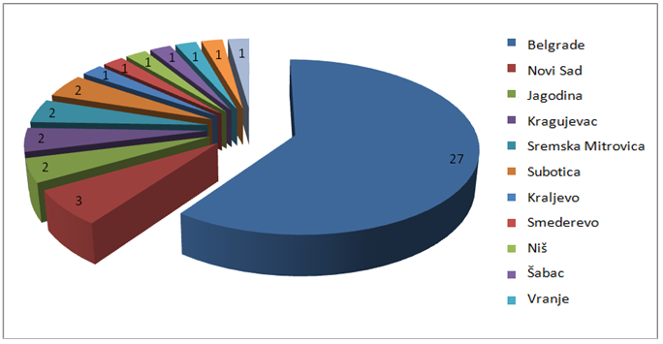

In the majority of the cases, the information was forwarded to the prosecution due to a suspicion of simulated legal affairs, corruption, trade in drugs, trade in humans, forging of business documentation, various sorts of fraud and links to the already known criminal groups in Serbia.

Ministry of Interior

The Ministry of Interior sent to the APML 400 requests for information in 2015. Out of the total number of requests, the Criminal Police Directorate of the Ministry of Interior sent 83 requests. At the request of state authorities, in addition to checking the databases available to it (cash and suspicious transactions databases), the APML also collected the data on turnover on bank accounts (for a period of eight years in average), transfer of money via money remitters and the data from foreign financial intelligence units via the Egmont Group secure website.

Police directorates directly sent a total of 31 requests for information to the APML. These involved checks on grounds of suspicion of abuse of authority in economy, tax evasion, fraudulent practices and simulated legal transactions.

Some requests sent to the APML by the Ministry of Interior were related to activities of task forces and involved cases which required urgent checks of numerous connected natural and legal persons and analyses of turnover on their accounts opened with all commercial banks in Serbia (currently 29 banks). Because of the urgency and importance of the cases, these data had to be processes very quickly (usually within 48 hours). Namely, in November and December 2015 the APML received 11 requests for information which needed urgent analysis. They mainly involved a suspicion of corruptive practices and money laundering.

The Unit for Financial Investigation of the Ministry of Interior sent to the APML a total of 286 requests, which in average required checks of 15 natural persons per request. The majority of the requests were sent since there was a suspicion on money laundering related to the predicate crimes such as fraud, tax evasion, illicit manufacture and trade in narcotics and abuse of the authority of a responsible person in a company and human trafficking.

During the analysis of suspicious transactions reported to the APML by its obligors, the APML sent to the Ministry of Interior a total of 108 requests which contained data, but which at the same time requested information on criminal offences, relations to criminal groups in Serbia and all other operational data they have at their disposal. Activities of the persons who were subject to analysis indicated to a suspicion whether the funds were gained legally, a suspicion of trade in narcotics, fraudulent activities, abuse of the authority of a responsible person, human trafficking, terrorism financing, manipulations with securities, etc.

Security Information Agency

In 2015 the Security Information Agency sent to the APML a total of 39 requests for information, which in addition to checking the databases available to the APML also required checking turnover on accounts, usually for a period of two years. The majority of the information exchanged referred to a suspicion on trade in narcotics and human beings, terrorism financing, links to criminal organisations, transfers of funds of dubious origin to accounts in Serbia and forgery of identification documents by natural persons.

Further, after the analysis of suspicious transitions, the APML sent 51 referrals to the Security Information Agency for its further action, requesting it to inform the APML of the results of its checks. These situations mainly involved foreign citizens who own bank accounts or execute transactions at commercial banks in Serbia, whose activities raise suspicion of being related to trade in narcotics and human beings, frauds and terrorism financing.

Due to the severe migrant crisis, reporting of suspicious transactions by money remitters is very frequent. All these transactions were forwarded to the Security Information Agency because of a suspicion of terrorism financing or human trafficking.

Military Security Agency

In 2015 the Military Security Agency sent to the APML five requests for information, based on a suspicion of illicit trade in weapons, corruption and terrorism financing.

At its own initiative the APML sent two disseminations to the Military Security Agency, for the purpose of additional checks. These situations involved activities where the funds were suspected to originate from illicit trade in weapons.

Tax Administration

In 2015 the Tax Administration, Tax Police Sector, sent four requests for information to the APML, while the APML sent to the Tax Administration 77 requests for conducting checks within the remit of the Tax Administration. The APML’s requests for information mainly referred to a suspicion that simulated legal transactions are being conducted, whose purpose is to remove cash from accounts of legal persons so as to avoid tax obligations. A portion of the APML’s requests involved repayment of a founder’s loan for the company’s liquidity, suspected of being fictitious.

Based on the Working Procedure signed between the APML and Tax Administration, Tax Police Sector, a total of three cases were opened at the APML and these included analysis of turnover on accounts of subject individuals both in the country and abroad, as well as of other data gathered from foreign financial intelligence units.

Anti-Corruption Agency

According to the National Risk Assessment, corruptive crimes are assessed to be highly risky for money laundering.

In 2015 the Anti-Corruption Agency sent to the APML a total of 17 requests for information, which involved a suspicion arising from a discrepancy between earnings and property of officials and persons connected to them as reported to the Anti-Corruption Agency, as well as a suspicion of the legitimacy of the funds used to finance political parties.

For the purpose of establishing the origin of property and money of persons subject to checks at the APML, the Anti-Corruption Agency was sent two requests for information.

National Bank of Serbia

Pursuant to item 6 of the Agreement on Cooperation in the Area of Prevention of Money Laundering and Terrorism Financing signed between the National Bank of Serbia and the Ministry of Finance - APML, in 2015 the National Bank of Serbia sent to the APML five requests for checking data related to transactions reported by obligors (the number and quality of reported suspicious and cash transactions).

Privatisation Agency

According to Article 13, paragraph 1 of the Law on Privatisation (RS Official Gazette No 83/14 and 46/15), in 2015 the Privatisation Agency sent to the APML 46 request which required from the APML its opinion on the purchasers of legal entities in privatisation process.

COOPERATION WITH FOREIGN FINANCIAL INTELLIGENCE UNITS

In 2015, the APML responded to 100 requests for information received from foreign financial intelligence units (FIUs). These requests mainly referred to Serbian citizens holding accounts abroad and suspected of being linked to criminal groups or activities, as well as to foreigners holding accounts with commercial banks in Serbia or participating in criminal activities in Serbia.

The APML also received 10 spontaneous disseminations from foreign FIUs and these mainly referred to suspicious activities of natural or legal persons from Serbia with accounts at banks abroad. Information on legal persons from abroad who have accounts with banks in Serbia which are suspected to be used to conceal assets illicitly gained abroad was also sent to the APML in form of spontaneous information.

During its work on analytical cases, the APML sent 134 requests for information to foreign FIUs. These requests mainly involved non-residents with either accounts or business activities in Serbia, based on a suspicion of potentially illicit origin of the assets or legitimacy of business activities. Further, some requests for information were sent to foreign FIUs with the aim of identifying property of Serbian nationals located abroad.

In 2015 the APML forwarded to foreign FIUs three spontaneous disseminations involving non-residents, their business activities or money in Serbia.

Most information was exchanged with the neighbouring countries: Montenegro, Bosnia and Herzegovina, Slovenia, Bulgaria and Hungary. Information exchange with foreign FIUs was mainly related to transfers of funds from or to accounts of natural persons when it was not clear what the purpose of the transfers was.

 | Requests received from foreign FIUs | Requests sent by the APML
Bosnia and Herzegovina | 6 | 12
Montenegro | 11 | 8
Slovenia | 6 | 7
Bulgaria | 6 | 4
Hungary | 7 | 4

ANALYSIS OF SUSPICIOUS TRANSACTIONS

In 2015 obligors reported to the APML a total of 5,674 suspicious transactions/activities.

An overview of the reported suspicious transactions per type of obligor is presented in the chart below.

Obliged entities | No of reported suspicious transactions/activities
Banks | 737
Money remitters | 4,881
Notaries public | 2
Accountants | 3
Auditors | 11
Bureaux de change | 4
Entities engaged in postal communication | 17
Insurance companies | 18
Leasing | 1
Factoring | 1

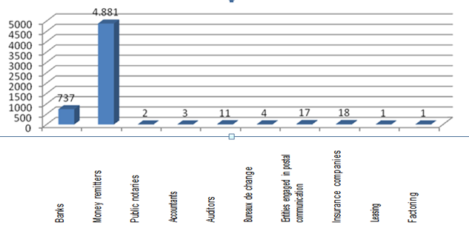

As it can be seen from the chart, most suspicious transactions in 2015 were reported by money remitters and banks.

Detailed explanations of the suspicion of money laundering or terrorism financing in the descriptions accompanying the reported transactions are submitted by banks, which in addition to an explanation for a particular transaction also include information on the activities of the reported persons prior to the report itself. Out of the total of 737 suspicious transactions reported by banks, 152 remained with the APML to be monitored, while the rest were forwarded to other relevant state authorities for further action.

All transactions reported by money remitters (4,881 in total) were forwarded to other state authorities for further action.

The persons who participated in the execution of the transactions which were decided to be monitored by the APML staff, that is those where there was not enough evidence to support the suspicion of money laundering or terrorism financing, are subject to monitoring and if new transactions involving them are reported as suspicious, they are analysed and assessed again.

The activities which obligors usually reported as suspicious involve: tax evasion, integration of money of unknown origin into the financial system of the Republic of Serbia, forgery of personal identification documents, abuse of the position of responsible person in legal entities, suspicious purchases by legal entities, suspicious usage of granted credits by natural persons, terrorism financing through charity organisations etc.

Tax evasion remains to be the criminal offence most frequently recognised by obligors when reporting suspicious transactions. Such activities usually include simulated businesses with the purpose of removing cash from accounts of legal persons or transactions with questionable origin of funds, such as loans for which it is later concluded through analysis that they do not originate from legal business operations of the natural person paying the loans.

Numerous transactions involve various types of fraudulent activities (forging of documentation and personal IDs and abuse of credit cards).

Trade in goods on the black market is still very frequent in the Republic of Serbia. Persons import and sell goods for cash, without entering the transactions in the business books, where payments for the purchased goods are executed by alternative channels avoiding the banking sector (such as through money remitters). The goods are sold on the black market and money is sent with the stated purpose of transactions: aid to family.

What is also noticeable is the existence of frequent business activities of charity organisations headquartered in the areas assessed as risky for terrorism financing in Serbia. It is suspected that these organisations are abused for the purpose of financing and training potential terrorist.

During the analysis of suspicious transactions a tendency was noticed for non-residents who do not perform business activities in Serbia to open accounts at commercial banks in Serbia. These accounts are credited from abroad based on various grounds with significant amounts, where there is no clear evidence of the origin and purpose of the transactions.

In 2015 commercial banks also reported to the APML a total of 10 planned, that is to say intended but not executed prior to reporting to the APML, transactions in relation to which a suspicion of money laundering was formed based on the available data. These transactions involved attempts of individuals to integrate in the financial system of the country massive amounts of money. The stated purpose of the planned transactions was investment in the country, without a specific explanation of what exactly that assumed.

Based on a suspicion of terrorism financing, banks reported 4 transactions to the APML in 2015.

As regards the transactions reported as suspicious by money remitters, these mainly referred to foreign citizens originating from areas risky for terrorism financing (Syria, Saudi Arabia, Pakistan, Afghanistan, etc.). The transactions through money remitters are mainly in lower amounts and what is also noticeable is the existence of individuals who deposit or withdraw cash on behalf of several persons.

It is important to highlight that there was a significant increase in the frequency of use of services of money remitters by Serbian citizens in the last several months of 2015. These transactions usually involve receiving money from family members working abroad.

Services of money remitters could easily be abused by owners of legal entities to pay for goods. In these cases the purpose is tax evasion and money laundering.

STRATEGIC ANALYSIS AND OTHER RESEARCH

In addition to working on specific cases, in 2015 the Department for Analysis, Financial Information and Cooperation with other State Authorities worked on research and strategic analysis of the following:
- Analysis of AML/CFT activities in banks;
- Analysis of transactions conducted through money transfer agents, reported for suspicion of ML/TF;
- Analysis of cash transactions based on criteria indicating tax evasion and money laundering;
- Analysis of money flows through import invoices;
- Money laundering through investments in real estate;
- Money laundering through trade in gold and other precious metals;
- E-banking and e-money as areas of ML/TF risk;
- Work in progress on new ML/TF methodologies and typologies.

THE MOST COMMON MONEY LAUNDERING TYPOLOGIES IN 2015

Depositing funds of suspicious origin into non-resident accounts in Serbia

Foreign nationals very often physically carry cash into Serbia for the purpose of disguising its true origin. They declare cash at the border and receive the records on the import of cash. Declared funds are deposited into their non-resident accounts in commercial banks in Serbia. The funds accumulated in this way are used in payment card payments.

Agreement on a gift and the purchase of real estate with dirty money

A person from criminal milieu wishes to buy a real estate but to avoid doing business with a bank. The person concludes an agreement on a gift with the owner of the real estate, paying the owner in cash, using funds derived from illegal activities.

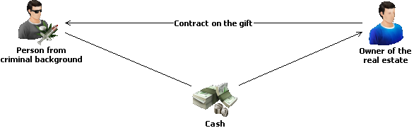

Drawing funds from an account of a legal person on the basis of a loan interest

The owner of a legal person loans funds to the legal person to purchase equipment. The Loan Agreement provides for a very high interest rate. The legal person transfers funds into the account of the owner for the purpose of interest repayment on a monthly basis, whereas the principal remains unpaid.
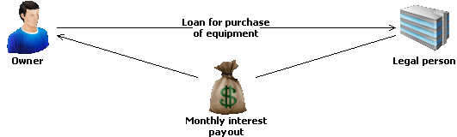

Privatization with funds of unknown origin

A newly established legal person acquires a company in privatization process. Funds for the acquisition are provided on the basis of a Loan Agreement with an off-shore company. The funds are repaid to the off-shore company in a short period of time, according to the Loan Agreement.

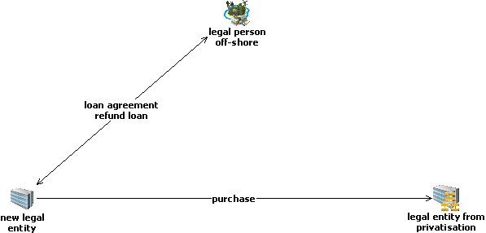

Abuse of money transfer agents for the purpose of human trafficking

A person is involved in human trafficking exploiting disadvantaged individuals. The person transports the victims illegally across the border while receiving funds for trafficking through money transfer agents.

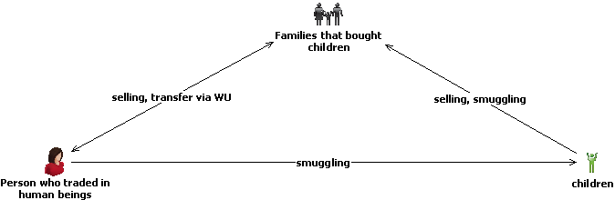

Money laundering through associate legal persons

Several legal persons connected through ownership and managerial structure, so called parent companies and their affiliates, use a single company as a “boiler”, conducting transactions without economic purpose.

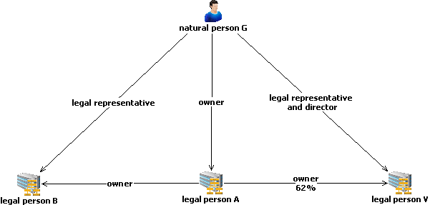

Money laundering through consultant activities

An off-shore company transfers significant amounts on the basis of consultancy services into an account of a non-resident, whereas a resident person has a signatory power over the account.



Introducing funds of unknown origin into legal flows through granted loans and as daily receipts of a business

Funds of unknown origin are very often introduced into legal flows through granted loans and as daily receipts of a business The most conducive companies for such operations are legal persons registered to pursue business with quick turnover of assets, such as retail business, hospitality industry, and similar.

Introducing funds of unknown origin to the financial system of Serbia through real estate and consulting

A person from Serbia establishes an off-shore company and introduces money of unknown origin into the company’s accounts. Funds from the accounts are introduced into Serbia through investments in real estate and payments for consultancy services.

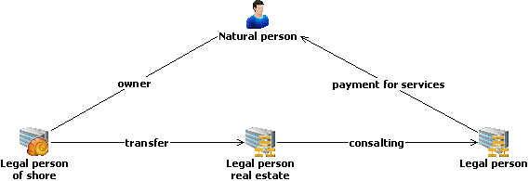

Integration of funds of unknown origin into the financial system through loans between associate legal persons

A person establishes several legal persons of different lines of business. In order to disguise the true origin of funds a person pays a loan to a legal person and subsequently transfers funds to another legal person, also as a loan.

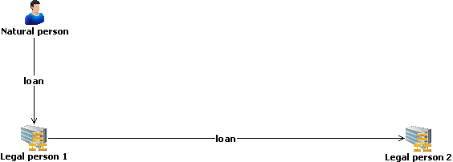

POSSIBLE WAYS TO FINANCE TERRORISM, AS IDENTIFIED IN 2015

Disguising the true identity of the beneficiary

A lot of persons from countries posing TF risk use money transfer agents to send significant sums of money to Serbia. Only one person, a resident, appears to be the beneficiary of the funds. In order to disguise the identity of the ultimate beneficiary of the transferred funds, the resident person receives the funds on behalf of several persons with temporary residence in Serbia.

Use of loans and other benefits granted without any grounds

A large number of persons employed by a religious organization take loans in banks. There is suspicion that the loans granted are used contrary to the intended purpose for terrorism financing.

Abuse of scholarships for the purpose of terrorism financing

A large number of individuals receive funds as scholarship from a charity organization. There is suspicion that the true purpose of the disbursement is actually terrorism financing.



Transfer of funds through Serbia for the purpose of terrorism financing

Several legal persons in Western Europe, the owners of which are originally from areas of risk for terrorist financing, send funds to a natural person in Serbia on the basis of consulting services. The funds are subsequently sent through WU to a state with terrorist financing.

Abuse of companies with quick capital turnover for the purpose of financing activities that may be related to terrorism

Terrorism can be financed from legal sources as well. One of the ways is to abuse companies with quick turnover of capital, by moving funds from companies’ accounts on different bases. Funds withdrawn in cash are given to persons related to terrorist activities.



THE ADMINISTRATION’S CASE STUDIES IN 2015

Case study no. 1: Investing capital of suspicious origin into current assets

Having analysed transactions recorded in the database of foreign payment operations, which is maintained by the National Bank of Serbia, a transaction worth a million EUR has been observed. From the account held by a Serbia-based legal person A there was a significant transfer in EUR, based on the rental of equipment, in favour of an account in a neighbouring country held by a legal person B based in an offshore destination.

Tracing the origin of the funds transferred to a neighbouring country, we analysed turnovers of all accounts held by the legal person A in commercial banks in Serbia, but the greatest portion of incoming transfers comes from the account held by the legal person E. Interestingly enough, the beneficial owner of legal persons A and E was the same person.

In order to identify the true source of funds transferred to the neighbouring country, we analyzed the turnover of all the accounts held by the legal person E in Serbia. Most funds were identified to stem both from loans granted by banks in Serbia and abroad, and from transfers from accounts of several state institutions in Serbia, based on trade in goods and services.

In order to trace further placement of funds transferred from Serbia into the neighbouring country, there was lengthy correspondence with the country’s FIU, which revealed the following:

Following the transfers into the account in the neighbouring country, the funds were partly transferred in favour of a legal person C in the off-shore, and were partly used for loan repayment of the legal person D in the same bank.

It should be mentioned that the beneficial owners of legal persons A, E, C, D were persons with criminal background.

The analysis of business relationship between legal persons A and B showed that they did not have direct business cooperation, although the funds on the basis of the equipment rental were transferred from the account of A into the account of B in the neighbouring country.

It was established that the legal person A had imported goods from the legal person F, based in an offshore territory. Then the legal person F concluded an agreement on assignment of receivables with legal person B, based on which A would pay for the rental (import) of equipment to B instead of F, which leads to a conclusion that the transfer of funds from A to B was done based on the agreement.

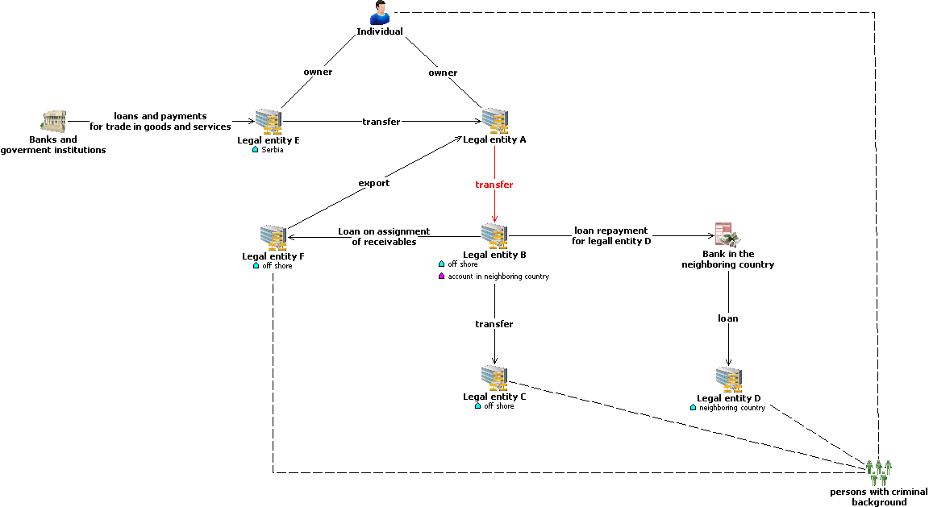

Case study no. 2: Integration of dirty money through payment of loans

Natural person L with several final convictions for different criminal offences makes cash deposits in very high amounts into an account of a legal person M which L owns. The funds are deposited on the basis of the founder’s loan. A smaller portion of deposited funds is repaid to the owner through loan repayment, while a larger portion is transferred to the account of a legal person P on the basis of a loan. One half of the transferred funds is withdrawn in cash by the owner of P on the basis of a loan and the other half is transferred into the account of a legal person K on the basis of trade in goods and services. The transferred funds are fully withdrawn in cash by the owner of the legal person K. Presumably, the owners of P and K are associates of individual L, and following the cash withdrawals, they channel the funds to L.

Having completed its analysis, the Administration referred the information above to the competent Prosecutor’s Office and Tax Police. The Administration was informed by the Tax Police that the companies above had been subject to inspection and that criminal reports were filed against them.

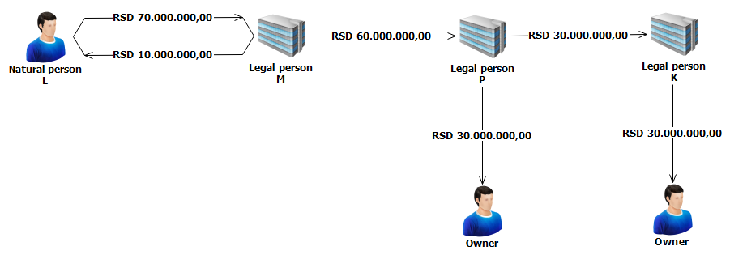

Case study no. 3: Human trafficking

In 2014 the Administration began to exchange information with a relevant prosecutor’s office on an individual T suspected of being involved in human trafficking.

Individual T took advantage of health issues of a little girl V and took her along to Germany (the little girl was thought to be mentally handicapped).
After the little girl V was taken to Germany, the individual T sold her to the individual A.

According to the operational data of the relevant authority in charge of international operational cooperation, the little girl V was sold to a Roma family from the town S in Germany, who then sold her to another Roma family in the town K.
Individual T received monetary compensation for selling the little girl - part of it was paid in cash and the other part was sent through money transfer agents.

Analysis of money flows showed that in the period around the trafficking case individual T received the total amount of EUR 3.561,00 from different senders through money transfer agents. There was a total of 20 transactions. The funds were mostly transferred from Germany, except for two transactions from France and one from Italy.

The little girl was returned to Serbia through international police cooperation.
The little girl said that T received a part of money (presumably, the sum was EUR 4.000,00) from the Roma family.

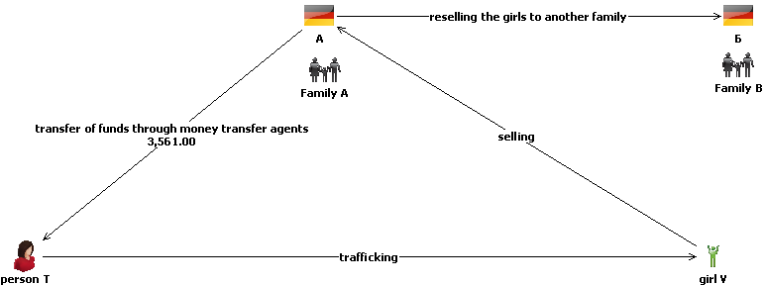

Case study no. 4: Acquiring a company in the privatization with funds of unknown origin

A reporting bank filed an STR, saying that a newly established company F acquired a company C in privatization process, using the funds provided by company H from an off-shore jurisdiction on the basis of a loan contract. The funds were repaid to the off-shore company in a short period of time, according to the Loan Agreement. A question arose as to the origin of funds as well as the beneficial owner of the company F.

Before conducting the analysis the Administration sent requests to banks and FIUs in the countries from which transfers originated.

Funds are transferred from accounts of associate companies A and B kept in banks in Serbia, into accounts held by company F, on the basis of trade in goods and services, as well as the export of goods.

In addition, a portion of funds in the accounts of company F originates from a bankruptcy mass of the company C, and are transferred through companies A and B.

The Administration sent a request to the FIU of K to check the legal person that transferred funds into accounts of the company in Serbia. FIU K responded, which led the Administration to approach the FIU of B, as one of the founders was a legal person from country B. According to the information received from FIU of B, the beneficial owner of the legal person was an individual V from Serbia.

Following the loan repayment, company H from the offshore jurisdiction of K transferred EUR 400.000,00 into a non-resident account of company D kept in Serbia. The funds were transferred on the basis of increase/decrease of share held by foreign banks and other financial organizations. On the same day legal person D sold foreign currency to a bank and transferred corresponding amount of Dinars into an account held by company G on the basis of investing foreign capital into domestic companies. The transfer was conducted on the basis of a decision of the governing body of company G.
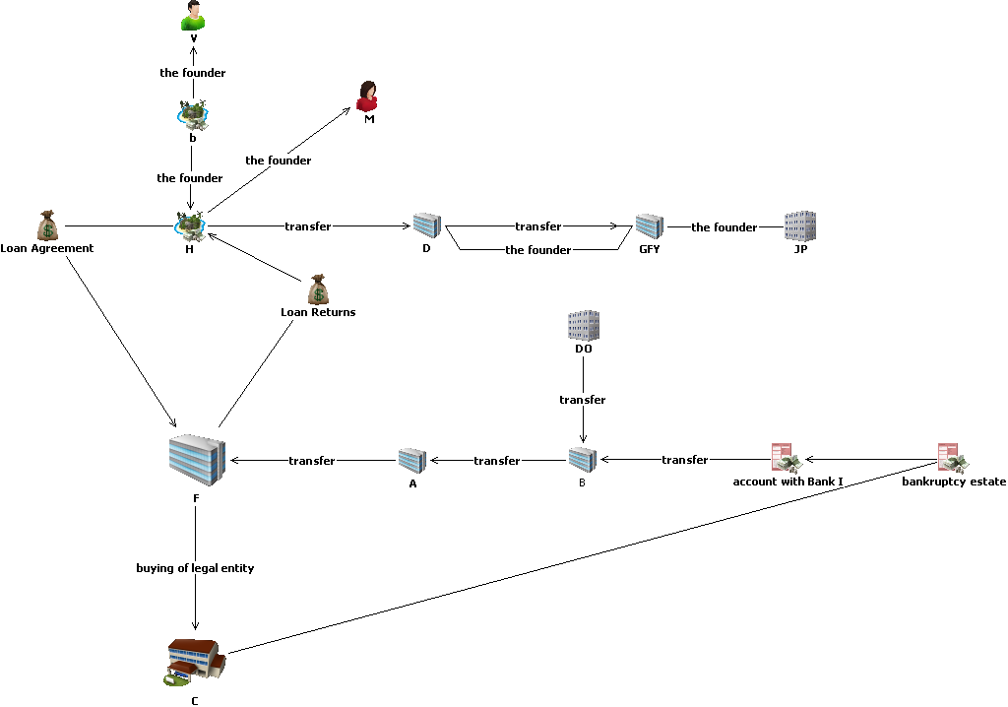

Case study no. 5: Obtaining a loan under false pretences

The Administration received a STR from a commercial bank.
In the time span of around two years, a large number of persons were granted cash loans in the total amount of RSD 29.000.000. The analysis of credit documentation showed that most of the persons were employed by a religious organization A as drivers, cooks, etc, and their salaries were above average in Serbia. As for the loan repayment by the persons, there was a delay. A person making cash repayments of all the loans is a natural person B, holding a high rank in the religious organization A.

A competent state authority was provided by the outcome of the analysis, as the Administration did not have information about the origin of funds used by person B to repay the loans of these persons. We pointed out suspicion as to legality of funds used by person B when repaying loans, as well as suspicion that person B forged documents to provide loans and that he was using funds for personal needs or in favour of the religious organization A.
The above said, we suspected that the case was about the criminal offence of obtaining and using credit and other benefits under false pretences.

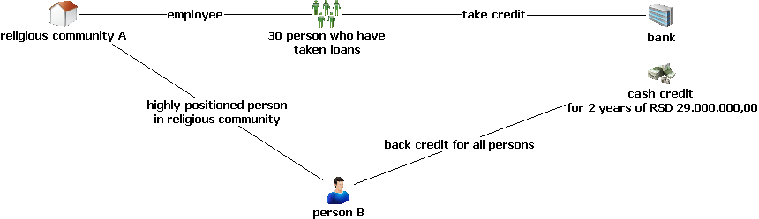

Case study no. 6: Scholarships and terrorism financing

The Administration received a STR from a commercial bank, indicating suspicion of terrorism financing.

Funds from the Middle East in the amount of cca EUR 20.000,00 are transferred into an account of a charity organization A. The funds were subsequently transferred as scholarships into accounts of 10 individuals who study at the private University in the same town where the registered seat of the charity is located. There was an issue in scholarship contracts, which were concluded a year before the transfers and which did not state the amount.

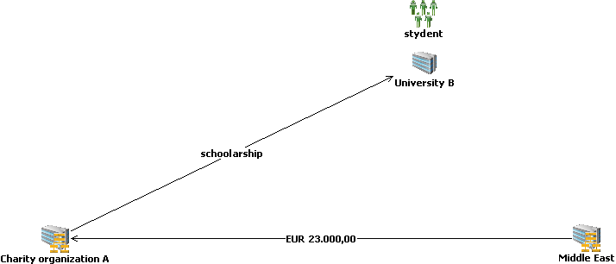

Case study no. 7: Human trafficking

Money transfer agents reported a large number of different STRs. Through analysis a connection was established between six nationals and three foreign persons who conducted frequent transactions of sending and receiving money through money transfer agents; some of the persons were registered as entrepreneurs in hospitality industry and taxi services.

What was detected immediately raised suspicion of possible migrant smuggling. A request was sent to check the databases of the Ministry of Interior, to check the statement of accounts kept by banks and transactions through money transfer agents. The analysis of the collected information showed that the persons involved already had convictions for cross-border human smuggling. It was also established that the persons often used money transfer services (in the period between January 2013 and November 2014 the total value of the transactions was around RSD 10.000.000,00), but they did not have many accounts in banks, whereas the overall balance for all the persons in November 2014 amounted to around RSD 9.500,00.

The analysed information was disseminated to the relevant prosecutor’s office.

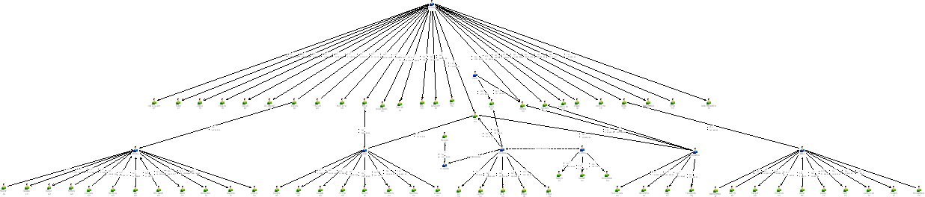

Case study no. 8: Drug trafficking, human trafficking
Money transfer agents reported a large number of persons for frequently receiving funds from Turkey. One person received funds from different persons from Turkey in one period and in other period, the same person sent funds from Turkey to different persons in Serbia.

A request was sent to check the databases of the Ministry of Interior, to check the statement of accounts kept by banks and transactions through money transfer agents. Following relevant checks in the Ministry of Interior, some persons were identified in a neighbouring country as members of an organized crime group, involved in smuggling and drug and human trafficking. It was established that one person had had his name changed.
It was also established that the persons often used money transfer services (in the period between March 2013 and May 2015 the total value of the transactions was around EUR 79.000,00 and RSD 3.600.000,00), but they did not have many accounts held by banks, whereas the overall balance for all the persons in June 2014 amounted to around RSD 3.500,00.

The analysed information was disseminated to the relevant prosecutor’s office.

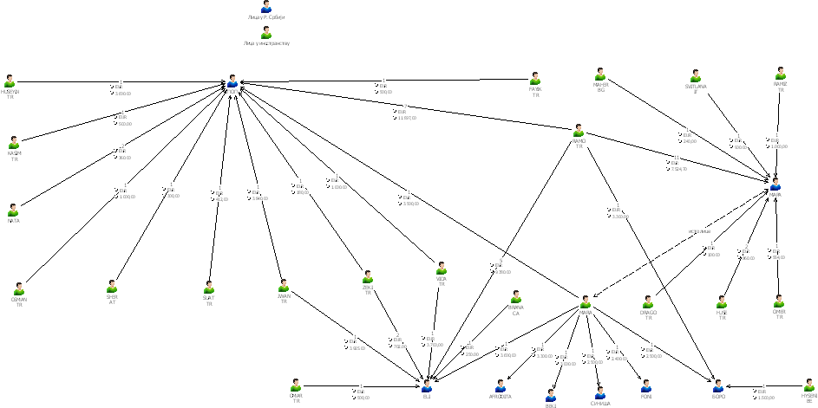

Case study no. 9: Establishing legal persons in Serbia for money laundering purposes

A person A, national of a neighbouring country, is the owner and the only director in the legal person M, registered in Serbia. The same person is the owner of a legal person F in another surrounding country.

Legal persons M and F hold accounts in banks in a country K. Analysis of the account turnovers of the two legal persons indicated the incoming transfers of significant amounts on the basis of trade in goods and services, originated by several companies from different countries. Immediately after the incoming transfers into accounts in country K, the funds are transferred to accounts of legal persons C and P. The legal persons hold accounts in banks in several surrounding countries. The owner of legal persons C and P is the same natural person D. There is suspicion that natural persons A and D are members of an organized crime group, which established legal persons in several countries and transferred funds among the legal persons, for the purpose of disguising the true origin of transferred funds.

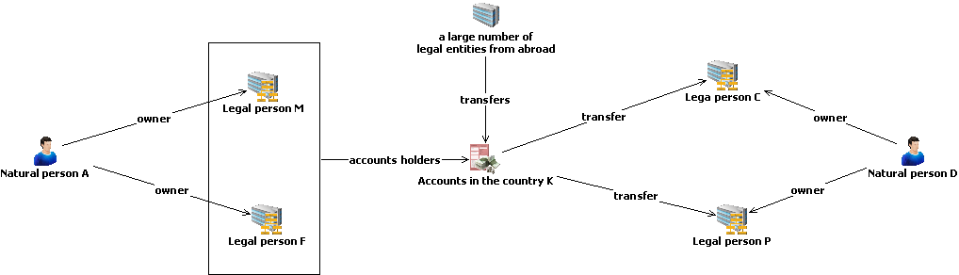

Case study no. 10 Integration and layering of illegal money into legal flows

The Administration received several STRs from a commercial bank. A legal person A from Cyprus is an owner of a legal person B in Serbia. The beneficial owner of a legal person A from Cyprus, as well as the legal representative of the legal person B is a natural person V. A legal person A from Cyprus is 62% owner of a legal person G in Serbia. There were transfers from the account of A from Cyprus into the account of legal person B in the amount of EUR 100.000,00, on the basis of the Loan Agreement that does not increase nominal capital. Next day the funds were converted and transferred to the account of G in the amount of RSD 12.025.140,00 on the basis of the Loan Agreement. There was suspicion that the money flows of the legal persons connected through ownership and managerial structure had been used to integrate and subsequently layer illegal money into legal money flows.

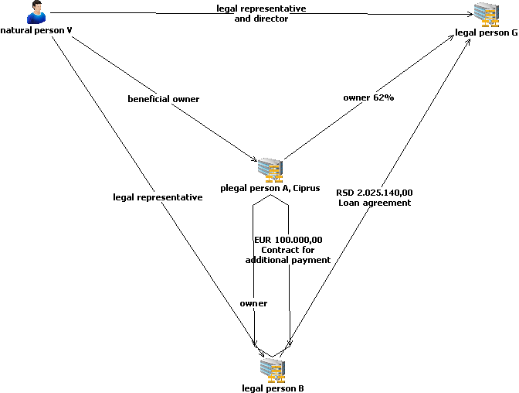

TRENDS

Having analysed activities which may lead to ML or TF, one can presume that in 2016 suspicious activities to be identified will be as follows:

Fictitious legal transactions aimed at drawing funds from accounts held by legal persons, and/or use of payment reference codes related trade in goods and services with the aim to disguise the true purpose of the conducted transfers; this conduct stands for one of the most common abuses that may indicate money laundering as well. The phenomenon above has been most recognized so far in the buy-out of secondary raw materials.

E-banking and virtual currencies, still being unexplored areas, are very critical for money laundering and terrorism financing. As new technologies are very often abused by persons in possession of illegal assets, this area needs special attention.

Consultancy services like all other types of services are still being abused for integration of illegal assets into legal money flows. The above is often used as a purpose of transaction when making payments from off-shore destinations.

Foreign trade, especially fictitious trade with off-shore legal persons, is a commonly used model of integration of illegal assets into a country’s financial system.

There is a growing number of non-resident persons who open accounts in banks in Serbia without having any business activity in the country. It has also been observed that there have been more and more newly established companies in Serbia, founded by non-residents, which have been conducting transactions without economic justification. These occurrences are risky as there is suspicion that the accounts opened in banks in Serbia have been used for the laundering of funds transferred from abroad, that is, that Serbia’s banking system has been used for the purpose of disguising the true source of assets illegally acquired abroad.

Transfers of funds based on inheritance and financial support will continue to be used in future when transferring funds with the intention to hide the true purpose.

Construction and sale of real estate for cash is still a risky activity, which is used to integrate illegal assets and is often used for laundering money from drug trade.

Trade in gold continues to be risky activity in terms of money laundering and terrorism financing.

Because of the migrant crisis in progress, it is expected that the use of money transfer services will persist in time to come. Analysing this type of transactions, we observed the growing number of Serbian residents frequently withdrawing cash for several foreign nationals.

SUPERVISION OF ACCOUNTANTS AND AUDITORS IN TERMS OF AML/CFT LAW

In line with Articles 82 and 83 of The AML/CFT Law (Official Gazette of RS, nos. 20/2009, 72/2009, 91/2010 and 139/2014 -hereinafter referred to as: The Law), the Administration supervises the implementation of AML/CFT Law by accountants and auditors through
- off-site inspection
- on-site inspection.

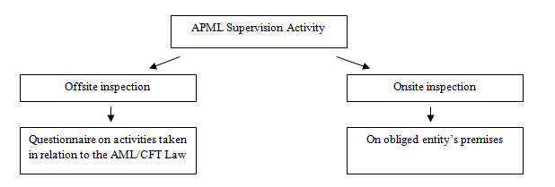

Off-site inspection is done through analysing a completed questionnaire, on the obligor’s (accountants and auditors) activities on the implementation of AML/CFT legislation, based on pre-determined criteria. The criteria based on which accountants are selected for receiving the Questionnaire are as follows: number of employees, annual income, net profit of the company/entrepreneur, information received from the APML’s Analytics Department, etc. As for registered auditing companies, they all received the Questionnaire.

On-site inspection is done on the premises of the controlled entity, by inspecting general and specific documents, records and documentation, as well as business books, statements of accounts, business correspondence and other documents; on-site inspection can also be done on the premises of a legal person with which the controlled entity is directly or indirectly linked, by interviewing a person in charge or other employees, as well as by requesting data from state authorities and holders of public powers and by inspecting documentation.
When making a Plan for On-Site Inspection in 2015, risk-based approach was applied, meaning that the obligors with greater exposure to ML/TF risk in exercising their registered line of business would have the priority when planning the on-site inspection.

Following elements serve as criteria for determining ML/TF risks:
- Results of ML/TF national risk assessment, according to which accountants and auditors have been classified into low to medium risk, as opposed to other sectors (auditors - low risk, accountants - medium to low risk)
- Results of off-site inspection; in case they indicate certain irregularities, on-site inspection will be used to establish facts;
- Number of employees within the obligor;
- Annual income of the obligor;
- Business relations with foreign PEPs;
- Information received from other state authorities, as well as from common people;
- Information obtained through searching the database of the Administration.

Within the framework of supervision over relevant reporting entities, inspectors check what actions and measures are undertaken by the obligors for the purpose of preventing and detecting money laundering and terrorism financing.
On-site inspection includes at least checking the following:
- if the reporting entity has complied with a requirement to do risk analysis in line with Guidelines for ML/TF risk assessment in auditing companies and providers of accounting services;
- if the reporting entity has undertaken actions and measures to prevent and detect money laundering and terrorism financing before, during and after business relationship has been established and if the reporting entities
- undertake CDD measures, that is, whether they established and verified the identity of the client and the beneficial owner;
- if they provide information, documentation and data to the Administration for the Prevention of Money Laundering;
- if they have a ML compliance officer and their deputy, and if they have provided a document on their appointment to the Administration within the prescribed deadline;
- if they introduce a program of annual professional training, education and specialization and if they have implemented it, and/or whether they enabled regular professional training, education and specialization of the employees;
- if they ensure regular internal audit and if they have written a report on the internal audit and measures undertaken following the audit, within prescribed deadline;
- if they have developed a list of indicators for recognising suspicious transactions;
- if they undertake other actions and measures prescribed by the AML/CFT Law.

OFF-SITE INSPECTION IN 2015

In 2015 the APML conducted off-site supervision of auditing companies and providers of accounting services by sending the Questionnaire on the obligor’s (accountants and auditors) activities on the implementation of AML/CFT legislation and analysing the responses.

The objectives of the Questionnaire are as follows:
- To comprehend the current level of the obligors’ knowledge of AML/CFT Law and of their legal requirements;
- To follow indirectly the development of the AML/CFT system;
- To comprehend the understanding of AML/CFT regulations.

Questions in the Questionnaire are divided in five parts:
Part I - General information on the Company
Part II - Company’s activities
Part III - Information on clients
Part IV - Reporting to the Administration
Part V - Training of the employees

There are 66 auditing companies in Serbia.. Last year the Administration sent letters to all then registered auditing companies, informing them that they were obligors in line with the AML/CFT Law. In addition to the information, the Administration sent the Questionnaire on AML/CFT activities undertaken by auditing companies to 60 such companies. 59 auditing companies underwent off-site control; one company did not due to the fact that the Questionnaire had not been received. Five reminders were sent to auditing companies in 2015, all of which were responded to. APML also sent instructions to six newly established auditing companies in 2015 to inform them on being obligors in line with Article 4 of the AML/CFT Law, and to help them establish the AML/CFTV system in the companies.

It should be emphasised that auditing companies have demonstrated utmost readiness to cooperate.

The total number of providers of accounting services providers (companies and entrepreneurs) in Serbia exceeds 7000. In 2015 off-site control was conducted in the period February - December according to different criteria, by sending the Questionnaire on AML/CFT activities undertaken by accounting services providers. A sample of 213 accounting services providers was taken, who received a letter informing them of being obligors in line with Article 4 of the AML/CFT Law and giving them a 20-day-deadline to provide the answers. Out of the sampled accounting services providers 210 were legal persons and 3 were natural persons - entrepreneurs. Out of 213 accounting services providers which underwent control, 133 responded to the Questionnaire, while 80 failed to do so. Out of the total number of those that failed to respond to the Questionnaire, 21 accounting services providers did not receive the Questionnaire due to the change of registered address, in 46 the control began in December 2015 and so their responses are expected in 2016, while 13 accounting services providers simply did not provide the answers to the Questionnaire. 63 reminders were sent to unresponsive accounting services providers, 50 of which responded, while 13 did not.

ON-SITE INSPECTION

In 2015 the APML undertook four on-site inspections of the relevant reporting entities. The four controls included one auditing company and three accounting companies. Irregularities were found in the latter; they were not found in the former.

There were nine economic offences established in three accounting companies, namely:
- One accounting company did not fully complete risk analysis in line with the Guidelines for ML/TF Risk Assessment by Auditing Companies and Accounting Services Providers, issued by the APML, which constitutes violation of Article 7, para. 1 and 2 Of the AML/CFT Law;
- 2 accounting companies failed to insert date, time and the name on Decisions of the Serbian Business Registers Agency, of the person who inspected the documentation, which constitutes violation of Article 15, para.2 Of the AML/CFT Law;
- 2 accounting companies failed to provide the name and position of the AML officer and the deputy within 15 days following the appointment, which constitutes violation of Article 42, para. 3. Of the AML/CFT Law;
- One accounting company failed to provide regular training and specialization in AML/CFT for their employees, which constitutes violation of Article 43, para. 1. Of the AML/CFT Law;
- One accounting company failed to perform regular internal audit and to write a report on the internal audit and measures undertaken following the audit, which constitutes violation of Article 44. Of the AML/CFT Law;
- One accounting company failed to develop a list of indicators for identifying suspicious transactions, which constitutes violation of Article 50, para 1 Of the AML/CFT Law;
- One accounting company failed to keep records on the information on its clients in line with Article 81 of the AML/CFT Law.

Following the control on the premises of the companies, the APML inspectors continued with the process on the premises of the APML by making reports on the on-site supervision of the implementation of the AML/CFT Law. The controlled companies were given a deadline of 15 days in the reports to provide comments on the facts established.

After the deadline has passed, the inspectors filed a report for economic offence against an accounting company to the First Basic Prosecutor’s Office in Belgrade, while reports against others will be filed after the deadline for comments has expired.

COURT DECISIONS

In 2015 the APML was provided with six final decisions of the Economic Court in Belgrade. Of all the final cases, one controlled company lodged an appeal against the amount of fine, but the decision of the Appellate Court sustained it.

Following is a short analysis of all decisions issued by the Commercial Court in 2015:

One controlled company, against which the APML filed a report for economic offence in 2012, received a single fine in the amount of 500.000,00 RSD for the company and 50.000,00 RSD for the person in charge of the company, which according to the exchange rate of the National Bank of Serbia on the day the decision became final amounted to 4.083,63 EUR for the company and 408,36 EUR for the person in charge of the company.

Second controlled company, against which the APML filed a report for economic offence in 2013, received a single fine in the amount of 540.000,00 RSD for the company and 53.000,00 RSD for the person in charge of the company, which according to the exchange rate of the National Bank of Serbia on the day the decision became final amounted to 4.420,07 EUR for the company and 433,82 EUR for the person in charge of the company.

Third controlled company, against which the APML filed a report for economic offence in 2014, received a single fine in the amount of 260.000,00 RSD for the company and 90.000,00 RSD for the person in charge of the company, which according to the exchange rate of the National Bank of Serbia on the day the decision became final amounted to 2.160,18 EUR for the company and 747,75 EUR for the person in charge of the company.

Fourth controlled company, against which the APML filed a report for economic offence in 2013, received a single fine in the amount of 330.000,00 RSD for the company and 29.000,00 RSD for the person in charge of the company, which according to the exchange rate of the National Bank of Serbia on the day the decision became final amounted to 2.701,15 EUR for the company and 237,37 EUR for the person in charge of the company.

Fifth controlled company, against which the APML filed a report for economic offence in 2013, received a single fine in the amount of 260.000,00 RSD for the company and 90.000,00 RSD for the person in charge of the company, which according to the exchange rate of the National Bank of Serbia on the day the decision became final amounted to 2.701,15 EUR for the company and 237,37 EUR for the person in charge of the company.

Sixth controlled company, against which the APML filed a report for economic offence in 2015, received a single fine in the amount of 30.000,00 RSD for the company and 10.000,00 RSD for the person in charge of the company, which according to the exchange rate of the National Bank of Serbia on the day the decision became final amounted to 248,42 EUR for the company and 82,80 EUR for the person in charge of the company.
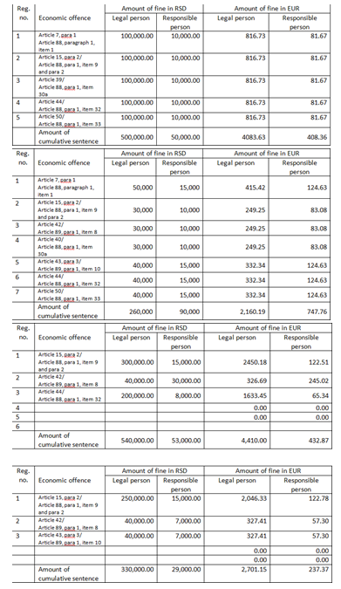
Table 1: the amounts of fines imposed against controlled companies 1, 2, 3 and 4
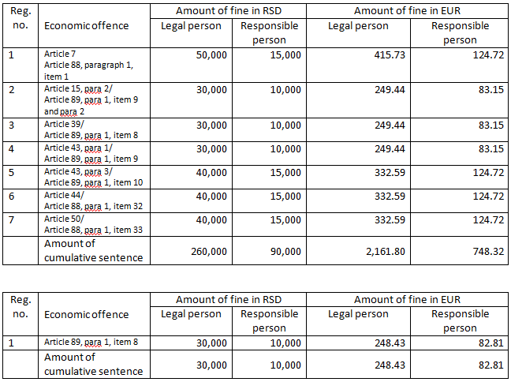
Table 2: the amounts of fines imposed against controlled companies 5 and 6
Chart showing economic offences in 2015 established in accounting companies

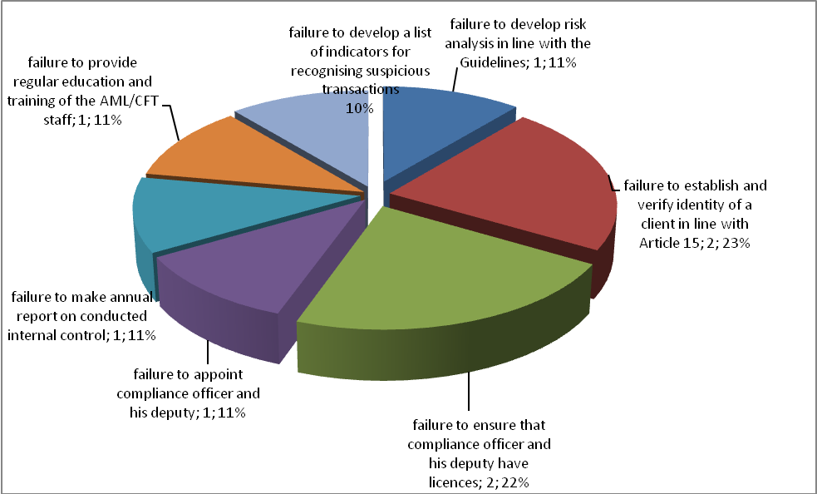
Chart showing the ratio between the total number of controlled companies, established economic offences and court decisions in 2015

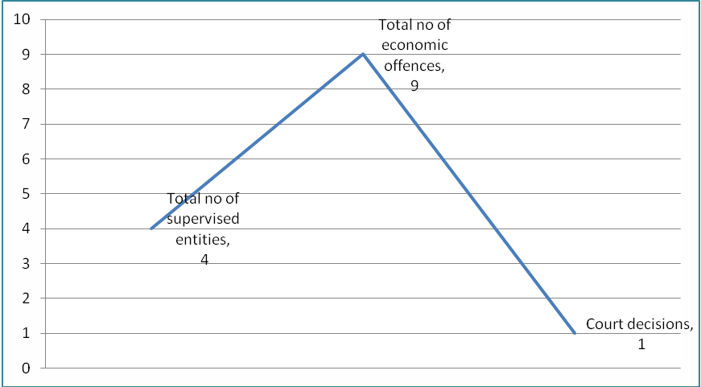

COOPERATION BETWEEN RELEVANT STAKEHOLDERS AT NATIONAL LEVEL

Standing Coordination Group for supervision of the implementation of the National anti-money laundering and countering the financing of terrorism (AML/CFT) strategy
The Standing Coordination Group for supervision of the implementation of the National anti-money laundering and countering the financing of terrorism (AML/CFT) strategy (hereinafter referred to as: the SCG) was formed by the Government decision on 23 April 2015. Implementation of the activities from the accompanying Action Plan was intended for the period 2015 - 2019. The Action Plan envisages concrete activities with set deadlines, responsible institutions and necessary assets. The body in charge of the supervision of the process of implementation of the Strategy is the SCG. Its members are representatives of the state bodies involved in the implementation of the AML/CFT Law. The SCG consists of 30 members from 19 state authorities.
The APML is responsible for administrative and technical tasks necessary for the work of the SCG. The SCG had four meetings in 2015. The activities of the APML as a member of the SCG include: reviewing the minutes from each meeting and analysing potential topics for the following meeting, compiling lists of participants at the meetings, sending invitations to the members, establishing the topics for the meetings, providing the members with agenda and other material necessary for the meetings, keeping records of the members who confirmed attendance at the meetings, cancellations and replacements for the delegated members. After each meeting, a report is produced and sent to all participants.

Responding to requests of the Privatisation Agency

Based on the Law on Privatisation, the APML has an obligation to conduct checks of the participants in privatisation process and inform the Privatisation Agency within 15 days from the date of the receipt of its request whether there are any obstacles regarding purchasers. Any potential purchaser, and in case it is a legal person also any connected entity, is subject to detailed analytical work at the APML, which includes collecting data from all banks and relevant state authorities. Since the beginning of the privatisation process, the APML processed over 50 such requests involving more than 70 persons.

APML EU - SERBIA NEGOTIATION PROCESS ACTIVITIES

Negotiating chapter 4 - Free movement of capital

Free movement of capital is one of the four freedoms on which the functioning of the EU internal market is based. Prevention of money laundering and terrorism financing is one of the topics under this negotiating chapter, in addition to harmonisation of legislation in the area of capital movements and current payments. The Ministry of Finance is the coordinator of the negotiating group for this chapter.

In the free movement of capital area, member states are required, with certain exceptions, to remove all restrictions to capital movements both within the EU and between member states and other countries. Current payments are related to current transactions, i.e. transactions involving residents and non-residents, whose underlying aim is not transfer of capital. Rules have been defined concerning the national and cross-border payment services in the EU. The aim is for the member state to have simple, efficient and safe cross-border payments while improving the beneficiaries’ rights to use of payment services. Also, the intent is to improve competition by opening the payment services market to new participants, thus fostering increased efficiency and reduction of costs and establishing the necessary platform for a single area for payment in Euros.

Full liberalisation of capital movements is a prerequisite of EU membership and opens up possibilities, for instance, of opening bank accounts abroad, granting loans to non-residents, taking cash in and out of country without restrictions, equal treatment of nationals of other member states with respect to the acquisition of legal title over real estate, etc. In achieving liberalisation of capital movements, there is a considerable risk of attempts to misuse the free movement of capital and freedom of provision of financial services which are characteristic of the integrated financial area. It is this possibility of misuse that constitutes the reason why measures, which are the subject-matter of relevant EU acquis, are needed at the EU level. Misuse of the financial system to move illegal proceeds but also of the money that has been legally obtained but can be used to finance terrorism, poses a clear threat to integrity, proper functioning, reputation and stability of financial systems.

The most important preventive enactment of the EU in the area is the so-called Fourth directive, i.e. the Directive (EU) 2015/849 of the European Parliament and of the Council of 20 May 2015 on the prevention of the use of the financial system for the purposes of money laundering or terrorist financing, amending Regulation (EU) No 648/2012 of the European Parliament and of the Council, and repealing Directive 2005/60/EC of the European Parliament and of the Council and Commission Directive 2006/70/EC. In addition to the Third Directive, relevant EU enactments are the Regulation (EC) No 1781/2006 of the European Parliament and of the Council of 15 November 2006 on information on the payer accompanying transfers of funds.

Even though Serbian system in this area is harmonised to a large extent with the relevant EU regulations, further harmonisation will be of exceptional importance particularly bearing in mind the adoption of the Fourth Directive in 2015, which is being done by working on amendments to the AML/CFT Law. The adoption of a Fourth Directive at the EU level is also a reflection of the need to harmonise the current EU system with the 2012 FATF Recommendations.

Negotiating chapter 24 - Justice, freedom, security

Creating an area of justice, freedom and security is also one of the EU objectives. Even though it is addressed under Negotiating Chapter 4 on free movement of capital, prevention of money laundering and terrorism financing, i.e. the criminal aspect of these issues, is covered also within Negotiating Chapter 24 - Justice, freedom, security, particularly under the section on fight against organised crime (money laundering) or fight against terrorism (financing of terrorism). The Ministry of Interior is the coordinator of the negotiating group for this chapter.

In addition to the above areas, this chapter addresses also the areas of asylum, migration, visa policy, border control and Schengen, as well as certain aspects of fight against human trafficking, fight against drugs, police cooperation, justice cooperation in civil and civil matters, customs cooperation and Euro counterfeiting.

Relevant acquis in the ML/TF area, which are covered in this chapter, are contained in one EU act, i.e. Council Decision of 17 October 2000 concerning arrangements for cooperation between financial intelligence units of the Member States in respect of exchanging information. In 2015 relevant authorities worked on amendments to the AML/CFT Law to harmonise the provisions regulating the principle of reciprocity in information exchange and confidentiality and personal data protection with the Council of Europe Convention of 28 January 1981 for the Protection of Individuals with regard to Automatic Processing of Personal Data and taking account of Recommendation No R(87)15 of 15 September 1987 of the Council of Europe Regulating the Use of Personal Data in the Police Sector, which the Council’s Decision refers to.

The APML actively participated in drafting of the Action Plan for the Negotiating chapter 24 in its segment related to the prevention of money laundering.

Negotiating chapter 31 - Foreign, security and defence policy

Common foreign and security policy of the European Union was established in the Mastricht Treaty, and especially strengthened in the Lisbon Treaty, as the EU wants to speak with one voice when it comes to foreign policy. It is mostly founded on consensus of the member states and it constitutes a mechanism for adopting common declarations and guidelines for political and security issues that lead to common diplomatic action and to undertaking common actions. Decisions are adopted to define the EU position towards certain issues and measures to implement Common foreign and security policy, including sanctions. In addition to diplomatic action, main lines of action within this chapter are the Common security and defence policy, restrictive measures and arms control. Ministry of Foreign Affairs is the coordinator for this negotiating chapter.

Relevant EU acquis, within the APML’s remit, are mostly those related to restrictive measures taken where the EU decides that certain country violates international law or human rights and that it does not respect fundamental democratic values and rule of law as well as the acquis related to the fight against terrorism, i.e. its financing (e.g. The fight against terrorist financing [Council 16089/04], 14 December 2004; Revised Strategy on Terrorist Financing [Council 11778/08], 11 July 2008). Sanctions may vary from diplomatic to economic, and the candidate country is expected to align, in the negotiation process, with the regime of restrictive measures provided by EU.
The segment where the APML offered its contribution is related to the application of international restrictive measures. Namely, the Law on freezing of assets with the aim of preventing terrorism specifies the measures for freezing of assets thereby implementing the UN Security Council Resolutions 1267 and 1373 and hence the relevant EU acquis, more precisely:

- Council Regulation (EC) No 467/2001 of 6 March 2001 prohibiting the export of certain goods and services to Afghanistan, strengthening the flight ban and extending the freeze of funds and other financial resources in respect of the Taliban of Afghanistan (implementing UNSCR 1267(1999) and 1333(2000);
- Council Regulation (EC) No 881/2002 of 27 May 2002 imposing certain specific restrictive measures directed against certain persons and entities associated with Usama bin Laden, the Al-Qaida network and the Taliban, and repealing Council Regulation (EC) No 467/2001 prohibiting the export of certain goods and services to Afghanistan, strengthening the flight ban and extending the freeze of funds and other financial resources in respect of the Taliban of Afghanistan;
- Common Position 2001/931/CFSP on the application of specific measures to combat terrorism [implementing UNSCR 1373 (2001)];
- Council Regulation (EC) No 2580/2001 of 27 December 2001 on specific restrictive measures directed against certain persons and entities with a view to combating terrorism;
- Council Framework Decision 2002/475/JHA on Combating Terrorism of 13 June 2002, amended by Council Framework Decision 2008/919/JHA of 28 November 2008 (OJ L 330, 09/12/2008, p. 21–23).

As the FATF in its revised recommendations set the standard also with respect to the prevention of the financing of proliferation of weapons of mass destruction, the issue of prevention of proliferation of WMD, which is covered in this chapter, will be more and more important for APML work.

INTERNATIONAL COOPERATION

Activities within the Council of Europe Moneyval Committee
Serbia has been a member of Moneyval Committee since 2003. The Committee functions on the principle of mutual peer evaluations according to the FATF (Financial Action Task Force – international AML/CFT standard setter) Methodology and Standards. The Serbian delegation comprises representatives of the APML, Ministry of Interior, Ministry of Justice and the National Bank of Serbia; the APML Director is the Head of Delegation.

During 2015 three regular Moneyval plenary sessions were held (47th Plenary: 9.4 - 13.4.2015; 48th Plenary: 14 - 18.9.2015 and 49th Plenary: 8 - 11.12.2015), attended by the APML Director and/or members of the APML staff.

After its 48th meeting, the Moneyval adopted decisions to revoke its public statement on Bosnia and Herzegovina since in May 2015 this county adopted the required amendments to the Criminal Code in relation to the crime of money laundering and confiscation. Bosnia and Herzegovina was removed from the list of countries subject to a special Moneyval procedure for improvement of the level of harmonisation.

Fifth round of mutual evaluation

Serbia is the second Moneyval member which underwent the fifth round of evaluation according to the new FATF Methodology and Moneyval rules, more complex than those from 2009. The fifth round is organised so that state authorities are tasked with filling in two complex and detailed questionnaires, which is possible to do after all the necessary data are gathered from the financial and nonfinancial sector in the country. The evaluation itself included an onsite visit to the country by Moneyval experts, who stayed in Serbia for two weeks from 28.9. to 9.10.2016. During the visit, more than one hundred meetings with representatives of the state authorities and financial and nonfinancial sectors were held. The evaluators had an opportunity to see the APML’s and NBS’s premises, as well as to have meetings with representatives of the commercial banks in Serbia in their premises. The APML had a role of coordinator and lead institution in the process.

Activities within the FATF

The Financial Action Task Force (FATF) is the global standard setting body for anti-money laundering and combating the financing of terrorism on national and international level. FATF is actually the policy regulator, which works on creation of political will for alteration of the regulatory framework in the area of prevention of money laundering and terrorism financing on a national level. In doing this job the FATF cooperates with other international bodies involved in fight against money laundering and terrorism financing. One of the most important documents which represents the essential international legal standard in the area is The FATF Recommendations - International Standards on Combating Money Laundering and the Financing of Terrorism. In the course of the fifth evaluation round, the Moneyval experts actually assessed the level of harmonisation of the national legislation with these recommendations.

In 2015 the FATF published several public statements. The first referred to a report on the ISIL financing and was published in February 2015. In June 2015, it published a public statement on the countries with strategic deficiencies and risky for the international financial system and a list of countries whose level of compliance with the international standards is constantly monitored due to established strategic deficiencies. In October 2015, the third document was published, named “Improving Global AML/CFT Compliance: on-going process”.

Activities within the Egmont Group
Egmont Group is an informal association of financial intelligence units (FIUs) worldwide, whose objective is to propagate and promote cooperation in terms of financial intelligence exchange among FIUs, according to the principles formulated at the Group Level and best practices. Egmont Group is an inclusive, non-political organisation, whose membership includes the APML since 2003 and which convenes twice a year, namely in Plenary Meeting (between May and July) and in Working Groups and Heads of FIUs Meetings (usually in January and February). The APML Director is a member of Legal Working Group (LWG), although members of one working group can attend meetings of another group if necessary.

In 2015 Working Groups and HoFIUs meetings were held in Budapest, Hungary 25 - 30 January and the Plenary was held in Bridgetown, Barbados, 7 - 12 June. A new chair of the Egmont Group to be in the position until 2017 was elected at the HoFIUs meeting. After the Plenary, the Egmont Group has grown to 150 members, a number which is expected to increase, since at the same meeting four new members were elected for full membership, namely the FIUs of Cambodia, Cuba, Nepal and Niger. The Regional Footprint, dividing members into eight groups for the purpose of better coordination of activities and pursuing the issues of common interest, discussed a Global Methodology and the need for urgent adoption of action plans for the implementation of this methodology.

Memoranda of understanding (MOUs)
In 2015 the APML signed no MOUs with foreign FIUs and thus the number of signed memoranda remains 44.

OSCE
Cooperation between the APML and the Organization for Security and Cooperation in Europe successfully continued throughout 2015.
The OSCE Mission to Serbia provides assistance, mainly financial, in the implementation of the Action Plan for the implementation of the National anti-money laundering and countering the financing of terrorism (AML/CFT) strategy. Some of the activities fulfilled in cooperation with the OSCE Mission to Serbia are: drafting of the methodology for updating of the national money laundering and terrorism financing risk assessment, drafting and publication of the study Money laundering typologies - case studies, issuing recommendations and guidelines for reporting suspicious transactions relevant for intermediaries in trade and lease of real estate, accountants, auditors and broker-dealer companies and authorised banks; issuing indicators for recognising suspicion of money laundering and terrorism financing relevant for intermediaries in trade and lease of real estate, accountants, auditors and broker-dealer companies and authorised banks; drafting of the rulebook on the manner of submission of information about a designated persons and his property by the state authorities, organisations and persons entrusted with public authorisations in line with the Law on the freezing of assets with the aim of preventing terrorism.

In addition, the OSCE Mission in Belgrade supported the organisation of the workshop dedicated to amendments to the AML/CFT Law intended for representatives of the sector of intermediaries in trade and lease of real estate, both entrepreneurs and legal persons (Belgrade, Serbia, 9 November 2015).

The OSCE also supported the organisation of three workshops for updating of the Methodology for implementation of the National ML/FT risk assessment exercise in Serbia (Vrdnik, Serbia, on 12 and 13 November, 26 and 27 November and 21 - 23 December 2015).

HUMAN RESOURCES AND TRAINING

On 31 December 2015, there was a total of 40 positions envisaged by the internal job classification and organisation scheme, where actually 28 employees had permanent contracts (27 civil servants and one person on a position of the director), out of whom three persons were on either maternity or childcare leave. The APML had three employees on temporary contracts - two substituting for the workers on leave and one based on increased workload. One person had a contract for services. The lack of work space/offices was the major hurdle for hiring new staff. Prohibition of recruitment in the public sector has been in force for two years.

 | Name and location of the seminar | Date  2015 | No of participants
 | Annual meeting of banks, the APML and the NBS at the Association of Serbian Banks | 4. 3. | 6
 | Abuses in public procurement procedures, organised by the Ministry of Justice of the USA and the OSCE, Aranđelovac, | 28 - 30. 10. | 3
 | Investigations and processing of the crimes of terrorism financing, Belgrade | May | 4
 | Annual consultation for the compliance sector in banks, organised by the Association of Serbian banks, Palić | 4 - 5. 6. | 4
 | Seminar on terrorism financing, organised by the Embassy of the USA and the Government of the Republic of Croatia, Zagreb, | 8 - 12.6. | 1
 | Workshop on managing public finances SIGMA (Support for Improvement in Governance and Management) | 14 - 15. 5. | 1
 | Money laundering - prevention and available resources (attended by representatives of relevant state authorities of Serbia and France), organised by the OSCE and the Embassy of France, Belgrade | 24. 6. | 3
 | Regional workshop named: “Providing support in prevention of abuse of non-profit organisations for terrorism financing for the OSCE member states in Southeast Europe”, organised by the OSCE, Sarajevo | 14 - 16. 7.
 | Seminar on the risk-based approach in supervision of financial institutions, organised by the Joint Vienna Institute, Austria, | 24 - 28. 8. | 1
 | Implementation of the Law on inspection, organised by the USAID and the Official Gazette, Belgrade | 29.10.
 | Regional workshop on strengthening of cross border cooperation in fight against smuggling in the Western Balkans countries, organised by the UNODC and OSCE, Belgrade | 4 - 5. 10. | 1
 | The UNODC seminar on joint investigative teams - good practices and challenges, Budapest | 13 - 15. 10. | 1
 | “The basis of administrative procedure and dispute”, organised by the Government Human Resource Management Service, Belgrade | 9 - 10. 11. | 1
 | Training for internal auditors, organised by the Chamber of Authorised Auditors | 6.11. | 2
 | Seminar “Intermediaries in trade and lease of real estate as obliged entities”, Belgrade | 9. 11. | 2
 | Abuse in usage of the EU funds, organised by the OSCE, Belgrade | 7 - 8. 12. | 2
 | Counselling on practical implementation of the Law on Public Procurements, organised by Žuta knjiga information and business centre | 18.11. | 1
 | Alternative payment manners and terrorism financing, organised by the OSCE, Belgrade | 26 - 27. 11. | 3
 | Training for Moneyval evaluators, organised by the Moneyval Committee, Liechtenstein | 23 - 27. 11. | 1
 | Implementation of the AML/CFT Law by intermediaries in trade and lease of real estate, Chamber of Commerce of Belgrade | 18. 12. | 1
 | Journalists in fight against corruption | 9. 12.
 | Conference “New trends in public procurements in Serbia”, organised by the Public Procurement Office, supported by the Embassy of the USA, Belgrade | 21. 12 | 1
 | Training for improvement of knowledge in the area of public procurement - European procurements, organised by the Ministry of Foreign Affairs of the Netherlands, the Hague, the Netherlands | 4 - 14. 10. | 1

Development of IT

In 2015 the APML conducted an analysis of the existing IT system and produced technical documentation for its improvement. Based on the documentation, the hardware and software was purchased, necessary for the initiation of the project for virtualisation of the APML’s IT structure. The virtualisation project was started in December 2015.

In 2015 the APML worked on stabilisation, elimination of flaws and improvement of performances of the Data Warehouse and Document Management systems.

One of the priorities of the APML in 2015 was drafting and planning of projects related to the improvement and modernisation of the APML, as well as budgeting of the projects intended to be carried out in 2016.

FINANCIAL AND MATERIAL MANAGEMENT

In 2015 the APML successfully conducted all main activities with the aim of preparing and drafting the financial plan, thus ensuring most efficient use of the funds following adoption of the Budget Law. Timely and adequate planning provided for accurate execution of all tasks related to finances, accounting and bookkeeping, by regular settlement of obligations on daily and monthly bases and in line with available appropriations, in order to ensure legitimate use of the budget funds, record keeping and reporting.

The 2015 Budget Law allowed a total of RSD 55,008,000 for APML operations financed by the Republic of Serbia budget, while the budget execution percentage against the total earmarked funds was RSD 44,543,129.66, indicating there were no big discrepancies between the amounts of granted and executed funds on any appropriation. The execution percentage was 80.89%. In comparison with the previous year, this percentage is somewhat smaller since the procedure for two contracts (one on purchase of goods and the other on purchase of services) was conducted in the last quarter of 2015, according to the Procurement Plan, but the contracts were actually concluded at the beginning of the following year, i.e. later than 31.12.2015.

An APML internal act (Directive) was drafted based on the Law on Public Procurements governing the public procurement procedure and in application as of 12.10.2015. In 2015 the APML successfully completed 6 public procurement procedures, in more detail: one procurement of goods - hardware and software (servers and additional equipment, network equipment, licences and the accompanying software for virtualisation of the existing infrastructure) and five procurements of services, one of which was related to hosting services, thus ensuring continuity of operations and security of the entire IT system. The other public procurements were conducted based on framework agreements of the Administration for Joint Services of the Republic Bodies as centralised procurements as envisaged by the Procurement Plan. Each of the public procurements included an assessment of whether it was justified and purposeful respecting the principle of rational spending of public funds and control of expenditure.

CHALLENGES AND OBSTACLES IN ACHIEVING OBJECTIVES

Lack of capacities in terms of human resources and an extremely wide remit of APML responsibilities is a problem for APML operation. Namely, even though 40 posts are envisaged, only 27 civil servants are currently permanently employed. The European Commission and other international organisations following the money laundering area in Serbia have drawn attention to the problem of the scarce APML resources particularly having in mind the various APML’s responsibilities whose number is significantly higher than what international AML/CFT standards require of an FIU.

In order to increase the number of employees it is necessary to secure adequate work premises even for work of the current employees.

Further strengthening of interagency cooperation for a more efficient functioning of the entire AML/CFT system will be APML’s priority for the future. Namely, experience from STR analysis so far and feedback received from competent prosecutors’ offices point to the need for the APML to have access to the Interior Ministry’s database.

The plan to set up an AML/CFT training centre is yet to be implemented. The reason for failure to materialise this idea is the lack of adequate office space.

The information was taken from the website of the Chamber of Certified Auditors - www.kor.rs

