Analysis of AML/CFT operations in commercial banks
2012 - 2014

Administration for the Prevention of Money Laundering
Belgrade, April 2015

Contents
Banking sector in Serbia 3
AML compliance officer 3
Bank softwares for identifying suspicious transactions 3
Indicators for recognizing suspicious transactions 5
Suspicious transactions and cash transactions 5
Reported persons 8
Money laundering typologies 9
Implementation of national risk assessment in banking sector 11
The analytical cases opened on the basis of STRs 12
Requests sent to banks 14
Structure of banks’ clients 14
Establishing the beneficial ownership of a legal person (trust) 16
Summary 17

Banking sector in Serbia

In the year 2014 there were 28 banks in operation in the Republic of Serbia, with the exception of "Univerzal banka" JSC Belgrade, whose licence was revoked on 31 January 2014 by the National Bank of Serbia due to critical subcapitalization and compromised liquidity.

In the period from 2012 to the end of 2014 the number of banks in Serbia decreased from 32 to 28. The clients of these banks were taken over by „Banka Poštanska štedionica“ JSC Belgrade, which is one of the reasons why the bank has the largest number of clients, namely 2.508.667 inclusive to 31. 12. 2014. In addition to other obligors (reporting entities), banks are also obliged in line with Article 37 of AML/CFT Law to provide the Administration with data

- When there are grounds to suspect money laundering or terrorism financing related to a transaction or client, and
- On any cash transaction amounting to or exceeding EUR 15.000.

AML compliance officer

According to Article 39 of AML/CFT Law, an obligor is bound to nominate AML compliance officer and their deputy to conduct AML/CFT operations
All commercial banks in Serbia met this legal requirement and are in compliance with legal minimum.

Years 2012, 2013 and 2014 saw the increase in the number of AML/CFT compliance officers. Namely, relevant AML/CFT departments in banks had the total of 91 staff members in 2012, 93 in 2013 and 98 in 2014. Most banks, nine of them, have only two AML/CFT officers (which is minimum legal requirement – a compliance officer and deputy compliance officer), seven banks have three AML/CFT officers, five banks have four such officers, five banks have five officers, and there are only two banks which have seven AML/CFT employees.

In the analysed period, years 2012 – 2014, banks increased the number of AML/CFT officers, which is an indicator of their having recognized ML/TF as a threat to the banks’ operations and to the entire functioning of the Republic of Serbia as well.

Notwithstanding the above said, during discussions that the Administration had with compliance officers and their deputies they shared their views that the number of such officers shoud be larger due to relevance, complexity and workload of this matter.

Bank softwares for identifying suspicious transactions

Use of advanced information systems enables banks to manage human resources successfully in the sense that AML/CFT staff are able invest more time and energy into analysing transactions already marked as suspicious by the system.

Of the total of 28 commercial banks in Serbia 26 of them use specially designed softwares for identifying suspicious transactions or persons.

All the banks have information systems which identify cash transactions the total value of which amounts to or exceeds EUR 15.000.

In addition, it should be emphasized that all the banks which own the software for recognizing suspicious transactions or persons integrated some of the indicators for recognizing suspicious transactions which were developed by the Administration.
Some banks included their own indicators for recognizing suspicious transactions or persons. Those “internal” indicators were developed thanks to their own experience in monitoring business operations of their clients.

Indicators developed by the Administration are mainly descriptive, whereas “internal” banks' indicators are more specific and contain several connected parameters that the software can recongnize and bring into certain relations. The parametres most frequently used are about amount of transactions, types of transactions, frequency of transactions, analysing period, countries involved in transactions (offshore), and the like.

Most banks have “Norcom” software for the search and analysis of transactions. „Norcom“ software enables full management of CDD measures as of the moment when cooperation with a client is established. A risk category is automatically assigned based on a client’s characteristics, available data, internal end external information, changes in the client’s profile. AML/CFT staff are only required to intervene manually with regard to medium and high risk clients, which enables them to focus their research on a relatively small number of potentially suspicious clients requiring enhanced due diligence, rather than a large number of clients categorized as low risk for money laundering.

International sanctions lists and bank group’s internal lists can be incorporated into “Norcom“ software, which is good for foreign bank groups from the perspective of the newly adopted Law on the Freezing of Assets with the Aim of Preventing Terrorism.

Transactions are scanned against the lists implemented in the system in real time. In addition, tracking is done on the basis of integrated scenarios, which identify transactions that are unusual or are out of regular business activities pattern. In other words, certain indicators have been implemented ino the software, namely, cash payments and withdrawals exceeding EUR 15.000,00 in Dinar countervalue and those conducted within several days, transactions involving high risk countries, increased account turnover, quick turnover of funds through an account, activation of an account after a long dormant period, etc.

Information systems which are adequately implemented facilitate and enable identification, tracking, analysis and reporting of suspicious activities, thus diminishing a possibility for a bank officer to fail to notice a supsicious transaction.

Indicators for recognizing suspicious transactions

In the process of preparing new indicators for identifying suspicious transactions in banks, the Administration engages with banks themselves as end users of these indicators, as well as with the National Bank of Serbia - Department for Bank Supervision, the supervisory authority for the implementation of AML/CFT Law by banks.

Namely, before the latest indicators were introduced, and they started to apply on 1 October 2014, the Administration formed a working group tasked with developing new indicators, the members of which were compliance officers from several banks, and representatives of the National Bank of Serbia.

A new list of indicators for identifying suspicious transactions related to terrorism financing was introduced and it started to apply on 1 June 2015. It was also a result of work done together by the Administration, compliance officers of some banks, money transfer service providers, as well as of the National Bank of Serbia and Tax Administration.

Indicator most frequently used in STRs for the last three years are as follows:
- Frequent cash deposits into a company’s account on the basis of founder’s loan for liquidity, whereby such loans account for major source of financing. Such cases often involve newly established companies and so a question arises as to the source of funds held by the founder and intended for these cash deposits.
- Cash deposits or transfers into accounts held by legal persons, followed by a transfer into accounts held by individuals and shortly afterwards, withdrawal of cash, without any economic or logical reason.
- Interrelated transactions below reporting threshold which in the sum make a significant amount and exceed the AML/CFT reporting threshold of EUR 15.000,00. Bank officers very often recognize such transactions and suspect that this pattern is used to avoid reporting CTRs to the Administration.
- Indicators very often overlap and there are usually several of them concurring in an STR. Such situations include a few intermediaries or multiple acounts, especially if the parties to a transaction come from countries that do not apply AML/CFT standards or countries with strict laws on bank secrecy.
- Transactions are often related with off-shore jurisdictions for the purpose of trade in services (for example, consultancy, marketing, accounting, intermediary services, etc), the value of which is difficult to ascertain and which are not in line with a client’s expected and/or usual activities. It is difficult to determine a value of a transaction for the purpose of trade in services, as well as whether it was provided at all.

Suspicious transactions and cash transactions

During 2014 the Administration received the total of 552 STRs, which is a decrease by approximately 7% compared to the year 2013, when banks reported the total of 594 suspicious transactions, and the decrease by approximately 29% compared to the year 2012, when banks reported the total of 781 suspicious transactions.

One should not be worried at all by the decrease in the number of reported transactions –it demonstrates that the obligors have followed recommendations made by the Administration that making an STR should follow ML/FT risk assessment rather than indiscriminate adherence to the indicators. This has resulted in an ever improving quality of STRs, although STRs filed purely for precautionary measures against control by the supervisory authority can stil be found. This is particularly conspicuous in terms of cash transactions conducted for the purpose of founder’s loan for liquidity (whereas an analysis shows that such transactions are necessary for a company’s liquidity and the funds are used for settlement of current liabilities) and in terms of off shore transactions (less significant transactions that indicate a geographical risk only and not the client risk).

Narratives explaining reasons for suspicion are satisfactory as well, and they are not sheer listing of indicators, which used to be common before. Documentation provided along with STRs (account turnover, contracts, copies of various documents, associate persons, etc) seems to be in support of explanation of suspicion and makes it easier for an Administration analyst to have a more objective view of circumstances preceding a transaction and reasons for filing an STR.

Number of CTRs, filed in line with Article 37 of the AML/CFT Law, is 190.601 in 2014. As in STRs, CTRs tend to decrease every year and so in 2013 there were 221.411 CTRs and 242.438 in 2012.

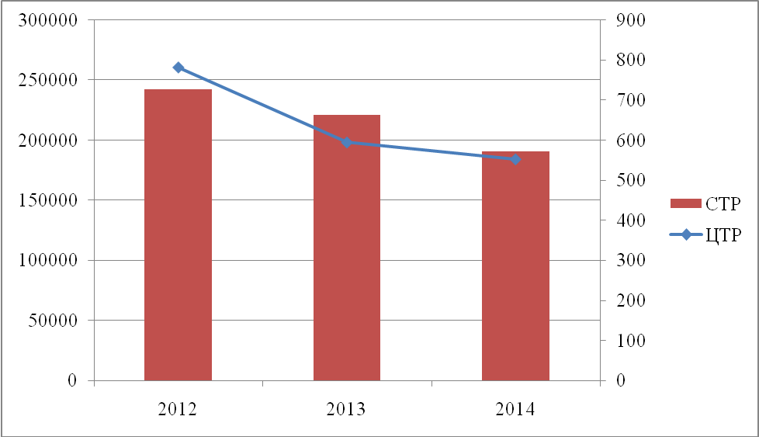
NB: CTP means STRs and ЦТР means CTRs

One should note that a number of CTRs is significantly lower than than the number of actual cash transactions amounting to or exceeding EUR 15.000,00 because banks are not required to report cash transactions conducted by public enterprises, direct and indirect budget users, or funds transfer between accounts kept in the same bank, conversion of funds in an account into another currency when the funds remain in the account, making fixed-term deposits or renewing fixed term deposits.

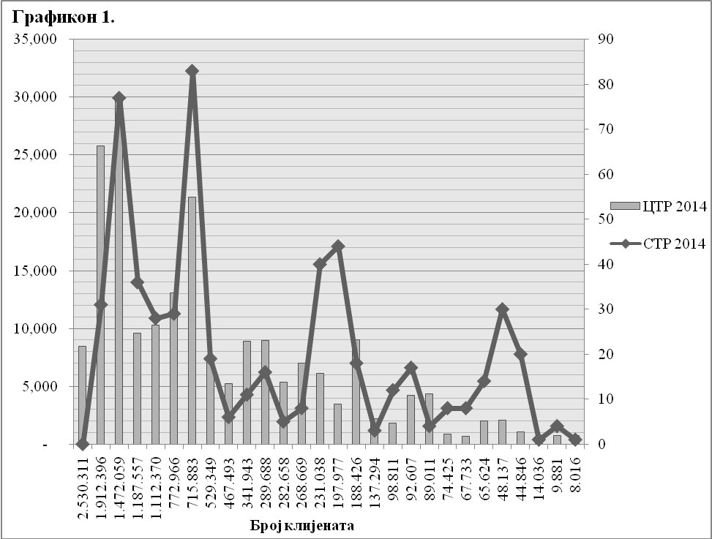
NB: Број клијената means number of clients

As it can be seen in the Diagram 1, which illustrates a presentation of STRs and CTRs compared to the number of a bank’s clients, the number of STRa is not in proportion to the number of clients in all banks. The same is seen in relation to the number of CTRs.

The presented cannot be deemed illogical, given the fact that banks with the largest number of clients usually foster retail operations, that is, their clients are predominantly natural persons, who open accounts for their current personal needs, and/or use products which bear low ML/TF risk in their nature and complexity (receipt of salaries, payments of bills, accounts opened by the order of Privatization Agency for the purpose of payments of bonus shares, and the like). However, it is a matter of concern that the bank with the greatest number of clients has had constantly few STRs – in 2014 it had none, in 2013 one and in 2012 none.

On the other hand, banks which report a large number of STRs have demonstrated quality in their analysis of transactions and clients’ activities prior to reporting. Information contained in the report made by the bank that reported most STRs were disseminated further to other state authorities in more than 90%. Some banks still do not demonstrate sufficient level of suspicion of money laundering and terrorism financing in their reports to be worked on further. One third of transactions on average remain monitored, whereas more than half the reported transactions filed by 9 banks were not further alnalysed. The said indicated the need for further training with the aim of achieving a better quality of analysis by obligors.

Reported persons

As it has already been said, in 2014 the Administration received 552 STRs, involving 695 persons. The latter is the number of persons reported as parties to transactions. The total number of persons listed in narratives of STRs is by far larger and is not included in this analysis. The number of reported persons per transaction has increased in comparison to the year 2012, when there were 753 persons in 781 transactions. In 2013 800 persons were reported in 594 suspicous transactions.

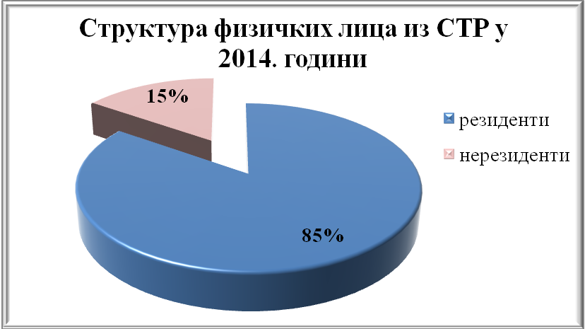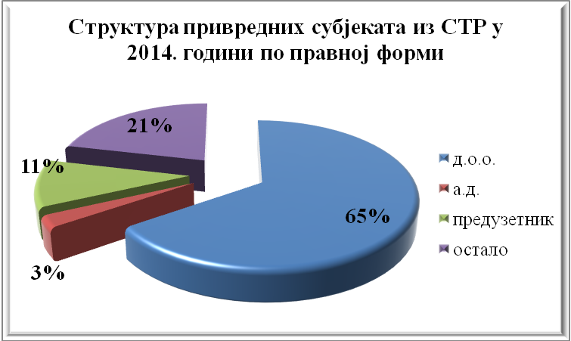
NB: резиденти means residents; нерезиденти means non-residents.
NB: д.о.о means limited liability company; а.д. means joint stock company; предузетник means sole trader, entrepreneur; остало means other.

Number of non-resident natural persons reported in STRs has increased significantly in 2014 in comparison to 2013 (from 36 to 54 persons, that is 50%), whereas the number of non-resident legal persons has decreased by 42% approximately, that is, from 43 to 18. Table no.1 illustrates the structure of reported persons for 2012, 2013. and 2014.

Table no. 1 | 2012 |  | 2013 |  | 2014
Table no. 1 | resident | non-resident | resident | non-resident | resident | non-resident
Natural persons | 356 | 34 | 338 | 36 | 299 | 54
Limited liability company | 255 | 10 | 285 | 33 | 216 | 8
Joint stock company | 5 | 1 | 6 | 1 | 7 | 2
entrepreneur | 38 | 0 | 44 | 1 | 35 | 1
other | 40 | 14 | 48 | 8 | 66 | 7
TOTAL | 694 | 59 | 721 | 79 | 623 | 72
 | 753 |  | 800 |  | 695

Table 1 shows that in terms of types of companies involved in STRs, most STRs are related to limited liability companies. However, during 2014 a number of STRs involving other types of legal persons increased significantly, namely - associations, foundations, sports associations, etc. This proves that attention should be paid to possible abuse of accounts held by foundations, associations, etc for the purpose of money laundering and terrorism financing.
Accounts kept abroad through which reported suspicious transactions were conducted are most often found in Cyprus, BVI, Belize, Turkey and China. However, from the requests that the Administration sent to foreign counterparts, which are presented below, one can conclude that the accounts kept in other countries (mostly off-shore countries, that is, those with dual tax policy, very favourable for companies which only have a registered address there and no business operations) are actually held by Serbian nationals or nationals from the region.

Money laundering typologies

With the support of OSCE, the Administration has published two volumes of “Money Laundering Typologies in the Republic of Serbia”, which were translated into English. The first one was published in 2012 and the second was published in 2015. The first volume deals with typologies in banking sector, exchange operations, capital market, insurance, etc. The volume published this year deals with typologies which are identified as the most relevant from the perspective of national risk assessment, namely tax evasion, corruptive crimes (offering and accepting bribe, embezzlement, abuse of office, misfeasance in commercial operations…) and trade in narcotics.

At meetings and seminars organized for the Administration staff and AML/CFT compliance officers, the latter found the typologies mentioned above highly beneficial for the process of analysis and risk assessment and the same could be said of typologies published in the Administration's annual reports, which are available on APML website.
Bank compliance officers recognize in the process of analysis certain types of typologies, which are recurrent over years but new ones also emerge.

Five most common typologies were recognized in STRs in 2012, 2013. and 2014, as follows:

  - Transfer of funds through a number of accounts held by associate legal persons, followed by withdrawal of cash by one or several individuals. There is suspicion that the individuals use fictitious documentation to withdraw cash; funds are partly used to finance private matters and partly to finance new business activities, first of all the incorporation of new companies. This typology has been equally common in 2012, 2013 and 2014.

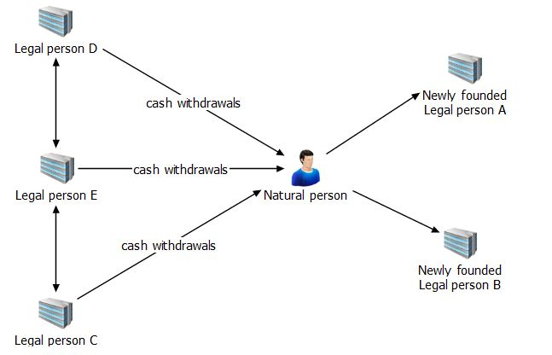
  - Fictitious trade through shell companies, set up solely for the purpose of “grey area” trade and legalization of proceeds. This typology has been equally common in 2012, 2013 and 2014.
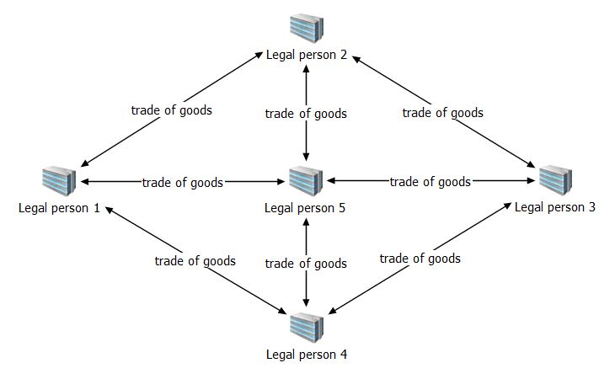

  - Illicit funds are transferred into accounts of offshore companies in less significant amounts for provision of services in market exploration, consulting, marketing, legal counselling and accounting.
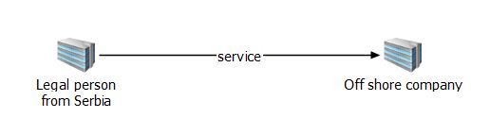
  - Transactions for the purpose of purchase of secondary raw materials and different types of manipulation in the purchase, usually with fictitious documentation for ”declaring” the traded goods and for subsequent withdrawal of funds from accounts. This was the most common typology during 2013.
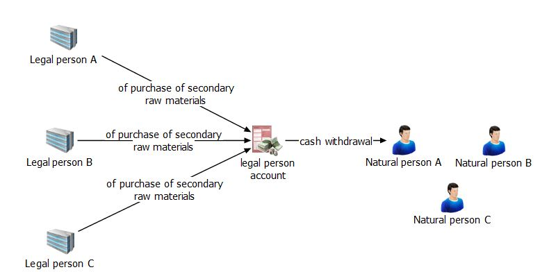

- Transfers to foreign countries for the purpose of financial support to one’s family, with suspicion that persons involved are not family related, rather they are involved in payment for illegally imported goods. A large number of such transactions have the People’s Republic of China as the final destination. There is suspicion that this is a way to avoid tax obligations. This typology, as well as the previous one, was particularly common in 2013.

The typologies mentioned above have been recognized in STRs filed by banks and are in line with assessed ML risks. This is particularly visible in terms of connection between tax evasion and money laundering.

Implementation of national risk assessment in banking sector

The revised FATF Recommendations from February 2012 introduced the implementation of NRA as an obligatory international standard. In line with the Recommendations, NRA for Serbia was conducted and was referred to the Government in April 2013 for information on money laundering risk. The NRA was conducted by the Administration working together with other relevant authorities directly and indirectly involved in AML, the National Bank of Serbia and private sector. Bank compliance officers also took part in this process, which made acceptance, understanding and implementation of risks in banking sector easier.

According to the NRA, banking sector is seen as the most vulnerable and tax evasion, illicit trade in narcotics and corruption criminal offences are seen as bearing high risk from money laundering.

Following the process of NRA and publicising of relevant findings, one of the topics at each seminar, workshop or meeting was to share the results of NRA with participants, regardless of whether they included obligors or representatives of other state authorities, all of which was for the purpose of raising risk awareness in all the institutions and undertaking relevant activities.

Bank officers are familiar with NRA and when submitting a STR they give due consideration to behavior patterns, products and services identified as risky for money laundering risk assessment.

The most indicative example of the above is the fact that most suspicious transactions submitted by banks indirectly involve suspicion of tax evasion, which is in NRA identified as the riskiest predicate offence for money laundering in Serbia.

Analysis of STRs submitted by banks in 2014 identifies following activities indirectly indicating tax evasion and money laundering, namely, unknown source of funds on accounts – cca 24% of all STRs, payments of loans for liquidity – cca 20% of STRs, significant amount of funds on accounts – cca 7%, funds derived from black area of business – cca 5% and construction business, that is, constructing residential buildings and office space – cca 4%.
All these phenomena indirectly indicate certain types of tax evasion.

The analytical cases opened on the basis of STRs

Of all STRs in 2014 223 transactions were related to the analytical cases already opened, 173 are still being monitored and new analytical cases were opened on the basis of 156 STRs, involving persons who were not previously subject to the APML analysis.
Although 2014 saw fewer STRs, the number of new analytical cases opened on the basis of STRs increased in comparison to 2013, when 135 new analytical cases were opened. The number of transactions related to the cases already opened also increased in comparison to 2013, when it was 81.
A large number of suspicious transactions is about the persons who are already a subject of the analysis, most often triggered by the requests sent by the Ministry of Interior, for trade in narcotics, human trafficking and corruption criminal offences. The above shows that although they may not be able to identify certain crimes, banks can recognize behaviour patterns and transfers indicative of those crimes.
In 2014 the Administration referred on its own initiative the total of 321 pieces of information to relevant authorities, which can be broken down in the following manner:

Prosecutor's offices | 57 (Superior prosecutor's offices - 48, Prosecutor for Organized Crime- 8 and State Prosecutor's Office - 1)
Tax Administration | 37
Ministry of Interior | 37
Security Information Agency | 11
Securities Commission | 7
Military Security Agency | 4
Anti-Corruption Agency | 3
Customs Administration | 2
Foreign FIUs | 163

In 2013 the Administration referred on its own initiative the total of 344 pieces of information to relevant authorities, which can be broken down in the following manner:

Prosecutor's offices | 123 (State Prosecutor's Office - 85, Superior prosecutor's offices - 22, Prosecutor for Organized Crime - 15 and Basic Prosecutor’s Offices - 1)
Tax Administration | 32
Ministry of Interior | 11
Security Information Agency | 19
Securities Commission | 3
Anti-Corruption Agency | 4
Customs Administration | 4
Foreign FIUs | 148

In 2012 the Administration referred on its own initiative the total of 288 344 pieces of information to relevant authorities, which can be broken down in the following manner:

Prosecutor’s offices | 112 (State Prosecutor's Office - 62, Prosecutor for Organized Crime - 31, Superior prosecutor's office and Basic Prosecutor’s Offices - 19)
Tax Administration | 21
Ministry of Interior | 18
Security Information Agency | 18
Securities Commission | 2
Agency for Chemicals | 1
Foreign FIUs | 116

The number of referrals to the State Prosecutor’s Office decreased due to the Agreement signed on 23 January 2014 between the Administration and the State Prosecutor’s Office, according to which the analytical cases are referred directly to the relevant prosecutor’s offices following a detailed analysis.

The FIUs that were the most common recipients of Administration requests were FIUs of Montenegro, Hungary, Slovenia and Macedonia. The above indicates that reported non-resdent persons, both as parties to transactions and as part of ownership/management structure, usually came from the region.

Requests sent to banks

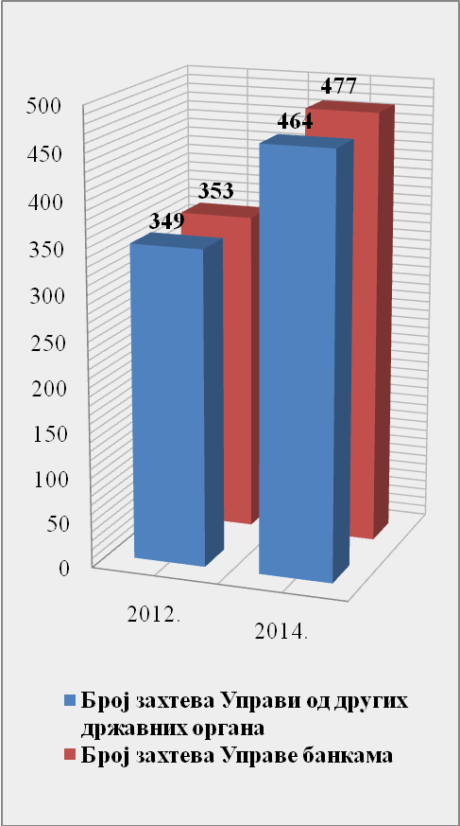
In 2014 the Administration sent 477 requests on average per bank, 64% of which were related to accounts’ turnovers and 36% related to the accounts’ balance. The requests included the total of 2093 persons, 94% of which were natural persons and 6% were legal. Out of all requests, 93% related to resident natural and legal persons and 7% of foreign natural and legal persons.

Increased number of requests sent to the Administration by other state authorities resulted in the increase of requests sent by the Administration in comparison to 2013 and 2012, when the Adminstration sent 475 and 353 requests respectively per bank, especially having in mind that the number of commercial banks operating in Serbia has decreased by 12,5% since 2012.

NB: In the Diagram blue columns stand for a number of requests sent to the Administration by other relevant authorities whereas red columns stand for a number of requests sent by the Administration by banks.

Structure of banks’ clients

There has been a trend of decrease in the number of banks’ clients in recent years. In December 2012 the total number of clients was 14.022.942, whereas in September 2013 the number was 13.533.799. The number of clients continued to decrease in 2014 and so in December of the same year it was 13.251.204. However, the analysis of the completed questionnaire on managing money laundering and terrorism financing risk reveals an interesting point – namely, enhanced CDD was applied on 1,80% of clients in 2012, wheras in 2014 it was applied on 0,80%. Conversely, the number of clients subject to simplified CDD increased from 2,73% in 2012 to 6,56% in 2014.

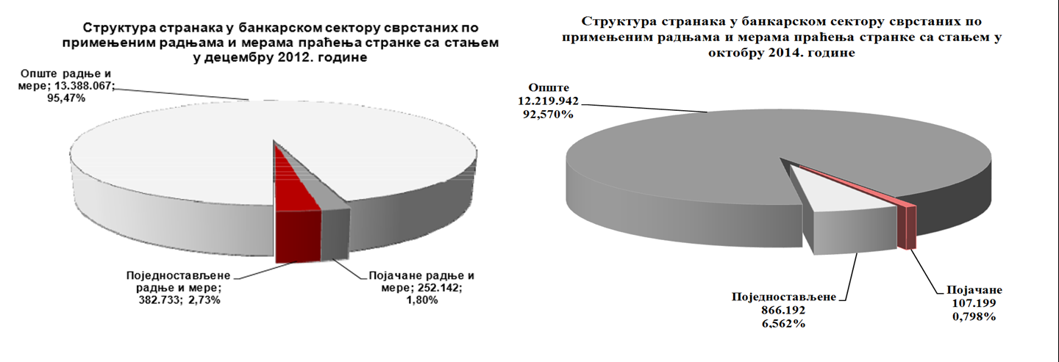
There were 98.584 non-resident individual clients of banks in September 2014, which was significantly less than in 2012, when the number was 113.572, but more than in 2013, when it was 91.458. In the total number of natural persons as clients, number of clients coming from high risk countries in 2014 has increased in comparison to 2013, namely 8,86% and 6,3% respectively. In the total number of natural persons as clients, number of clients coming from off-shore countries has remained approximately the same.

In 2014 the Administration received 144 STRs involving transactions conducted with foreign partners or by non-residents, 43 of which were related to countries carrying high ML or TF risk.. In 2013 the number was 159 (55 transactions related to high risk countries), and in 2012 the number was 172 (61 transactions related to high risk countries).

Suspicious transactions related to foreign countries or non-residents which were reported in 2014 most often included transactions the purpose of which was payment for services whose market value is difficult to establish (for example, consulting, accounting, computer services, etc). There were 30 of such transactions. Transactions to follow are payments for goods and services – 26

STRs, increase in deposits of foreign nationals – 15 STRs, deposits and withdrawals of cheques on non-resident accounts – 15 STRs and financial support and gifts – 14 STRs. Please note that the number of suspicious transactions conducted for the purpose of financial support and gift sharply increased (5 suspicious transactions in 2013 and 3 suspicious transactions in 2012) in 2014. Misuse of purpose of payment code 767 – financial support and gift- is becoming a trend and typology of payments to foreign suppliers for goods (which is most often sold in black and grey market).

 | 2014. | 2013. | 2012.
Number of STRs involving foreign countries or non-resident clients | 144 | 159 | 172
Number of STRs involving persons from high-risk countries | 43 | 55 | 61

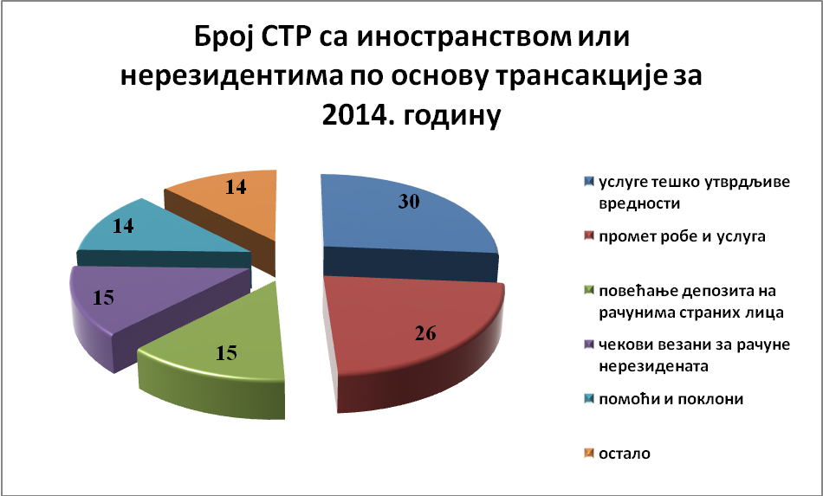
Number of STRs involving foreign countries or non-residents in 2014

NB: Section 30 refers to services the value of which is difficult to ascertain; Section 26 refers to trade in goods and services; Section 15 (green) refers to increase in deposit of accounts held by foreign legal or natural persons; Section 15 (purple) refers to cheques related to accounts of non-residents; Section 14 (blue) refers to financial aid (assistance) and gifts; Section 14 (orange) refers to other purposes of payments.

Establishing the beneficial ownership of a legal person (trust)

In accordance with Article 20 of the AML/CFT Law, an obligor is bound to establish the identity of the beneficial owner of a legal person and a trust.

Based on Article 8, para.2 of the AML/CFT Law, the obligor is bound to refuse an offer to establish a business relation as well as to conduct a transaction if it is not able to implement general CDD, and/or establish and verify the identity of a client, and/or establish the identity of the beneficial owner of a client which is a legal person.
Administration and compliance officers in banks exchange their knowledge and experience in this matter, including about trusts as legal arrangements. Trust as a legal form in the ownership structure so far has only been recognized in a small number of clients, however, it is estimated that there is comprehension of legal requirements when it comes to a legal arrangement – a trust and that a bank will establish the identity of the beneficial owner of a trust, if it appears in an ownership structure.

Banks establish information on beneficial owners for various legal types and/or models of companies.

Although banks are not required to keep recordes of their clients by type/form, some bank still keep this kind of records.

Trusts appear in the ownership structures of many corporations (complex forms) which are clients of a bank in Serbia. Presumably, this is also the case with other banks. For example, in three banks, which keep this kind of records, trusts have been recognized in the ownership structure, namely, in 2012 – 11 clients, in 2013 – 16 clients and in 2014 – 15 clients.

A bank said that according to its internal procedures, if it is established that a legal person was registered in off-shore jurisdiction or is owned by another legal person, the director of the legal person in Serbia and the nominee director signs a statement on the beneficial owner, regardless of the company's type/form.

We would like to reiterate that trust as a legal arrangement is not regulated in Serbia’s legal system, and as the requirement to establish beneficial owner is the most demanding one in AML/CFT Law, obligors should be further trained, especially banking sector, which is the most vulnerable and exposed to assessed ML/TF risks.

Summary

Based on the analysis presented above, one can note that banking sector improves in AML/CFT terms as each year passess.

The number of AML/CFT staff in banks increases each year, which means they are adequately prepared to handle these matters. Softwares used in banks for identifying suspicious transactions are sufficiently advanced to enable the staff to dedicate more time to analysing each transaction. This is surely one of the reasons why, in our opinion, the quality of STRs has increased, which results in an increased number of cases disseminated by the Administration to other relevant state authorities.

Money laundering typologies document that the Administration developed, as well as the National Risk Assessment paper prepared by the Administration in cooperation with other relevant authorities are of great usefulness to the AML/CFT staff in banks, which results in an enhanced quality of reported STRs and their improved analysis by banks. The Administration will try and continue with good practice.

Refer to page 13: „Cases opened by the Administration following an STR“
Source: National Bank of Serbia, "Analysis of the completed questionnaire submitted by banks on managing money laundering and terrorism financing risk, "www.nbs.rs
Ibid.
Ibid.
Decision on Guidelines for Assessing Money Laundering and Terrorism Financing Risks defines factors based on which it is determined whether a certain country or a geographical location carries a higher ML and TF risk, namely: countries subject to sanctions, embargo or similar measures imposed by the UN, Council of Europe, OFAC or other international organizations; countries designated by relevant institutions (FATF, Council of Europe, etc) as non-applying adequate AML/CFT measures; countries designated by relevant institutions as supporting or financing terrorist activities or organizations; countries designated by relevant institutions (for example, WB, IMF) as having high rate of corruption and crime.
This information is established by inspecting an original document or its certified copy from an official public register, which must not be older than three months. If it is not possible to obtain the information from an official public register, the obligor is bound to obtain missing information by inspecting the original official document or its certified copy or other business documentation provided by the client’s legal or empowered representative. Please note that the obligor is bound, based on risk assessment, to verify the identity of the beneficial owner of the legal person and legal arrangement, so that the obligor is satisfied it knows the beneficial owner of the client.

