STRATEGIC ANALYSIS

FOREIGN CURRENCY OPERATIONS AND MONEY LAUNDERING

Belgrade, April 2015

Contents

THE CONCEPT OF FOREIGN CURRENCY OPERATIONS 3
Introduction 3
LEGISLATION 3
Supervisory authority 4
Persons performing foreign currency exchange operations 4
Licensing procedure for foreign-currency exchange business 4
Conditions for and manner of conducting foreign-currency exchange operations 4
Instructions for implementing the Decision on the conditions for and manner of conducting foreign-currency exchange operations 5
Law on the Prevention of Money Laundering and Terrorism Financing 6
How foreign-currency exchange business is conducted – ML vulnerability 6
MONEY LAUNDERING AND FOREIGN CURRENCY EXCHANGE OPERATIONS 8
ACTIVITIES OF THE ADMINISTRATION FOR THE PREVENTION OF MONEY LAUNDERING WITH RESPECT TO LICENSED EXCHANGE OFFICES AND FOREIGN CURRENCY EXCHANGE OPERATIONS 9
Exchange offices and STRs - experiences from APML cases 10
APML and foreign-currency exchange operations 11
APML databases and foreign-currency exchange operations 11
LICENSED EXCHANGE OFFICES - CURRENT SITUATION IN SERBIA 12
SUPERVISION OVER THE LICENSED EXCHANGE OFFICES AND FOREIGN-CURRENCY EXCHANGE OPERATIONS 14
Application of the ML NRA by licensed exchange offices 14
Supervision of exchange office “S” 15
Supervision of exchange office “B” 15
TRENDS OF MONEY LAUNDERING THROUGH LICENSED EXCHANGE OFFICES 16
CONCLUSION 16
SOURCES 17

THE CONCEPT OF FOREIGN CURRENCY OPERATIONS

Introduction

Foreign currency exchange operations can be defined as operations of purchase or sale of effective foreign currency and cheques in foreign currency to natural persons.
Money laundering through foreign currency exchange operations is a very efficient way of disguising the true origin of illegal proceeds and their integration into the legal financial flows. However, it seems that exchange offices are not used for money laundering directly but they are rather used for layering dirty money on its long way towards apparent legalisation and placement in the legal financial system of a country.
The 1990s in the Republic of Serbia provided favourable grounds for a great number of illegal business activities or activities that were conducted in the so-called grey economic area.
One of the features of the time was a specific way of conducting cash exchange operations. Namely, cash was mainly exchanged by street dealers who were handling large amounts of cash. The exchange rates they applied were different from those offered by banks. The official exchange rate for the effective foreign currency offered by banks was considerably lower than that applied by the street dealers so the dealers would purchase foreign currency in banks at the so-called official exchange rate and then sold it at a significantly higher exchange rate thereby earning large sums of money.
Exchange offices as financial institutions in Serbia officially operate as of 2000. In 2013, there were 2648 exchange offices in Serbia (3596 exchange posts), and in 2014 this number was 2669 exchange offices (3585 exchange posts).

LEGISLATION

In the early 2000s, regulation of the segment of the financial market related to foreign-currency exchange operations started. Today, the foreign currency exchange operations are regulated by the following:

- Law on Tax Procedure and Tax Administration (˝Official Gazette of the RS˝, Nos. 80/02, 84/02 - corr., 23/03 - corr., 70/03, 55/04, 61/05, 85/05 - other law, 62/06 - other law, 61/07, 20/09, 72/09 - other law, 53/10, 101/11, 2/12 - corr., 93/12, 47/13, 108/13, 68/14 and 105/14)
- Law on Foreign Exchange Operations (“Official Gazette of the RS“ Nos. 62/06, 31/11, 119/12 and 139/14)
- Decision on the conditions for and manner of conducting foreign-currency exchange operations (“Official Gazette of the RS“ No. 93/11)
- Instructions on the implementation of the Decision on the conditions for and manner of conducting foreign-currency exchange operations (“Official Gazette of the RS“ 93/11)
- Law on the Prevention of Money Laundering and the Financing of Terrorism (“Official Gazette of the RS“ No. 20/09, 72/09, 91/10 and 139/214)

Supervisor

The Law on Amending the Law on Tax Procedure and Tax Administration placed Foreign Exchange Inspectorate’s responsibilities in licensing and de-licensing exchange offices, issuing certificates for the foreign currency exchange business and supervision of the foreign currency exchange business under the remit of the Tax Administration.

Persons performing foreign currency exchange operations

Foreign-currency exchange operations can be performed by banks, licensed exchange offices, and resident legal entities and entrepreneurs that are licensed by the Tax Administration to perform the currency exchange business. In order for a legal person or an entrepreneur to be licensed for the foreign currency exchange business they must meet the conditions stipulated in the Law on Foreign Exchange Operations, i.e. to be registered with the Business Registers Agency, that their founders and personnel working on foreign currency exchange operations have not been convicted in a final court decision for the crimes against economy, property, life and limb and public peace and order, as well as that the exchange post must be organised, equipped in terms of equipment and human resources needed for the foreign currency exchange business.

Licensing procedure for foreign-currency exchange business

The Tax Administration verifies if the applicant (business entity) meets the above conditions and decides on the application within 30 days from the date of application. The Tax Administration passes a decision issuing the licence for the foreign currency exchange business; these decisions are passed for each of the exchange posts mentioned in the agreement, and they are delivered to such business entity while the bank which has signed an agreement with such business entity is sent a photocopy of the decision. The licensed exchange office must make the original of the licence visible at the exchange post. The licensed business entity must start its business within 30 days of the date of receipt of the licensing decision. In addition, the licensed exchange office must notify any change of data to the Tax Administration no later than within five business days from the date of such change whereas the notification on the change of business premises for currency exchange operations must be sent before the occurrence of such change.

Conditions for and manner of conducting foreign-currency exchange operations

The Decision on the conditions for and manner of conducting foreign-currency exchange operations provides for the conditions and manner of purchasing from natural persons - residents and non-residents - and sale to such persons of effective foreign currency and cheques in foreign currency.
The licensed exchange office purchases and sells effective foreign currency and cheques according to the regulation specifying the type of foreign currency and effective currency purchased and sold on the foreign currency market.
The exchange office once a day, at the beginning of the business day, sets its exchange rate freely and it is valid until the next exchange rate of that exchange office is published. The exchange rate is set based on the exchange rate for the effective money of the bank with which such exchange office has an agreement. The exchange offices apply the buying or the selling exchange rate for foreign effective currency and cheques within the range between the buying and selling exchange rate from its current exchange rate list for foreign effective currency. When buying or selling foreign cash in one business day, the lowest selling exchange rate of the bank or licensed exchange office by the unit of foreign currency for a specific type of effective currency may not be equal to its highest purchasing exchange rate for that type of effective foreign currency or lower than that exchange rate.
In addition, this decision also specifies the obligations of the exchange office related to notices that need to be posted at the exchange posts. The notices include as follows:
- The exchange office is obliged to inform the natural person, before the execution of transaction, about the total amount of dinars that this person will get by the unit of the foreign currency he/she wishes to sell, or the total amount of dinars that this person must pay for by the unit of foreign currency it wishes to buy. These amounts must be identical to or more favourable for the natural person than those posted on the notice board.
- The exchange office is obliged each time when it sells USD 50 and USD 100 banknotes to a natural person to note the following information in the sale certificate: name and surname of the resident and his/her personal number from the valid personal ID card or passport, or name and surname of the nonresident and number of his/her valid travel document, as well as the serial numbers of the banknotes.
- The exchange office is obliged each time when it sells effective foreign currency to a natural person to note the following information in the sale certificate, if such natural person requests so: name and surname of the resident and his/her personal number from the valid personal ID card or passport, or name and surname of the nonresident and number of his/her valid travel document, as well as the serial numbers of the banknotes.

Instructions for implementing the Decision on the conditions for and manner of conducting foreign-currency exchange operations

These instructions lay down the conditions for and manner of conducting and implementation of the Decision on the conditions and manner of conducting foreign-currency exchange operations. The banks are conducting foreign currency exchange operation based on this Decision and these Instructions, whereas the exchange offices do so based on the foreign-currency exchange agreements. Specifically, banks and licensed exchange offices specify in more detail their mutual relationships related to foreign currency exchange operations in the agreement. The agreement must contain as follows:
- business name and registered addresses of the contracting parties;
- time and place of contract;
- list and valid addresses of the exchange posts of the licensed exchange office;
- the manner of sale of effective foreign currency and cheques;
- obligations in case of identified differences - shortages, surpluses, counterfeit banknotes, etc.
- obligations relative to the return of ID cards;
- obligations in case of contract termination.

Natural persons buying effective foreign currency in the amount higher than EUR 5,000 or its equivalent in a different foreign currency are obliged to announce this purchase at least 48 hours before. This Decision is in line with the Law on the Prevention of Money Laundering and Terrorism Financing under which the obliged entity operating a money exchange business must carry out the actions and measures laid down in this Law each time when it conducts a transaction amounting to the RSD equivalent of EUR 5,000 or more, irrespective of whether such transaction is carried out in a single or more than one interrelated operations;

Law on the Prevention of Money Laundering and Terrorism Financing (AML/CFT Law)

The AML/CFT Law lays down the measures and actions that the exchange office, being an obliged entity under this law, must conduct for the purpose of preventing money laundering or the financing of terrorism.
The obliged entity operating a money exchange business must identify the natural person in case of a transaction amounting to the RSD equivalent of EUR 5,000 or more, irrespective of whether this is one or more than one interrelated transactions.
Exchange offices apply the AML/CFT formally, meaning that most of them met their obligation to send to the APML information on the AML/CFT compliance officer and their substitutes The APML updates these data on a daily basis.
At the time when the APML organised the licensing exams for exchange office AML/CFT compliance officers, only 169 persons were licensed.
In addition, the licensed exchange offices, as well as any other obliged entity under the AML/CFT Law, must develop a list of indicators to for recognising persons and transactions with respect to which there are reasons for suspicion of money laundering or terrorism financing.

How foreign-currency exchange business is conducted - vulnerability from the point of view of money laundering

Foreign currency exchange business is conducted in the following manner: In order to buy foreign cash, the licensed exchange office transfers to the bank from its RSD current account the RSD equivalent of the foreign cash. The licensed exchange office must, according to the agreement it has with the bank which sold him the effective foreign currency, and no later than within seven days of the date of purchase, to sell to the bank effective foreign currency in the same amount and the same currency or the equivalent of the cash in other currency.
Any disproportion between the amount of the money withdrawn from the account and the amount of the money returned to the account raises suspicion that money of unknown origin enters, through the exchange office’s daily receipts, into the payment operations of the exchange office thereby being also placed into the financial system of the Republic of Serbia. This phenomenon may constitute one of the indicators of money laundering in the specific case.

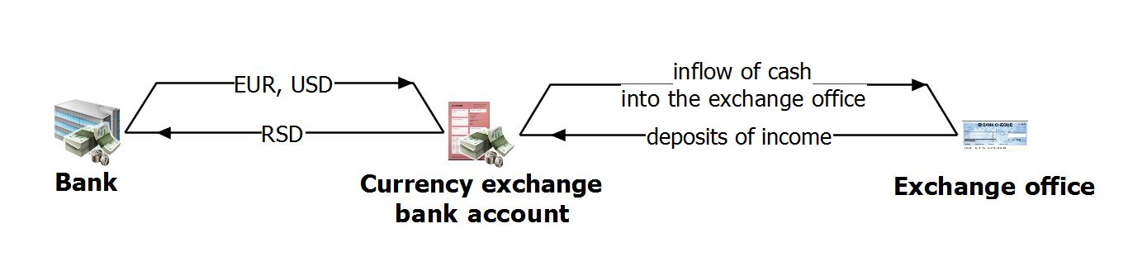

In addition, the licensed exchange office must at least once a week, and no later than the first business day at 12.00 o’clock after the expiry of the business weekdays, sell to the bank at least 80% of the total net purchase of the effective currency that it had over the business weekdays regardless of the structure of the foreign cash by the type of currency. The net purchase is the difference between the purchases and sales of foreign cash from/to natural persons. The foreign cash generated in the above manner may be deposited into the current foreign currency account opened with a bank according to the regulation governing the conditions for opening and manner of keeping resident foreign currency accounts. In other words, net purchases are the profit that the licensed exchange office earned during that week.

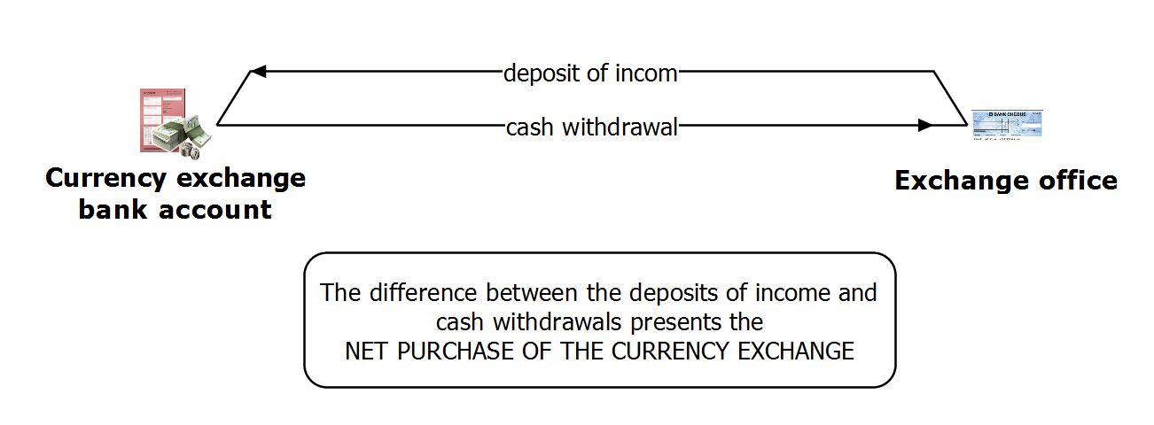

The earnings of exchange offices thus depend on the difference between the purchasing and selling exchange rate both in transactions carried out with natural persons when converting one currency into another as well as when transactions are conducted between the exchange office and the banks with which it has a business agreement.
For instance, the Euro exchange rate applied by the exchange office when purchasing Euro from natural persons is RSD 110.00 whereas when it sells Euro it offers RSD 110.70. This shows that the profit of the exchange office amounts at RSD 0.70 per one Euro, which means that the exchange office must purchase EUR 1,000 in order to cover the exchange rate difference of RSD 700.00. Below is an extremely conservative calculation of the costs of an exchange office. If we assume that the business premises, equipment and software cost an exchange office RSD 23,000.00 a month and that one employee costs a total (gross) of RSD 37,000.00 then in order for the exchange office only to only cover its costs (this is why we do not include the cost of taxes in this calculation), its monthly turnover should be EUR 85,714.29. Considering that there are an average of 2,500 exchange offices in Serbia, the monthly turnover of all exchange offices will be EUR 214,285,725.00, i.e. EUR 8,928,571.86 a day, if we assume there are 24 business days a month.
This example shows that a significant amount of money can be transferred through the financial system through currency exchange operations in a short period of time.
The considerable turnover of money is an indicator of how important the implementation of the AML/CFT Law by the exchange offices is, from client identification, to timely risk analysis and assessment and to suspicious transaction reporting.
It is necessary to establish an internal system in the obliged entity which will not allow the possibility of dirty money entering the financial system and which will ensure that circumstances indicating suspicion on illicit activities be recognised on time and reported to the APML in a timely manner.

MONEY LAUNDERING AND FOREIGN CURRENCY EXCHANGE OPERATIONS

The most frequent ways of disguising the true origin of money through exchange offices are as follows:

- Conversion of large amounts of cash to a different currency
There is a possibility that this money originates from organised crime. More specifically, the natural person having on him/her a large amount of cash generated from crime will not take the money to the bank; it is simpler to take the proceeds from crime to an exchange office and convert it to a different currency. It often happens that the exchange office’s employee does not even identify such clients.

- Conversion of funds through a number of small cash transactions
It has been noticed that conversion of large amounts are the most frequently conducted through a number of smaller transactions. The aim of these transactions is to avoid the requirement to identify the client under the AML/CFT Law and this is why they seek to make transactions under EUR 5,000, which is the identification threshold. Such transactions are often conducted in more than one exchange office. What often happens is that several individuals are engaged by persons who have money of suspicious origin to execute the transactions for a small fee.

- Execution of a large number of transactions in exchange offices which was physically impracticable
Certain exchange offices show that they conducted a large number of transactions in a very short period of time even though this is technically impossible. The purpose of this is to conceal conversion of a large amount of cash so it was shown as a larger number of smaller transactions, yet judging by the timing of their conversions, this was not technically possible.

- Conversion of funds of one foreign currency into another
In order to perform this transaction in Serbia the foreign currency first have to be converted into Serbian dinars and then convert the dinars into another currency. These transactions are not economically justified as the owner of the funds usually loses a certain amount of funds but this is not important for money launderers as their only aim is to conceal the source of funds in any manner possible.

- Conversion of banknotes in denominations commonly counterfeited or related to certain criminal activities
Certain countries recommend that their currency exchange offices stop selling EUR 500 banknotes due to their use by organised crime. This banknote is a favourite one for the criminals as they can launder larger amount through less transactions. In addition, they are more convenient for transportation as the denomination is higher making the transport much more easier than if this were done with smaller denomination banknotes.

- Conversion of marked banknotes
When handling foreign banknotes, special attention should be paid to marked banknotes that can indicate a link to individuals involved in money laundering or terrorism financing. These marks may not be visible as they are often written in substances that can be seen under ultra-violet light only.

- Conversion of damaged banknotes
Account should be taken of the type of damage and the way damage was made to the converted banknotes as they can originate from criminal activity. It may be that the banknotes have been damaged deliberately. These banknotes are exchanged for large fees, which is less important for the criminals as their only aim is to conceal their true origin.

ACTIVITIES OF THE ADMINISTRATION FOR THE PREVENTION OF MONEY LAUNDERING WITH RESPECT TO LICENSED EXCHANGE OFFICES AND FOREIGN CURRENCY EXCHANGE OPERATIONS

According to the Law on the Prevention of Money Laundering and the Financing of Terrorism (AML/CFT Law) the exchange offices too are listed as obliged entities required to report to the APML transactions and activities suspected to be related to money laundering or terrorism financing.
Yet, a check of the cash transaction reports (CTR) and suspicious transaction report (STR) databases reveal that licensed exchange offices are not too active when it comes to suspicious transaction reporting. This is illustrated by the following tables:

Table 1: Number of CTRs and STRs reported by licensed exchange offices by year

Year STRs CTRs Total
2002 0 5 5
2003 0 53 53
2004 1 514 515
2005 0 1005 1005
2006 0 534 534
2007 0 373 373
2008 0 750 750
2009 0 919 919
2010 0 899 899
2011 0 1325 1325
2012 0 3048 3048
2013 2 5432 5434
2014 4 4652 4656
2015 2 882 884

The analysis of the data in the above table shows as follows:
From 1 July 2002 to 2 September 2013 the licensed exchange offices reported to the APML a total of 12.852 CTRs and only 2 STRs. A surge in CTRs was noted in 2011 with 1325 CTRs reported while in 2013 a total of 5432 CTRs and only one STR were reported. In 2014, 4652 CTRs and 4 STRs were reported. In the first 3 months of 2015, 882 CTRs and 2 STRs were reported.
The analysis of CTRs shows that there was a misunderstanding among the exchange offices staff relative to the interpretation of Article 9 of the Law on the Prevention of Money Laundering and Terrorism Financing. More specifically, according to Article 9 of the AML/CFT Law, the obliged entity performing the currency exchange operations is required to identify the natural person when conducting a transaction amounting at the RSD equivalent of EUR 5,000 or more regardless of whether this is one or more than one interrelated transactions. In practice, currency exchange offices have reported to the APML transactions amounting to the RSD equivalent of EUR 5,000 or more whereas they were only obliged to identify the customer performing the transaction(s).
The above information indicate that the licensed currency exchange operators are aware of the obligation to report transactions to the APML but as they have not reported suspicious transactions it can be concluded that the compliance officers in exchange offices are not aware enough of the procedures for assessing and analysing client-related risks, purpose of the suspicious transaction reporting indicators, supervisor’s guidelines or other requirements from this Law.
This situation that has been identified with the currency exchange offices also serves as a signal for the APML to increase the level of training for those involved in currency exchange operations.
In addition, the STRs reported contain no descriptions of suspicion and the obliged entities have not analysed the related risk but they have only sent the STRs because of the high amounts of the transactions, e.g. they have sent STRs involving transactions exceeding EUR 15,000.

Exchange offices and suspicious transaction reporting - experiences from APML cases

Cases the APML has worked on with investigation authorities indicate that individuals from the criminal milieu have used currency exchange businesses to conceal the origin of funds. The money exchanged in the currency exchange office was used by individuals and members of organised crime groups (OCGs).
In one of the cases, an individual on a continuous basis exchanged money from one currency into another just below the statutory cash transaction reporting threshold whereas in another case that the APML worked on together with the Interior Ministry an extremely high amount of foreign currency was exchanged which was supposed to be an indicator for the exchange business to further analyse the client information available, in particular having in mind that the individual concerned owns a great number of companies and that a search of public information sources indicate there were certain indications that the client is related to illegal activities.
These examples only illustrate what direction the training of currency exchange offices must take and what AML/CFT areas such training should cover additionally. Also, this indicates that suspicious ML/TF transactions can be identified through the money exchange business.
In addition, information that the APML has access to show that most of the CTRs reported arrive from larger towns (mainly Belgrade and Novi Sad) so the question emerges of the training level of money exchange businesses from other parts of Serbia required to recognise transactions that must be reported to the APML. These issues should be dealt with much more in future.

APML and foreign-currency exchange operations

The APML continuously follows the operations of licensed exchange offices and analyses the transactions related to currency exchange business and potential money laundering or terrorist financing.
Given that the APML as far back as in 2008 transmitted the results of its analyses of 20 exchange offices with highest turnovers to other competent state authorities so that they take any actions or measures within their remit of responsibility, and that results cannot be seen to this day, a conclusion can be drawn that for a successful prevention of money laundering and terrorism financing an active participation of other state authorities, too, in charge of monitoring and controlling the currency exchange business is required in addition to the APML’s.
For instance, according to the information held by the APML, a exchange office with one of the highest turnovers in Serbia buys-off from individuals a monthly average of RSD 4 billion, whereas in a same period it sells to individuals around RSD 35 million. According to unofficial information, the exchange office from our example is an office manipulating a large amount of cash of unknown origin. While inspecting this exchange office the inspectors identified irregularities due to non-compliance with the AML/CFT Law provisions. Specifically, while conducting multiple interrelated transactions together exceeding EUR 5,000, the exchange office employees did not identify the individual who requested conversion of currency even though they were obliged to do so. Based on the results of this inspection the National Bank of Serbia in 2010 filed a referral to the First Basic Prosecutor’s Office of Belgrade for economic offence.
According to the information held by the APML, another exchange office has a high turnover generated by the purchase of RSD from individuals, however its turnover being much lower than that of the above mentioned exchange office. The owners of this exchange office had a record of being involved in illegal activities related to the purchase of shares of a bank, which supports the premise that exchange offices provide favourable ground for concealing true origin of funds and indeed money laundering. The owners of this exchange office are associated with individuals that are indirectly linked with drug traffickers.

APML databases and foreign-currency exchange operations

Characteristic basis of payment codes involved in foreign currency exchange operations:
- code 572 – purchase of effective foreign currency and cheques from licensed exchange offices
- code 576 – depositing of effective foreign currency by the licensed exchange office.

After analysing the transactions conducted under the above payment codes recorded in the APML’s CTR database, the following has been revealed:

Year | Code 572 | Code 576
2012 | RSD 11,701,654,994.08 (EUR 104,494,722.17) | RSD 10,249,287,208.11 (EUR 90,435,109.37)
2013 | RSD 3,096,596,453.25 (EUR 27,407,529.03) | RSD 31,953,627,836.59 (EUR 281,782,083.94)
2014 | RSD 19,591,875,154.24 (EUR 168,963,169.40) | RSD 24,070,201,864.36 (EUR 205,297,279.35)
2015 (first quarter) | No suspicious transaction reports (STRs) | RSD 4,421,155,300.86 (EUR 36,456,189.81)

Based on the above data we can conclude on the one hand that the volume of converted funds from one currency into another has increased significantly, and on the other hand that the awareness of the obliged entities has risen, as the are starting to recognise ML threats in the area of foreign currency exchange operations.
The banks that have agreements with licensed exchange offices are interested in the methods of monitoring and reporting transactions conducted by licensed exchange offices who are themselves among the obliged entities under the AML/CFT Law. Thus a question presents itself as to the way to treat the licensed exchange offices as clients of the bank the have an agreement with.
The APML’s view on these issues, based on the AML/CFT Law, is as follows: the licensed exchange offices are classified as low-risk clients to which simplified CDD may be applied which means that the bank is not required to report CTRs (RSD equivalent of EUR 15,000 or more). If there is an ML/TF suspicion concerning a client or transaction, enhanced CDD must be applied and the obliged entity (bank) must report all CTRs and STRs as well.
Based on interviews with bank compliance officers it has been established that most of the banks in Serbia observes this APML’s interpretation and therefore they classify exchange offices as low-risk clients which does not mean that they are not actively monitor the transactions of conversion of effective foreign currency.

LICENSED EXCHANGE OFFICES - CURRENT SITUATION IN SERBIA

Currency exchange operations in Serbia can only be performed by natural persons having a certificate to conduct this business. Currently there are 19 516 certified individuals in Serbia. Detailed data from the register of exchange offices and register of certified individuals can be found on the website of the FX section of the Tax Administration at www.devizni.gov.rs.
In addition to exchange offices, the currency conversion business is conducted also by banks where, in the opinion of the authors of this text, the level of transaction controls is higher and more successful than in licensed exchange offices. Transactions in this sector are conducted almost exclusively in cash which increases the risk that illegal proceeds will be introduced in a series of transactions into the legal money flows, which calls for higher attention.
According to the statistics of the National Bank of Serbia, the total amounts of purchased and sold effective currency by the licensed banks and branch offices of the National Bank of Serbia from 1 January 2015 to 28 February 2015 is as follows:

Month | Purchase of foreign cash (in mln EUR) | Sale of foreign cash (in mln EUR)
January | 178.62 | 69.20
February | 177.37 | 59.39
Total | 355.99 | 128.59

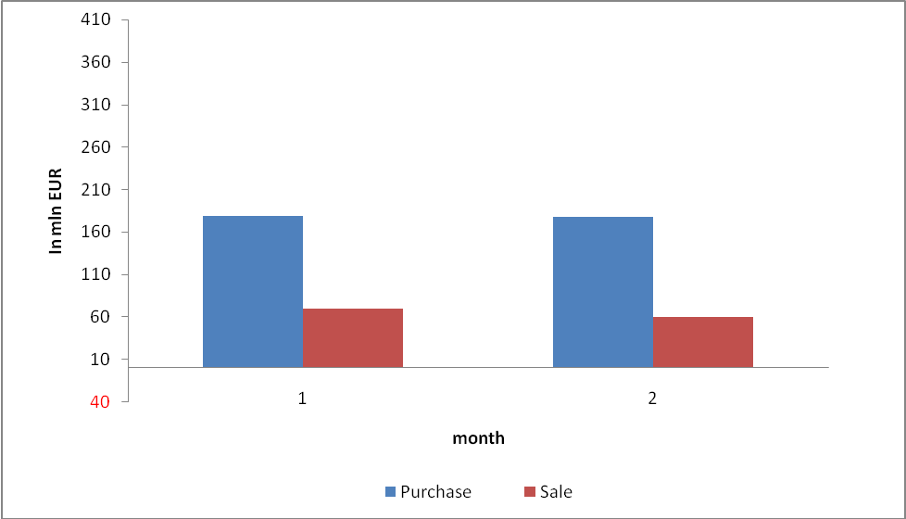

Supervision over the currency exchange business is conducted by the Tax Administration (previously, the supervision was the responsibility of the Foreign Exchange Inspectorate) which employs around 40 people in charge of currency exchange supervision, licensing and de-licensing and on-site inspections.

SUPERVISION OVER THE LICENSED EXCHANGE OFFICES AND FOREIGN-CURRENCY EXCHANGE OPERATIONS

The Law on Tax Procedure and Tax Administration governs the procedure for supervising foreign currency exchange operations. The supervision of foreign currency exchange operations in banks and licensed foreign currency exchange businesses is conducted by the Tax Administration as of 1 January 2012.
Supervision (SER. kontrola) is the procedure of inspecting and verifying the legality and regularity of currency exchange operations according to the legislation governing foreign exchange operations. The Tax Administration conducts desk-based and onsite control of the foreign currency exchange operations. Where the tax inspector in an onsite inspection identifies illegality or irregularity which can be remedied, the Tax Administration will pass a decision ordering the specific bank or licensed exchange office to remedy the identified illegality or irregularity and sets a deadline for action.
According to Article 85 of the AML/CFT Law, the state authorities competent for supervision of obliged entities are required immediately to inform the APML in writing of any measures taken in their supervision, any irregularities or illegal acts found as well as any other relevant facts in relation to the supervision, and shall send a copy of the document that they pass. The information refer any facts related to money laundering or terrorism financing.
The Tax Administration has sent to the APML a report stating that in 2012 it carried out 397 comprehensive onsite inspections in entrepreneurs and legal entities performing currency exchange business. Irregularities were found in two obliged entities: one exchange office failed to appoint the AML/CFT compliance officer and a minor offence report was submitted; while the other exchange office failed to conduct CDD, i.e. it did not identify the client when conducting the foreign currency exchange transaction according to the AML/CFT Law.
In 2013, the Tax Administration - Foreign Exchange and Games of Chance Section conducted 673 comprehensive onsite inspections of entrepreneurs and legal entities performing currency exchange business, and in 2014 1105 comprehensive and onsite inspections of entrepreneurs and legal entities performing currency exchange business activities.

Application of the national money laundering risk assessment by licensed exchange offices

The revised 2012 FATF recommendations made the national ML risk assessment a mandatory international standard. According to the recommendations, an ML NRA for the Republic of Serbia was conducted and sent in April 2013 to the Government of the Republic of Serbia for the purposes of informing it on the ML risks.
According to the ML NRA, licensed foreign currency exchange offices were classified as medium vulnerable sector. More specifically, what classifies exchange offices as the medium vulnerable category from the point of view of money laundering is that the exchange offices are used for money laundering structuring stage as well as the fact that exchange offices operate only using cash.
The solution to this problem, according to the national risk assessment lies in intensifying the activities of the supervisor (TA - FX and games of chance section).
It should be noted here that the inspections have already intensified which is shown by the above data, i.e. that the supervisor in 2013 conducted 673 comprehensive onsite inspections of entrepreneurs and legal entities performing the currency exchange business, and in 2014 it conducted 1105 comprehensive and onsite inspections of these persons.

Supervision of exchange office “S”

The supervisor (TA - FX and games of chance section) conducted in 2014 the inspection of this exchange office and found the following irregularities:
The licensed exchange office every day in the early morning, from 8:19:16 h to 8:47:13 h takes out the money from the cash register of the exchange post using the option ‘payment of RSD into the current account - outgoing’. A check of the bookkeeping documentation and individual receipts reveals that the exchange office did not pay the RSD into his own current account but he cancelled these receipts on the same day in the afternoon from 15:04:17 to 15:51:03 h and thereby refunded the money into the exchange post’s cash register. This pattern was repeatedly done daily and it always involved the amount of approx. RSD 760,000.00. The owner (JM) of this exchange office explained this as follows:
“I used the option ‘payment of RSD into the current account - outgoing’ with the intention of withdrawing my own profit in the amount ranging from 759,350.00 to 799,350.00. Due to serious personal problems and commitments and lack of time I have not been able to go to the bank and do this. Therefore I cancelled these amounts after returning to the exchange post”. An inspection of the documents held by exchange office “S” shows that this exchange office had been repeating this same action every day starting from 9 April 2014”.
After a check of APML’s databases (the persons involved were not recorded in the databases), the above findings were transferred to the Criminal Police Directorate of the Ministry of Interior.

Supervision of exchange office “B”

On 4 November 2014, the TA’s FX and games of chance section sent a report to the APML informing it of a supervision of exchange office ''В'', owned by PJ. The inspection was conducted in two exchange posts.
The inspection at both these posts revealed as follows:
- The licensed exchange office while carrying out transactions amounting to EUR 5,000 or more in RSD countervalue, failed to apply the official median exchange rate of the National Bank of Serbia as on the date of execution of transaction.
- Within short time intervals, a number of purchasing transactions were recorded and a number of selling transactions of foreign currency (EUR) in amounts below the threshold for customer identification and reporting according to the AML/CFT Law;
A check of the CTR and STR databases revealed that PJ owned the exchange office and that in 2007 he conducted cash transactions at a bank in amounts below the reporting threshold which was a reason for the bank to report these transactions as suspicious.
After a comprehensive analysis of this case, a report was sent for further action to the Ministry of Interior – Criminal Police Directorate.

TRENDS OF MONEY LAUNDERING THROUGH LICENSED EXCHANGE OFFICES

After analysing currency exchange operations as practiced nationally and internationally and their vulnerability to money laundering, and having in mind the overall financial situation in Serbia, the following trends can be identified for the currency exchange business:

- conversion of dirty cash (mainly originating from the drug street sale) into a different currency, mostly into higher denominations allowing for easier handling of cash;
- organised money laundering by OCGs through the chain of exchange offices assumed to be owned by them;
- money launderers are more and more distancing from banks as the most organised ML/TF preventing sector and are coming closer to non-banking financial institutions such as currency exchange offices and money remittance businesses;
- an increased number of transactions carried out through exchange offices in smaller towns mostly for the reason of less intensive inspections that these exchange posts are exposed to than in larger cities;
- EUR 500 bills can be very suspicious as being related to criminal proceeds. More specifically, as these are high denomination bills, they are convenient for transporting large amount of funds.

CONCLUSION

Based on the above data, it can be noted that a considerable amounts of funds are converted for various reasons from one currency into another which is from the point of view of money laundering and terrorism financing a very convenient way to conceal the true origin of funds and the place the illicit proceeds into a country’s financial system. The foreign currency exchange sector poses ML risks due to the fact that it handles cash the true origin of which is difficult to establish.
The legislation governing exchange offices and currency exchange business is complete and comprehensive but there are obvious difficulties with respect to interpretations of the AML/CFT Law concerning the amounts of transactions to be reported to the APML. This leads to the conclusion that the obliged entities need additional training on the importance of the AML/CFT dimension in Serbia.
Also, for an effective AML/CFT system it is necessary for all competent authorities to be adequately and comprehensively engaged in the supervision of these financial institutions.
Raising awareness with the entire population regarding money laundering through the currency exchange business and ways to prevent integration of proceeds from crime into the legal financial system is essential.

SOURCES

- Law on Tax Procedure and Tax Administration
- Law on Foreign Exchange Operations
- Decision on the conditions for and manner of conducting foreign-currency exchange operations
- Instructions for implementing the Decision on the conditions for and manner of conducting foreign-currency exchange operations
- Law on the Prevention of Money Laundering and Terrorism Financing (AML/CFT Law)
- Money laundering typologies in the Republic of Serbia
- Republic of Serbia National Money Laundering Risk Assessment
- APML databases
- Analysts’ experiences
- Internet

