ANALYSIS OF SUSPICIOUS TRANSACTIONS CARRIED OUT THROUGH MONEY REMITTANCE SYSTEM

CONTENT

Reporting of suspicious transactions 3
Comparative overview of reports submitted by agents and subagents 4
Analysis of reports 4
Work on STRs - improvements to the system 5
Transfers indicating suspicion of money laundering 6
Geographic areas and money transfers 8
Meetings with money transfer agents - feedback and improvements to the system 10

ANALYSIS OF SUSPICIOUS TRANSACTIONS CARRIED OUT THROUGH MONEY REMITTANCE SYSTEM

In Serbia, money can be transferred through Western Union, MoneyGram and Ria. The banks and legal persons which act as representatives of these agents in the country include: Tenfore, Eki transfers, Poštanska štedionica, Societe generale bank, UniCredit bank, KBM bank, Alpha bank, Sberbank, Eurobank EFG, Piraeus bank and Aik bank. These agents only provide for receipt of money (transfers towards Serbia), whereas postal money orders of the PE Post of Serbia allow for both receipt and sending of money. One major change that happened on the market is the fact that not long ago KBM bank became a representative of Ria money transfer after Agrobanka, the former Ria representative, went insolvent. Ria provides only for receipt of money in Serbia, not sending.

Reporting of suspicious transactions
In line with the Law on the Prevention of Money Laundering and Terrorism Financing of the Republic of Serbia (hereinafter referred to as: the AML/CFT Law), all money transfer service providers are obliged to report suspicious transactions. In the period 2010 – early 2015, money remitters reported a total of 16,719 suspicious transactions to the Administration for the Prevention of Money Laundering (hereinafter referred to as: the APML). Graphic representation of the number of STRs per year is shown in Chart 1.

Comparative overview of reports submitted by agents and subagents
 | 2010 | 2011 | 2012 | 2013 | 2014 | 2015
Money remitters | 2871 | 3977 | 3578 | 1865 | 3822 | 436
Subagents (banks) | 6 | 33 | 20 | 3 | 4 | /
Postal services providers | 62 | 31 | 10 | 5 | 2 | /
TOTAL | 2939 | 4041 | 3608 | 1873 | 3828 | 436

Analysis of reports
The data provided show that agents are reporting more STRs than subagents (banks). They report more than 95% of all suspicious transactions related to money remittance. Some reasons for such discrepancy include: availability of most data to these agents, advanced IT technology they have, as well as good organisation of the AML/CFT department which analyses suspicious transactions carried out through money remitters.
Descriptions accompanying STRs are very similar, taking into account a big number of reports. Namely, in most cases the description is based on indicators only, the following two particularly: several receipts of money in a short period by one or several connected persons and the origin of funds or the funds beneficiaries are from high risky countries. In other words, what lacks is analysis and transactions are reported when their cumulative sum per one person exceeds an amount assessed by an AML officer as the limit. This in many cases refers to the following indicator: several interconnected transactions whose total aggregate in a month is EUR 7,000 or more.
The quality of analysis is also influenced by lack of data on originators of foreign transfers. These data are difficult to access by domestic money transfer service providers, which motivates them to report a transaction as suspicious, regardless of its amount or frequency, since they are not able to find a logical connection between the sender and the receiver of funds. These flaws are caused by the fact that persons performing AML/CFT tasks at money remitters are not legally bound to request more detailed information and data from clients when executing smaller transactions.
Furthermore, another problem is falsification of identification documents submitted by clients when sending or receiving money. Namely, sometimes a suspicion of what the real motives for execution of transactions are is triggered when employees of a money transfer service provider are doubtful of the veracity of identification documents of clients.
Additionally, it has been noticed that there are numerous Serbian citizens who withdraw funds on behalf of other individuals for monetary compensation (mainly foreign citizens or asylum seekers). However, it should be noted that in most cases the reason for such activities is not to conceal the actual beneficiary of funds, but the fact that these persons do not speak Serbian or English and only use Arabic alphabet.
It is worth mentioning that the indicators for recognising suspicious transactions relevant for money transfer service providers were updated in June 2014. The APML involved these obligors themselves in the process of drafting new indicators, since they are their actual end users, as well as the Tax Administration as the supervisory authority for this group of obligors. Joint work of this team resulted in new indicators which have better practical usage than the former ones.

Work on STRs - improvements to the system

In 2014 the APML changed its method of acting upon STRs received from money transfer agents so as to organise the system of reporting and analysing these suspicious transactions since money transfer services are being increasingly used for remitting money with illicit origin.
Namely, analysis of suspicious transactions used to be performed on three and six month basis, after which data were forwarded to intelligence and investigative authorities.
Since 2014, the manner of reporting suspicious transactions was also improved by introduction of the electronic reporting system. Money transfer agents now report suspicious transactions through a web application which makes it possible for reported transactions to be sorted automatically in the APML’s database, thus providing for a more efficient and timely processing of STRs.
In 2014, the APML sent an average of 79 requests per agent for provision of data on transactions executed through money remittance system. This figure is a significant increase in comparison to the figures from 2013 and 2012, when 25 and 33 requests per agent were sent, respectively. Such an increase is the result of improvement of the process of data exchange between the APML and money remitters as its obligors. All this demonstrates that the system has been improving and that in the work on cases these services are being checked more frequently.

Transfers indicating suspicion of money laundering – modi operandi

Analysis of suspicious transactions reported by money remitters established that the following modi operandi are successfully recognised.
Typology 1 – financing of border crossing
Persons form Western Europe countries send money to Serbian residents to whom they are not connected in any obvious way. The money is sent as compensation for illegal transport over the state border of persons linked to senders of the money by family ties.
Typology 2 – transactions of persons with criminal background
Persons convicted of serious criminal offences and dealing with organised crime use money transfer services to avoid the banking system and obligation to state the origin of their property. Moreover, it can be the case that such persons use falsified documents or shells.
Analysis of reported suspicious transactions established that the majority of them involve persons seeking asylum in Serbia and persons who are residents of Serbia and receive money for immigrants. Most asylum seekers do not possess any identification documents and cannot in person withdraw money sent to them. These transactions are characteristic for amounts much above the current status of these persons. When reporting suspicious transactions, AML officers cannot recognise predicate offences since there is lack of data on the subject persons.
In addition to the described cases, money remitters’ services are also used by persons who trade in narcotics and human beings, as well as those who participate in illicit transportation of immigrants over the state border. Although these situations are fewer in number in comparison to the cases of receipt of money by asylum seekers, they must not be overlooked as a way of abuse of money remittance system.

Case studies
In one of the cases where persons used money remittance services an indictment for terrorsim financing also ensued.

Deploying persons to war zones
An NPO headquartered in Serbia, with an Islamic religious building as its part, received significant income to its bank account from foreign persons from Arab countries. It was established through further analysis that members of the NPO were linked to terrorist organisations, as well as that they frequently appeared as beneficiaries of funds sent through money transmitters. These funds mostly originated from Western Europe countries. Work on this case established that the money was sent so as to cover for travel costs of persons deployed to war zones in Syria, and this particular case resulted in indictment for terrorism financing.
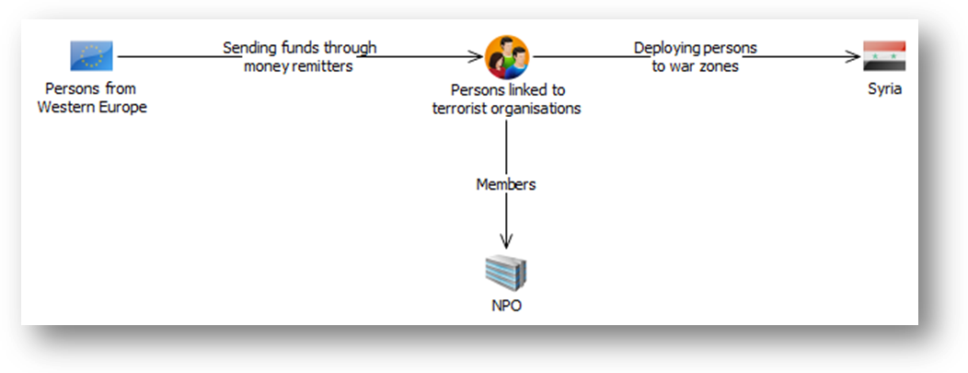
Avoiding the banking sector
A natural person received through Western Union a lot of cash in a short time from various natural persons from Russia. It was established through analysis that some foreign transactions were executed exclusively through money remitters, even though this person owned accounts opened with several business banks in Serbia. Amounts and frequency of the transactions were unusual for money remitters, which indicated a suspicion that this person intentionally avoided the banking system and chose a different sort of financial services to carry out transactions with foreign countries. A more detailed analysis showed that the subject person was already registered as having criminal record.

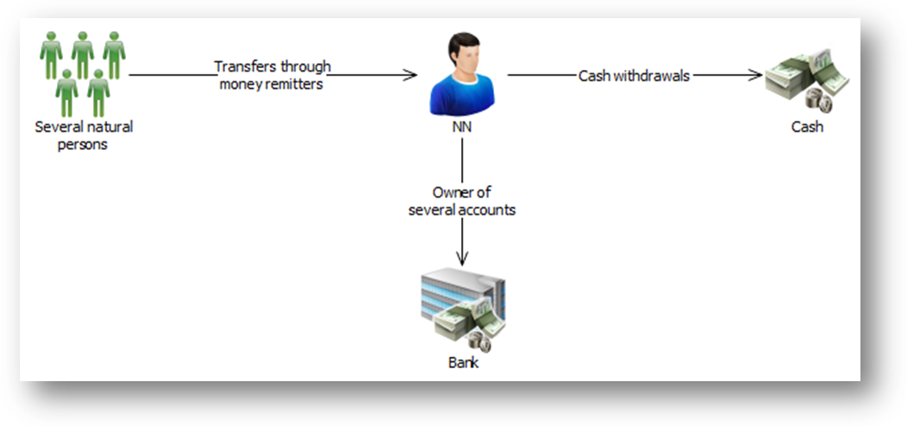

Geographic areas and money transfers

Through analyses of suspicious transactions it was established that certain countries stand out in number or value of transactions with Serbia.
It was noticed that in the period 2010 – 2015 the majority of funds sent to Serbia originated from the following countries: Greece, Russia, Turkey, Germany and the USA.
Regarding the countries to which money was sent from Serbia via money remitters, the list is different, though: Pakistan, Benin, Russia, China and Hungary (picture 1).
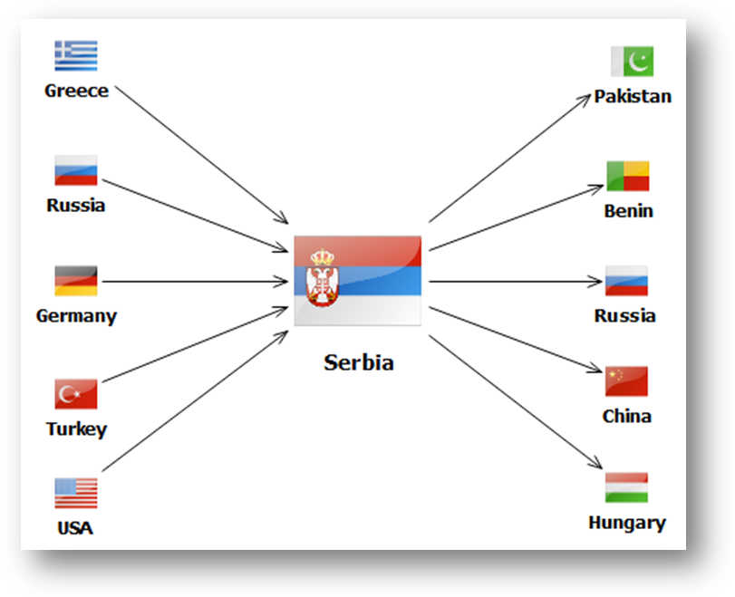
Picture 1
A overview of share in transacations carried out through money remittance system per country in 2012 and 2014 is shown in the follwing charts:

It can be seen from the charts that Greece continues to be the leading country in the number of transactions with Serbia executed through money remitters. Contrary to this, some significant changes in the presence of transactions with these countries are also evident. Namely, in 2012 the USA and Switzerland were massively present in the transactions with Serbia executed through money remitters, whereas in 2014 Turkey took their position on the list as the second country, right after Greece. Moreover, the number of transactions with Pakistan is also increasing, from 5% in 2012 to 17% in 2014, which is a significant increase.
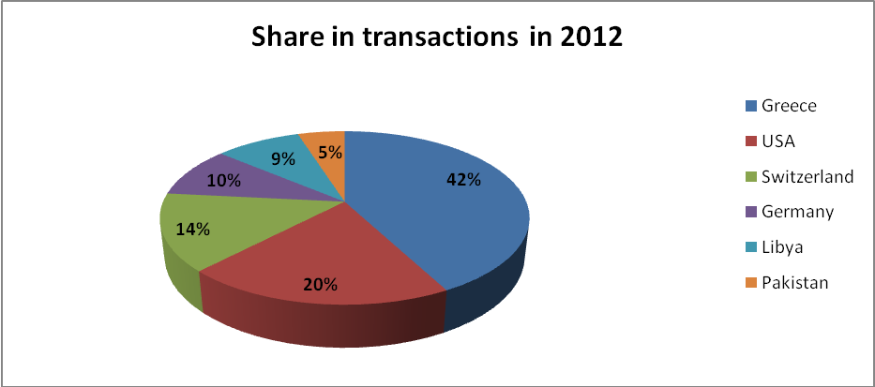

Meetings with money transfer agents - feedback and improvements to the system

At the beginning of 2015, the APML staff held meetings with money remitters employees responsible for reporting suspicious transactions. The topic of the meeting was feedback on the APML’s activities on the cases initiated by money remitters. Possibilities for improvement of the quality of the transactions reported and the reporting system itself were also discussed. It is worth mentioning that these meetings contributed to enhancement of the dialog between the APML and obligors and that this was the first occasion when these obligors received good quality feedback on the APML steps following their reports.

Quality of reported suspicious transactions
It was noticed through work on cases that additional effort should be invested so as to improve the quality of descriptions and analyses of transactions reported by money remitters. Namely, numerous transactions are reported solely because of matching one of the situations described in the indicators for recognising suspicious transactions, although actual suspicion of ML/FT lacks. Most transactions reported are based on the following indicators:
- Several connected transactions which total EUR 7,000.00 or more in one month, if it is unusual for the client or the country from which the transfers originate;
- Client receives from one or more senders several transfers in a short period and is not connected to the sender/senders in a logically obvious way;
- Any transaction which appears to be unusual based on knowledge and experience of the obligors’ employees.
Since Serbia is a transit country for refugees from war zones (Syria, Yemen, Iraq, Afghanistan, etc.) whose final destination is Western Europe, numerous transactions match the above indicators. However, many are not linked to ML/FT and descriptions accompanying the reports are very modest – they involve only indicators recognised, without any explanation why the reported transactions raise suspicion of ML/FT.
Taking into consideration all the above, there are numerous transactions reported by money remitters; however, only a small percentage of these is actually related to ML/FT.
What is encouraging, though, is a positive attitude towards the APML and good organisation of work of the staff at legal entities which represent money transfer agents. To sum up, it should be noted that even though some improvement has been achieved in this area, additional joint efforts are needed with the aim of further improvement of the quality of reporting suspicious transactions and recognising ML/FT suspicion.

Ria Financial Services was founded in 1987 and is currently third in size company dealing in fast money transfers.

