Administration for the Prevention of Money Laundering Work Report
1 January - 31 December 2014

CONTENTS
CONTENTS 2
1. 2015 - 2019 NATIONAL AML/CFT STRATEGY 4
AML/CFT System Development at Legislative Level 5
Proposal for a Law on freezing of assets with the aim of preventing terrorism 5
Draft Law amending the AML/CFT Law 5
1.4. ML/TF suspicious transaction indicators for banks 6
1.5 ML/TF suspicious transaction indicators for MSBs 6
2. FINANCIAL INTELLIGENCE ACTIVITIES IN 2014 7
2.1. Feedback analysis – prosecutor’s offices 2012 – 2014 9
2.3. Security Intelligence Agency 11
2.4. Ministry of Defence 11
2.5. Tax Administration 11
2.6. Аnti-Corruption Agency 11
2.7. Securities Commission 12
2.8. Customs Administration 12
2.9. Information exchanged with foreign FIUs 12
2.10. Analysis of suspicious transactions 14
2.11. Typological cases – ML suspicion 17
2.12. Examples of case studies forwarded to the prosecutor’s offices – STR analysis 25
2.14. Trends 30
3. SUPERVISION OF ACCOUNTANTS AND AUDITORS FOR COMPLIANCE WITH AML/CFT LAW 33
3.1. Offsite inspections in 2014 34
3.2. Onsite inspections in 2014 36
3.3. Analysis of penalties sanctioned by courts 37
Chart showing the ratio between the total of entities supervised and economic offences found in 2013, and court decisions passed in 2014 38
4. COOPERATION BETWEEN RELEVANT STAKEHOLDERS AT NATIONAL LEVEL 40
4.1. Cooperation agreement between APML and Republic Public Prosecutor’s Office 40
4.2. Working group on APML - Tax Police cooperation and information exchange operating procedures 40
4.3. Serbian National TF Risk Assessment 40
5. APML EU - SERBIA NEGOTIATION PROCESS ACTIVITIES 41
5.1. Negotiating Chapter 4 - Free movement of capital 41
5.2. Negotiating Chapter 24 - Justice, freedom, security 42
5.3. Negotiating Chapter 31 - Foreign, security and defence policy 42
5.4. Other EU integration-related activities 44
6. Major IT Team’s activities in 2014 44
7. INTERNATIONAL COOPERATION 46
7.1. Activities within the Council of Europe MoneyVal Committee 46
7.2. Activities within the Egmont Group 47
7.3. Memoranda of understanding (MOUs) 47
7.4. OSCE 47
7.5. Eighth regional HoFIUs conference, 20-21 October 2014, Podgorica, Montenegro 48
8. HUMAN RESOURCES AND TRAINING 49
9. APML FINANCIAL REPORT 51
10. CHALLENGES AND OBSTACLES IN ACHIEVING OBJECTIVES 52

1. 2015 - 2019 NATIONAL AML/CFT STRATEGY
The work on the development and adoption of a new National anti-money laundering and countering the financing of terrorism (AML/CFT) strategy continued also in 2014. The Standing Coordination Group (SCG) adopted at its meeting of 6 June 2013 a proposal to set up a Project Group mandated with developing a new national strategy, bearing in mind that a 5-year-period had passed since the adoption of the previous AML/CFT strategy, the first of the kind at that time, during which the main objective of that strategy was achieved, i.e. to establish an AML/CFT system.

Based on SCG proposal, APML director passed in October 2013 a decision to set up a Project Group mandated to develop a new national strategy against money laundering and terrorism financing and an accompanying action plan to further develop the measures provided for under the strategy. The authorities participating in the development of the new strategy were as follows: Supreme Court of Cassation, National Bank of Serbia, Securities Commission, Ministry of Justice and Public Administration, Republic Public Prosecutor’s Office, Ministry of Interior, Security Information Agency, Military Security Agency, Anti-Corruption Agency, Tax Administration and Administration for the Prevention of Money Laundering.

Upon finalisation in 2014 of the Proposal for a national strategy by relevant authorities that were represented in the development of this strategic document, Serbian Government at its session of 31 December 2014 adopted the National Strategy against Money Laundering and the Financing of Terrorism and its Action Plan (National AML/CFT Strategy).

The overall objective and purpose of the National Strategy is to contribute, through substantial strengthening of individual AML/CFT segments using targeted and well designed measures, to a full protection of the financial system and economy of the State from the threat caused by money laundering and terrorism financing and proliferation of weapons of mass destruction, whereby the integrity of the financial sector is strengthened and safety and security are contributed to.

A specific feature of this National Strategy is that it highlights the importance of cooperation between all competent authorities given that the AML/CFT system can only be effective through such cooperation, including through information and expertise sharing, access to databases, and setting-up of task forces.

In designing the National AML/CFT Strategy and Action Plan, the findings of the National ML Risk Assessment were taken into account as well as experiences working on the national TF risk assessment.

The most recent changes to the international legal standards applicable in the area were also taken into account in working on the National AML/CFT Strategy. International AML/CFT standards now require not only technical compliance to standards but the success of an AML/CFT system will be assessed against the effectiveness of their implementation. The National Strategy intends to ensure that the standards (at the legislative and institutional levels) are met but in such a way to achieve effective results.

Having in mind the commitment of the Republic of Serbia with regard to the European Union membership and the ongoing negotiations, the competent state authorities have taken into account, when developing the National AML/CFT Strategy, the comments and recommendations of the relevant European Commission services.

AML/CFT System Development at Legislative Level

Proposal for a Law on freezing of assets with the aim of preventing terrorism
In 2014, work on the Draft law on freezing of assets with the aim of preventing terrorism was finalised. In addition to the APML and other Serbian authorities, international experts in the area also participated.

The Draft law on freezing of assets with the aim of preventing terrorism was submitted to Government which approved it at its session of 31 October 2014 and transmitted it as its legislative proposal to the National Assembly of the Republic of Serbia for adoption.

By passing this legislation, Serbia will comply with the provisions of Chapter VII of the UN Charter which provides that the UN member states are obliged to take measures to implement resolutions adopted by the UN Security Council within its remit (hereinafter: UN SC). UN SC resolutions laying down the measures for preventing the financing of terrorism and terrorism in general include: Resolution 1267 of 1999 containing a list of persons designated by UN SC against whom such measures are applied, Resolution 1373 of 2001, Resolutions 1333 of 2000, 1363 of 2001, 1455 of 2003. The Proposal of the Law was put in line with the FATF recommendations as revised in February 2012, in particular with Recommendation 6.

Draft Law amending the AML/CFT Law
In 2014, APML worked intensively on drafting a Draft law amending the current AML/CFT Law. A working group was set up for this purpose, comprising, in addition to APML representatives, also the experts from the Tax Administration’s Sector for bureau de change and foreign exchange operations and games of chance, National Bank of Serbia, Securities Commission and Ministry of Trade, Tourism and Telecommunications Market Inspectorate. A number of workshops and meetings were held in 2014 with supervisors and obliged entities to hear and discuss proposals and suggestions for improving the preventive AML/CFT legal framework in Serbia.

The envisaged amendments are designed so as to put the current legislative provisions with the new AML/CFT standards, i.e. FATF’s 40 Recommendations revised in February 2012. In designing the legislative amendments, the working group was guided, in addition to the FATF’s recommendations, also by the Directive 2005/60/ЕC on the prevention of the use of financial system for the purpose of money laundering and the financing of terrorism, adopted in 2005, (so-called Third EU AML Directive), as well as the proposed Fourth Directive of the European Parliament and Council which will address the same subject-matter as the Third Directive, most of whose provisions are known to the AML/CFT community, even though its adoption is expected to happen in 2015.

1.3. Suspicious Transaction Reporting, CDD and No Tipping-Off Guidelines

On 9 July 2014, Suspicious Transaction Reporting, CDD and No Tipping-Off Guidelines were passed and published on APML’s website.

In early 2014, APML and National Bank of Serbia agreed on establishing a project group to develop new STR indicators for banks and suspicious transaction reporting guidelines. The two authorities held a common position that the project group should include, in addition to APML and NBS, also the obliged entities who applied the indicators and guidelines daily. At the regular annual APML consultations with the bank AML/CFT compliance officers and their representatives, held on 5 March 2014 at the Association of Serbian Banks, bank representatives’ concerns were mostly related to the indicators; in particular, they thought it would not be possible to implement the indicators in their banks’ ICT systems and that the indicators were subjective in nature thus making it difficult to defend their application in internal and external inspections. The model of indicators at the time was related more to possible scenarios and less to objective criteria. Indicators were thereafter objectivised so as to be implementable into the IT system so as to point in an unambiguous manner to the transaction that needs to be further analysed as it is potentially suspicious. Nevertheless, the previous indicators were found useful in developing the new guidelines which describe scenarios of possible methods, schemes and activities used by those who intend to launder money through banks and bank services and products.

1.4. ML/TF suspicious transaction indicators for banks
On 30 June 2014, APML director passed a Directive publishing the ML/TF suspicious transaction indicators. The amended list of indicators for recognising suspicious transactions relevant for banks was published on the APML official website in order to provide guidance to the banking sector as to which type of transactions and business relationships should be reported to the APML. The obliged entities are required to implement this list of indicators as of 1 October 2014.

1.5 ML/TF suspicious transaction indicators for MSBs
In cooperation with supervisors and MSBs, the APML developed a new list of ML/TF indicators for MSBs. On 22 July 2014, APML director passed a Directive publishing the ML/TF suspicious transaction indicators. The obliged entities are required to implement this list of indicators as of 1 October 2014.

2. FINANCIAL INTELLIGENCE ACTIVITIES IN 2014
In 2014, the APML worked on the total of 589 cases: 445 new analytical cases opened at the initiative of other state authorities, supervisors, at the requests of foreign FIUs and on basis of analysis of suspicious reports submitted by obligors, and 145 cases from the previous years (new information and data on persons who had already been subject to analysis in the APML).

In requests for provision of information sent by the other state authorities to the APML, the most frequent crimes involve: abuse of authority in economy, abuse of the position of a responsible person in a company, illicit crossing of the state border and human smuggling, trade in narcotics, terrorism and terrorism financing, human trafficking and various sorts of fraud.

The majority of cases involve the suspicion about economic justifiability of transactions when analysis of funds on accounts could not establish the source of the funds which have entered the financial system.

These mainly referred to big cash deposits, in cases when business activities and other sources of funds could not “justify” for such big cash transactions or massive turnover on the accounts. Some of these persons are linked to construction activities and investments. In these cases there is also a suspicion of tax evasion, corruption and connections to organized crime groups.

The analysis of cases indicating to a suspicion of money laundering also referred to corruptive practices of top management in business entities (directors, authorized persons, founders) and manipulations during acquisition of ownership in some companies, conclusion of fictitious contracts, or help for persons linked to individuals from the criminal milieu.

In addition to unknown source of funds, many cases were analysed because of a suspicion involving fictitious money transfers between legal persons, i.e., that through a fictitious economic activity – trade in goods, money is transferred between interconnected legal persons and then withdrawn in cash. It is suspected that the beneficial owner of an offshore and a domestic legal entity is the same person and that this way money from illegal activities is returned to the country.

Statistics – 2014

Prosecutor’s Offices
In 2014, prosecutor’s offices sent a total of 37 requests to the APML.
 | Requests
Prosecutor’s office for organized crime | 14
Higher public prosecutor’s office | 22
Basic public prosecutor’s office | 1
Description of a ML suspicion is most commonly related to the crimes: abuse of office, fraudulent practice, misuse of the purpose of donations, embezzlement, human trafficking, various malfeasances with credits, etc.
APML forwarded information to the prosecution in 57 cases. Nine cases involved submitting additional data on persons already subject to exchange of information with the prosecution for whom new information or transactions indicating to a suspicion of ML were established.

 | Initiative
Prosecutor’s office for organized crime | 8
Higher public prosecutor’s office | 48
Republic public prosecutor’s office | 1

Most analyses and information about suspicion of ML were sent to the Higher public prosecutor’s office in Belgrade (24 cases in total), Higher public prosecutor’s office in Novi Pazar (3 cases), while Higher public prosecutor’s offices in Jagodina, Novi Sad, Pirot, Sombor, Sremska Mitrovica and Subotica were forwarded two cases each and the prosecutor’s offices in Pančevo, Kraljevo and Niš were forwarded one case each.
For persons from Belgrade, the majority of information was forwarded based on a suspicion of money laundering. Regional overview of the cases per prosecutor’s office is shown in the chart below.

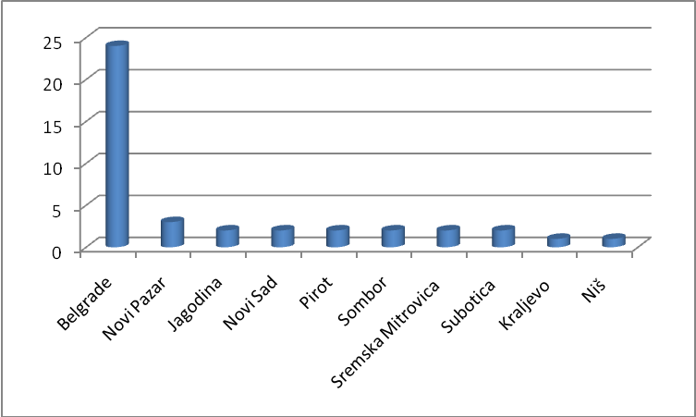

Activities indicating to a suspicion of money laundering and predicate criminal offences related to the cases forwarded to the prosecution:

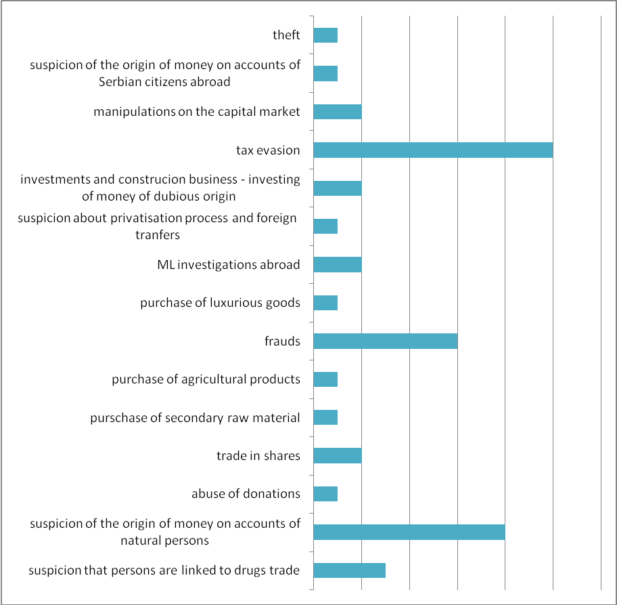

In the majority of cases forwarded to the prosecution, information was sent on grounds of a suspicion of existence of elements of tax crimes and money laundering, simulated legal affairs with an intention to integrate illegally gained assets through financial institutions; the number of cases related to frauds increased – identity theft and falsifying of business documentation. An increase is also present in the number of initiatives involving suspicion that persons are connected to members of criminal groups dealing with trade in narcotics.

2.1. Feedback analysis – prosecutor’s offices 2012 – 2014
A problem with feedback still remains. For same cases there is indirect feedback, that is, it can be concluded that the case is being worked on, since the APML is address by the other state authorities so as to collect data, usually by the police, and that way information that data procession in the cases forwarded by the APML is underway is received indirectly.

Feedback on the cases forwarded to the prosecution:
 | No. of cases sent to the Republic Public Prosecutor’s Office | Feedback | No grounds for further work
2012 | 87 | Indirect feedback for 3 cases: 2 (requests of other state authorities)  1 (one indictment brought, but not for ML) | 3
2013 | 93 | Charges pressed for tax evasion – 5 (ML was not included)  2 (requests of other state authorities – being worked on) | 8
2014 | 48 |  | 1

2.2. Ministry of Interior – Criminal Police Directorate

The Ministry of Interior sent a total of 357 requests for information to the APML.
The Criminal Police Directorate of the Ministry of Interior sent 73 requests for information in 2014. At the requests of the Criminal Police Directorate, a total of 244 natural and 112 legal persons were subject to checks. At the request of the state authority, in addition to checks of databases of the APML, data collected also included turnover on accounts (average period for data on accounts turnover is 6 years), money transfers and data from foreign countries gathered through the EGMONT group.

The police directorates directly sent a total of 26 requests for information to the APML. These involved checks of numerous natural and legal entities on grounds of suspicion of abuse of authority in economy and some sorts of economic crime, extortion, disputable privatizations and tax evasion.

Some requests were sent by task forces formed within the Criminal Police Directorate for the purpose of investigating dubious privatizations, corruption, etc.

Such requests were grounds for action in 12 cases in which the APML collected and analysed data on accounts turnover and data gathered from foreign counterparts through the EGMONT group – ownership and managing structure of companies and data on personal accounts of natural persons.

The Unit for Financial Investigation sent a total of 246 requests to the APML. The majority of these were sent since there was a suspicion on money laundering and the most common predicate crimes involved fraud, tax evasion, illicit manufacture and trade in narcotics and abuse of authority of a responsible person in a company.

During analysis of suspicious transactions, the APML sent to the Ministry of Interior a total of 37 requests for information. Activities of persons subject to analysis indicated to a suspicion of legality of cross-border transfers, especially with offshore destinations and neighbouring countries; significant amounts of cash were noticed on accounts of natural persons and these were not accompanied with information on the source of funds, as well as situations when information from the media pointed to connections with drugs trade. The cases were also sent because of suspicion of the legality of some securities, the source of funds, suspicion of terrorism financing, fraudulent practice, human trafficking, motives for using money remitters’ services instead of the banking sector, etc.

2.3. Security Intelligence Agency
In 2014, a total of 30 pieces of information was exchanged with the Security Intelligence Agency during work on cases. The majority of these referred to a suspicion that persons are linked to organised crime groups, trade in arms and weapons of mass distraction. Subject to checks were also persons suspected to be participating as mercenaries in armed conflicts in other states, persons suspected of corruptive practices or linkage to terrorism, sources of funds used for the purchase of high value property, and some information was also exchanged because of a doubt whether personal documents used by certain foreign nationals are authentic.

2.4. Ministry of Defence
The APML exchanged data with the Military Security Agency in 8 cases, due to a suspicion of terrorism financing, corruptions and trade in arms.

2.5. Tax Administration
In 2014, the APML received 17 and sent 37 requests to the Tax Administration with the aim of checking data within the competence of the Tax Administration, based on a suspicion that money gained through various fictitious businesses was being incorporated into the financial system of the country with an intention to conceal its origin.

Since according to the National risk assessment tax evasion is a high risk predicate crime to money laundering, the APML and Tax Police signed a document on work procedures and a task force was formed to work jointly on cases involving suspicion of tax evasion and money laundering. In line with these procedures, transactions of persons suspected of laundering the proceeds from tax evasion are analysed. The procedures will contribute to more efficient preventive work and analyses of cash transactions, which are now subject to regular checks and not to “ad-hoc” analyses.

2.6. Аnti-Corruption Agency
In 2014, the Anti-Corruption Agency sent 17 requests to the APML while the APML forwarded 3 cases to the Agency, based on a suspicion there have happened some malpractices during reporting of assets and income, or on a suspicion of the legality of sources for funding political parties.

2.7. Securities Commission
On grounds of suspicion that there were manipulative practices in the capital market – joint activities of legal entities during companies’ takeover, the APML exchanged a total of 11 pieces of information with the Securities Commission. During work on the cases, 5 requests for information were sent to the Central Securities Depository and Clearing House, for the purpose of checking the process of acquisition and alienation of securities.

2.8. Customs Administration
The APML exchanged information with the Customs Administration during work on 7 cases. The subject to checks were legal entities involved in foreign trade operations and transfers with foreign countries based on payments for goods, when there was a suspicion whether documentation accompanying the goods was proper. Amounts on the invoices based on which foreign payments were executed were also dubious.

Subject to checks were also natural persons deprived of funds when crossing the state border and in these cases data were exchanged with foreign financial intelligence units, so as to check a foreign national who did not declare the money.

2.9. Information exchanged with foreign FIUs
In 2014, the APML responded to 69 requests for information received from foreign FIUs. In the same period, the APML received a total of 14 reports - spontaneous information. In one of the analysed cases, a person was reported by an obligor and the case was forwarded to the prosecution because of a suspicion of money laundering.

When foreign FIUs’ requests for information were analysed, it was noted that the majority of them referred to funds on bank accounts held by Serbian citizens in foreign countries and questionable sources of these funds. Fewer cases involved a suspicion that persons participated in trade in narcotics and dubious transfers through offshore destinations to Serbia.

The APML sent 163 requests for information to foreign FIUs. These were sent based on analysis of suspicious transactions – collecting data on non-residents noticed in the banking system of the country, transactions with dubious purposes, checking data on transfers to offshore companies and neighbouring countries, as well as based on requests received from the other state authorities related to disputable privatisation processes.

Most information was exchanged with the neighbouring countries, just as it was the case in the previous years, primarily with Montenegro, Slovenia, Bosnia and Herzegovina and Macedonia. In majority of the cases, analyses indicated a suspicion that funds originating from corruptive practices were transferred to accounts in the neighbouring countries, suspicion of the legality of sources of funds of non-residents held in accounts in Serbia, and connections with companies from neighbouring countries. In addition to these countries, much information was exchanged with Cyprus. Many inquires were related to ownership structure of foreign companies and beneficial owners of companies.

 | Requests received from  foreign FIUs | Requests sent by the APML
Montenegro | 11 | 20
Slovenia | 10 | 9
Cyprus | 3 | 14
Bosnia and Herzegovina | 8 | 6
Macedonia | 4 | 9

2.10. Analysis of suspicious transactions
A total of 3822 suspicious transactions, that is, 587 suspicious reports were submitted to the APML in 2014.

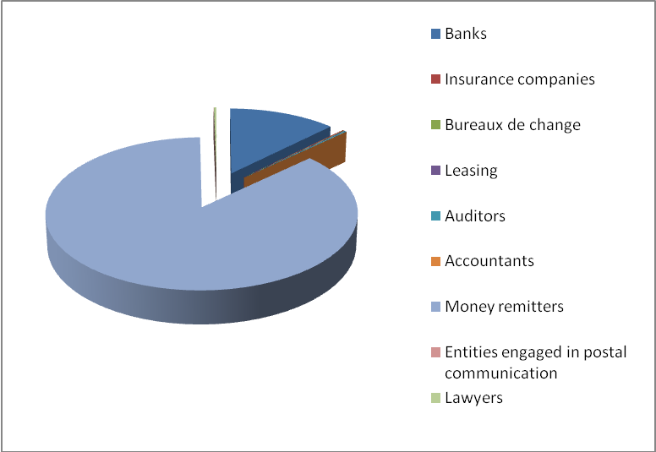
Obligors | No of reported suspicious activities
Banks | 552
Insurance companies | 5
Bureaux de change | 3
Leasing | 3
Auditors | 9
Accountants | 1
Money remitters | 3822
Entities engaged in postal communication | 1
Lawyers | 13

Most reports in 2014 were filed by financial institutions – money remitters and banks.

Banks are the institutions which submit the most thorough description of a ML suspicion accompanying a report. They provide information on connections between persons, as well as all the other information available to the banking sector when the subject person is their client. Out of the 552 reports submitted by the banking sector, 379 were assessed as having enough reasons to suspect ML so as to initiate a procedure in the APML.

In 156 cases the subject of reports were persons unknown to the APML, that is, persons who had never been subject to work in the APML, whereas in 223 reports it was established that the persons involved had already been analysed before. In these situations, data on new occurrences were incorporated into analysis and forwarded to the state authorities (the prosecution and police).

173 analysed reports were assessed as at the time not bearing enough grounds for further work, but activities of the subject persons are still being monitored in the IT system which, in case of new information (a new STR, request from another state authority, etc.) connected to persons involved in the previously reported transaction, signalises that a change has happened and that the old suspicion transaction should be reviewed under new circumstances.

Reports from the banking sector show that tax evasion is still a crime of high-risk for money laundering. The majority of reports refer to elements of tax evasion; these are followed in number by simulated legal arrangements and cash withdrawals from accounts based on fictitious business documentation.

A typological scheme recognised in the majority of reported transactions is the following: money transfers between three or more legal entities on basis of fictitious trade in goods, followed by cash withdrawals by one or more interconnected natural persons on behalf of the organisers of the fictitious business activities.

The next in number are reports related to a suspicion about the origin of funds in accounts of natural persons and business entities connected to them. Namely, the accounts in question record massive successive payments of cash of unknown origin. Based on collected data (e.g. on assets and business activities), it could not be established that the money originated from business activities or any other known sources, which is the reason why the cases were forwarded to the state authorities.

Referring to analysis of sources of funds in accounts of legal persons, suspicion of ML was triggered by payments based on loans, founder’s loans for the purpose of maintaining the company’s liquidity and, less commonly, daily payment orders, when it could not be confirmed that the funds paid to the accounts were actually intended to be used for development or maintenance of business activities, but the real motives of the founders were questionable.

The number of reports indirectly indicating to various sorts of fraud also increased – identity theft, falsifying of personal IDs, abuse of authority, falsifying of documentation and abuse of payment cards.

A slight growth was also noticed in the number of reports on persons who could be linked indirectly to human and drug trafficking. In these reports, amounts involved were not significant, but financial institutions suspected, on basis of clients’ risk analyses, they could be linked to persons from the criminal milieu.

Trade in goods on “the black market” also participates massively in reports, and the same modus operandi is still present in these activities. Namely, persons import and sell goods on the black market and then transfer from their personal accounts the money for payment for the imported goods, using as a description accompanying the transactions “aid to family”. These transfers are mainly directed towards China and the natural persons are usually sole traders.
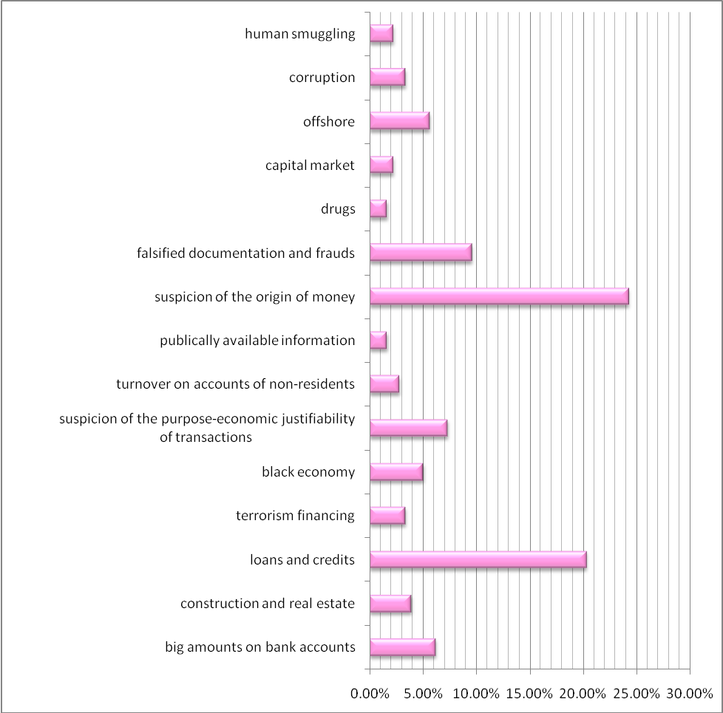
In descriptions of suspicious activities reported by the non-financial sector, ML suspicion was triggered by big cash deposits on basis of loans, either unaccompanied by proper documentation or accompanied by documentation based on which sources of money could not be established. Beneficial owners of companies, when founders of domestic companies are registered abroad and when complex ownership structures are involved, were also causes of ML suspicion because of the real motives behind this sort of organisational structure, especially when founders can be linked to offshore destinations. Foreign trade remains relevant for ML. Namely, advance payments towards offshore destinations indicate a suspicion about further materialisation of business activities, especially when there is information that goods paid for in advance were never delivered. Frequent changes to managing structures of companies also trigger ML suspicion, if they appear to be more frequent than usually necessary for regular business operations.

In 2014 banks reported 12 planned transactions – those not yet executed at the moment ML suspicion was formed.

Suspicion of terrorism financing triggered 4 reports.

Analysis of STRs showed that other financial institutions are being used increasingly for money transfers. Transactions reported by money remitters referred to natural persons – foreign citizens who mainly cross the state border illegally. Amounts involved were usually small and to the benefit of persons residing in Serbia at the moment.

Namely, although persons have bank accounts, they do not use them for cross-border transfers, which is not usual, especially when amounts involved are bigger (e.g. during a-few-months period, amounts of EUR 50,000 or more were transferred through money remitters). This type of behaviour aroused suspicion of the real motives of participants in these transactions and that these are not regular financial activities, but that persons are connected because of illegal practices. Such cases are mainly forwarded to intelligence agencies and the police.

Strategic analyses and other research
Analysis of bureaux de change – implementation of the Law and activities indicating to suspicion of ML
Analysis of transactions indicating to tax evasion and ML
Comparative analysis of work of FIUs – organisational structure, analysis of STRs, cooperation with the other state authorities, analytical tools
Analysis of typological activities in STRs filed by banks and analysis of future trends
Abuse of money remitters – Analysis of STRs submitted by money remitters and connections of persons with illegal activities

2.11. Typological cases – ML suspicion
The following modi operandi were noticed during work on cases as the activities indicating to a suspicion of money laundering or terrorism financing:
- Transfers between connected legal persons and withdrawals of cash from accounts of legal persons;
- Transfers via numerous connected legal persons based on fictitious businesses (trade in goods) followed by withdrawals executed by nominees to accounts, on behalf of organisers;

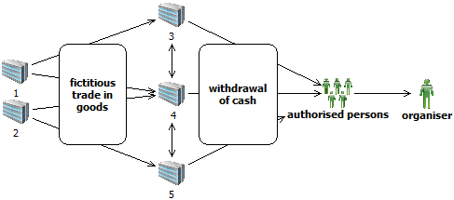
- Founder’s loan to maintain the company’s liquidity is a frequently abused purpose of transactions;
- Frequent withdrawals based on repayment of loans to maintain companies’ liquidity. The transactions were not preceded by loan payments and this way of withdrawing funds from accounts was used only to draw money from the companies’ accounts.


- Payments of founder’s loans to accounts of legal persons registered for providing hospitality services. In the media, the persons involved are linked to criminal activities. Sources of the funds paid to the accounts of these companies are dubious.


- Payments of founder’s loans to accounts of companies owned by the same person. Namely, large amounts are paid to an account of a company and then transferred to an account of another connected legal person.
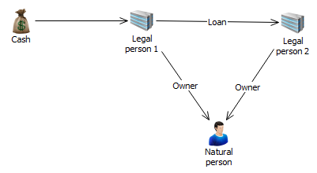
- Large cash deposits to accounts of a legal person in a short period of time (very commonly based on a founder’s loan for company’s liquidity). The money is used to settle obligations to the state, and sources of the money disposed of by the natural person – the company owner – are disputable.

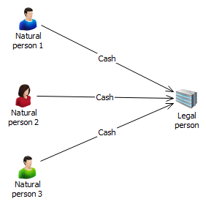
- Integration of money from selling of goods on the “black market”: The responsible person in a legal person has earned a lot of cash by selling goods on the “black market”. So as to integrate the funds into the financial system of the country, these persons use founders’ loans.

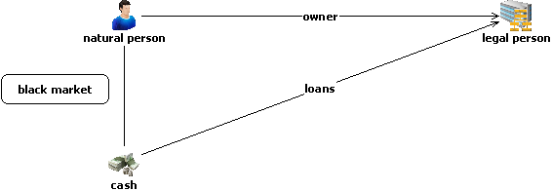

- Purchase of secondary raw material
Withdrawals of funds from accounts of legal persons based on purchase of secondary raw material by several interconnected persons, accompanied by usage of falsified documentation.

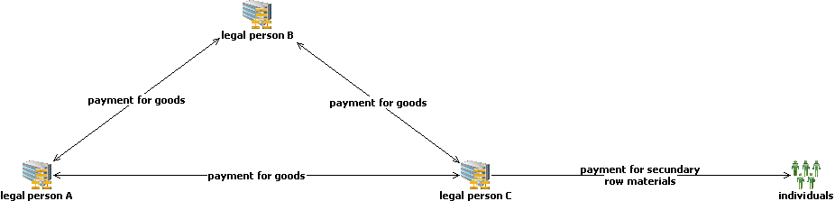

- Purchase of agricultural products
Transfers between accounts of several legal persons are accompanied by falsified documentation. Money is drawn from accounts based on purchase of agricultural products.
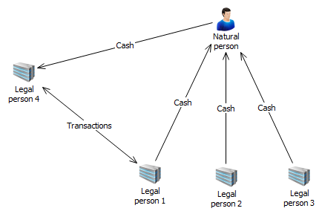
- Abuse of the transaction purposes: aid to family, inheritance, allowance and aid
Large cash deposits to personal accounts and further transfer of money (based on inheritance, allowance and aid) to accounts of several natural persons in China. It is suspected that a Serbian citizen is importing goods from China illegally so as to avoid paying customs taxes and tax on trade in goods and that the transactions to China described as inheritance, allowance and aid are actually payments for the goods imported. These transactions purposes are also used to pay for other sorts of illicit activities – persons are linked to drugs trade and human smuggling.

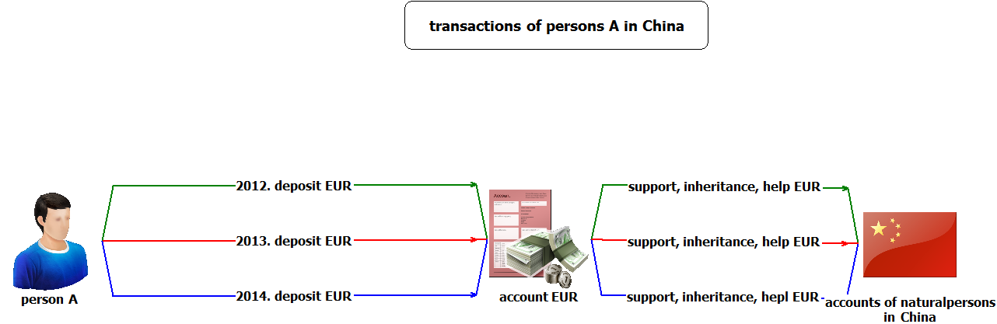

- Frauds and payment cards
Persons connected to criminal groups involved in various frauds pay big amounts to their personal accounts after which these are withdraw by the groups’ members who use payment cards in foreign countries. 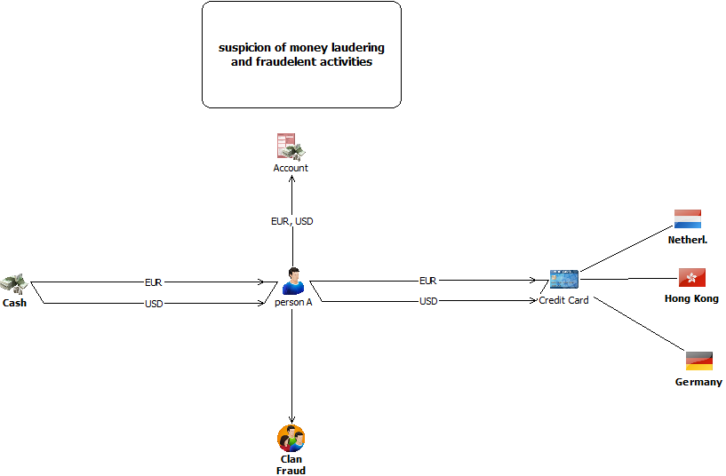

- Transactions with offshore companies
Transfer of big funds from offshore companies to accounts of Serbian companies and investing into the real estate sector. The beneficial owner of domestic and offshore companies is the same person.
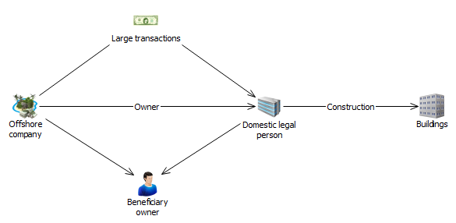

- “Cyber” crime and impersonation
- Money gained illegally (smuggling of cigarettes in foreign countries) is transferred through “hacked” accounts to accounts of “money mules” and then sent further to the smugglers’ accounts in Serbia.
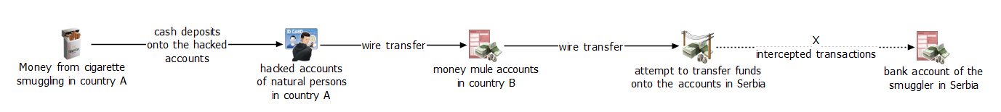

- Persons use false names and pretend to be raising funds for various purposes (e.g. money for a sick child). On that occasion, these individuals use personal accounts opened under their real names. Frequent cash deposits by numerous donors – payment orders are on false names and the transaction purpose is “payment for medical treatment of a child”. The funds are withdrawn in cash immediately.

- Person deposits cash, suspected to originate from drug trafficking, to several personal accounts held with different banks and uses the same documentation as a proof of the origin of these funds. The funds are invested in purchase of business premises which further generate material gain.

- Elements of corruption
- renting: enabling persons linked to criminals to rent state-owned land for a long period and get all the necessary permissions from responsible persons in the state authorities or public enterprises to build objects. After building objects, the responsible persons become owners of a part or the whole residence or office building, or receive monetary compensation.
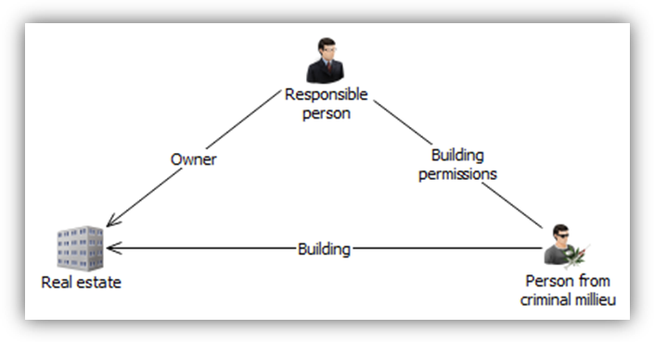
- abuse in the process of public procurement: adjusting the terms and conditions of a tender to suit legal entities whose owners are in friendly relationships with responsible persons in public enterprises. After winning the tender, the owners of the legal persons reward the responsible persons in the public enterprise with monetary compensation.
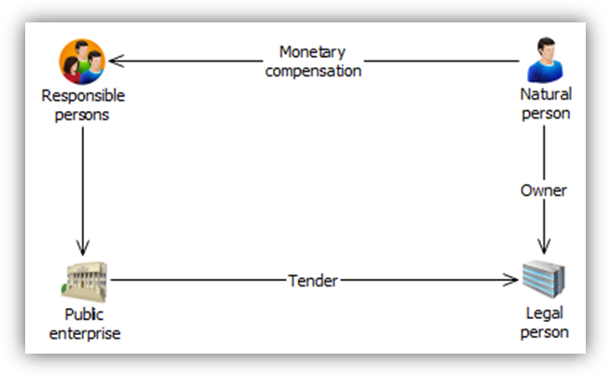
- granting credits to legal persons which do not meet the requirements: granting big credits to legal persons which do not meet the necessary requirements for credit approval, with help of persons holding prominent positions in the financial sector who are in return rewarded with monetary compensation or another favour. Money from the credit is further transferred through an account abroad back to the country and is used for personal needs.
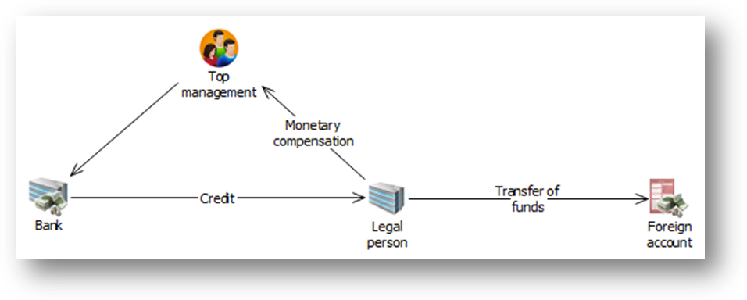
- Circulation of funds through accounts of connected persons
Contract on trade in immovable property signed between a legal entity and natural persons connected to the owner of the legal entity (via familiar or marital connections). The purchaser – connected person pays the agreed sum in cash. The owner of the legal person withdraws the funds based on founder’s loan to maintain the company’s liquidity.

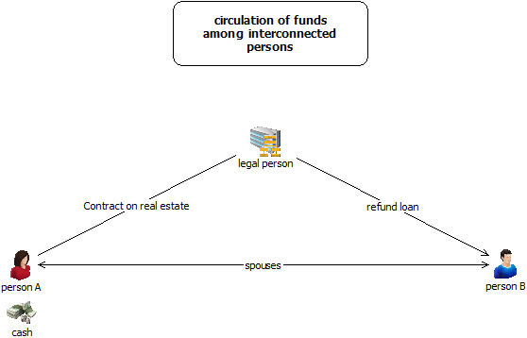

- Suspicion of terrorism financing
- Domestic association receives a lot of money in a short period from an organisation in a foreign country, based on donations from persons included in several lists of persons sanctioned in various countries because of terrorism. After the funds arrive to the account of the domestic association, they are successively withdrawn by a nominee to the account.

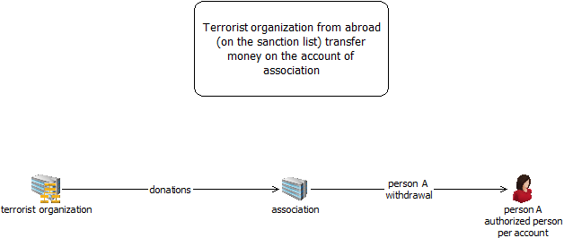

- Several humanitarian organisations from foreign countries transfer funds to the benefit of a humanitarian organisation in Serbia in a short time period. The funds are transferred in small amounts from many organisations from the EU countries (Germany, Albania, Belgium, Great Britain, etc.). Every transfer is accompanied by a contract on gift and aid. A smaller portion of the money is used for regular business activities while the most of it is withdrawn in cash.

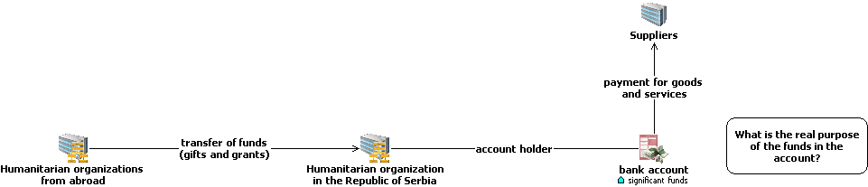

2.12. Examples of case studies forwarded to the prosecutor’s offices – STR analysis
Case study no. 1: Laundering money from foreign countries in Serbia

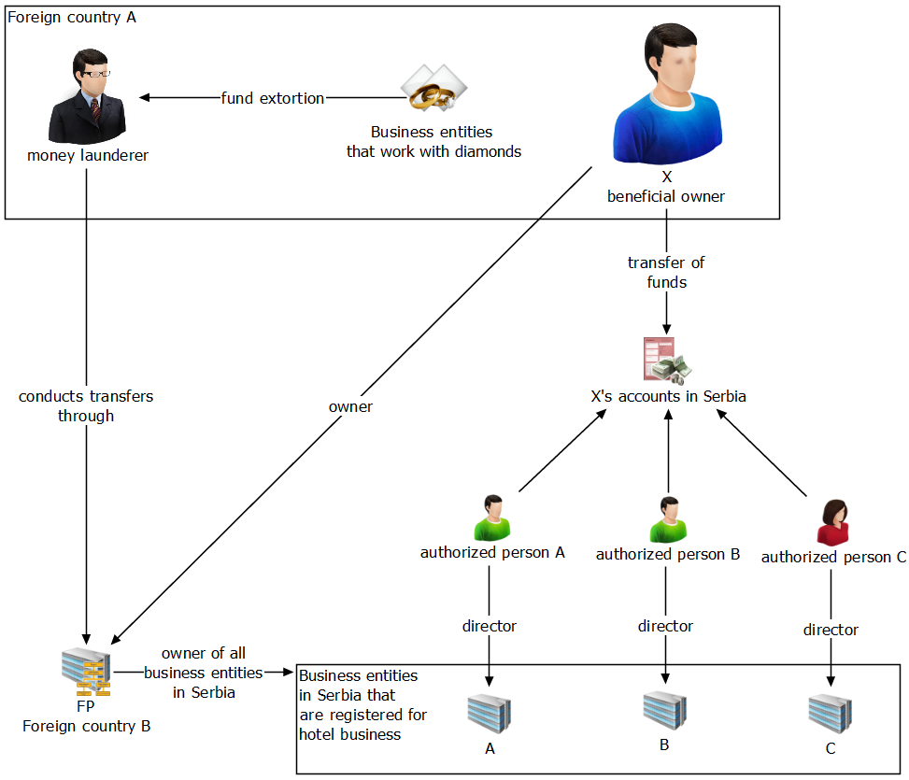
X is known to the police of the country А as a person who, according to a “money launderer’s” statement, can execute transactions quickly thorough his company FP registered in the county B. The “money launderer” drew money out of several business entities registered in the country A and doing the business with diamonds. The FIU of the country A says that X is the main person behind numerous companies involved in diamond business, from which money was pulled out. He is the organiser of the whole offshore construction with the purpose of avoiding to be connected to these activities. X transferred a lot of money of unknown origin to a personal account in Serbia. Nominees to this account are natural persons A, B and C – Serbian citizens. Natural persons A, B and C are directors in legal
persons A, B and C, registered in Serbia for the business of hotels and similar accommodation, owned by legal person FP. X was a shareholder in legal persons A, B and C and he transferred, in a short period, his share to legal person FP, registered in an offshore country B.

Case study no. 2: Suspicion of the source of funds on accounts of natural person

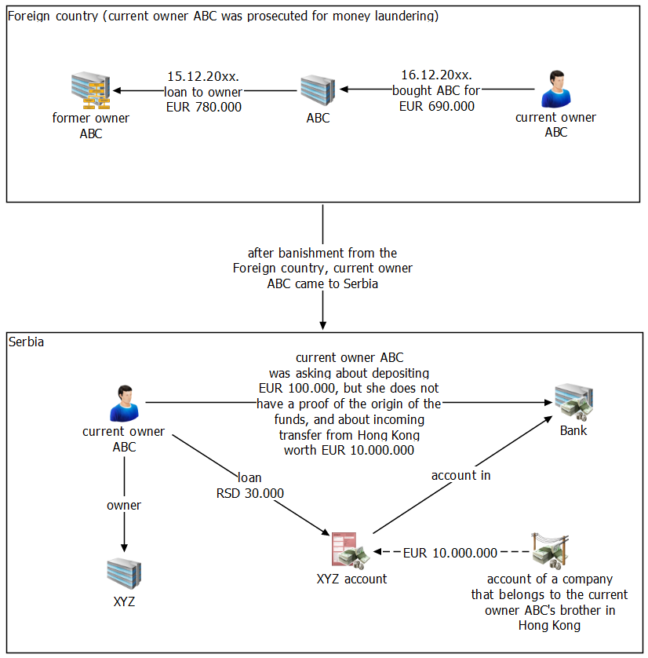
The current owner of ABC inquired in 2014 in a business bank how to credit a legal person’s account with EUR 100,000 based on the founder’s loan. He stated that he had the money in cash but did not have a confirmation of the Customs Administration since he was bringing it into the country on several occasions. He also claimed that he was expecting income to a foreign currency account of the legal person in the amount of EUR 10,000,000 from Hong Kong, from an account of his brother’s company. The current owner of ABC was banished from the foreign country for three years on 23 March 2012 by a decision of the foreign country’s authority in charge of affairs with foreigners, and is forbidden from entering the country until 29 July 2015. The reason for the decision was illegal stay in the country. Furthermore, the foreign country’s FIU states that according to the Business Register Agency in the foreign country, the current owner of ABC is the founder and director of legal person “ABC” d.o.o. (ltd). The founding capital of the company is EUR 692,800. Ownership takeover in this legal entity was the reason for initiation of prosecutorial investigation against the present owner of ABC. In mid 2011, a legal person from a third country – “former owner of ABC” – purchased the facility “OPR” d.o.o., which started to operate under the name “ABC” d.o.o. On 16.12.2011, 100% share in the legal person “ABC” d.o.o. was sold to the natural person – the present owner of ABC. On that occasion, he took over all debts and receivables of the company “ABC” d.o.o., including the claim for the founder’s loan transferred from the account of “ABC” d.o.o. to the account of “former owner of ABC” (founder of “ABC” d.o.o., before the present owner of ABC took over shares in this legal person), on 15.12.2011 (one day before the sales of the share), in the amount of EUR 780,000, based on the founder’s loan to maintain the company’s liquidity. On 30.12.2011, the Interpol red notice was issued against the present owner of ABC by the country B.

Case study no. 3: Suspicion of the source of funds on accounts of natural person

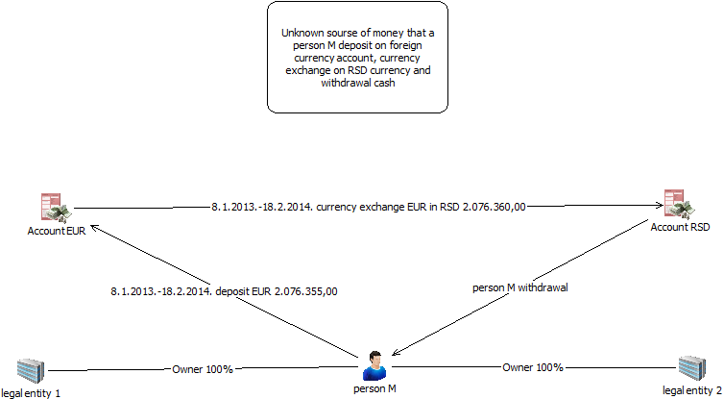
Person М executes frequent cash payments to his personal foreign currency account. Immediately after the payments, he converts the money to Serbian currency – RSD and withdraws it on the same day. Total turnover on the account in the period 1.1.2013 - 20.2.2014 amounted to more than EUR 2,000,000. Comparative analysis of transactions on accounts of the companies owned by M and on his personal accounts established no connections between these money flows, that is, it could not be confirmed that the big amounts M paid in cash to his personal accounts he had previously withdrawn from the accounts of the legal entities in his ownership, nor that the money originated from income these companies accrued. The legal entities in question trade in alcoholic beverages and cigarettes. It is suspected that the money being integrated into the financial system of the country originates from illicit activities. It is supposed that this way the ordering party in these transactions attempted to conceal the source of these funds, bearing in mind the fact that the money is transferred quickly thorough the accounts and then withdrawn in a short time period, as well as the main line of business these companies are registered for.

Case study no. 4: Transfers through offshore companies

A person against whom several criminal charges for most serious crimes were pressed in the countries of Western Europe established a legal entity in Serbia. After founding the legal person, this individual credited its account with cash in big amounts, based on founder’s loan to maintain the company’s liquidity. Additionally, a lot of money was transferred from the founder’s account abroad to foreign currency accounts of this legal entity in Serbia. The funds accumulated this way were later invested in building objects. After a while, the founder sold for at a high price the legal person to an offshore company whose beneficial owner is him. Transferring funds from abroad to the account of the domestic legal person continued, but now from the account of the offshore company.
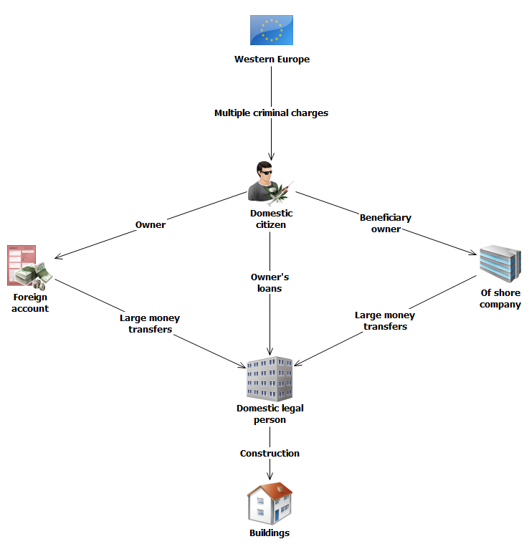

Case study no. 5: Tax evasion, abuse of authority in economy and money laundering

After execution of transactions and CDD measures applied, a bank reported an STR to the APML, related to legal person “P.I.P.H” d.o.o. Belgrade. In the period 18.3.2013 - 21.3.2013, there were four incoming transactions from the account of the agricultural cooperative “U.B.” to the account of legal person “P.I.P.H” d.o.o. Belgrade, totalling RSD 20,000,000 (approximately EUR 200,000). All the payments were executed from the account of the agricultural cooperative “U.B.”. These funds were used immediately to purchase foreign currency totalling EUR 178,630.12, after which they were wired to the account of legal person “M Company” Delaware. This account was opened with a bank in Cyprus. Trade in goods was provided as the purpose of these payments. Furthermore, on 22.3.2013 a payment was executed from the same account of legal person “P.I.P.H” d.o.o. Belgrade to the benefit of legal person “S Company”, Delaware, USA, totalling EUR 75,175.00. The account of “S Company” was opened with a bank in a neighbouring country. The stated purpose of this transaction was payment based on trade in goods. Joint work of the APML, Ministry of Interior and the Tax Police Sector of the Republic of Serbia established that the total of 6 legal persons from Serbia purchased foreign currency from daily income to their RSD accounts and these funds (totalling EUR 8,872,695.56 and USD 2,217,587.00) were further transferred to four accounts of foreign companies opened with a Macedonian bank, more precisely: “S Company”, Delaware, USA, “SP Company”, County of Sussex, USA, “L Company”, Mahe, Seychelles and “A Company”, Delaware, USA. During investigation, it was established these activities involved trade in goods in the black market. The funds accrued from selling of goods were transferred to accounts of six legal persons in Serbia (fictitious companies). The funds were then transferred to accounts of legal persons in the neighbouring country, and then further to accounts of numerous Chinese citizens suspected to be the beneficial owners of the goods sold in Serbia. The acting prosecutor’s office is currently leading a procedure against the participants in these activities, based on a suspicion of the crimes of tax evasion, abuse of authority in economy and money laundering.

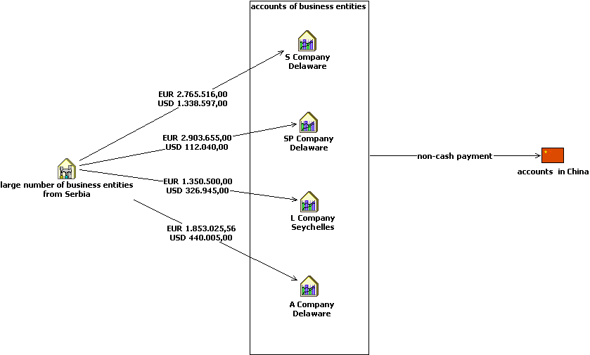

Case study no. 6: Transfer of money via the Western Union system conducted by persons linked to criminal groups

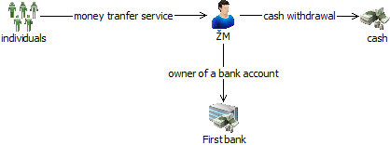
In a short time, a natural person received a lot of money from various persons from Russia, via the Western Union system. Analysis of data on the subject natural person established that he executed several foreign transactions, exclusively through money remitters, despite owning accounts opened with a few business banks in Serbia. Amounts involved and the transactions frequency were unusual, which aroused suspicion that the person intentionally circumvented the banking system and opted for another sort of financial services to execute transactions with foreign countries. Further analysis showed that the person in question was already registered with the relevant authorities as having committed a criminal offence.

2.14. Trends
Based on the experience so far, it is supposed that in 2015 the following activities will be prominent:

Numerous crimes of corruption as predicate offences for money laundering in analysed cases. A lot of abuse has happened in the process of privatisation and public procurements. The area of public procurements and transactions involving purchase of goods and services should be subject to enhanced scrutiny.

Identity theft and usage of bank accounts of persons with no criminal background to execute various transfers so as to send money abroad quickly are activities carrying very high risk. It is suspected that these modi operandi will be increasingly used in the future, especially when it comes to trade in narcotics.

Virtual currencies (e.g. “bit coin“) and insufficiently explored and regulated area of virtual communications and new methodologies creates for criminals a wide spectrum of new ways for investing money originating from illegal activities. Moreover, “non face to face” business relationships have influence on increase in the number of potential abuses. In the following period, these activities should be given more attention and the virtual currencies market should be monitored more closely, especially bearing in mind that some hospitality facilities and educational institutions are already accepting virtual money as a means of payment.

Certain games of chance and clients who deal with organising games of chance deserve attention as well. Insufficiently clear-cut authorisations of the state authorities in supervision of this area motivate criminals to turn to this business.

Simulated legal affairs with the aim of withdrawing funds from accounts of legal entities and abuse of the transactions with the code no. 221- trade in goods and services, so as to conceal the real purpose of transfers, is a way commonly used by persons intending to make illicit profit and draw money out of accounts, and it is assessed that this sort of fictitious business activities will continue in the period to come.
Use of services of money remitters so as to execute a cross-border transaction and transfer the money originating from illegal activities, especially when this involves frequent transactions in a short time period and in big amounts, should remain subject to closer observation and analysis.

Cross-border transactions executed on grounds of help and inheritance are often used to pay for illegally imported goods, and it is necessary to monitor them more attentively.

Transactions based on services - consultancy, marketing, research and development, etc. are an easy way for layering and integrating dirty money since it is difficult to determine the real market price of such services, as well as if the provision of services actually happened.

Sales of real estate for cash and payment of money to personal accounts of investors or contractors. The real purchaser is not identified in the banking sector, which leads to potential concealment of the actual owners of the real estate – only the investor in registered in the financial system.

Transfer of money from offshore destinations. The money transferred in forms of various loans, credit arrangements and founding capital should be subject to meticulous attention, especially when beneficial owners of companies registered in the so-called “tax heavens” cause suspicion.

Although the capital market has been facing crisis for a longer now, experience from the previous years shows that the process of a company’s takeover is still being used to conceal beneficial owners and persons intending to take over most of the capital of the company subject to takeover, especially when offers come from companies whose founders are registered in offshore destinations.

Offshore companies and construction works should be observed more attentively in the period to come. Investments in the real estate sector when founders of the building companies are offshore firms should be monitored with special attention, because of a suspicion that this way illegally gained profit has been invested into the regulated sector.

Import of goods at inflated prices: this way capital is still taken out of the country, despite increased obligations being paid. Companies frequently abuse this manner of payment so as to also pay for a part of goods sold in the black market, and it is supposed that these activities will continue in the future. Such payments are most commonly directed towards offshore companies.

Cash payments in short time and in big amounts, especially when foreign currency is involved, deserve a special approach. Related to cash payments, founder’s loans and other loans as methods to introduce money are often used for concealment of funds for goods sold in the black market and such transactions should be additionally analysed.

Illegal trade and smuggling of high value goods (luxurious goods) are a big source of dirty money. So far, fewer illicit activities and suspicious transactions have been related to this criminal offence, but such transactions should always be additionally monitored and the market for luxurious goods should be under enhanced supervision.

The unregulated area of trade in gold leaves a lot of room for manipulations. Purchase of scrap gold by organised criminal groups, illicit transfer over the state border, smuggling of golden jewellery and its further reselling, as well as purchase of gold through chains of jewelleries and exchange offices are activities which deserve greater attention.

In is not unusual that companies use transfer prices to avoid paying tax obligations. Since these prices are not subject to market influences, it is necessary for them to be constantly monitored.

“Carousel frauds” are a constant method for manipulations used by persons willing to acquire material gain accrued this way. International transfers involving big amounts in a short time period and with the purpose of getting tax credit should be analysed additionally.

3. SUPERVISION OF ACCOUNTANTS AND AUDITORS FOR COMPLIANCE WITH AML/CFT LAW
Based on Articles 82 and 83 of the AML/CFT Law (RS Official Gazette No. 20/2009, 72/2009, 91/2010 and 139/2014 – hereinafter referred to as: AML/CFT Law), the APML conducts supervision of accountants and auditors for their compliance with the AML/CFT Law, including:
- offsite and
- onsite supervision.

APML Supervision Activity
On obliged entity’s premises
Onsite inspection
Offsite inspection
Questionnaire on activities taken in relation to the AML/CFT Law

Offsite supervision is conducted by sending out, based on certain criteria, of questionnaires on the activities that the obliged entities, i.e. accountants and auditors, take in applying the AML/CFT legislation and by analysing the answers received. The criteria used to decide to whom the questionnaire will be sent, with respect to accountants, include the following: number of employees, annual operating income, net profit of the legal entity/entrepreneur, information received from the APML’s Section for Analysis, etc. In regard of auditors, the questionnaire was sent to all officially registered auditing companies.

Onsite supervision is conducted by inspecting general and individual acts, records and documentation, as well as business books, extracts from accounts, correspondence and other documents on the supervised subject’s premises or those of the entity directly or indirectly related to the supervised subject, by taking statements from the responsible person or other supervised subject’s employees, as well as by requesting information from state authorities and holders of public authority and inspecting documentation.

In developing the 2014 Onsite Inspection Plan, risk-based approach was applied; this approach means that the obliged entities that are assessed as exposed to a higher ML/TF risk in performing their registered business will be prioritised accordingly when fixing the Inspection Plan timetable.

The following elements were used as criteria for assessing the exposure to ML/TF risk:
- ML/TF NRA findings, based on which accountants and auditors were assessed as vulnerable at a low-to-medium level compared to other sectors (auditors: low level; accountants: medium-to-low);
- Offsite inspection findings where, in case that they reveal certain irregularities, the onsite inspection will be used to confirm the factual situation;
- Number of obliged entity’s employees;
- Obliged entity’s annual income;
- Business relationships with foreign PEPs;
- Information the APML received from other state authorities and anonymous persons;
- Information obtained from APML’s databases.

In conducting supervisions, the APML’s inspectors look at what kind of AML/CFT actions and measures the obliged entities take. Onsite inspection covers at least whether the obliged entity:

- has fulfilled the obligation to develop a risk analysis in line with the ML/TF Risk Assessment Guidelines for auditing and accounting service providers;
- conducts actions and measures for the prevention and detection of money laundering and terrorism financing before, during the course of, and following the establishment of a business relationship and whether the obliged entities:
- applies CDD, i.e. whether they have identified and verify the identity of the customer and established the identity of the beneficial owner;
- sends information, documentation and data to the APML;
- has appointed the compliance officer and his/her deputy and whether they delivered the act on the appointment of the above individuals to the APML in the statutory timeline;
- has adopted an annual training plan and whether they implemented the training programme, i.e. whether they delivered regular professional training to their employees;
- has conducted regular internal control and whether they made the report on the controls conducted and measures taken after the control within the statutory timeline;
- has developed a list of indicators for recognising suspicious transactions;
- applies other actions and measures set out in the AML/CFT Law.

3.1. Offsite inspections in 2014
APML conducted in 2014 offsite inspections of accountants and auditors by delivering to them a questionnaire on their AML/CFT activities taken as part of their compliance with the AML/CFT legislation, as well as by analysing the answers received.

The main objectives of the questionnaire on AML/CFT activities in compliance with the AML/CFT legislation are to:

- Screen the current level of obliged entities’ awareness of their obligations under the AML/CFT Law and their activities in compliance with the AML/CFT Law;
- Monitor in an indirect manner the development of the AML/CFT system;
- Learn about the level of obliged entities’ understanding of the AML/CFT legislation.

The Questionnaire is divided into 5 sections:

Part I – General information about the entity
Part II – Entity’s activity
Part III – Information on clients
Part IV – Reporting to the APML
Part V – Training of entity’s employees.

In the first part of the questionnaire, the obliged entity fills in the basic information on the entity, including the name, address and total number of employees as on 31 December 2014.

In the second part of the questionnaire, obliged entities replied to questions related to the entity’s activities and provided answers to the following questions: who is the compliance officer and his/her deputy; has the auditing/accounting service provider delivered to the APML the decision on the appointment of the compliance officer and his/her deputy; name and date of adopted procedures; have the procedures been put in line with the amended AML/CFT Law. Further questions were related to risk analysis, and they asked as follows: has the entity developed a risk analysis in accordance with APML’s Guidelines; is there a client classification in place in accordance with the risk analysis (low, medium and high); are there any instances of client business monitoring; has the entity ever terminated business relationships for failure to conduct CDD and client monitoring; and has the entity ever relied on third parties for CDD.

In the third part of the questionnaire, the obliged entities provided client-related information, including: the number of clients as on 31 December 2014; has the number of clients decreased or increased compared to 30 June 2014 and, if yes, the reason for such the change; whether the accounting or auditing service provider conducts client identification in line with Article 15 of the AML/CFT Law. In the third part of the questionnaire, the obliged entities provided client-related information, including: the number of clients as on 31 December 2014; has the number of clients decreased or increased compared to 30 June 2014 and, if yes, the reason for such the change; whether the accounting or auditing service provider conducts client identification in line with Article 15 of the AML/CFT Law; number of low- and high- risk clients; in which situations they apply simplified CDD, as well as the number of clients with respect to whom they apply simplified, normal and enhanced CDD; procedure to establish if a client is a foreign PEP; and information on whether the accounting or auditing service provider establishes the beneficial owner in case of medium- and high-risk clients.

In the fourth part of the questionnaire, the obliged entities provided information on the number of STRs, reasons for suspicion, number of internal reports sent by the entity’s staff to the compliance officer and number of internal reports sent by the staff to the compliance officer that were not forwarded to the APML.

In the fifth part of the questionnaire, the obliged entities provided information on employee training, including how many employees are directly involved in AML/CFT business; is there an annual training plan; is training delivered and how often; is knowledge tested and how often; and are the test results kept and for how long as well as whether the accounting and auditing service provider made a report on the conducted internal control and measures taken after the control according to Article 11 of the Rulebook on the methodology for implementing the AML/CFT Law.

The total number of auditing companies in Serbia is 60. In the previous year, the APML had sent letters to all registered auditing companies to date informing them that they had obligations under the AML/CFT Law. Along with this notification, questionnaires were sent to 57 auditing companies. Offsite inspection was conducted in all of the 57 auditing companies. It should be highlighted that the auditing companies showed exceptional willingness to cooperate; the fact that 57 of the auditing companies returned the filled-out questionnaire in the set timeframe testifies to such an assessment.

The total number of accounting service providers in Serbia is around 7000. In 2014, offsite inspections were carried out from February to December using various criteria, by sending out AML/CFT activity questionnaires. 173 firms were sampled and sent a letter informing them that they had obligations under Article 4 of the AML/CFT Law and were given a 20-day deadline to return the filled-out questionnaire on the accounting service provider’s AML/CFT activities. Of the total number of accounting service providers, 139 were legal entities whereas 34 were natural persons/entrepreneurs. Of the 173 supervised entities, 152 accounting service providers responded to the letter, whereas 17 entities failed to respond. 74 reminders were sent to accounting service providers; 61 entities responded, whereas 13 failed to do so.

3.2. Onsite inspections in 2014
In 2014, the APML conducted 8 onsite inspections. All onsite inspections carried out were related to accounting services providers.

Irregularities were found in all supervised entities, i.e. accounting firms.

46 economic offences were found in 8 supervised accounting service provides, as follows:

- 5 accounting firms had not developed a risk analysis, thereby breaching Article 7 of the AML/CFT Law;
- One public enterprise providing accounting services had not fully developed a risk analysis, i.e. had not developed the risk analysis in line with the APML’s ML/TF risk assessment guidelines for accounting services providers, thereby breaching Article 7 para 1 and 2 of the AML/CFT Law;
- Eight accounting firms had not recorded on the Business Registers Agency’s decisions the date, time and name of the employee inspecting the documents, thereby breaching Article 15 para 2 of the AML/CFT Law;
- Six accounting firms had not appointed compliance officer and his/her deputy, thereby breaching Article 39 of the AML/CFT Law;
- Four accounting firms had not submitted the name and work position title of the compliance officer and his/her deputy within 15 days of the date of their appointment, thereby breaching Article 42 para 3 of the AML/CFT Law;
- Seven accounting firms had not provided for regular AML/CFT training of their staff, thereby breaching Article 43 para 1 of the AML/CFT Law;
- Seven accounting firms had not developed an annual AML/CFT training plan for staff tasked with detecting and preventing money laundering and terrorism financing, thereby breaching Article 43 para 3 of the AML/CFT Law;
- Three accounting firms had not conducted regular internal control and or made the report on the internal control conducted and measures taken after the internal control within the statutory timeline, thereby breaching Article 44 of the Law;
- Five accounting firms had not developed a list of indicators for recognising suspicious transactions, thereby breaching Article 50 para 1 of the AML/CFT Law;

Upon conducting the onsite inspections on supervised entities’ premises, APML inspectors continued the onsite inspection at the APML by making the inspection report. The reports provided for a deadline of 15 days within which the supervised entities could submit objections to the factual situation found. 4 of the supervised entities submitted their objections to the factual situation found and noted in the inspection report. After receiving the objections to the factual situation found, the APML’s inspectors established that the supervised entities had not submitted enough evidence corroborating the objections, so the factual situation noted in the reports remained unchanged.

Amendment to the inspection report was made in case of one accounting firm due to an error that had changed the factual situation noted in the inspection report.

After the statutory deadline expired, the APML inspectors submitted to the basic prosecutors’ offices of Belgrade and Novi Sad economic offence reports against 8 supervised entities.

3.3. Analysis of penalties sanctioned by courts
In 2014, the Belgrade Commercial Court notified and sent to the APML 6 final and binding judgments. Of the total number of closed cases, two supervised entities appealed against the relevant judgment, which lead the Appellate Court to impose a lower amount of fine.

In the first case an aggregate fine in the amount of RSD 520,000 was imposed on the legal entity and RSD 60,000 on the responsible person in the legal entity, which was equivalent, according to the NBS median rate on the date when the judgment became final, to EUR 4,429.30 for the legal entity and EUR 511.07 for the responsible individual in the legal entity.

In the second case, an aggregate fine in the amount of RSD 320,000 was imposed on the legal entity and RSD 25,000 on the responsible person in the legal entity, which was equivalent, according to the NBS median rate on the date when the judgment became final, to EUR 2,769.60 for the legal entity and EUR 216.38 for the responsible individual in the legal entity.

In the third case, an aggregate fine in the amount of RSD 360,000 was imposed on the legal entity and RSD 30,000 on the responsible person in the legal entity, which was equivalent, according to the NBS median rate on the date when the judgment became final, to EUR 3,066.44 for the legal entity and EUR 255.54 for the responsible individual in the legal entity.

In the fourth case, an aggregate fine in the amount of RSD 680,000 was imposed on the legal entity and RSD 50,000 on the responsible person in the legal entity, which was equivalent, according to the NBS median rate on the date when the judgment became final, to EUR 5,877.78 for the legal entity and EUR 432.19 for the responsible individual in the legal entity.

In the fifth case, an aggregate fine in the amount of RSD 1,230,000 was imposed on the legal entity and RSD 50,000 on the responsible person in the legal entity, which was equivalent, according to the NBS median rate on the date when the judgment became final, to EUR 10,631.86 for the legal entity and EUR 432.19 for the responsible individual in the legal entity.

In the sixth case, an aggregate fine in the amount of RSD 900,000 was imposed on the legal entity and RSD 70,000 on the responsible person in the legal entity, which was equivalent, according to the NBS median rate on the date when the judgment became final, to EUR 7,779.41 for the legal entity and EUR 605.07 for the responsible individual in the legal entity.

The chart showing the economic offences found in 2014 in accounting services providers

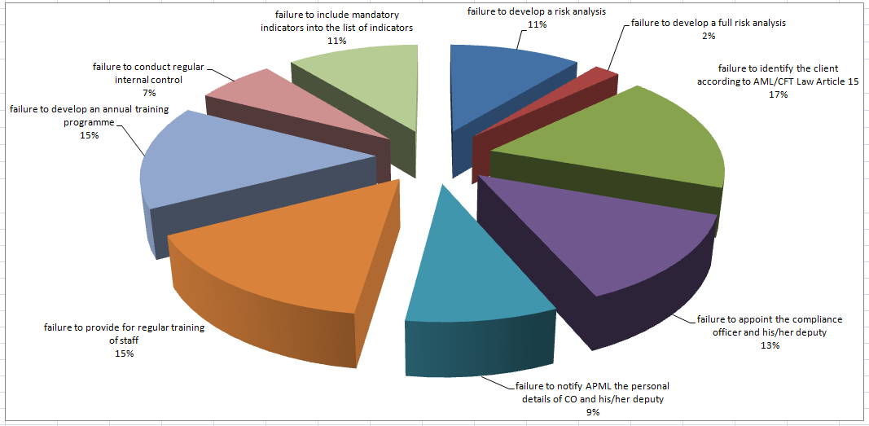

Chart showing the ratio between the total of entities supervised and economic offences found in 2013, and court decisions passed in 2014

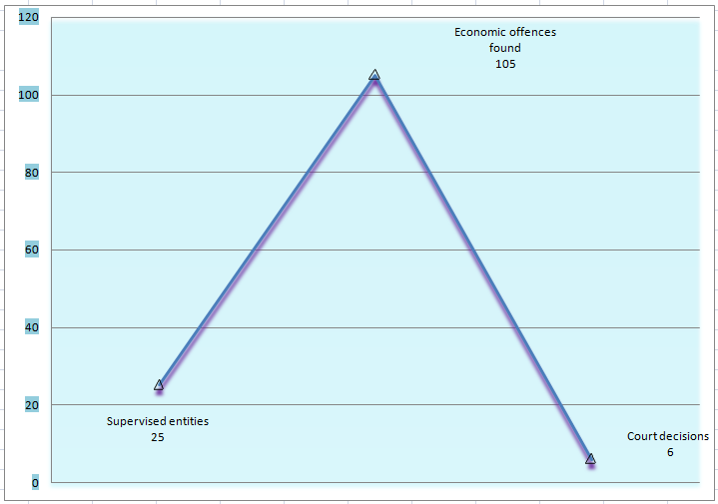

4. COOPERATION BETWEEN RELEVANT STAKEHOLDERS AT NATIONAL LEVEL

4.1. Cooperation agreement between APML and Republic Public Prosecutor’s Office
On 22 January 2014, the APML and Republic Public Prosecutor’s Office signed an Agreement on cooperation in preventing and detecting money laundering and terrorism financing.

This agreement further enhances the cooperation between the APML and the Republic Public Prosecutor’s Office at the operational level and in the financial intelligence exchange area, but also at the level of training and exchange of expertise, experiences and information. A permanent working group was established with the mandate to monitor the implementation of this cooperation agreement.

4.2. Working group on APML - Tax Police cooperation and information exchange operating procedures
Bearing in mind that the ML NRA found tax crimes to be high-risk predicate crimes, the APML and the Tax Administration Tax Police Sector in December 2014 set up a joint working group.

The objective is to ensure timely information exchange based on clearly defined criteria and procedures which should result in an increased efficiency and larger number of suspected ML cases with tax crimes as predicate crimes.

4.3. Serbian National TF Risk Assessment
In the first half of 2014, a terrorist financing national risk assessment was conducted. The TF NRA and the previously conducted ML NRA combined constitute one whole whereby the FATF Recommendation 1 is fully implemented. Namely, FATF Recommendation 1 calls upon countries to identify, assess and understand money laundering and terrorism financing risks. Authorities that participated in the work of the project group mandated to conduct the NRA were as follows: Ministry of Justice, Organised Crime Prosecutor’s Office, Ministry of Interior, Ministry of Foreign Affairs, Security Information Agency, Military Security Agency, Military Intelligence Agency, Customs Administration, National Bank of Serbia, and the APML. Security Information Agency, Ministry of Interior, Military Information Agency and Organised Crime Prosecutor’s Office had the task, each within their own remits of competences and areas of action, of describing the situation in Serbia (threat of terrorism, TF system vulnerability, measures taken and measures to be taken, etc.). The APML and Ministry of Justice analysed the legislation governing terrorism financing and terrorism in general. NBS and APML covered the segment related to the financing of terrorism. APML and Ministry of Interior covered statistics, and provided explanations describing the statistics. This information was collated in one single document, translated and sent to a Council of Europe expert for analysis and opinion. At the second workshop, two foreign experts provided their proposals for amendments of the text. After the amendments were made, the finalised text was shared with the state authorities and experts for another round of opinions. The final version of the NRA text was made in June 2014.

5. APML EU - SERBIA NEGOTIATION PROCESS ACTIVITIES

5.1. Negotiating Chapter 4 - Free movement of capital
Free movement of capital is one of the four freedoms on which the functioning of the EU internal market is based. Prevention of money laundering and terrorism financing is one of the topics under this negotiating chapter, in addition to harmonisation of legislation in the area of capital movements and current payments. The Ministry of Finance is the coordinator of the negotiating group for this chapter.

In the free movement of capital area, member states are required, with certain exceptions, to remove all restrictions to capital movements both within the EU and between member states and other countries. Current payments are related to current transactions, i.e. transactions involving residents and non-residents, whose underlying aim is not transfer of capital. Rules have been defined concerning the national and cross-border payment services in EU. The aim is for the member state to have simple, efficient and safe cross-border payments while improving the beneficiaries’ rights to use of payment services. Also, the intent is to improve competition by opening the payment services market to new participants, thus fostering increased efficiency and reduction of costs and establishing the necessary platform for a single area for payment in Euros.

Full liberalisation of capital movements is a prerequisite of EU membership and opens up possibilities, for instance, of opening bank accounts abroad, granting loans to non-residents, taking cash in and out of country without restrictions, equal treatment of nationals of other member states with respect to the acquisition of legal title over real estate, etc. In achieving liberalisation of capital movements, there is a considerable risk of attempts to misuse the free movement of capital and freedom of provision of financial services which are characteristic of the integrated financial area. It is this possibility of misuse that constitutes the reason why measures, which are the subject-matter of relevant EU acquis, are needed at the EU level. Misuse of the financial system to move illegal proceeds but also of the money that has been legally obtained but can be used to finance terrorism, poses a clear threat to integrity, proper functioning, reputation and stability of financial systems.

The most significant preventive act of the European Union in this area is the so-called Third Directive (Directive 2005/60/EC of the European Parliament and of the Council of 26 October 2005 on the prevention of the use of the financial system for the purpose of money laundering, and terrorist financing, Official Journal L 309, 25.11.2005, p. 15), which will have been replaced, as announced from the European Union, by a Fourth Directive by the second quarter of 2015. In addition to the Third Directive, relevant EU acquis are the Regulation (EC) No 1781/2006 of the European Parliament and of the Council of 15 November 2006 on information on the payer accompanying transfers of funds (Official Journal L 345, 8.12.2006, p. 1)and Commission Directive 2006/70/EC of 1 August 2006 laying down implementing measures for Directive 2005/60/EC of the European Parliament and of the Council as regards the definition of politically exposed person and the technical criteria for simplified customer due diligence procedures and for exemption on grounds of a financial activity conducted on an occasional or very limited basis (Official Journal L 214, 4.8.2006, p. 29–34).
It is the content of the preventive measures and other actions in this area that were the subject of the so-called explanatory and bilateral screening of European Union and Serbian legislation respectively. APML actively participated in these processes, and official meetings concerning these two screenings were held in Brussels on 13 October 2014 and 15 December 2014 respectively.

Even though Serbian system in this area is harmonised to a large extent with the relevant EU acquis, further harmonisation will be of exceptional importance particularly bearing in mind the expected adoption of the Fourth Directive in 2015. The adoption of a Fourth Directive at the EU level is also a reflection of the need to harmonise the current EU system with the 2012 FATF Recommendations.

5.2. Negotiating Chapter 24 - Justice, freedom, security
Creating an area of justice, freedom and security is also one of the EU objectives. Even though it is addressed under Negotiating Chapter 4 on free movement of capital prevention of money laundering and terrorism financing, i.e. the criminal aspect of these issues, is covered also within Negotiating Chapter 24 - Justice, freedom, security, particularly under the section on fight against organised crime (money laundering) or fight against terrorism (financing of terrorism). The Ministry of Interior is the coordinator of the negotiating group for this chapter.

In addition to the above areas, this chapter addresses also the areas of asylum, migration, visa policy, border control and Schengen, as well as certain aspects of fight against human trafficking, fight against drugs, police cooperation, justice cooperation in civil and civil matters, customs cooperation and Euro counterfeiting.

Relevant acquis in the ML/TF area, which are covered in this chapter, are contained in one EU act, i.e. Council Decision of 17 October 2000 concerning arrangements for cooperation between financial intelligence units of the Member States in respect of exchanging information, Official Journal L 271 of 24.10.2000, p. 4 – 6). Bearing in mind the importance of fighting ML and TF within the activities against organised crime, the explanatory and bilateral screening meetings looked at other issues other than those contained in the above Decision, such as the need for harmonising with the prospective Fourth Directive and specific measures that were provided in the proposal of the now adopted National AML/CFT Strategy and its Action Plan.

After explanatory and bilateral screening meetings on 2 - 4 October 2013 and 11 - 13 December 2013, respectively, in Brussels, Belgium, and following the official submission of the screening report, development of an Action Plan ensued to fulfil the criteria for opening the negotiations under Negotiating Chapter 24. APML took an active part in preparatory activities and development of the Action Plan throughout 2014 and the recommendations directly related to the APML include mostly the need to improve APML spatial and other capacities.

5.3. Negotiating Chapter 31 - Foreign, security and defence policy
Common foreign and security policy of the European Union was established in the Maastricht Treaty, and especially strengthened in the Lisbon Treaty, as the EU wants to speak with one voice when it comes to foreign policy. It is mostly founded on consensus of the member states and it constitutes a mechanism for adopting common declarations and guidelines for political and security issues that lead to common diplomatic action and to undertaking common actions. Decisions are adopted to define the EU position towards certain issues and measures to implement Common foreign and security policy, including sanctions. In addition to diplomatic action, main lines of action within this chapter are the Common security and defence policy, restrictive measures and arms control. Ministry of Foreign Affairs is the coordinator for this negotiating chapter.
Relevant EU acquis, within the APML’s remit, are mostly those related to restrictive measures taken where the EU decides that certain country violates international law or human rights and that it does not respect fundamental democratic values and rule of law as well as the acquis related to the fight against terrorism, i.e. its financing (e.g. The fight against terrorist financing [Council 16089/04], 14 December 2004; Revised Strategy on Terrorist Financing [Council 11778/08], 11 July 2008). Sanctions may vary, from diplomatic to economic, and the candidate country is expected to align, in the negotiation process, with the regime of restrictive measures provided by EU.
The segment where the APML offered its contribution is related to the application of international restrictive measures. Namely, the Proposal for a law on freezing of assets with the aim of preventing terrorism specifies the measures for freezing of assets thereby implementing the UN Security Council Resolutions 1267 and 1373 and hence the relevant EU acquis, i.e.

- Council Regulation (EC) No 467/2001 of 6 March 2001 prohibiting the export of certain goods and services to Afghanistan, strengthening the flight ban and extending the freeze of funds and other financial resources in respect of the Taliban of Afghanistan (implementing UNSCR 1267(1999) and 1333(2000);
- Council Regulation (EC) No 881/2002 of 27 May 2002 imposing certain specific restrictive measures directed against certain persons and entities associated with Usama bin Laden, the Al-Qaida network and the Taliban, and repealing Council Regulation (EC) No 467/2001 prohibiting the export of certain goods and services to Afghanistan, strengthening the flight ban and extending the freeze of funds and other financial resources in respect of the Taliban of Afghanistan;
- Common Position 2001/931/CFSP on the application of specific measures to combat terrorism [implementing UNSCR 1373 (2001)
- Council Regulation (EC) No 2580/2001 of 27 December 2001 on specific restrictive measures directed against certain persons and entities with a view to combating terrorism;
- Council Framework Decision 2002/475/JHA on Combating Terrorism of 13 June 2002, amended by Council Framework Decision 2008/919/JHA of 28 November 2008 (OJ L 330, 09/12/2008, p. 21–23).

As the FATF in its revised recommendations set the standard also with respect to the prevention of the financing of proliferation of weapons of mass destruction, the issue of prevention of proliferation of WMD, which is covered in this chapter, will be more and more important for APML work.

APML representative participated in the work of the Negotiating team for chapter 31, including at explanatory and bilaterally screening meetings held in Brussels on 15 July 2014 and 10 October 2014 respectively.

5.4. Other EU integration-related activities
APML gives its contribution in the process of implementation of teh Stabilisation and Association Agreement (SAA) which runs in parallel with the EU negotiation process. An APML representative took part at the first meeting of the EU - Serbia Sub-Committee on justice, freedom and security, held in Brussels from 5 - 6 June 2014.

In addition, the APML actively uses the European Commission’s mechanism for technical assistance and exchange of information for acceding counties (TAIEX (Technical Assistance and Information Exchange Instrument), especially for the purpose of improving the issues identified in the EU - Serbia negotiating process, i.e. relevant action plans. In 2014, APML was the beneficiary of two forms of assistance:

a) Study visit of the APML staff to FIU Malta in order to learn about good practices in the regime of sanctioning for violation of AML/CFT legislation; and
b) Expert mission of two staff members of FIU Poland provided their expertise to the APML in analysing APML capacity for performing its core functions and provided recommendations for improvement.

6. Major IT Team’s activities in 2014
In 2014, IT Team was implementing the procedures for the change of indicators for banks within APML Transaction Management Information System (TMIS) and in the database held by APML so as to have the old indicators still there on the reports and analyses and that they can be used, and to ensure that new indicators are visible only to the users.

Server certificates for obliged entities that are necessary for TMIS applications operation were renewed. In 2014 issuing and administering of user certificates for TMIS application was carried out.

New network devices were installed in the APML so as to have a more reliable and secure network and faster network traffic. A new network protection device was installed and set in order to increase security and prevent unauthorised access to APML IT system.

For greater reliability and smooth functioning of the APML, alternative services for main IT system components were set. This allows for the data held by APML to be safeguarded in case of mechanical and technical malfunctions and accidents. Work continued to stabilise, remove errors in and improve performances of DWH (Data Warehouse) and BI (Business Intelligence) systems that had been implemented in 2013.

Negotiations were held with a number of state authorities with the aim of networking databases of various authorities with the APML IT system with the purpose of using these databases in detecting and preventing money laundering and terrorism financing. Various queries were created, as well as reports and analyses that the APML staff need in their work, as well as for cooperation with other state authorities.

The IT team gave its contribution in the development of APML budget, by designing and planning IT projects related to the improvement and modernisation of the APML in 2015.

New applications and reports were created for analysing financing information of business entities that are further used in supervision activities as provided for under the AML/CFT Law. Support was provided to obliged entities in using APML’s application for transaction reporting and exchange of documents.

Continuous monitoring, supervision and maintenance was carried out of the APML entire IT system in the operative state (databases, internal and external network, applicative servers, applications, domain servers, email servers, devices for protection of IT system from unauthorised access, APML website, etc.).

7. INTERNATIONAL COOPERATION

7.1. Activities within the Council of Europe MoneyVal Committee
Serbia has been a member of Moneyval Committee since 2003. The Committee functions on the principle of mutual peer evaluations according to the FATF (Financial Action Task Force – international AML/CFT standard setter) Methodology and Standards. The Serbian delegation comprises representatives of the APML, Ministry of Interior, Ministry of Justice and the National Bank of Serbia; the APML Director is the Head of Delegation.

During 2014 three regular Moneyval plenary sessions were held (44th Plenary 31 March–4 April 2014; 45th Plenary 15-19 September 2014 and 46th meeting, 8-12 December 2014), attended by the APML Director and/or members of the APML staff.

In cooperation with Egmont Group (please refer to the part of the annual Report dedicated to Egmont Group), Moneyval almost entirely completed the typologies project Laundering of Proceeds from Organized Crime in 2014. An APML representative, who previously was a national risk assessment coordinator, was a leader of the Project, which gathered representatives from 27 countries, including those from out of Europe. The Project team held a meeting in San Marino, 13-14 May 2014, which in addition to FIU staff saw the presence of prosecutors, who held case study presentations. Serbian Deputy Prosecutor for Organized Crime delivered a presentation, which was subsequently included in the final typologies document. At the 46th Plenary in December 2014 a Draft Typologies Report was presented. Delegations are currently providing opinions and comments on the Draft and the adoption of the final document is expected at the next regular meeting in April 2015.

Serbia is the second Moneyval member to undergo the fifth round of evaluation by the new FATF Methodology and Moneyval rules more complex than those from 2009. This time the evaluation virtually lasts ten working days; relevant Serbian authorities are working on two complex Questionnaires, and are gathering information from financial and non-financial sectors. There is much to be done in terms of organization and the APML has a role of coordinator and lead institution. Basic guidance as to how to prepare for the fifth round evaluation was provided at a training workshop delivered in Belgrade 22-23 September 2014 by Moneyval Executive Secretary Mr. John Ringguth and the Head of Monitoring, Typologies and Training Unit Mr. John Baker. The Workshop was attended by the representatives of relevant AML/CFT authorities (Ministry of Interior, Ministry of Justice, Tax Administration, Customs Administration, National Bank of Serbia, Securities Commission, Security Information Agency, Military Information Agency, Military Security Agency, Prosecutor for Organized Crime, Supreme Court of Cassation, etc) and banks, and was organized by the APML.

The APML Director completed the training for evaluators in the fifth round, held in Strasbourg 3-7 November 2014.

The APML is monitoring the developments in Bosnia and Herzegovina, which has been under special monitoring regime since June 2014 due to the failure to pass proposed amendments to the Criminal Code with regard to terrorism financing. MoneyVal issued a public statement about this and placed Bosnia and Herzegovina under CEPs, that is, called for member states and jurisdictions to advise their financial institutions to undertake enhanced CDD measures with regard to clients/transactions from/related to Bosnia and Herzegovina. The APML put the public statement on its website and called upon banks to adhere to the recommended measures.

7.2. Activities within the Egmont Group
Egmont Group is an informal association of financial intelligence units (FIUs) worldwide, whose objective is to propagate and promote cooperation in terms of financial intelligence exchange among FIUs, according to the principles formulated at the Group Level and best practices. Egmont Group is an inclusive, non-political organization, whose membership includes the APML since 2003 and which convenes twice a year, namely in Plenary Meeting (between May and July) and in Working Groups and Heads of FIUs Meetings (usually in January and February). The APML Director is a member of Legal Working Group (LWG), although members of one working group can attend meetings of another group if necessary.

In 2014 Working Groups and HoFIUs meetings were held in Budapest, Hungary 16-19 February and the Plenary was held in Lima, Peru, 1-6 June. At the meeting in Budapest, the LWG discussed FIU Kosovo’s application for membership, despite the opposition expressed by a number of FIUs including the APML representative. In addition, WGs discussed new, amended membership procedures and a new version of a LWG questionnaire for potential members. Amendments to Memorandums of Understanding (MOUs) to be signed between FIUs were presented. At the Plenary in Lima the APML Director took part at the Outreach Working Group (OWG) meeting as the Kosovo FIU matter was discussed further. Due to systemic shortcomings identified during the sponsors’ visit, Kosovo FIU was not admitted to membership. Two strategic documents were adopted - Egmont Group Strategic plan 2014-17 and a new Regional Footprint, dividing members into eight groups for the purpose of better coordination of activities and pursuing the issues of common interest. Thus the APML was classified into the group Europe II, together with FIUs of non-EU member states. In the framework of national risk assessment training, which was held by the World Bank on the margins of the Plenary, the APML Director held two presentations on Serbia's experience in that respect. Furthermore, MOUs were signed between the APML and FIUs of Monaco and Liechtenstein respectively. The number of MOUs that the APML has in place is thus 44, although for most FIUs it is not a prerequisite for information exchange. Following the Plenary, Egmont Group has 147 members, a number which is expected to grow.

7.3. Memoranda of understanding (MOUs)
In 2014 the APML signed MOUs with two FIUs on the exchange of information related to money laundering and terrorism financing, namely with FIUs of Monaco and Liechtenstein respectively. Therefore by the end of 2014 the number of MOUs in place is 44.

7.4. OSCE
Cooperation between the APML and the Organization for Security and Cooperation in Europe successfully continued throughout 2014.

The most important activities include significant support given by the OSCE to the working group on ML trends and typologies in high risk criminal offences, as identified in the Report on National Risk Assessment in the Republic of Serbia. The working group created a typologies document, which is being prepared for print.

In addition, OSCE Mission in Belgrade supported the organization of two workshops on amendments to the AML/CFT Law in respect of supervision. The workshops were held at Vrdnik, Serbia, 27-29 August; 29 September – 1 October 2014.

Below is the list of activities organized by the OSCE alone or in cooperation with other entities, attended by the representatives of the APML in the capacity of either listeners or speakers:

- Delegation of Uzbekistan government officials visited the Administration during a study visit to Serbia with regard to the fight against corruption, 2-4 December 2014;
- Seminar on VAT Fraud in the European Union, 18-20 November 2014, with presenters from Europol, Eurojust and Eurofisc;
- 2014 Economic and Environmental Dimension Implementation Meeting – 2014 EEDIM, Vienna, Austria, 23-24 October 2014;
- Training on money laundering phenomenon, 28 – 30 October 2014, where an APML representative presented ML typologies
- Workshop on Terrorism Financing Investigations and Prosecutions, Belgrade, Serbia, OSCE and American Embassy in Belgrade
- Workshop on Improving Practices in Direct International Interagency Cooperation and Mutual Legal Assistance in Money Laundering Investigations and Asset Recovery, Ashgabat, Turkmenistan (APML presenter), 2 September 2014;
- Seminar on improving inter-institutional cooperation in the use of databases, organized by the OSCE Law Enforcement Division, 7 October 2014;
- Training on financial investigations for prosecutors, jointly organized by OSCE, State Department and US Ministry of Justice, 29 April 2014, Novi Pazar, Serbia, where an Administration representative presented a case study on money laundering;
- An APML representative participated as a presenter at regional workshops (Belgrade, Novi Sad, Kragujevac an Niš) on fighting against money laundering and financial investigations, organized for the Ministry of Interior.

7.5. Eighth regional HoFIUs conference, 20-21 October 2014, Podgorica, Montenegro
Montenegrin Administration for the Prevention of Money Laundering hosted and organized under the auspices of OSCE Mission to Montenegro the Eighth Heads of FIUs' Regional Conference in Podgorica, 20-21 October 2014.

The Conference brought together the representatives of FIUs of Serbia, Slovenia, Albania, Bosnia and Herzegovina, Macedonia, Croatia and Montenegro. The Ninth Heads of FIUs regional conference will be held in Bosnia and Herzegovina in 2015.

8. HUMAN RESOURCES AND TRAINING
For a more efficient and effective APML operation, and taking into account the change in international standards focusing on the usability of financial intelligence, APML prepared in 2014 a proposal for a new internal organisation and classification of work posts. The new proposal created a new Department for cooperation with other state authorities that will work on cases opened at the initiative of national authorities, whereas the analysis of STRs and reports collected from obliged entities will be done by the Department for analysis and financial intelligence. A total of 26 posts were envisaged to be filled by 40 staff members in total. The total number of permanently employed staff as on 31 December 2014 was 29 civil servants; all employees hold university degrees.

APML Organigram
Team for international cooperation, training and projects
Administration for the Prevention of Money Laundering
Department for analysis and financial intelligence
Department for interagency cooperation
International and Legal Department
Section for Supervision
ICT Team
HR and Financial Section
Section for legal affairs and harmonisation of legislation with international standards

The following is a list of trainings, conferences and other relevant events that APML staff attended as participants or speakers:

 | Event | Date | No of participants
1 | Seminar on secret data protection, held by Serbian National Security Authority | 24 January 2014 | 20
2 | Workshop on Amending AML/CFT Law, Hotel Park, Belgrade, organized by Coe MOLI project Serbia | 5-7 February 2014 | 4
3 | Seminar on legitimate and illegitimate use of offshore corporate structures, legal arrangements, foreign trade and free trade zones, Belgrade, under MOLI-Serbia Project | 24-25 February 2014
4 | Workshop on Enhancing the capacities of the Serbian Anti-Corruption Agency, Belgrade, Taiex | 26-28 February 2014 | 1
5 | Initial meeting on conducting National Risk Assessment on Financing the Terrorism in Serbia, Belgrade, organized by Coe MOLI project Serbia | 27 February 2014 | 5
6 | Introduction to Banking Supervision For non-supervisors, Joint Vienna Institute, Vienna, Austria | 3-7 March 2014 | 1
7 | Regular meeting with Serbian banks on STR quality and general feedback (presentations), Association of Serbian Banks | 5 March 2014
8 | Seminar on Financial and Economic Crime, Ministry of Interior – Financial Investigations Unit, Belgrade, organised by EU TAIEX Instrument | 6-7 March 2014 | 3
9 | Workshop on Terrorism Financing Investigations and Prosecutions, Belgrade, Serbia, OSCE and American Embassy in Belgrade | 13-14 March 2014 | 4
10 | Discussion on APML Importance and Status in AML/CFT and fight against ogranised crime, Serbian Association of Internal Auditors, Belgrade (presenter) | March 2014 | 1
11 | Conference on economic cooperation between the UK and Serbia, Serbian Chamber of Commerce, Belgrade | 7 April 2014 | 1
12 | Terrorist Financing National Risk Assessment Workshop, Belgrade, organized by CoE MOLI project Serbia | 8-9 April 2014 | 5
13 | Workshop on Analysis of Money Laundering Jurisprudence in Serbia, Belgrade, organized by CoE MOLI project Serbia | 9 May 2014 | 8
14 | Workshop delivered on NRA for FIU Macedonia (experience sharing, suggestions), Belgrade | May 2014 | 2
15 | Laundering the Proceeds of Organised Crime Workshop, San Marino | May 2014 | 1
16 | OeNB Seminar "Institutional Challenges for Candidate and Potential Candidate Countries on the Road to the EU and EMU", Joint Vienna Institute, Austrian Central Bank, Vienna, Austria | 12 - 16 May 2014 | 1
17 | Compliance function in banks (annual consultations with AML compliance officers) by Association of Serbian Banks, Belgrade, Serbia | 29 May 2014 | 7
18 | VII Expert Convention on Improvement, control and regulation of games of chance in former Yugoslav countries and EU, Euromat, Jakta | 9 June 2014
19 | Seminar on AML/CFT Law measures and actions to be taken by accountants, Belgrade, organised by Belgrade Chamber of Commerce (presenter) | 19 June 2014 | 1
20 | Study visit to the Maltese FIU, Valletta, Malta, TAIEX | 23 June 2014 | 3
21 | Infosession, AML/CFT Law application, typologies, supervision procedure, NRA, Belgrade Chamber of Commerce (presenter) | July 2014 (+September) | 1 (60)
22 | Workshop on Legal Drafting and the Revised FATF 40 Recommendations, Joint Vienna Institute, Vienna, Austria, organized by International Monetary Fund and Joint Vienna Institute | 4-8 August 2014 | 1
23 | Workshop on the Draft Law amending the AML/CFT Law, for supervisors and APML, Vrdnik, Serbia, supported by OSCE | 27-29 August 2014 | 10
24 | Workshop on Improving Practices in Direct International Interagency Cooperation and Mutual Legal Assistance in Money Laundering Investigations and Asset Recovery, Ashgabat, Turkmenistan (APML presenter) | 7-9 September 2014 | 1
25 | Seminar on amendments to Labour Law | 8 September 2014 | 1
26 | Workshop on the Financing of Terrorism, Belgrade, one APML presenter, organised by OSCE and American Embassy in Belgrade | 17-19 September 2014 | 5
27 | Infosession, AML/CFT Law application, typologies, supervision procedure, NRA, Belgrade Chamber of Commerce (presenter) | September 2014 (+ July) | 1 (60)
28 | 5th round MoneyVal evaluation training, Belgrade | 22-23 September 2014 | 12
29 | Seminar on Cash couriers, cross-border cash transportation, Ohrid, Macedonia, supported by UNODC | 23-25 September 2014
30 | Workshop on the Draft Law amending the AML/CFT Law, Vrdnik, Belgrade, supported by OSCE | 29 September – 1 October 2014 | 8
31 | Seminar on Tax Fraud Investigations, USDOJ, Belgrade, Serbia | 7-9 October 2014
32 | Business Support Network, Seminar on Amendments to the Law on Accounting, Belgrade | 7 October 2014 | 1
33 | Factoring - current state of play and future prospects - one year after the adoption of Law on Factoring, organised by Belgrade Chamber of Commerce | 15 October 2014 | 1
34 | Amendments to the AML/CFT Law - a look at the conducted supervision of audit companies; Belgrade, organised by Authorised auditors chamber (APML presenter) | 28 October 2014 | 1
35 | Seminar on AML/CFT Law, Serbian Chamber of Commerce (APML presenter) | October 2014 | 1 (120)
36 | NRA report writing workshop, Montenegro (APML presenter) | October 2014 | 1
37 | Regional HoFIUs Meeting on new ML typologies, FATF recommendations, PEPs, Podgorica, Montenegro | 20-21 October 2014 | 1
38 | Seminar on Carousel fraud and EU funds fraud, Belgrade, by OSCE and Europol | 18-20 November 2014
39 | Novelties introduced by recent amendments to the AML/CFT Law; case studies and practical examples with typologies (APML presenter), Belgrade, organised by Belgrade Chamber of Commerce | 6 November 2014 | 3
40 | Foreign Investors Association Conference - White book launching, Belgrade (guide to foreign investment) | November 2014 | 1
41 | Seminar on ML, typologies, procedure to initiate an APML case for Security Information Agency (APML presenters) | November 2014 | 2 (35)
42 | Seminar on Organised crime and fight against terrorism/extremism, Security Information Agency, Belgrade | 24-25 November 2014 | 10
43 | Course on Staff Assessment (work targets, assessments), Belgrade | 5 December 2014 | 1
44 | Anti-Corruption Agency Conference, debate on the Anti-Corruption Law - analysis and results (esp. political party financing in election campaigns), Belgrade | 9 December 2014 | 1

9. APML FINANCIAL REPORT
In 2014, APML successfully closed all financial and accounting operations and tasks and secured, through timely and adequate financial planning, timely collection and payment of liabilities, at monthly and daily level within the available appropriations, an efficient and legitimate use of the APML budget that was less by almost 20% compared to 2013.

The 2014 Budget Law allowed a total of RSD 63,442,000 for APML operations financed by the Republic of Serbia budget, while the budget execution percentage against the total earmarked funds was 85.62 % and has the rising tendency compared to previous years which is shown in Chart 1.

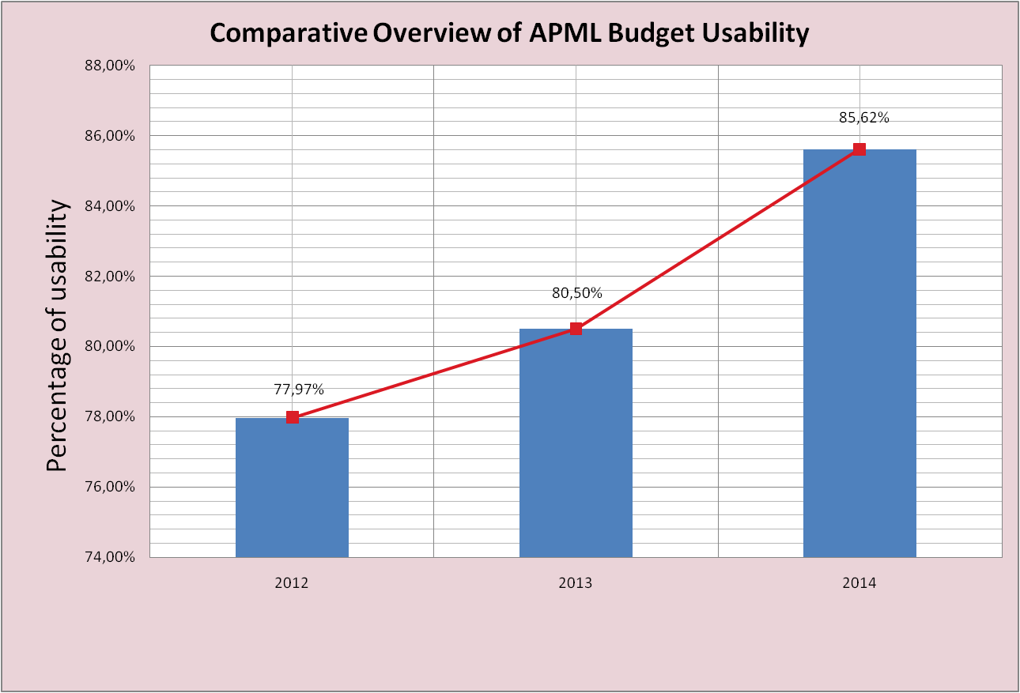

Chart 1: Comparative overview of APML budget usability

In 2014 a total of 460 decisions for payment were passed based on which payments were made and developed 100 supporting specifications. The APML Financial Team also issued, through the Treasury Administration, electronic payment orders for all payment orders through and monitored execution of liabilities undertaken. For the execution of payment orders, exchange of financial data and following of statutory provisions related to public procurement, the APML’s financial staff use seven specific software applications ensuring direct connection to other state authorities thereby networking the APML directly into the Finance Ministry’s IT system.

An APML internal act (Directive) was drafted based on the Law on Public Procurements governing the public procurement procedure and in application as of 11 March 2014. Nine public procurement procedures were conducted for procurement of goods and services: 6 procurements of goods (hardware - servers and additional equipment), virtualisation software for current infrastructure and 3 procurements of services one of which was related to hosting services, thus ensuring continuity of operations and security of the entire IT system. Each of the public procurements included an assessment of whether it was justified and purposeful respecting the principle of rational spending of public funds and control of expenditure.

10. CHALLENGES AND OBSTACLES IN ACHIEVING OBJECTIVES
Lack of capacities in terms of human resources and an extremely wide remit of APML responsibilities is a problem for APML operation. Namely, even though 40 posts are envisaged, only 27 civil servants are currently permanently employed. The European Commission and other international organisations following the money laundering area in Serbia have drawn attention to the problem of the scarce APML resources, particularly having in mind the various APML’s responsibilities whose number is significantly higher than what international AML/CFT standards require of an FIU.

In order to increase the number of employees it is necessary to secure adequate work premises even for work of the current employees.
Further strengthening of interagency cooperation for a more efficient functioning of the entire AML/CFT system will be APML’s priority for the future. Namely, experience from STR analysis so far and feedback received from competent prosecutors’ offices point to the need for the APML to have access to the Interior Ministry’s database.

The plan to set up an AML/CFT training centre is yet to be implemented. The reason for failure to materialise this idea is the lack of adequate office space.

Cases are forwarded to prosecutor's offices according to the Agreement signed with the Republic Public Prosecutor's Office on 22 January 2014.
The statistics refers to the cases forwarded at the initiative of the APML to the Republic and higher public prosecutor’s offices
In December 2014, the APML established working procedures with the Sector of Tax Police. All transactions referring to the criteria defined in the Procedures are analysed for a specified period of time.
Analysis – Prepaid cards is published on the website of the APML (www.apml.org.rs)
Information taken from the Authorised Auditors Chamber website - www.kor.rs

