MONEY LAUNDERING TRENDS AND TYPOLOGIES 2012 – 2014

MONEY LAUNDERING TYPOLOGIES IN 2012

The analysis of the transactions reported to the APML in 2012 revealed the following typologies:

• Natural persons deposit considerable amounts of foreign currency in cash to their foreign currency accounts held with different banks as time‐deposit. The origin of funds cannot be established. The depositors are most frequently young persons, and in most cases unemployed.

• Natural persons deposit considerable amounts of cash to their personal bank accounts, both foreign currency and RSD. In a large number of cases these individuals are founders of real estate trading companies. The above cases revealed failures to comply with Article 36 of the AML/CFT Law related to the prohibition of cash payment for goods or services in the amount of EUR 15,000 or more. The real estate is believed to be sold for cash and the money deposited to the personal bank accounts of the companies’ owners for further investment.

• There is a continuing trend of company founders’ depositing considerable amounts of money to the bank account of newly‐founded legal entities under the purpose of founder’s loan for company liquidity. The money is then transferred through bank accounts of a number of associated legal entities, the transactions most frequently being described as trade in goods and services, even though the actual trade or any business activity have never occurred; the funds then, following numerous transfers, returns to the bank account and is withdrawn in cash.

• Legal entities transfer funds among each other as provision of services (consulting services, market research and development, etc.) the price of which is difficult to determine, followed by further transfers of funds to off‐shore destinations;

• A large number of legal entities make transfers among each other described as loan, followed by withdrawal of the funds by natural persons other than the company owners or its nominees, which raises suspicion as to the beneficial ownership of the companies;

• Legal entities transfer funds to companies located abroad as advance payment for import of goods, where the import actually never takes place;

• Funds are transferred from off‐shore areas as approved credit facilities or loans to the bank accounts of legal entities in Serbia, followed by a transfer of the funds to the bank accounts of other associated legal entities (same owners, same company addresses, etc.) shortly afterwards. The funds are then transferred to new companies whose owner is usually registered in an off‐shore area.

• Natural persons’ bank accounts are credited from abroad as financial support. The money is credited successively in smaller amounts and then withdrawn in cash. The individuals withdrawing the funds from the accounts are not their holders but nominees and are linked to individuals from the criminal milieu;

• Natural persons, Serbian citizens, deposit cash to their personal foreign currency accounts. They also hold accounts with banks in neighbouring countries. After crediting the accounts in cash, the money is transferred to RSD accounts of natural persons, i.e. founders of investment companies, and withdrawn as material cost.

• Non‐resident persons deposit cash to their personal bank accounts and then transfer the money further to a large number of bank accounts held by different individuals. Further checks reveal that even though they have recently crossed the Serbian border they have declared no funds at the crossing, which they were required to do under Article 67 of the AML/CFT Law. These individuals also hold bank accounts in the countries of their origin, yet have not used them to transfer the money to Serbia. The databases show that they only use the accounts to receive cash payments. The income they make is far below the average cash deposits that they make to their bank accounts in Serbia.

• Legal entities transfer funds as payment for services to bank accounts of foreign legal entities, and then, in short time, the same amount of money is returned to Serbia and is later withdrawn from the accounts of these legal entities. The founders of the Serbian legal entities are foreign companies whose bank accounts are credited under the grounds of payment for services.

• Legal entities act in collusion with the aim of taking ownership over a company;
• Purchase of share in a company; more specifically, when founding a company, the founding capital is introduced in rights or securities. After a certain time, the rights are transferred to another owner (‘the shares are sold’).

• A large number of transactions are transfers to offshore company accounts where the stated purpose for the transactions is development services provided. The accounts of the newly‐founded companies show frequent transactions on the grounds of loan provision involving also other associated legal entities, and then, immediately after the depositing of the loans, the funds are transferred to offshore areas.

• A large number of persons from foreign countries transfer funds to the bank account of an individual in Serbia who immediately withdraws it in cash. The individual in Serbia has no family, business or any other relationship with the persons from foreign countries.

• Money is withdrawn from bank accounts of newly‐founded companies on the grounds of income from company’s profit, even though this is not justifiable (there are no financial statements on the company’s business operations).

• Funds are transferred from the bank account of a legal entity to the bank accounts of a large number of companies on the grounds of investment in buildings and equipment and quickly afterwards the money is further transferred from these bank accounts to the accounts of newly registered companies. One and the same natural person is the nominee for all bank accounts of all companies.

• Newly‐founded companies make an extremely high volume of transactions in their accounts immediately after registration. The money is then quickly transferred to the bank accounts of companies headquartered in tax‐havens.

MONEY LAUNDERING TRENDS

Money laundering trends in Serbia are influenced by a set of factors such as the level of Serbia’s economic development (GDP and standard per capita), level of development of individual industries or economic sectors that may attract or that attract investment; poor legislation which may provide opportunities for money laundering or financing of terrorism; exposure to international financial flows; existence of institutions and organisation at national level against money laundering and terrorism financing; resilience to the influence of crime on the economic and financial systems; existence of awareness of the detrimental effect of money laundering and terrorism financing on the country.

If we take into account the above factors and the findings of the National Risk Assessment process, together with the observed money laundering typologies in certain sectors, we assume the money laundering will have a trend in the following sectors of the Serbian economy:

Banking sector

As the key sector in terms of financial flows in Serbia we can expect the following:

• A tendency of placing and integrating dirty money in banking products yielding income to investors or money transfers through the banking system towards the final integration in the target investment (purchase of real estate, investment into securities, acquisition of companies, etc.);

• A tendency of placing and structuring of dirty money through a number of business accounts with the aim of disguising the origin of the money and making the identification of those involved in the transactions and of the owners of the money difficult;

• International flows of capital with questionable origin, especially the incoming transactions from the bank accounts of offshore companies that are difficult to identify in business and financial terms as well in terms of their ownership, and which are assumed to have acquired the money in an illegal manner. Experience shows that this incoming money is integrated through the provision of loans to Serbian companies or through founders’ shares in the initial capital, through credit facilities or payment of services that are not economically reasonable with the intention thereby to introduce the dirty capital into legal financial system;

• Numerous cash and non‐cash transactions involving natural and legal persons and indicating that they arrive from the grey area of economy, which points to the crime of tax evasion;

• Capital flight, especially in the form of funds transfers through payment for fictitious services (especially in the area of marketing and consulting) which leads to “disguising the operating costs” and unrealistic presentation of income in the balance sheet which also points to the intention of decreasing the amount of tax base and the liabilities due to be paid as public revenue. We also noted that dirty money is ‘legally’ taken out of the country; there is a trend of ‘fictitious’ services (that have never been actually rendered) being paid to offshore companies.

• Incoming flows of money to non‐resident accounts of suspicious natural persons where the origin of the money is difficult to establish and which is coming from countries with strict banking secrecy rules and with characteristics of offshore areas;

• Inflows in extremely large amounts from companies whose owners are unknown where the incoming transactions arrive from offshore zones and the money is then used to purchase shares in companies with no apparent economic justification;

• Experience shows that numerous perpetrators of proceeds‐generating crimes place their illicit proceeds in the banking sector in the form of deposits or targeted transfers the aim of which is their integration in investments.

Capital market

• Even though the capital market has been in crises for several years now, previous experience indicates that the trend of company acquisitions will continue; the acquisitions take place in the form of purchasing of blocks of majority shares by investors with suspicious biographies and capital, related to acquisition offers coming from offshore companies owned by unknown individual or where the money is invested through ‘front’ companies with the aim of disguising the trace to the origin of the funds;

• Purchase and sale of securities where the collateral was secured by cash deposits in specific‐purpose accounts and whose lawful origin cannot be reasonably proven;

• Foreign investment funds with unknown ownership and capital structure;

• The trend of market manipulation and insider trading will remain which is relevant from the AML point of view as these activities were criminalised and recognised as proceeds generating crimes. Here we should also take into account that the money deriving from crime has the tendency of being placed and multiplied through complex and less transparent activities;

Real estate market

• The analysis of the real estate market shows that this is, at the global level, “the most attractive sector” for investment by organised criminal groups, which can also be said for the Serbian market. Experiences show that the following trends of money laundering and integration will remain:

• Placement of dirty money by crediting bank accounts with cash or depositing money to bank accounts with the intention of purchasing construction land, construction or purchase of completely built houses, flats and business facilities.;

• Placements of dirty money through front companies and individuals buying or investing on behalf of the beneficial owners;

• Founding or acquisition of legal entities specialising in construction industry and placement of dirty money in these legal entities in order to boost their capital;

• Individual investors raising funds of unclear origin and from suspicious clients and further re‐investing or placing them in construction industry;

• Offshore investors, whose beneficial owners are unknown, appear as founders of legal entities engaged in construction industries, invest money of unknown origin in the form of capital increases, loans or in purchasing of company shares that are often overpriced.

Currency exchange operations

• Conversion of dirty money – daily receipts (usually originating from sale of drugs on the street) – into an effective foreign currency, mostly into higher denominations for a more convenient handling;

• Organised money laundering by organised criminal group members through exchange offices chains assumed to be owned by them;

• Conversion of dirty money through numerous fronts in order to conceal the suspicion caused by the amounts or suspicion on the origin of the funds.

Foreign trade

Over a longer period of time we have noticed a trend of foreign trade operations, especially of import activity through off‐shore companies figuring as sellers to Serbian companies where the seller and purchaser are associated, i.e. the purchaser is actually the founder of the seller. The goods usually originate from developed countries but are delivered through intermediaries contractors (official vendors), fictitious companies, usually headquartered in an off‐shore area. There is a trend of over‐invoicing in these transactions, for instance:

• The goods are imported using inflated invoices the purpose of which is to take out the surplus capital or to launder the gray or black economy, which constitutes crime. In these cases, the money pours out to offshore companies which then pay the actual price of the goods.

• Also noticed are a few instances of under‐invoicing (i.e. the receivables are fictitiously decreased) with the aim of establishing slush funds in offshore areas;

• Goods are imported at extremely low (dumping) prices in collusion with vendors. The goods are then lawfully sold at realistically shown, i.e. higher, prices and are also partly traded in the informal economy. In such cases, the liabilities toward the foreign vendors that are shown through the payment operations records are far lower than the actual prices (distortion of the ‘fair price’ principle and misstatement of figures in order to pay less taxes) where the ‘full price’ or ‘realistically shown price’, i.e. purchaser’s obligations, is compensated for through the creation of ‘fictitious invoices’ followed by cash payments usually by physically transferring the effective foreign currency across the state border.
• Smuggling of goods from other countries – influence on ‘black economy’. The goods are imported illegally and then sold for cash only. The foreign vendors, who the goods have been acquired from illegally, are usually paid by means of transactions from the accounts of numerous natural persons (mostly unemployed) from Serbia to the account of a foreign natural person (connected to the foreign vendor), the stated purpose of transactions being help to family, or something similar. The money flows are extremely difficult to track due to the abuse of the purpose of payment and many persons involved.

Internal trade

The most recent research points to a high level of grey economy whose ratio in the GDP is now as high as 30 %. This is a particularly important piece of data as it involves high levels of illegal money flows in the grey zone of the economy, which further involves evasion of public revenue, i.e. tax evasion, unfair competition and inefficient market distribution. There is a noted trend in internal trade of money laundering through:

• Fictitious trading through phantom firms opened solely in order to make the grey trading area appear legitimate and legalise the proceeds;

• Fictitious daily receipts intended to legitimise the cash;

• Provision of loans to legal entities out of the proceeds from grey economy, to be used as current assets in the company;

• Linked money flows among legal and natural persons in order to move the money through a number of accounts and bring it back again into cash flows (grey economy) by cash withdrawals.

Trade in gold

Gold has been and will remain the most important ‘money’ of all time. This has been particularly evident over the recent years with the emergence of the global financial crisis. Contrary to the overall economic situation and an ostensible economic slowdown in Serbia, there has been a noted increase in gold trade. In particular, there is an evident increase in the levels of purchase and smuggling of gold which is directly linked to organised crime activities. Additional ‘motivation’ for the criminals is provided by a rather unorganised legal environment when it comes to trade in gold.

Money laundering trends:

• Purchase of gold, especially of scrap gold in the black market by organised crime groups;

• Purchase of gold (scrap gold) using the money of unknown origin through the chain of goldsmiths’ shops and bureaux de change;

• Purchase of scrap gold using the money of unknown origin and its smuggling across the state border;

• Purchase of scrap gold by foreigners and nationals using the money of unknown origin and its export in an irregular manner (no licence, disguising the true form of gold, chopping and melting beyond recognition);

• Smuggling and import of jewlery to Serbia which is suspected to have been made out of the scrap gold purchased in the Serbian black market.

Games of chance – betting places

• Unauthorised organisation of games of chance by legal entities and individuals involved in crime and generation of proceeds therefrom, and dubious legality of the money flows used for the gaming, both in terms of gambling organisation and the participation in gambling or betting;

• Misuse of risk deposits for the purposes of paying out wins to gamblers, by constant payment of deposit, frequently cash of unknown origin, thereby avoiding the statement of income;

• Pay‐out ML technique. Money is laundered by purchasing chips using dirty money and then the chips are cashed out even without gaming.

MONEY LAUNDERING TYPOLOGIES IN 2013

Typologies which indicated suspicion of money laundering in 2013 are as follows:

- Movement of funds through several business entities, which are often affiliated, followed by the withdrawal of funds by one or several individuals. The persons are suspected to be drawing the funds using false documentation, which they use for personal spending, investing a portion of funds into new business activities, usually by setting up new businesses.

- Frequent withdrawals of funds by several individuals from (an) account(s) of a legal person – the reason for the withdrawals seems to be suspicious – possible drawing of funds from an account. In this manner and by using false documentation the individuals make misrepresentations in business books. A part of money is used for purchase and further sale of real estate, and the other part is invested in setting up companies for construction business.

- It is very common to misuse money transfers intended for so called “support to the family” without actual family relations. These transactions are possible to use to pay for illegally imported goods, but can also indicate drug trafficking and human trafficking criminal offences. A portion of funds is invested into the development of business activities, whereas the other is used again for illegal purposes, with the intention of integrating it into the financial system later.

- Individuals deposit significant sums into their bank accounts, explaining that the funds originate from working abroad. The money is most commonly invested in real estate and construction business. However, there are no cross-border currency declarations, nor the record to show that the persons has made any earnings abroad, especially when the money is measured in tens of thousands of Euros and the persons are of younger age. Such persons are suspected to be linked with persons with criminal background.

- Funds are deposited into a private account. The account holder is an investor with links to construction business. There is suspicion about the regularity of real estate trade and about the source of money used in investments. Possibly there are links to persons with criminal background.

- Transfers to off-shore zones or to countries with strict bank secrecy. Very often there is misuse of advance payments, loans or credits, only to have the funds transferred out of Serbia. Beneficial owners of companies registered abroad seem to be suspicious.

- It is not possible to identify the source of money deposited into the accounts of individuals and companies. There is suspicion that the deposits are preceded by illegal trade or that the persons are linked to the individuals with criminal background.

- Suspected inflated invoices (overinvoicing). Goods are imported from surrounding countries; payments are made to off-shore zones. In this way companies attempt to export money out of the country through foreign trade operations. The crucial question is about the beneficial owners of home companies and the identity of persons from off-shore zones. A portion of money is indirectly returned to the country for further development of business; other portion is used to purchase real estate abroad or to fuel an illegal activity.

- Advance payments are made to surrounding countries for imported goods, some of the money is more often than not returned to the account of the company in Serbia the following day, some of the money is transferred into the foreign accounts of beneficial owners. There is suspicion that the import of goods has not actually occurred, rather, the operation was used to transfer money out of the country.

- Transfers to associate companies in surrounding countries, usually on the basis of services provided. There is suspicion with regard to the basis of the transfer, and also that the surrounding companies are merely used to transfer the funds to off-shore zones. Beneficial owners are also under suspicion.

- Transfers in favour of companies from surrounding countries based on advance payments for goods. There is no record of the import of goods. There is suspicion that the money is further transferred into other destinations for services provided, ending up on private accounts abroad. Part of money is returned into the account of the originator in Serbia and is invested into business activities.

- Transfers in favour of associate businesses (usually holding companies) on the basis of loans and further transfers of money, in most cases into off-shore zones or the countries where strict bank secrecy laws are in place. The real reason for these transfers is under suspicion; the scenario may have been used only to enable an easier transfer of money abroad.

- Transfers of funds from the accounts held by companies in Serbia in favour of foreign companies’ accounts, followed by a transfer back into Serbia into private accounts of the companies’ owners, directly or indirectly through associate businesses.

- Transactions on the basis of loans – funds circle among several legal persons, the originator and other persons. The funds are used to buy shares in companies. There is the question as to the beneficial owner of the companies, as well as the source of money integrated into the system as loans. There is suspicion that the persons with criminal background are trying to take over companies in this matter and become involved in legal business activities.

- Company takeovers by associate persons/businesses. The bid is preceded by large cash deposits into the accounts of bidders – suspicion of associate persons. The source of deposited money is unknown. There is suspicion that it originates from criminal activities.

- Successive disbursements through money remitters – recipients are connected to persons with criminal background (drug trafficking and human trafficking). There is suspicion that the money is further on integrated into by associate persons, and a part of it is used for fuelling illegal activities.

- Organized acquisition of companies in privatization process, usually through front persons and subsequent takeovers by beneficial owners – criminals.

- Payment on the basis of different types of contracts made by NPOs into accounts held by companies from abroad. There is no information as to whether a contract has been implemented; however, funds are further moved into accounts in countries with strict bank secrecy laws, and withdrawn in cash.

- Abuse of powers by responsible persons (usually in sports organizations/clubs), payments for services into accounts with strict bank secrecy laws or off-shore zones. Funds are subsequently moved into accounts in neighbouring countries and are withdrawn in cash.

- Payments according to contracts, usually for the purchase of real estate or land. Prices stipulated in contracts are unrealistic (it is common for them to be multiply inflated). There is suspicion that in this way money from criminal groups is integrated into financial system through re-selling of real estate and formation of companies.

- Investments in construction of buildings. There is suspicion as to the source of money and on corruptive activities. Funds are integrated in investments through middlemen, with beneficial owners being persons employed in public enterprises, which earn financial means through the abuse of position.

- Construction work and investments. There is suspicion of corruptive activities when obtaining construction permit, as well as of money being integrated into financial system through representatives or lawyers, whereas beneficial owners come from criminal background.

MONEY LAUNDERING TRENDS

On the basis of experience so far and the analysis of cases from the previous period, it is possible to presume that in 2014 following activities will occur:

Placement of criminal money through construction business and investment. Actual financiers are often people from criminal milieu, who seek to integrate criminal money into legal financial system through the reselling of real estate, thus perpetuating their business activities.

Layering and integration of criminal money will be done through the use of services, especially consultancy, marketing and research & development services. Such services are often misused as it is difficult to establish their real market price, as well as to verify whether they have been delivered at all.

Misuse of payment purpose such as financial support for one’s family, inheritance, etc., for transfer of funds abroad. Experience so far has shown that this payment purpose is used for a faster transfer of funds into accounts abroad, whereas the actual purpose is to pay for illegal import of goods or for various psychotropic substances. Presumably these payment purposes will continue to be used for concealing illegal activities.

The problem of transfer prices persists. It is not uncommon for companies to use these prices to achieve a competitive position in the market but also to evade taxes. Tax fraud is a high risk predicate offence. The period to come requires transfer prices to be followed, not least because they are beyond market influence.

New investors purchase shares of existing companies or establish new ones with listing their shares in capital. The shares are further transferred to beneficial owners, which are affiliated with organized criminal groups. Criminals use this kind of activity and the trend will continue, as it makes easier for them to run companies and pursue business activities.

Illicit trade and gold smuggling are a significant source of dirty money. This section of market should be monitored separately and the scrutiny should be tightened in future.

The misuse of NPOs for money laundering or terrorist financing remains very likely. In future particular emphasis should be placed on how donated funds are expended, and whether there has been any misuse of funds.

Transaction regarding purchase of secondary raw materials and different types of manipulation with the purchase (it is common to use fictitious documents for subsequent withdrawal of funds) should be closely monitored in the period to come.

MONEY LAUNDERING TYPOLOGIES IN 2014

The following modi operandi were noticed during work on cases as the activities indicating to a suspicion of money laundering or terrorism financing:

- Transfers between connected legal persons and withdrawals of cash from accounts of legal persons;
- Transfers via numerous connected legal persons based on fictitious businesses (trade in goods) followed by withdrawals executed by nominees to accounts, on behalf of organisers;

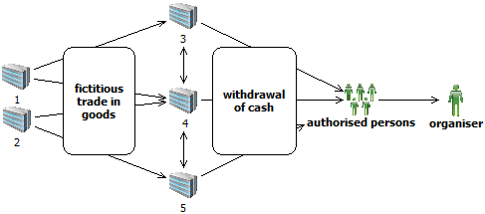

- Founder’s loan to maintain the company’s liquidity is a frequently abused purpose of transactions;

- Frequent withdrawals based on repayment of loans to maintain companies’ liquidity. The transactions were not preceded by loan payments and this way of withdrawing funds from accounts was used only to draw money from the companies’ accounts.


- Payments of founder’s loans to accounts of legal persons registered for providing hospitality services. In the media, the persons involved are linked to criminal activities. Sources of the funds paid to the accounts of these companies are dubious.


- Payments of founder’s loans to accounts of companies owned by the same person. Namely, large amounts are paid to an account of a company and then transferred to an account of another connected legal person.
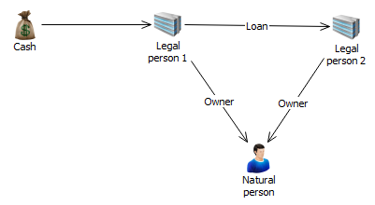
- Large cash deposits to accounts of a legal person in a short period of time (very commonly based on a founder’s loan for company’s liquidity). The money is used to settle obligations to the state, and sources of the money disposed of by the natural person – the company owner – are disputable.

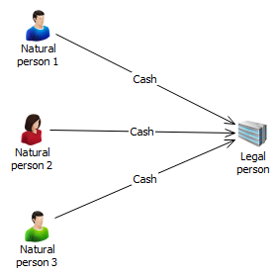

- Integration of money from selling of goods on the “black market”: The responsible person in a legal person has earned a lot of cash by selling goods on the “black market”. So as to integrate the funds into the financial system of the country, these persons use founders’ loans.

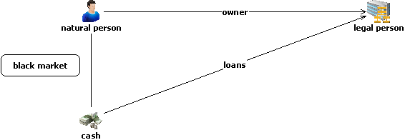

- Purchase of secondary raw material
Withdrawals of funds from accounts of legal persons based on purchase of secondary raw material by several interconnected persons, accompanied by usage of falsified documentation.

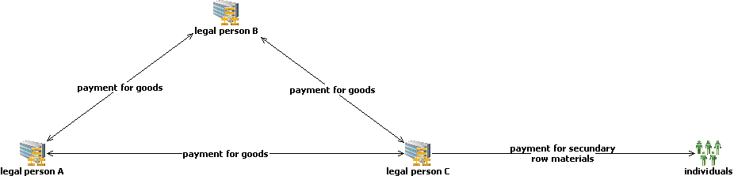

- Purchase of agricultural products
Transfers between accounts of several legal persons are accompanied by falsified documentation. Money is drawn from accounts based on purchase of agricultural products.
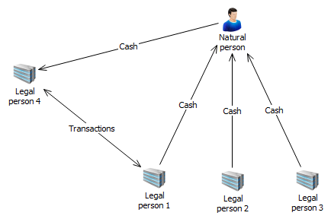

- Abuse of the transaction purposes: aid to family, inheritance, allowance and aid Large cash deposits to personal accounts and further transfer of money (based on inheritance, allowance and aid) to accounts of several natural persons in China. It is suspected that a Serbian citizen is importing goods from China illegally so as to avoid paying customs taxes and tax on trade in goods and that the transactions to China described as inheritance, allowance and aid are actually payments for the goods imported. These transactions purposes are also used to pay for other sorts of illicit activities – persons are linked to drugs trade and human smuggling.

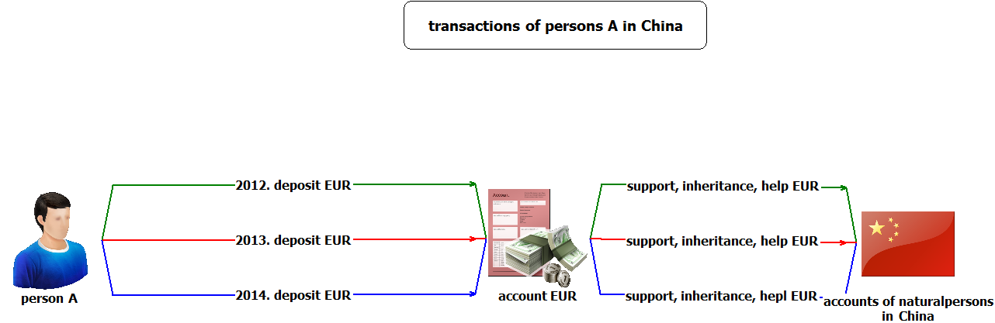

- Frauds and payment cards
Persons connected to criminal groups involved in various frauds pay big amounts to their personal accounts after which these are withdraw by the groups’ members who use payment cards in foreign countries.
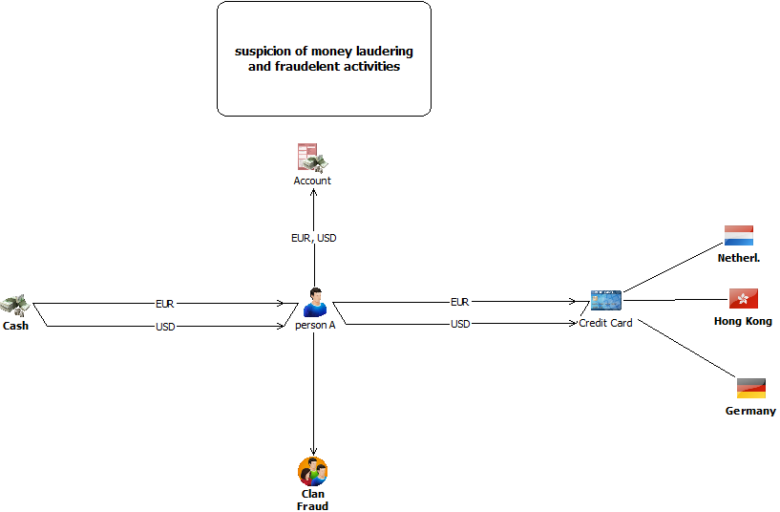

- Transactions with offshore companies
Transfer of big funds from offshore companies to accounts of Serbian companies and investing into the real estate sector. The beneficial owner of domestic and offshore companies is the same person.
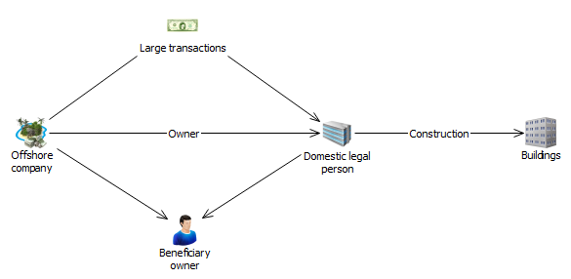

- “Cyber” crime and impersonation
- Money gained illegally (smuggling of cigarettes in foreign countries) is transferred through “hacked” accounts to accounts of “money mules” and then sent further to the smugglers’ accounts in Serbia.
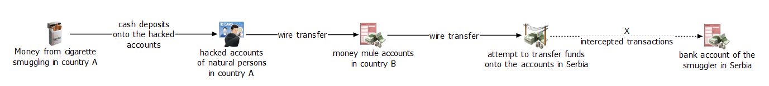

- Persons use false names and pretend to be raising funds for various purposes (e.g. money for a sick child). On that occasion, these individuals use personal accounts opened under their real names. Frequent cash deposits by numerous donors – payment orders are on false names and the transaction purpose is “payment for medical treatment of a child”. The funds are withdrawn in cash immediately.

- Person deposits cash, suspected to originate from drug trafficking, to several personal accounts held with different banks and uses the same documentation as a proof of the origin of these funds. The funds are invested in purchase of business premises which further generate material gain.

- Elements of corruption
- renting: enabling persons linked to criminals to rent state-owned land for a long period and get all the necessary permissions from responsible persons in the state authorities or public enterprises to build objects. After building objects, the responsible persons become owners of a part or the whole residence or office building, or receive monetary compensation.

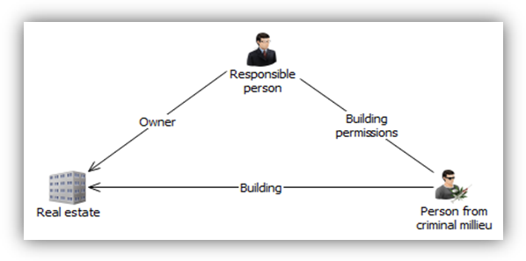
- abuse in the process of public procurement: adjusting the terms and conditions of a tender to suit legal entities whose owners are in friendly relationships with responsible persons in public enterprises. After winning the tender, the owners of the legal persons reward the responsible persons in the public enterprise with monetary compensation.

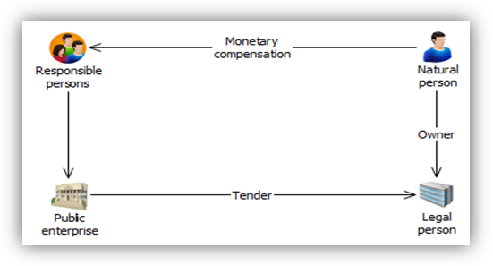

- granting credits to legal persons which do not meet the requirements: granting big credits to legal persons which do not meet the necessary requirements for credit approval, with help of persons holding prominent positions in the financial sector who are in return rewarded with monetary compensation or another favour. Money from the credit is further transferred through an account abroad back to the country and is used for personal needs. 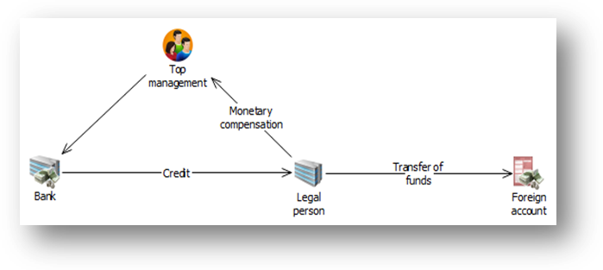
- Circulation of funds through accounts of connected persons
Contract on trade in immovable property signed between a legal entity and natural persons connected to the owner of the legal entity (via familiar or marital connections). The purchaser – connected person pays the agreed sum in cash. The owner of the legal person withdraws the funds based on founder’s loan to maintain the company’s liquidity.

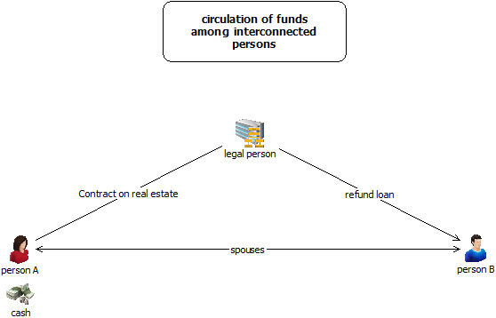

- Suspicion of terrorism financing

- Domestic association receives a lot of money in a short period from an organisation in a foreign country, based on donations from persons included in several lists of persons sanctioned in various countries because of terrorism. After the funds arrive to the account of the domestic association, they are successively withdrawn by a nominee to the account.

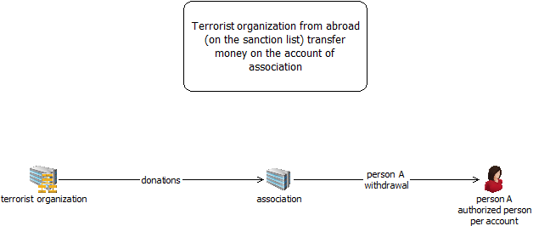

- Several humanitarian organisations from foreign countries transfer funds to the benefit of a humanitarian organisation in Serbia in a short time period. The funds are transferred in small amounts from many organisations from the EU countries (Germany, Albania, Belgium, Great Britain, etc.). Every transfer is accompanied by a contract on gift and aid. A smaller portion of the money is used for regular business activities while the most of it is withdrawn in cash.

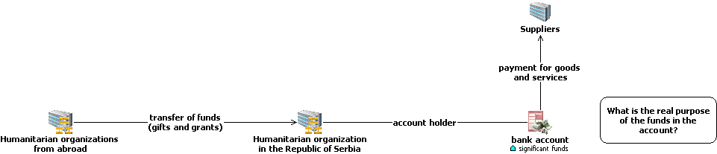

MONEY LAUNDERING TRENDS

Based on the experience so far, it is supposed that in 2015 the following activities will be prominent:

Numerous crimes of corruption as predicate offences for money laundering in analysed cases. A lot of abuse has happened in the process of privatisation and public procurements. The area of public procurements and transactions involving purchase of goods and services should be subject to enhanced scrutiny.

Identity theft and usage of bank accounts of persons with no criminal background to execute various transfers so as to send money abroad quickly are activities carrying very high risk. It is suspected that these modi operandi will be increasingly used in the future, especially when it comes to trade in narcotics.

Virtual currencies (e.g. “bit coin“) and insufficiently explored and regulated area of virtual communications and new methodologies creates for criminals a wide spectrum of new ways for investing money originating from illegal activities. Moreover, “non face to face” business relationships have influence on increase in the number of potential abuses. In the following period, these activities should be given more attention and the virtual currencies market should be monitored more closely, especially bearing in mind that some hospitality facilities and educational institutions are already accepting virtual money as a means of payment.

Certain games of chance and clients who deal with organising games of chance deserve attention as well. Insufficiently clear-cut authorisations of the state authorities in supervision of this area motivate criminals to turn to this business.

Simulated legal affairs with the aim of withdrawing funds from accounts of legal entities and abuse of the transactions with the code no. 221- trade in goods and services, so as to conceal the real purpose of transfers, is a way commonly used by persons intending to make illicit profit and draw money out of accounts, and it is assessed that this sort of fictitious business activities will continue in the period to come.
Use of services of money remitters so as to execute a cross-border transaction and transfer the money originating from illegal activities, especially when this involves frequent transactions in a short time period and in big amounts, should remain subject to closer observation and analysis.

Cross-border transactions executed on grounds of help and inheritance are often used to pay for illegally imported goods, and it is necessary to monitor them more attentively.
Transactions based on services - consultancy, marketing, research and development, etc. are an easy way for layering and integrating dirty money since it is difficult to determine the real market price of such services, as well as if the provision of services actually happened.

Sales of real estate for cash and payment of money to personal accounts of investors or contractors. The real purchaser is not identified in the banking sector, which leads to potential concealment of the actual owners of the real estate – only the investor in registered in the financial system.

Transfer of money from offshore destinations. The money transferred in forms of various loans, credit arrangements and founding capital should be subject to meticulous attention, especially when beneficial owners of companies registered in the so-called “tax heavens” cause suspicion.

Although the capital market has been facing crisis for a longer now, experience from the previous years shows that the process of a company’s takeover is still being used to conceal beneficial owners and persons intending to take over most of the capital of the company subject to takeover, especially when offers come from companies whose founders are registered in offshore destinations.

Offshore companies and construction works should be observed more attentively in the period to come. Investments in the real estate sector when founders of the building companies are offshore firms should be monitored with special attention, because of a suspicion that this way illegally gained profit has been invested into the regulated sector.

Import of goods at inflated prices: this way capital is still taken out of the country, despite increased obligations being paid. Companies frequently abuse this manner of payment so as to also pay for a part of goods sold in the black market, and it is supposed that these activities will continue in the future. Such payments are most commonly directed towards offshore companies.

Cash payments in short time and in big amounts, especially when foreign currency is involved, deserve a special approach. Related to cash payments, founder’s loans and other loans as methods to introduce money are often used for concealment of funds for goods sold in the black market and such transactions should be additionally analysed.

Illegal trade and smuggling of high value goods (luxurious goods) are a big source of dirty money. So far, fewer illicit activities and suspicious transactions have been related to this criminal offence, but such transactions should always be additionally monitored and the market for luxurious goods should be under enhanced supervision.

The unregulated area of trade in gold leaves a lot of room for manipulations. Purchase of scrap gold by organised criminal groups, illicit transfer over the state border, smuggling of golden jewellery and its further reselling, as well as purchase of gold through chains of jewelleries and exchange offices are activities which deserve greater attention.

In is not unusual that companies use transfer prices to avoid paying tax obligations. Since these prices are not subject to market influences, it is necessary for them to be constantly monitored.

“Carousel frauds” are a constant method for manipulations used by persons willing to acquire material gain accrued this way. International transfers involving big amounts in a short time period and with the purpose of getting tax credit should be analysed additionally.

